Week 2 – Day 1 Assignments
Class Room Assignment – Using GPT
ICETOP Technique:
Prompt :
Context: As a Expertise Tester with insurance domain you are required to generate the test cases.
Instructions:
- Generate a test cases for Member Enrolment.
- [Critical] : Generate the end to end test cases.
- [Important] : Generate 15 test cases.
Example:

TC_01 – Successful Self Enrollment
- Preconditions: User is logged in, policy is active
- Steps:
  - Navigate to Member Enrollment
  - Enter valid personal details
  - Select relationship as “Self”
  - Submit
- Test Data:
Name: Ravi Kumar
DOB: 15-06-1990
Policy ID: POL12345
- Expected Result: Member is successfully enrolled
Output:
Generate test cases in downloadable Excel format and review comments as a Tabular format.
TC ID | Test Scenario | Preconditions | Test Steps | Test Data | Expected Result | Priority | Type
TC_01 | Successful self enrolment | User logged in, active policy exists | Enter all valid details → Submit | Valid member data | Member enrolled successfully | High | Positive

Tone: Give the output in Professional tone only.
Persona: Review the generated test cases as a Domain Expertise Team Lead
Output from Chat GPT :
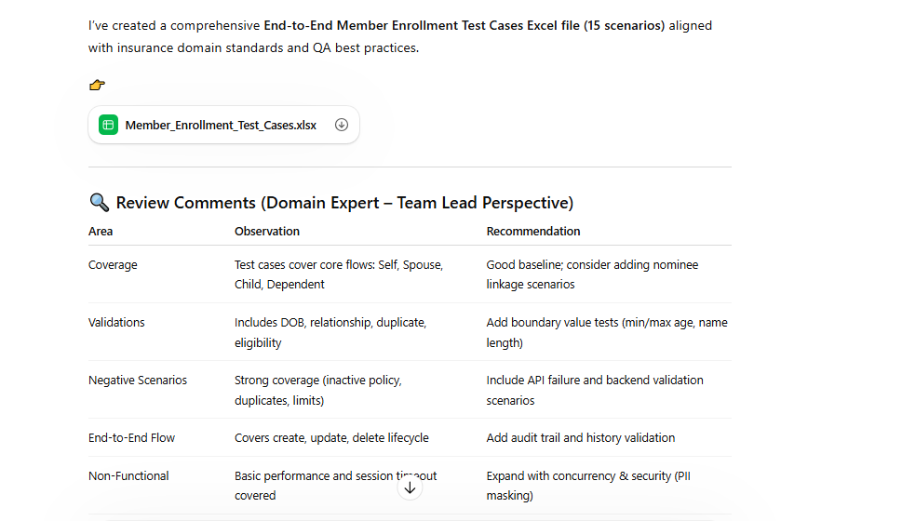

Chain of Thought Technique:
Prompt: Generate the test plan for Member Enrolment for an insurance policy take 5 questions step by step once after answering proceed with next question

Output after answering all questions:

Home Assignment

Task 1 : Prepare a test strategy document based on the domain, using a chain-of-thought approach (refer to the document provided in the ZIP file)

Chat Model Used : Qwen

Prompt :
Context : As a Expertise Test Lead with insurance domain you are required to generate the test strategy document.

  - Ask me 5 questions one by one for creating Test Strategy
  - Ask me next question after answering the
  - Test Strategy should follow the industry standard
  - Review the generated Test strategy as a Expertised test manager
Output should be a downloadable word document and review comments should be downloadable Excel format

Output Generated :

Task 2 : Design the automation framework structure using a chain-of-thought approach

Chat Model Used : Chat GPT

Context : As a Expertise Automation Tester generate the playwright automation framework structure

  - Ask me 5 questions one by one for framework Creation
  - Ask me next question after answering the
  - Framework should follow the industry standard
  - Review the generated framework as a Expertised test automation lead
Generated Output :

