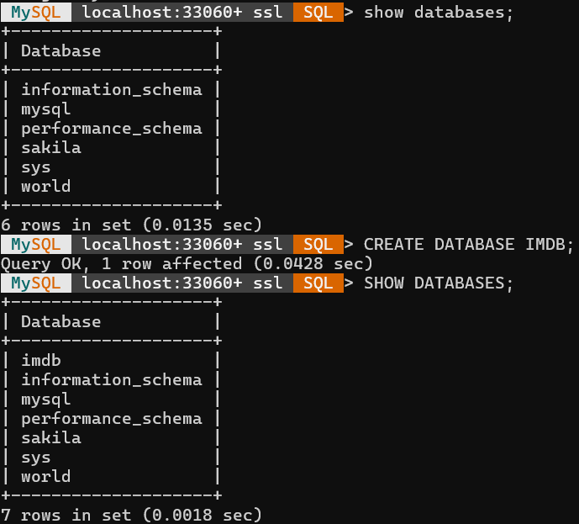
MySQL Shell Query Execution Screen Shots

Creating Database IMDB

Creating tables in imdb
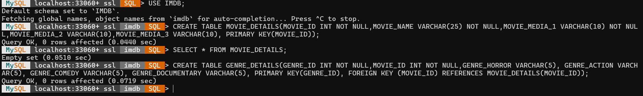
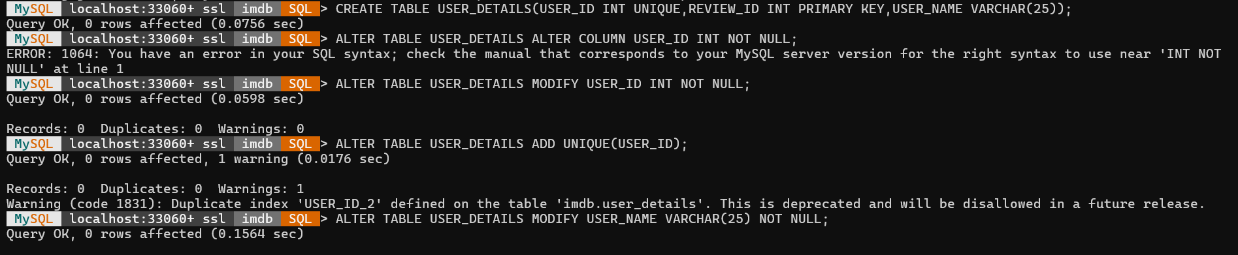

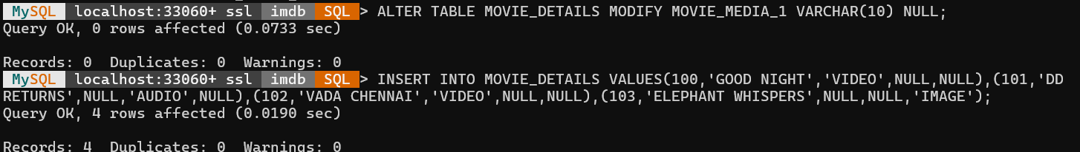

Inserting Values into the table

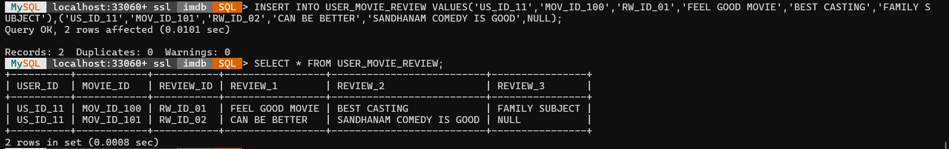
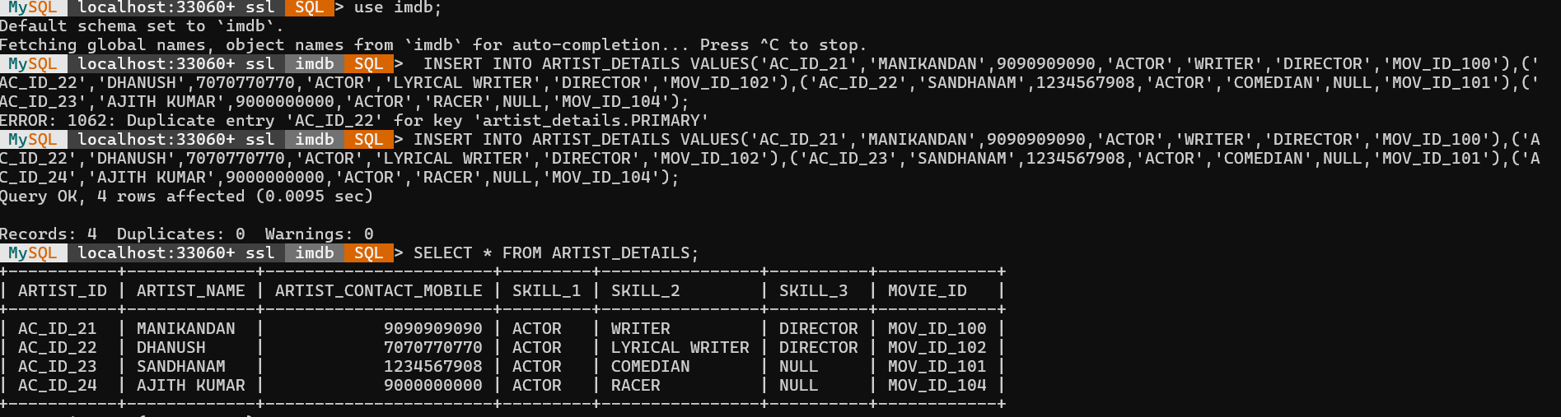
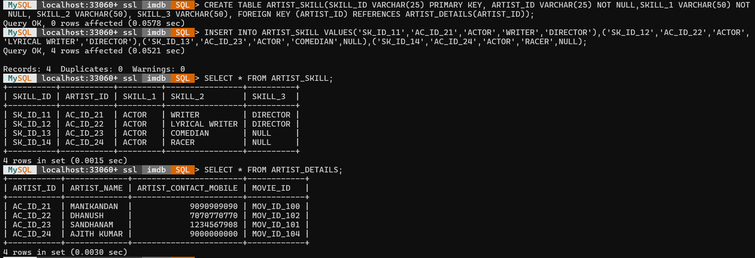

Updating Table data

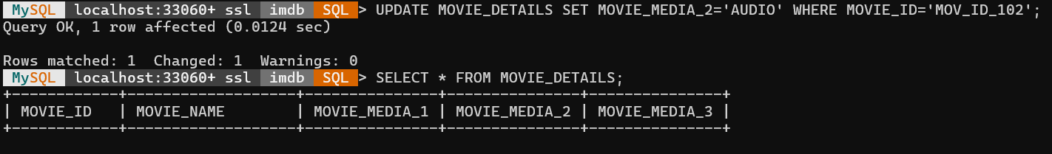
Altering Table column
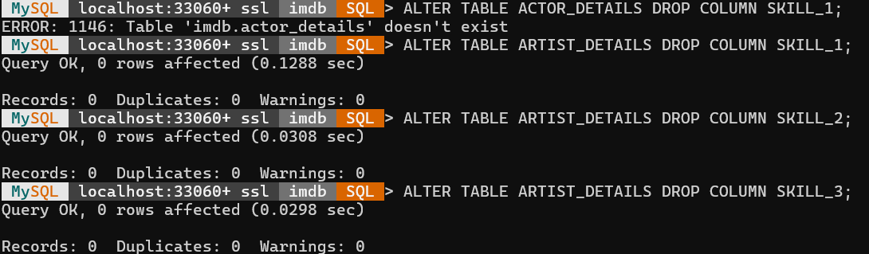

Stored Procedure
Notepad Screenshot
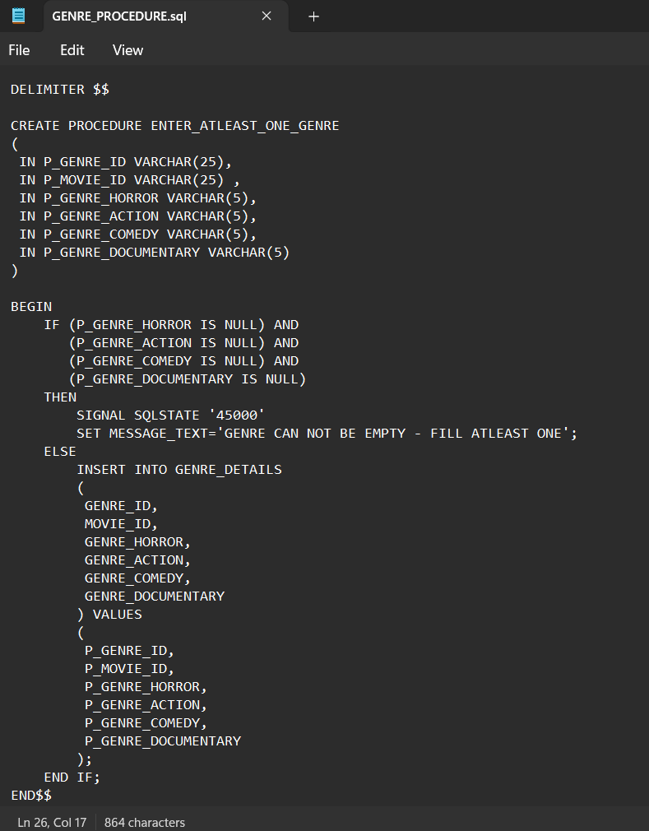

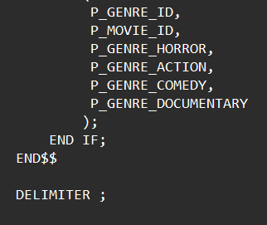
Calling and Inserting values using Procedure
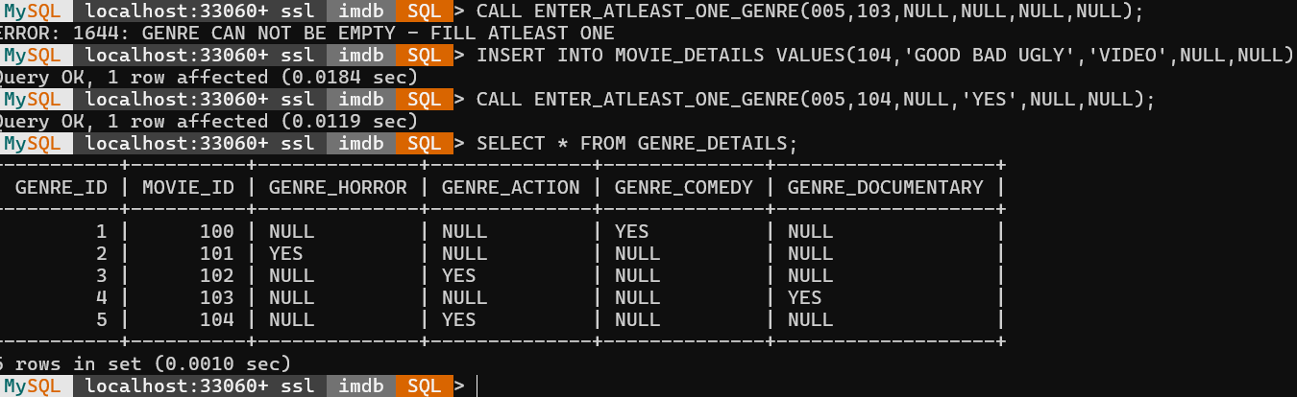

To View all the tables with its data

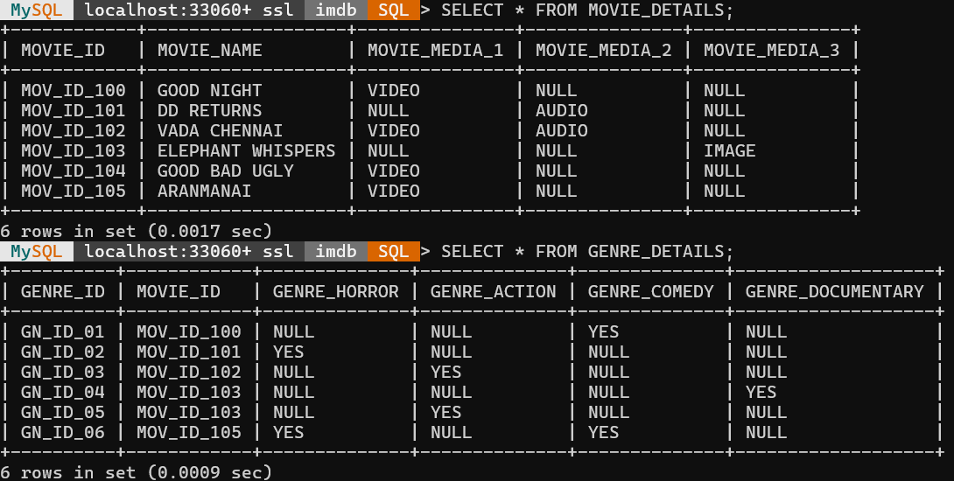
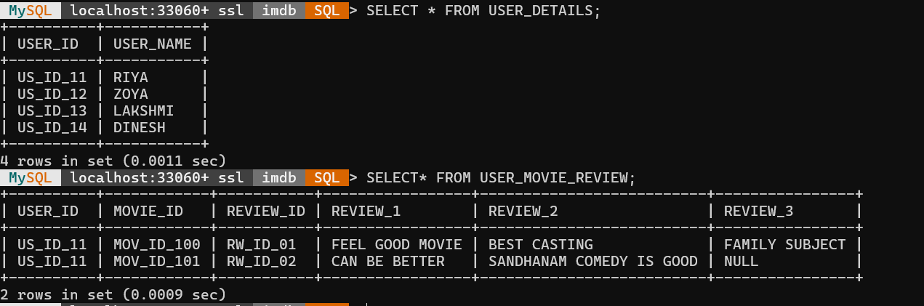

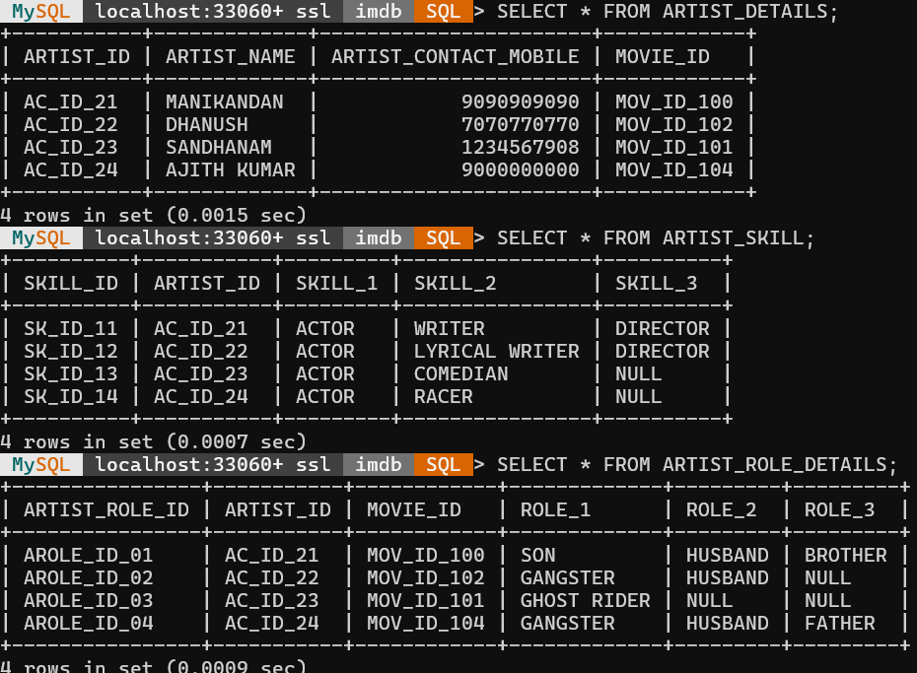

Join Concept

Sub-Query Execution

