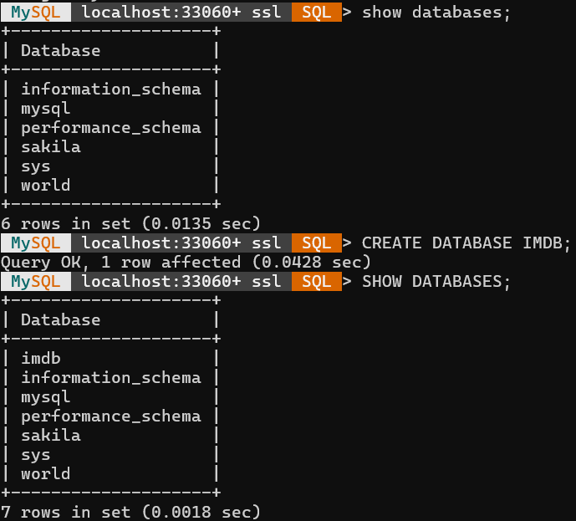
MYSQL Shell Screen Shots – Task- 7
1) Creating database imdb

2) Creating movie_details table, genre_details table in imdb database
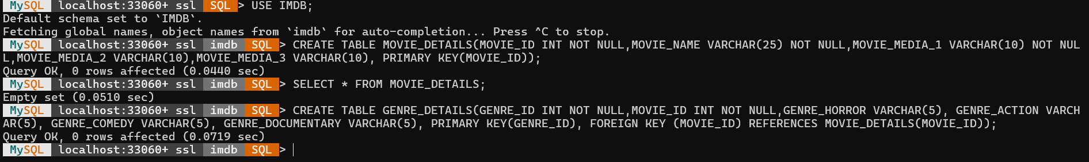

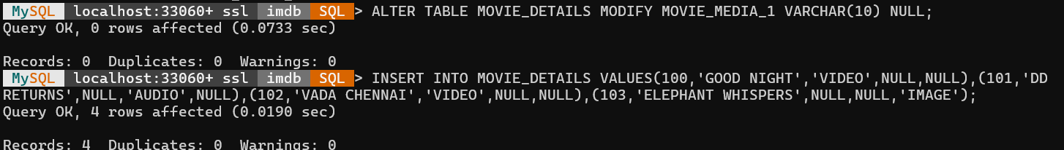
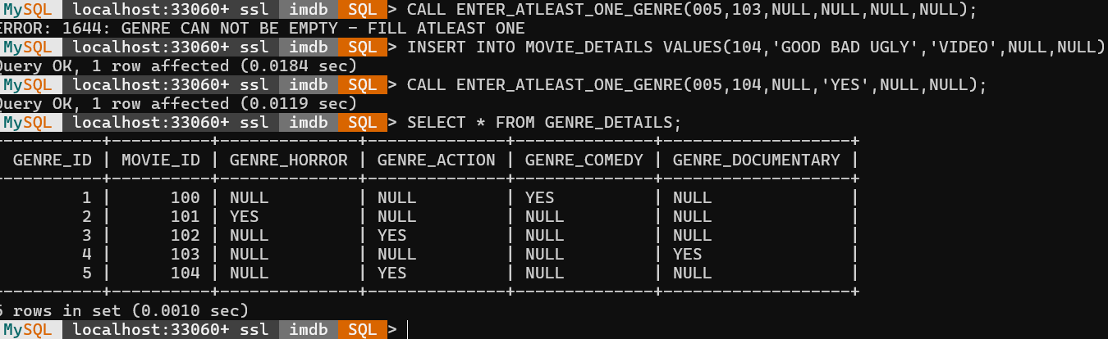
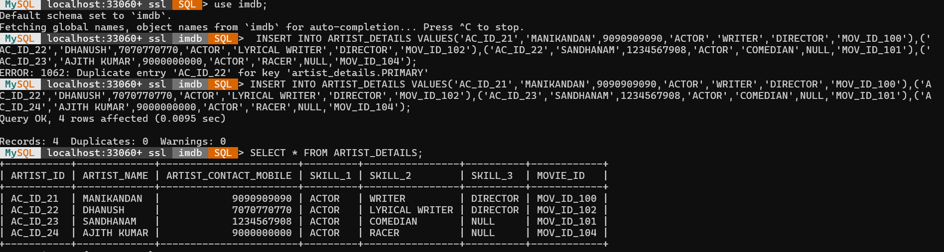
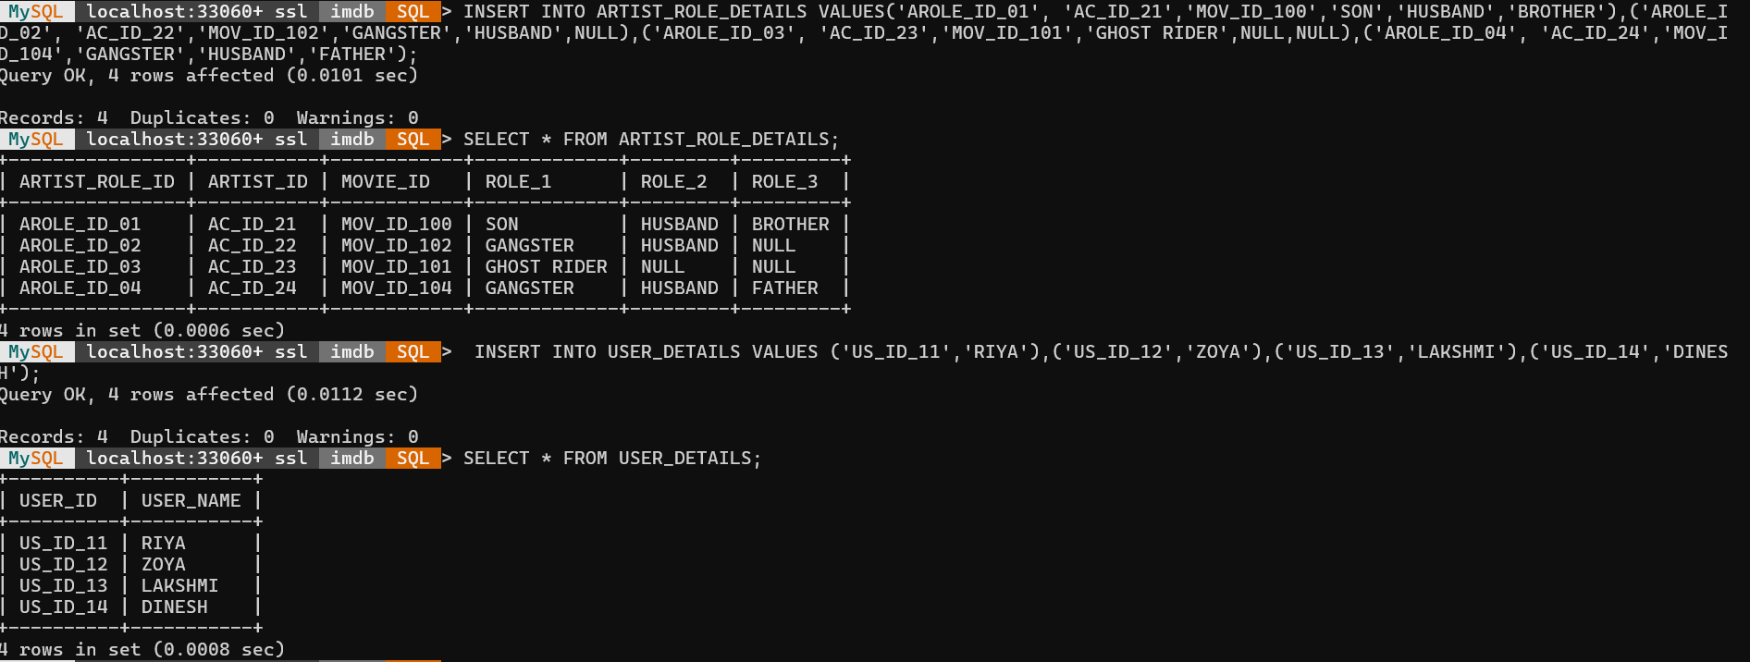
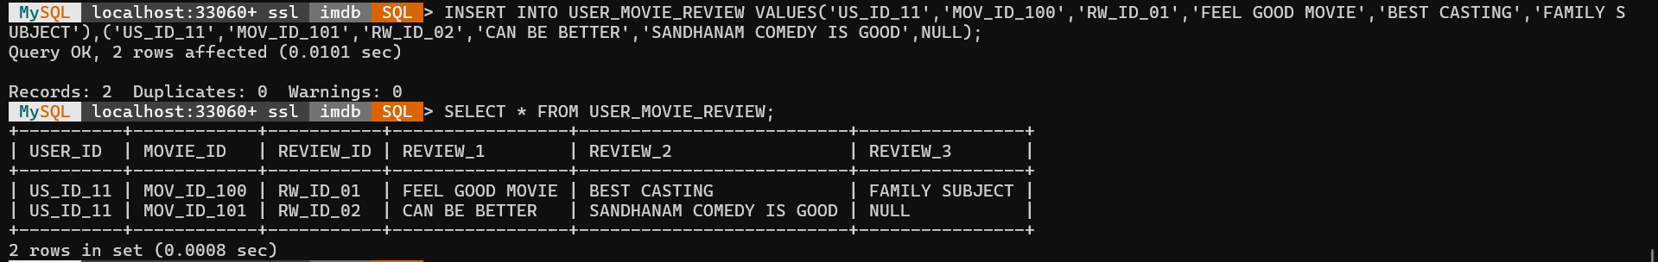
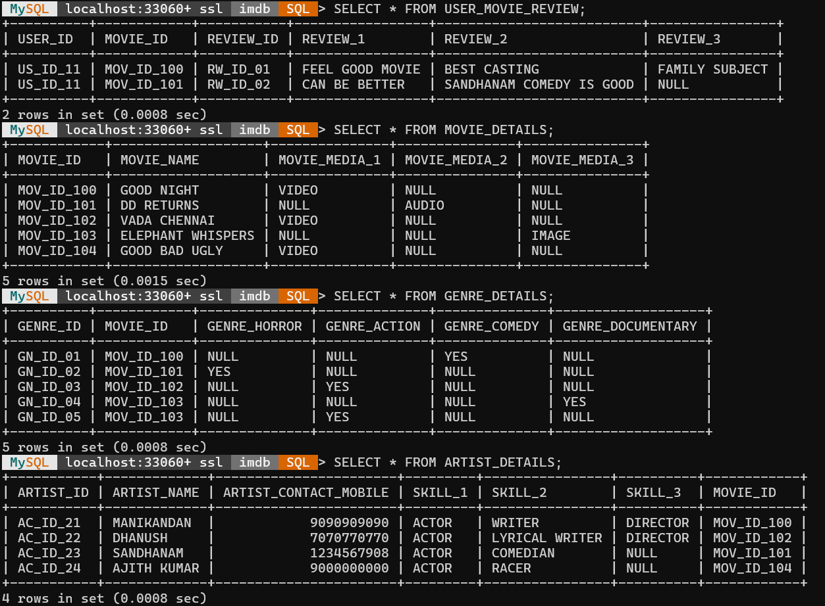
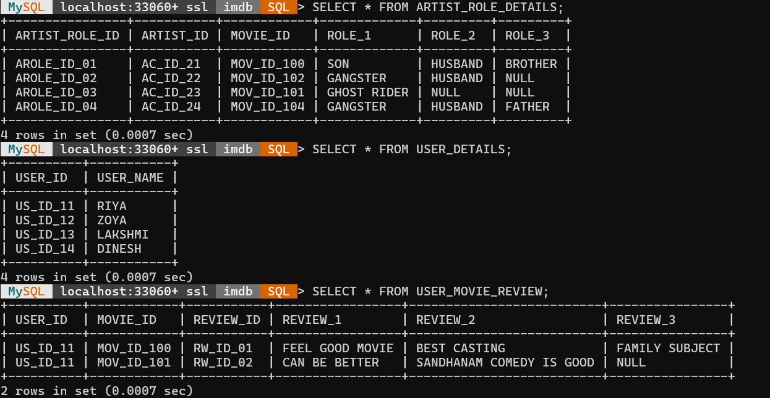
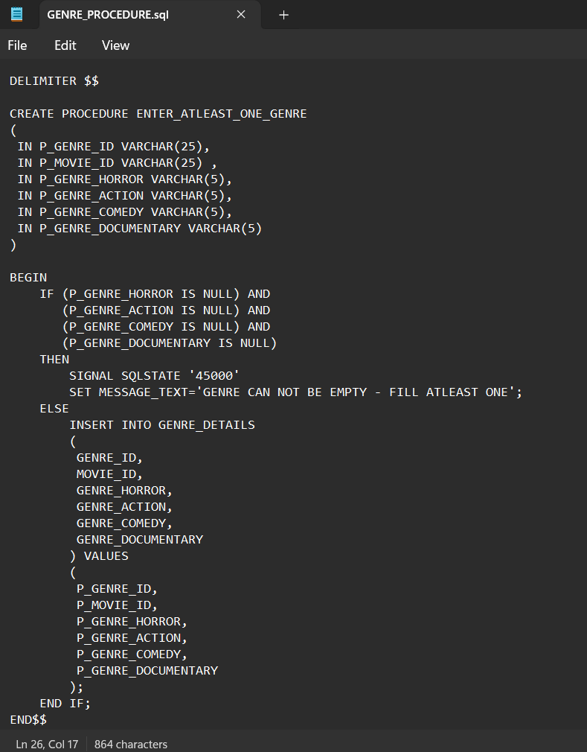
This is the notepad screenshot for stored procedure GENRE_PROCEDURE.sql
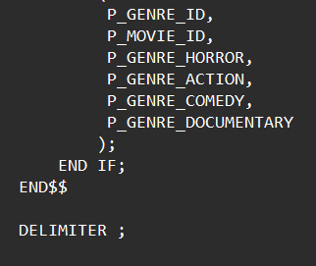
Join query execution
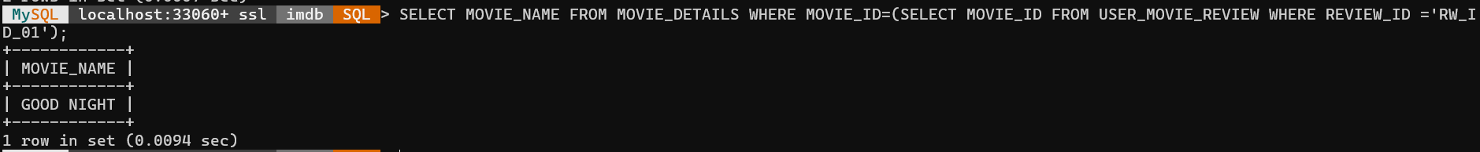
Sub-Query Execution
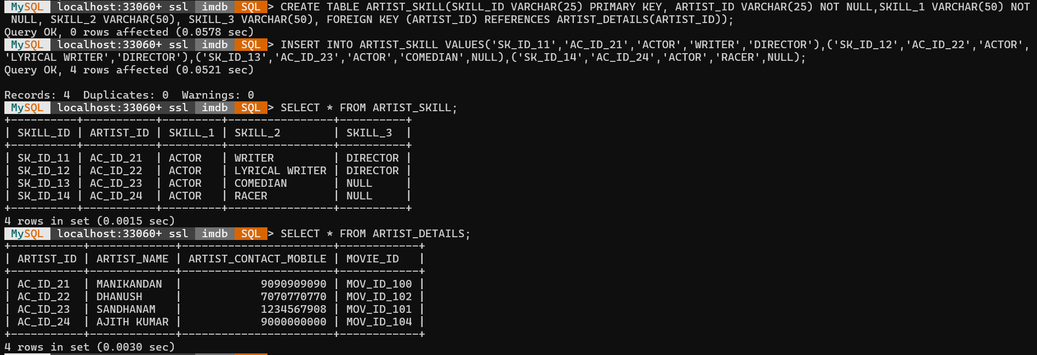
creating and inserting values for Artist_Skill table

