PROJECT REPORT
Employee Attrition Prediction using
Data Analytics and Machine Learning
Submitted in partial fulfillment of the requirements for the
AICTE – Bharat Cares Data Analytics Internship
(IBM SkillsBuild Track)
Submitted by:
Prathibha M
Panimalar Engineering College
Roll No: 2023PECIT207 | Final Year
AICTE Internship Program – 2026

Certificate
This is to certify that Prathibha M, a final-year student of Panimalar Engineering College (Roll No: 2023PECIT207), has successfully completed the "AICTE | IBM SkillsBuild Data Analytics with AI" Internship Program 2026, conducted by BharatCares in association with AICTE and IBM, and has submitted this project report titled "Employee Attrition Prediction using Data Analytics and Machine Learning" as part of the internship requirements.
This project was carried out during the internship period of 17th August 2026 to 30th September 2026, under the mentorship provided through the AICTE–BharatCares–IBM SkillsBuild internship framework.
We wish them continued success in their future academic and professional endeavors.

Date: 17/08/2026
Place: Chennai

_________________________
Internship Coordinator / Mentor Signature

Declaration
I, Prathibha M, a final-year student of Panimalar Engineering College (Roll No: 2023PECIT207), hereby declare that the project report titled "Employee Attrition Prediction using Data Analytics and Machine Learning" submitted in partial fulfillment of the requirements of the AICTE | IBM SkillsBuild Data Analytics with AI Internship Program 2026 (conducted by BharatCares, 17th August 2026 – 30th September 2026) is an original and authentic record of the work carried out by me.
The data used in this project has been obtained from a publicly available dataset (IBM HR Analytics Employee Attrition & Performance dataset), and all analysis, code, and findings presented in this report are the result of my own effort, guided by the mentorship and learning materials provided during the internship.
This report has not been submitted, in part or in full, to any other institution or organization for the award of any degree, diploma, or certificate.

Date: 17/08/2026
Place: Chennai

_________________________
Prathibha M

Acknowledgement
I would like to express my sincere gratitude to BharatCares, AICTE, and IBM for providing me the opportunity to undertake the "AICTE | IBM SkillsBuild Data Analytics with AI" Internship Program 2026, and for enabling me to gain valuable hands-on experience in the field of data analytics.
I am thankful to my trainer, Mr. Kartik Hooda, and the entire BharatCares internship coordination team for their continuous guidance, well-structured masterclasses, and valuable feedback throughout the duration of this project. Their insights greatly helped me structure this project professionally and understand real-world data analytics workflows.
I would also like to thank IBM for making the HR Analytics dataset and the IBM SkillsBuild learning platform publicly available for learning purposes, which formed the foundation of this project.
Finally, I extend my appreciation to Panimalar Engineering College, my faculty, family, and friends who supported and encouraged me throughout this internship journey.

Prathibha M

Abstract
Employee attrition is a significant challenge faced by organizations across industries, leading to increased recruitment costs, loss of institutional knowledge, and reduced productivity. This project presents an end-to-end data analytics solution to predict employee attrition using the IBM HR Analytics Employee Attrition dataset, which contains 1,470 employee records across 35 attributes including demographic, job-related, compensation, and satisfaction variables.
The project follows a structured data analytics pipeline comprising data cleaning, exploratory data analysis (EDA), feature engineering, and machine learning model development. Two classification algorithms — Logistic Regression and Random Forest — were trained and evaluated using accuracy, precision, recall, F1-score, and ROC-AUC metrics. The analysis revealed that overall attrition stands at approximately 16.1%, with OverTime, MonthlyIncome, Age, and TotalWorkingYears emerging as the most influential predictors of attrition.
The Logistic Regression model achieved a recall of approximately 74% and an ROC-AUC of 0.80, making it effective at identifying at-risk employees, while the Random Forest model provided valuable feature importance rankings for interpretability. Based on these findings, actionable business recommendations are proposed, including targeted overtime reduction, compensation review for junior roles, and proactive retention programs for early-career employees.
This project demonstrates the practical application of data analytics and machine learning techniques to solve a real-world human resources problem, providing a reusable framework that organizations can adapt for ongoing attrition monitoring and workforce planning.

1. Introduction
In today's competitive business environment, human capital is one of the most valuable assets an organization possesses. Employee attrition — the voluntary or involuntary departure of employees from an organization — poses a serious challenge to business continuity, productivity, and cost management. Studies consistently show that replacing an employee can cost anywhere from 50% to 200% of their annual salary when recruitment, onboarding, and lost productivity are accounted for.
Traditionally, HR departments have relied on exit interviews and periodic employee satisfaction surveys to understand attrition after it has already occurred. However, this reactive approach does little to prevent valuable employees from leaving in the first place. With the growing availability of structured employee data and advances in data analytics and machine learning, organizations now have the opportunity to move from a reactive to a proactive attrition management strategy.
This project leverages the IBM HR Analytics Employee Attrition dataset — a rich, structured dataset capturing demographic, job-related, compensation, and satisfaction attributes of 1,470 employees — to build a predictive model that identifies employees at risk of leaving. By combining exploratory data analysis with supervised machine learning classification techniques, this project aims to uncover the underlying patterns and drivers of attrition, empowering HR teams to make informed, data-driven retention decisions.

2. Literature Review
Employee attrition prediction has been a widely studied problem in the fields of Human Resource Analytics (HR Analytics) and People Analytics. Several prior studies and industry case studies have applied machine learning techniques to this problem with promising results.
Early HR analytics approaches relied primarily on descriptive statistics and manual correlation analysis to identify attrition trends — for example, simple comparisons of attrition rates across departments or tenure bands. While useful, these approaches often failed to capture complex, multi-variable interactions that influence an employee's decision to leave.
With the rise of machine learning, researchers and practitioners began applying classification algorithms such as Logistic Regression, Decision Trees, Random Forests, Support Vector Machines, and Gradient Boosting methods (XGBoost, LightGBM) to attrition prediction problems. These models are able to capture non-linear relationships between multiple employee attributes and the likelihood of attrition, generally outperforming simple rule-based or statistical approaches.
A commonly cited challenge in this domain is class imbalance — in most real-world datasets (including the one used in this project), the number of employees who leave is significantly smaller than the number who stay. This imbalance can bias models toward predicting the majority class unless addressed using techniques such as class weighting, oversampling (e.g., SMOTE), or careful selection of evaluation metrics (precision, recall, F1-score, ROC-AUC) rather than relying on accuracy alone.
This project builds on these established practices by applying a structured EDA-driven feature analysis combined with two widely used and interpretable classification algorithms (Logistic Regression and Random Forest), ensuring both predictive performance and business explainability — a balance that is essential for real-world HR analytics applications where stakeholders need to trust and understand model outputs.

3. Problem Statement
Employee attrition is costly and disruptive for organizations, yet HR departments often lack the analytical tools to identify which employees are at risk of leaving and why. The many contributing factors — compensation, job satisfaction, overtime, tenure, work-life balance, and more — are difficult to analyze manually across a large workforce.
This project addresses the problem: Can we use historical employee data to accurately predict which employees are likely to leave the organization, and identify the key factors driving this attrition, in order to support proactive retention strategies?

4. Objectives
- Analyze historical employee data to identify patterns and trends associated with attrition.
- Clean and preprocess the dataset to ensure data quality for analysis and modeling.
- Perform Exploratory Data Analysis (EDA) to visualize relationships between employee attributes and attrition.
- Build machine learning classification models to predict employee attrition.
- Evaluate model performance using appropriate classification metrics (accuracy, precision, recall, F1-score, ROC-AUC).
- Identify the most significant factors contributing to attrition using feature importance analysis.
- Derive actionable, data-driven business recommendations for HR retention strategy.

5. Methodology
This project follows the standard Data Analytics / CRISP-DM inspired lifecycle, structured into the following stages:
- Data Collection — Sourcing the IBM HR Analytics Employee Attrition dataset.
- Data Understanding — Inspecting structure, data types, and dataset size.
- Data Cleaning — Handling missing values, duplicates, irrelevant columns, and outliers.
- Exploratory Data Analysis (EDA) — Univariate, bivariate, and multivariate analysis using statistical summaries and visualizations.
- Feature Engineering — Encoding categorical variables and preparing the feature matrix.
- Model Building — Training Logistic Regression and Random Forest classification models.
- Model Evaluation — Assessing performance using accuracy, precision, recall, F1-score, and ROC-AUC.
- Insight Generation — Deriving business insights and actionable recommendations from the analysis and model outputs.
The entire pipeline was implemented in Python using Pandas and NumPy for data manipulation, Matplotlib and Seaborn for visualization, and Scikit-learn for machine learning model development and evaluation.

6. Dataset Description
The dataset used in this project is the IBM HR Analytics Employee Attrition & Performance dataset, a publicly available dataset originally released by IBM for analytics education and practice purposes.
Attribute | Description
Records | 1,470 employees
Columns | 35 features
Target Variable | Attrition (Yes / No)
Data Format | Structured CSV file
Missing Values | 0 (clean reference dataset)
Duplicate Records | 0

Key feature groups in the dataset include:
- Demographic: Age, Gender, MaritalStatus, DistanceFromHome
- Job-related: Department, JobRole, JobLevel, YearsAtCompany, OverTime, BusinessTravel
- Compensation: MonthlyIncome, PercentSalaryHike, StockOptionLevel
- Satisfaction: JobSatisfaction, EnvironmentSatisfaction, WorkLifeBalance, RelationshipSatisfaction
- Performance: PerformanceRating, TrainingTimesLastYear

7. Data Cleaning Process
Although the dataset was found to be free of missing values and duplicate records (a characteristic of this curated reference dataset), the standard industry data cleaning workflow was applied to ensure robustness and to demonstrate best practices applicable to messier real-world datasets:
- Removed non-informative columns: EmployeeCount, StandardHours, and Over18 (constant values across all rows) and EmployeeNumber (a unique identifier with no predictive value).
- Verified and handled missing values defensively using median imputation for numeric columns and mode imputation for categorical columns.
- Checked for and removed duplicate rows using pandas' drop_duplicates() function.
- Handled outliers in skewed numeric columns (MonthlyIncome, TotalWorkingYears, YearsAtCompany, NumCompaniesWorked) using the Interquartile Range (IQR) capping method, which limits extreme values to the acceptable range rather than deleting valid records.
After cleaning, the dataset was reduced from 35 to 31 columns (following removal of non-informative fields), while retaining all 1,470 employee records.

8. Exploratory Data Analysis (EDA)
Exploratory Data Analysis was conducted in three stages: univariate analysis (examining individual variables), bivariate analysis (examining relationships between two variables, primarily against Attrition), and multivariate analysis (examining relationships across multiple variables simultaneously).

8.1 Univariate Analysis
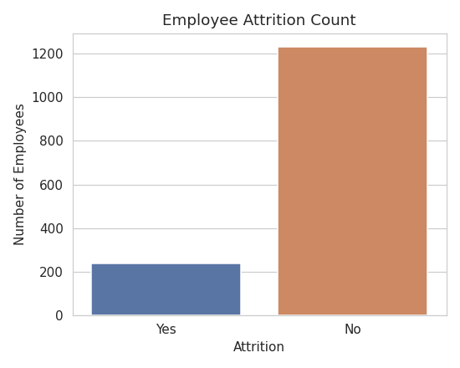
Figure 1: Distribution of employees by attrition status
The dataset shows a class imbalance, with approximately 83.9% of employees staying ("No") and 16.1% leaving ("Yes"). This confirms the need to use metrics beyond accuracy — such as precision, recall, and F1-score — when evaluating classification models.
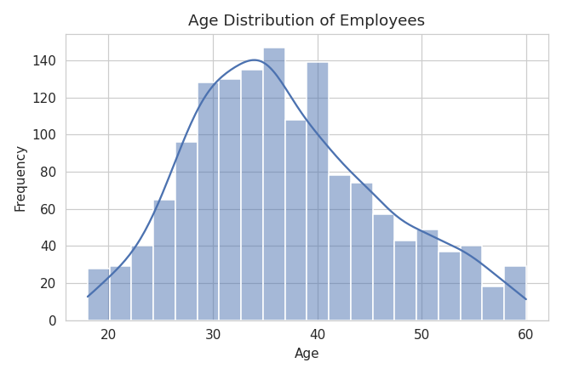
Figure 2: Age distribution of employees
The age distribution is approximately bell-shaped, centered between 30-40 years, indicating a workforce concentrated in the early-to-mid career stage.
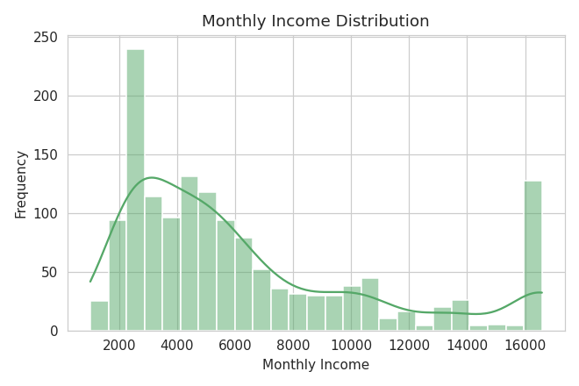
Figure 3: Monthly income distribution
Monthly income is right-skewed, with most employees earning in the lower-to-mid range and a smaller number of high earners, typical of real-world organizational salary structures.

8.2 Bivariate Analysis
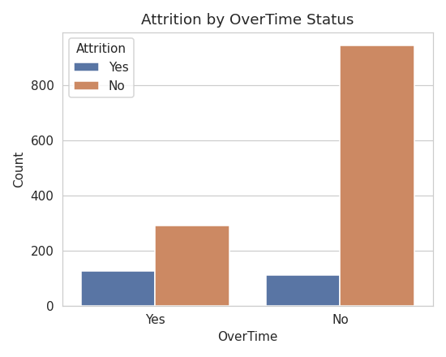
Figure 4: Attrition by OverTime status
Employees who work overtime show a substantially higher attrition rate compared to those who do not, identifying OverTime as one of the strongest attrition drivers in the dataset.
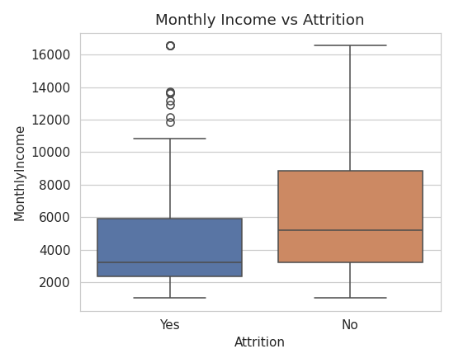
Figure 5: Monthly income vs. attrition (box plot)
Employees who left the organization tend to have a lower median monthly income than those who stayed, suggesting compensation plays a meaningful role in attrition decisions.
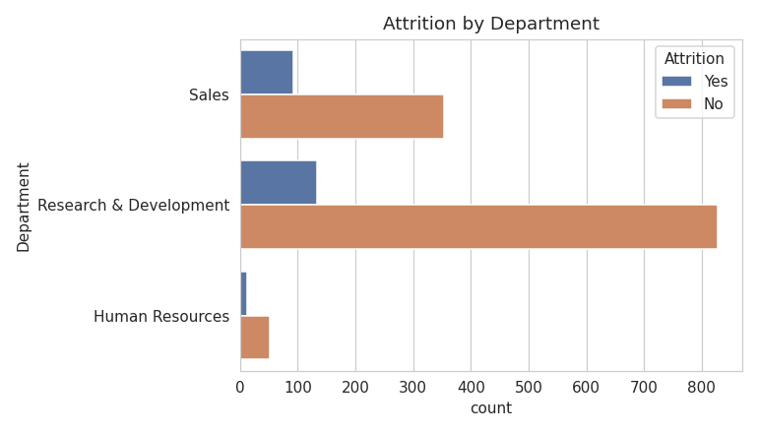
Figure 6: Attrition by department
While Sales and R&D departments have the largest employee counts and correspondingly larger raw attrition numbers, attrition rate (proportional) analysis is necessary to draw fair department-level conclusions.
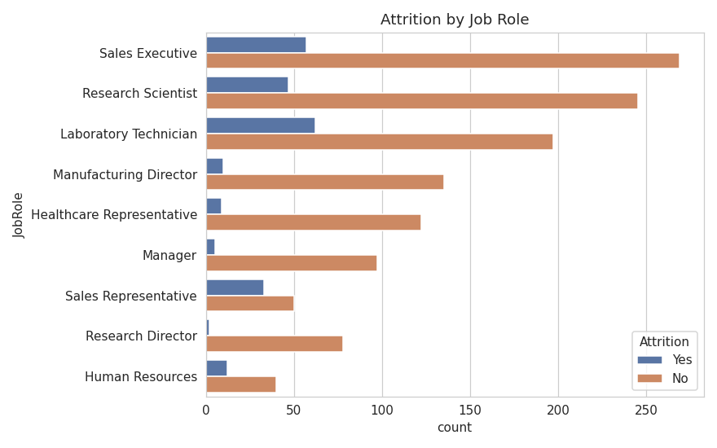
Figure 7: Attrition by job role
Roles such as Sales Representative and Laboratory Technician show proportionally higher attrition than senior roles such as Manager or Research Director, suggesting entry-level and high-pressure customer-facing roles are more attrition-prone.
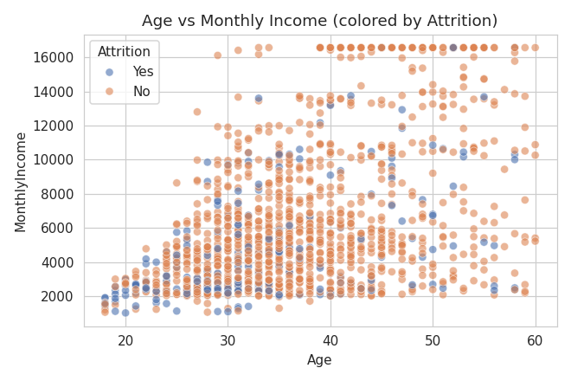
Figure 8: Age vs. monthly income, colored by attrition
Attrition cases are concentrated among younger employees with lower income, identifying this combination as a high-risk profile for HR to monitor.
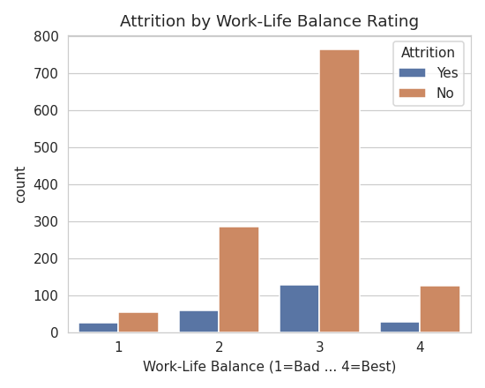
Figure 9: Attrition by work-life balance rating
Employees reporting poor work-life balance show a higher relative attrition rate, highlighting the importance of wellness and flexible work initiatives.

8.3 Multivariate Analysis
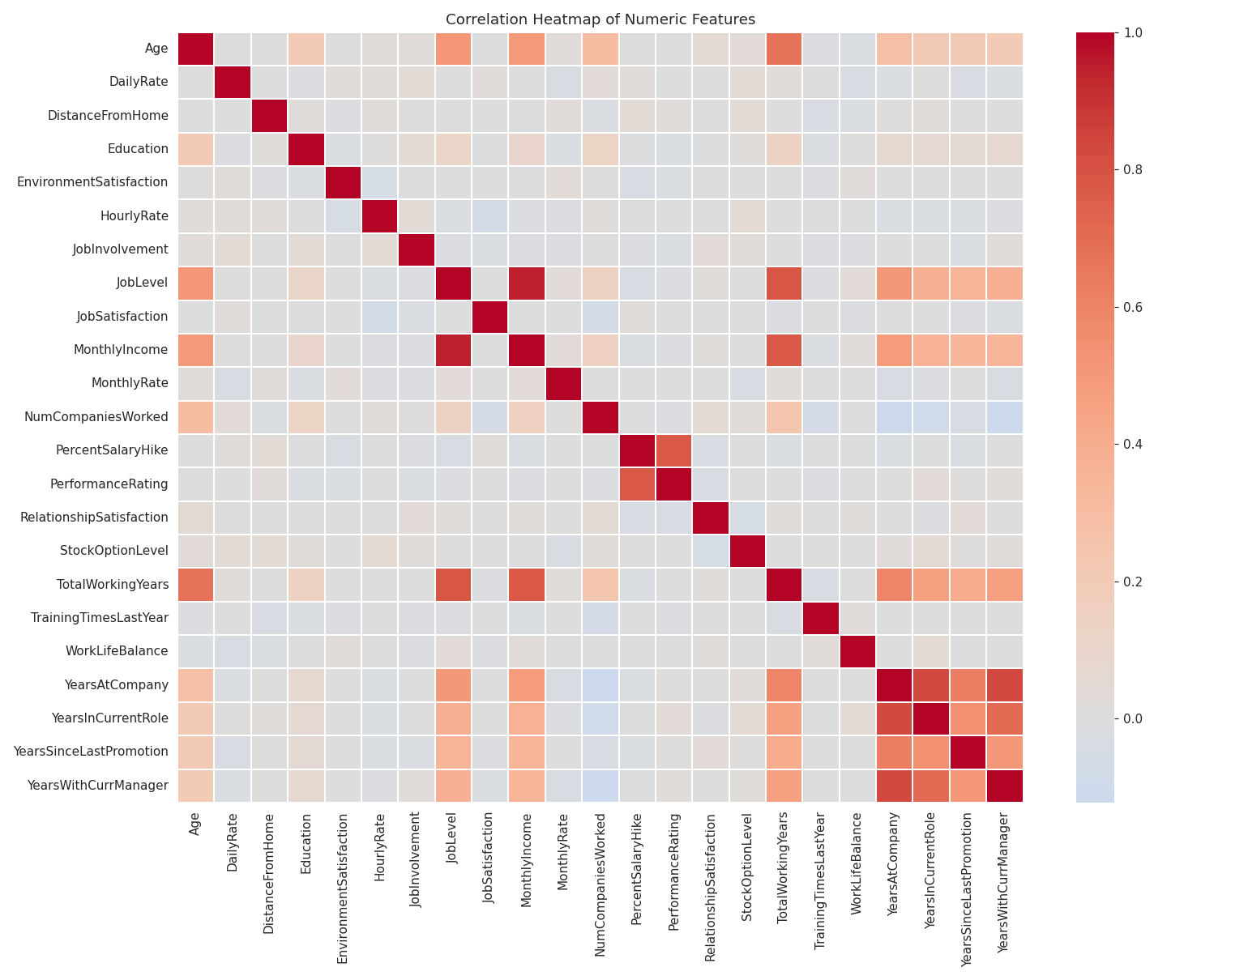
Figure 10: Correlation heatmap of numeric features
The correlation heatmap reveals strong positive correlations among naturally related variables, such as tenure-related fields (YearsAtCompany, YearsInCurrentRole, YearsWithCurrManager) and between JobLevel and MonthlyIncome. No single variable shows an extremely high correlation with attrition alone, confirming that attrition is a multi-factor phenomenon best captured through machine learning rather than simple univariate rules.

9. Machine Learning Model
Classification is a supervised machine learning technique in which a model learns from labeled historical data to predict a categorical outcome. In this project, the target variable is Attrition, with two possible classes: "Yes" (employee left) and "No" (employee stayed).

9.1 Data Preprocessing for Modeling
Categorical (text) columns were converted to numeric form using Label Encoding, since machine learning algorithms require numeric input. The target variable was encoded as 1 (Yes) and 0 (No). The dataset was then split into a feature matrix (X) and target vector (y), followed by an 80:20 train-test split using stratified sampling to preserve the original class distribution in both sets. Feature scaling (StandardScaler) was applied for the Logistic Regression model, which is sensitive to feature magnitude.

9.2 Algorithms Used
- Logistic Regression — a simple, interpretable baseline classification algorithm that estimates the probability of attrition using a weighted linear combination of features passed through a sigmoid function.
- Random Forest Classifier — an ensemble learning method that builds multiple decision trees and aggregates their predictions, generally offering strong performance on tabular data and providing feature importance scores for interpretability.
Both models were trained with class_weight='balanced' to counteract the class imbalance identified during EDA (16.1% attrition vs. 83.9% retention).

9.3 Model Evaluation Metrics
Metric | Logistic Regression | Random Forest
Accuracy | 0.7517 | 0.8197
Precision | 0.3646 | 0.3500
Recall | 0.7447 | 0.1489
F1-Score | 0.4895 | 0.2090
ROC-AUC | 0.8010 | 0.7845

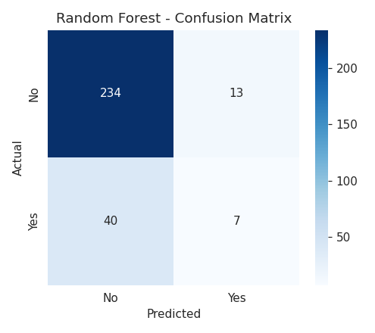
Figure 11: Confusion matrix — Random Forest classifier
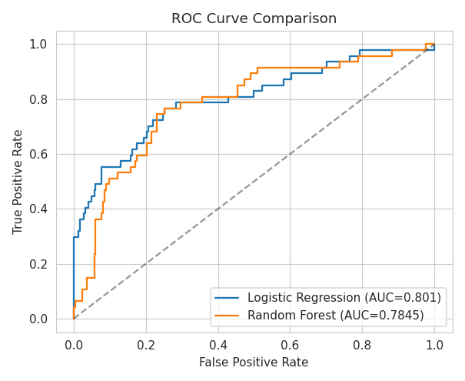
Figure 12: ROC curve comparison between models
Logistic Regression achieved a notably higher recall (74.5%) compared to Random Forest (14.9%) at the default classification threshold, meaning it is far more effective at correctly identifying employees who are actually at risk of leaving — an important priority for HR, where missing an at-risk employee (a false negative) is generally more costly than a false alarm. Random Forest achieved a higher overall accuracy but at the cost of missing many true attrition cases, illustrating the well-known accuracy-recall trade-off on imbalanced datasets. Both models achieved ROC-AUC scores between 0.78-0.80, indicating good overall discriminative capability, well above the 0.5 baseline of random guessing.

9.4 Feature Importance
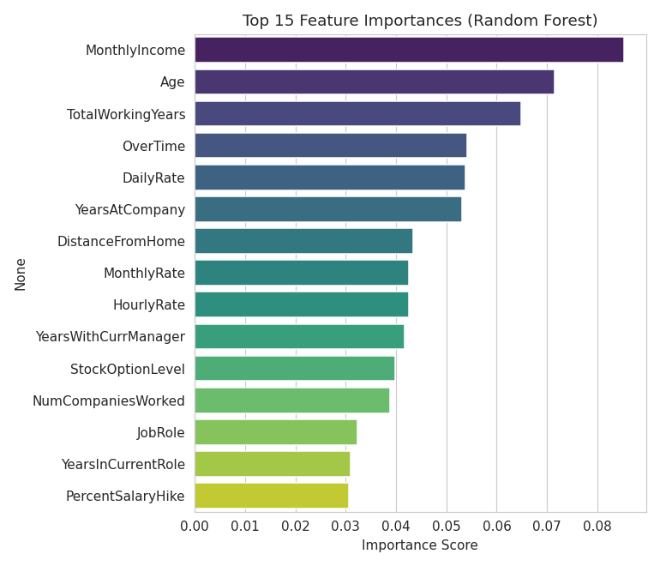
Figure 13: Top 15 feature importances from the Random Forest model
The Random Forest model's feature importance ranking identifies MonthlyIncome, Age, TotalWorkingYears, OverTime, and DailyRate as the top predictors of attrition. This aligns closely with the patterns identified during exploratory data analysis, reinforcing confidence in these findings through cross-validation between statistical exploration and model-driven analysis.

10. Results and Findings
Key Findings:
- The overall employee attrition rate in the dataset is approximately 16.1% — roughly 1 in every 6 employees leaves the organization.
- OverTime is one of the strongest attrition drivers — employees working overtime show a substantially higher attrition rate.
- Lower monthly income and younger age are strongly associated with higher attrition risk.
- Job role significantly affects attrition — Sales Representatives and Laboratory Technicians show higher attrition than Managers or Directors.
- Poor work-life balance correlates with higher attrition rates.
- The Logistic Regression model achieved a strong recall of 74.5% and ROC-AUC of 0.80, making it well-suited for flagging at-risk employees, while Random Forest offered valuable feature importance insights for interpretability.

Business Recommendations
- Target overtime reduction in high-risk roles through better workload distribution, process automation, or additional hiring.
- Review compensation bands for junior and lower-income roles, where attrition risk is highest.
- Build targeted retention programs for younger, early-career employees, including mentorship and clear promotion pathways.
- Deploy the predictive model as an early-warning system, scoring current employees periodically to proactively identify and engage high-risk individuals.
- Monitor work-life balance through regular pulse surveys, especially within high-turnover departments and roles.

Impact Analysis
Even a modest 5% reduction in attrition among identified high-risk employee segments could yield significant savings in recruitment, onboarding, and lost-productivity costs for the organization, while also improving employee morale, engagement, and retention of institutional knowledge. The predictive model developed in this project provides a scalable, data-driven foundation for such proactive HR interventions.

11. Conclusion
This project successfully demonstrates a complete, end-to-end data analytics workflow applied to a real-world human resources problem — from data cleaning and exploratory analysis through machine learning model development and business insight generation. Using the IBM HR Analytics Employee Attrition dataset, the analysis identified OverTime, MonthlyIncome, Age, and TotalWorkingYears as the primary drivers of employee attrition. A Logistic Regression classification model was found to be particularly effective at identifying at-risk employees, achieving a recall of 74.5% and an ROC-AUC of 0.80.
The insights and predictive model developed in this project can directly support HR decision-making, enabling organizations to move from reactive to proactive attrition management, and ultimately reduce the substantial costs associated with employee turnover.

12. Future Scope
- Incorporate time-series or longitudinal employee data to model not just whether, but when an employee is likely to leave.
- Apply SMOTE (Synthetic Minority Oversampling Technique) or other resampling methods to further address class imbalance and improve minority-class recall across both models.
- Experiment with advanced ensemble algorithms such as XGBoost, LightGBM, or Gradient Boosting Machines for potentially higher predictive performance.
- Develop an interactive HR dashboard (e.g., using Streamlit or Power BI) for real-time attrition risk monitoring and reporting.
- Incorporate employee sentiment or open-text survey data using Natural Language Processing (NLP) techniques for richer, more nuanced predictive signals.

13. References
- IBM HR Analytics Employee Attrition & Performance Dataset — Kaggle / IBM Watson Analytics Sample Data.
- Pandas Documentation — https://pandas.pydata.org/docs/
- NumPy Documentation — https://numpy.org/doc/
- Scikit-learn Documentation — https://scikit-learn.org/stable/
- Seaborn Documentation — https://seaborn.pydata.org/
- Matplotlib Documentation — https://matplotlib.org/stable/contents.html
- AICTE – Bharat Cares Internship Program Guidelines, 2026.
- IBM SkillsBuild Data Analytics Learning Resources.

