Lab 1: Analyze the relationship between the size of houses (measured in square footage) and their selling prices in a particular neighborhood. You have collected data on various houses in that neighborhood.Create a scatter plot using the below data and share your conclusion/analysis.

Input:

square_footage = np.array([1200, 1400, 1600, 1800, 2000, 2200, 2400, 2600, 2800, 3000])

selling_prices = np.array([250, 290, 315, 380, 410, 450, 500, 525, 570, 610])

Code:

#import numpy

import numpy as np

#import matplotlib

import matplotlib.pyplot as plt

#array of square_footage and selling_prices

square_footage = np.array([1200, 1400, 1600, 1800, 2000, 2200, 2400, 2600, 2800, 3000])

selling_prices = np.array([250, 290, 315, 380, 410, 450, 500, 525, 570, 610])

#creating a scatter plot

plt.scatter(square_footage,selling_prices)

#adding label to x axis

plt.xlabel('square_footage',fontsize=6)

#adding label to y axis

plt.ylabel('selling_prices',fontsize=6)

#displaying plot

plt.show()

Output:

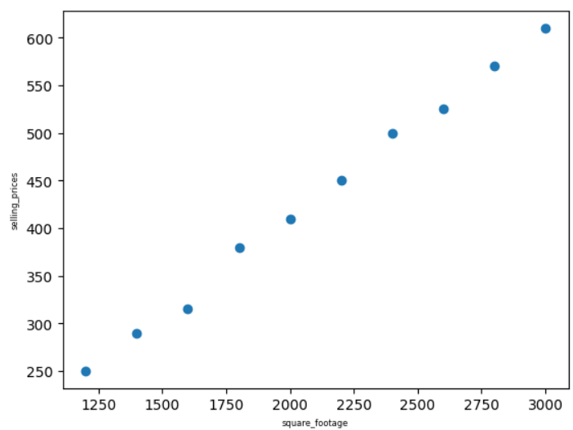

Lab2: Create a pie chart to visualize the distribution of your monthly income by source. You have collected data on the various sources of your income, such as salary, freelance work, investments, and rental income. Share your conclusion/analysis.

Input:

income_sources = ['Salary', 'Freelance', 'Investments', 'Rental', 'Other']

monthly_income = [5000, 1500, 1000, 600, 400]

Code:

#importing matplotlib

import matplotlib.pyplot as plt

#list of income_sources,monthly_income

income_sources = ['Salary', 'Freelance', 'Investments', 'Rental', 'Other']

monthly_income = [5000, 1500, 1000, 600, 400]

#creating pie chat

plt.pie(monthly_income,labels=income_sources,

autopct='%1.1f%%',startangle=120,colors=['g','b','r','y','m'])

#giving the tabel

plt.title('percentage of monthly income ',fontsize=10)

#displaying the pie chat

plt.show()

Output:

