---------------------------------------------------------------------------------------------------------------------------------------------------

1.Write a Pandas program to split the following data frame into groups based on Class and count the number of students in that particular class. Also generate a bar chart based on the result and explain the conclusion.

**Code:**

#importing pandas

import pandas as pd

#DataFrame 'student_data'

student_data = pd.DataFrame({

'school_code': ['s001','s002', 's003', 's001', 's002','s004'],

'class': ['V', 'VI', 'VI', 'VI', 'V', 'VI'],

'name': ['Alberto Franco', 'Gino Mcneill', 'Ryan Parkes', 'Eesha Hinton', 'Gino Mcneill', 'David Parkes'],

'age': [12, 12, 13, 13, 14, 12], 'height': [173, 192, 186, 167, 151, 159], 'weight': [35, 32, 33, 30, 31, 32], 'address': ['street1', 'street2', 'street3', 'street1', 'street2', 'street4']})

# Plot a bar chart showing the count of each class level in 'student_data'

student_data['class'].value_counts().plot(kind='bar')

**Output:**

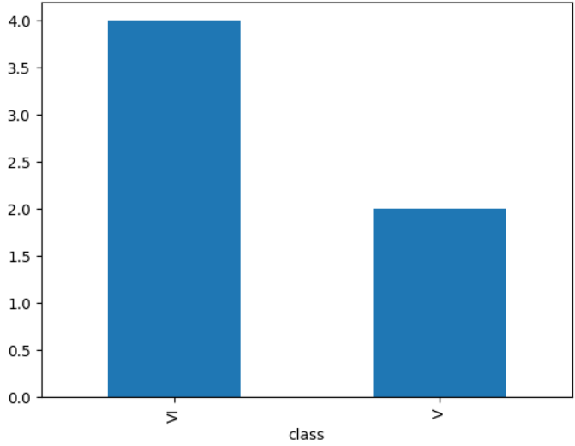

From the above graph, we can see that class VI has more students than class V

---------------------------------------------------------------------------------------------------------------------------------------------------

2.Write a Pandas program to split the following data frame into groups and calculate monthly purchase amount.Also generate a bar chart based on the result and explain the conclusion.

Code:

#importing pandas

import pandas as pd

#importing matplotlib

import matplotlib.pyplot as plt

# Input DataFrame

df = pd.DataFrame({

'ord no': [70001, 70009, 70002, 70004, 70007, 70005, 70008, 70010, 70003, 70012, 70011, 70013],

'purch amt': [150.5, 270.65, 65.26, 110.5, 948.5, 2400.6, 5760, 1983.43, 2480.4, 250.45, 75.29, 3045.6],

'ord date': ['05-10-2012', '09-10-2012', '05-10-2012', '08-17-2012', '10-09-2012', '07-27-2012', '10-09-2012',

'10-10-2012', '10-10-2012', '06-17-2012', '07-08-2012', '04-25-2012'],

'customer id': [13001, 3001, 3005, 3001, 3005, 3001, 3005, 3001, 3005, 3005, 3005, 3001],

'salesman id': [5002, 5005, 5001, 5003, 5002, 5001, 5001, 5006, 5003, 5002, 5007, 5001]

})

# Convert 'ord date' to datetime and group by month

df['ord date'] = pd.to_datetime(df['ord date'])

monthly_purchase = df.groupby(df['ord date'].dt.to_period('M'))['purch amt'].sum()

# Plot bar chart

monthly_purchase.plot(kind='bar', color='m', title='Monthly Purchase Amount', xlabel='Month', ylabel='Total Purchase Amount', rot=45)

#display

plt.show()

Output:

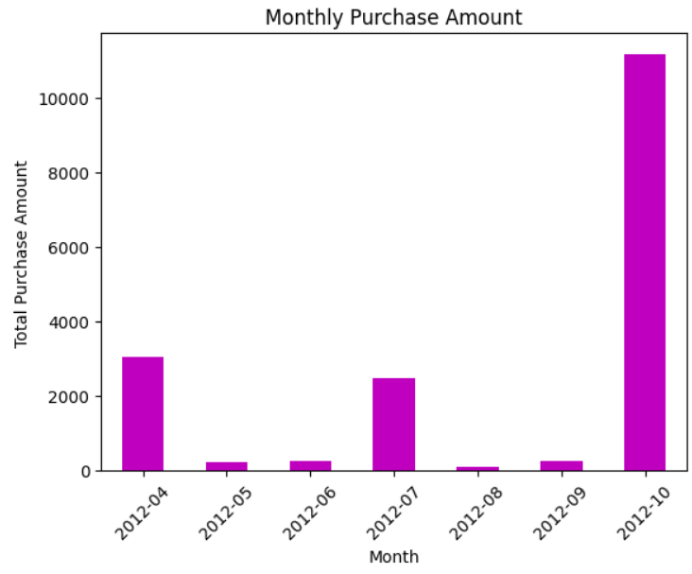 From the above graph, we can see that in October 2012, the highest amount of purchases took place, while in the 5th, 6th, 8th, and 9th months, it is comparatively less