MANGALORE UNIVERSITY

A Project Report On

**“****CHATBOT FOR COLLEGE ENQUIRY IN KANNADA”**

**BY**

**PRATHIBHA BHARATHI S D**

**201021387124**

**Under the Guidance**

**Dr. H L Shashirekha**

**Chairperson**

**Department of Computer Science**

**Mangalore University**

**Mangalagangothri- 574199**

#### DEPARTMENT OF POST GRADUATE STUDIES AND RESEARCH IN COMPUTER SCIENCE

**MANGALORE UNIVERSITY**

**MANGALAGANGOTHRI-574199**

**KARNATAKA, INDIA**



**MANGALORE** **UNIVERSITY**

**Accredited by NAAC**

**DEPARTMENT OF POST GRADUATION STUDIES AND** **RESEARCH IN**

**COMPUTER SCIENCE MANGALAGANGOTHRI -574 199**

**CERTIFICATE**

This is to certify that the project work entitled **“CHATBOT FOR COLLEGE ENQUIRY IN KANNADA”** has been successfully carried out in the Post-Graduate Studies and Research in Computer Science by **Ms. PRATHIBHA BHARATHI S D. (Reg.No:201021387124),** student of Third Semester MSc in Computer Science, under the supervision and guidance of **Dr. H L SHASHIREKHA,** Chairperson, Department of Post Graduate Studies and Research in Computer Science, Mangalore University. The dissertation is partial fulfilment of the requirements for the award of **Master of Computer Science** by **Mangalore University** during the academic year **2021-2022.**

**Internal Guide Chairperson**

**Internal Examiner External Examiner**

**Submitted for the Viva-Voce examination held on _______**

**DECLARATION**

This Project work entitled **“CHATBOT FOR COLLEGE ENQUIRY IN KANNADA”** has been successfully carried out by me under the supervision and guidance of **Dr. H L SHASHIREKHA**, Chairperson, Department of Post–Graduate Studies and Research in Computer Science, Mangalore University, Mangalagangotri-574 199. This dissertation is submitted in partial fulfillment for the award of MSc in Computer Science degree by Mangalore University during the academic year 2020-2022. This work or any part of this work has not been submitted to any other University or Institute/School for the award of any other Degree or Diploma.

**Date: Name: Prathibha Bharathi S D**

**Place: Mangalagangothri Reg. No: 2010213871324**

**ACKNOWLEDGEMENT**

It is indeed with a great pleasure and immense sense of gratitude that we acknowledge the help of these individuals. I am highly indebted to our Dean Dr. H L Shashirekha for their guidance and constant supervision as well as for providing necessary information regarding the project and also for their support in completing this minor project.

I would like express my gratitude towards Ms. Chaitra, Ms. Priyanka and Mangalore university computer science department for their kind co-operation and encouragement which helps in completion of this project**.**

**Prathibha Bharathi S D**

|  |  |  |
| --- | --- | --- |
| **Sl. No** | **CONTENTS** | **Page No.** |
| **Chapter 1** | **INTRODUCTION** | |
| 1.1 Overview | 7 |
| 1.2 Statement of The Problem | 7 |
| 1.3 Challenges | 8 |
| 1.4 Motivation | 8 |
| 1.5 Objectives | 9 |
| **Chapter 2** | **EXISTING SYSTEM** | |
| 2.1 Literature Review | 9-10 |
| **Chapter 3** | **PROPOSED METHODOLOGY** | |
| 3.1 Overview | 11 |
| 3.2 Methodology | 11 |
|  | 3.3 ARCHITECTURE OF SYSTEM/SYSTEM DESIGN | 12-13 |
| **Chapter 4** | **MERITS AND DEMERITS** |  |
|  | 4.1 Advantages | 14 |
|  | 4.2 Disadvantages | 14 |
|  | 4.3 Applications | 14 |
| **Chapter 5** | **HARDWARE AND SOFTWARE REQUIREMENTS** | 15 |
| **Chapter 6** | **EXPERIMENTS AND RESULTS** | |
| 6.1 Experiments | 16 |
| 6.2 Result | 16-17 |
|  | 6.3 Future Work | 17 |
| **Chapter 7** | **CONCLUSION** | 17 |
| **Chapter 8** | **REFERENCES** | 18 |

**ABSTRACT**

The communication of potential students with a university department is performed manually and it is a very time-consuming procedure. The opportunity to communicate with on a one-to-one basis is highly valued. However, with many hundreds of applications each year, one to one conversation is not feasible in most cases. The communication will require a member of academic staff to expend several hours to find suitable answers and contact each student. It would be useful to reduce his costs and time.

The project aims to reduce the burden on the head of admissions, and potentially other users, by developing a convincing chatbot. A suitable algorithm must be devised to search through the set of data and find a potential answer. The program then replies to the user and provides a relevant weblink if the user is not satisfied by the answer. Furthermore, a web interface is provided for both users and an administrator.

The achievements of the project can be summarised as follows. To prepare the background of the project a literature review was undertaken, together with an investigation of existing tools, and consultation with the head of admissions. This project aimed to implement online chatbot system to assist users who access college website, using tools that expose Artificial Intelligence methods such as Natural Language Processing, allowing users to communicate with college chatbot using natural language input and to train chatbot using appropriate Machine Learning methods so it will be able to generate a response.

Keywords – chatbots; Python; Natural Language Processing.

**1.INTRUDUCTION**

1.1 OVERVIEW

A chatbot is a software application used to conduct an online chat conversation via text or text-to-speech, in lieu of providing direct contact with a live human agent. Designed to convincingly simulate the way a human would behave as a conversational partner. Bots can be created by using language like Artificial Intelligence Mark-up Language (AIML), a language based on HTML that allow developers write rules for the bot to follow. The chatbot has been designed to provide students feel like talking to the staff from college and their queries are addressed through the conversational text. Responses can be provided to the user in text format, pictures and with many more features provided by the chat fuel.

1.2 STATEMENT OF THE PROBLEM

Chatbot for college enquiry system has been created utilizing artificial intelligence algorithms that examine the user queries. This chatbot system is an internet application that gives an answer to the broken-down queries of a user. Users simply need to choose the classification for inquiries. The system answers to users' queries with the assistance of effective Graphical User Interface (GUI).

1.3 CHALLENGES

* One of the biggest challenges with using chatbots in customer support comes with interpreting the messages and understanding the user intention.
* Chatbots Don’t Understand Human Context.
* They Can’t Make Decisions
* Chatbots can't answer all the queries and hence it can be seen as lacking personal touch
* Different chatbots require different installation procedures and hence increases initial installation cost unlike human beings.
* Chatbots Have the Same Answer for a Query

1.4 MOTIVATION

As students, we have a tendency to gain more of knowledge concerning our school, college and university throughout our course. Generally obtaining these details is very cumbersome and drawn-out. Like obtaining facts concerning our fee’s structure or the due fees remaining may be a terribly drawn-out method that we have to travel to administration building and notice the right window so explore for a no dues form then fill it with correct information so submit it to the acceptable person so that person can tell us our due fees. This is all long, hectic and unnecessary. We as a computer science student are always looking forward to solving the problems around us using the technology that we learn and how to implement them to achieve ease of usage in real life. This is where we thought of using an intelligent bot delivering this information. Think about an application, where all you have to do is just ask. there is no need of doing a lengthy and hectic procedure. If you want to know the process of admission, no problem our bot will tell you the steps. It can also solve the dilemma when a student is about to join the college. He/she may want to enquire about the fee structure of various colleges and know their admission procedure. Now in the current system, it can be a long process. You would have to go to various college sites and then check it. Then our chatbot can do it for you in seconds all you will have to do is to ask it.

1.5OBJECTIVES

* The aim of this project is to contribute to the solution of the problem of direct communication between applicants and the university.
* To develop a graphical user interface which aims to give the ability to potential students and their families to submit questions in a chatbot and get convincing replies.
* Applying machine learning approach for the best matching response.
* Making application to produce best response within less time.

**2. EXISTING SYSTEM**

2.1 LITERATURE REVIEW

Eliza is considered as the first Chatbot, which works on the pattern matching system. It is developed by Joseph Weizenbaum in 1964. ALICE is rule-based chatbot based on the Artificial Intelligence Markup Language (AIML). It has more than 40,000 categories, where each category has combination of pattern and its response. By utilizing the field of Artificial Intelligence, one can develop numerous applications one of that is mentioned in this paper is a college chatbot system. In spite of the fact that chatbot can be deployed in various fields like marketing, education, banking, clinical and finance. Research is being done in making the regular rule based chatbots to be informative, responsive and complete the correspondence in a conversational human language. This requires the incorporation of Natural Language Processing (NLP) and Machine Learning (ML) technologies into the college chatbot system.

Michael Maudlin created "Chatter Bot Algorithm" in 1994 and published in the book Julia and was used to answer the queries. Taking this initial idea, further projects were developed to create a chatbot system. The user needs to login to

Chat-Bot application. At exactly that point the user is permitted to submit complaints and queries. When user query is submitted to the bot, context of the query is recognized and NLP is applied. User questions are checked in the knowledge database. If the appropriate response is discovered, at that point that

answer is sent to that user. If a particular query isn't found in the database such inquiries are replied by administrator. When the administrator answers the query, at exactly that point the appropriate response is sent to the user. Question alongside answer is put in database so that at whatever point such inquiries will be posed with the intention that they get addressed legitimately from the database. Because of this administrator doesn't have to address same query physically any longer. Different algorithms such as Porter Stemmer Algorithm is used for expelling suffixes from words in English.

The user is permitted to ask any number of questions with respect to institution. Chatbots after receiving query from user checks confidence score and gives legitimate response to the user. The utilization of logic adapters to choose a response is another algorithm used for chatbot applications. The aim of an input adapter is to get input from bot source, and then convert it into a format that makes chatbot understand. The chatbot system uses a special logic adapter that allows to pick the fitting response from all the responses. The Multi Logic Adapter is used to choose a single response from the responses returned by all of the logic adapters that the chat bot has been configured to use. Pre-processing of information is done by word embedding. Here each word is mapped to a vector and the vector structure is spoken to in one-hot encoded structure which implies 1 represents the presence of word and 0 for everything else. Natural Language Toolkit (NLTK) is a python library which offers assistance for Natural Language Processing (NLP). NLTK has inbuilt tokenizers. The NLTK incorporates a wide scope of tokenizers which are as per the following norm, letters, path, words, keywords, class, N-gram, pattern and so on. The most usually utilized tokenizer is the word-punkt tokenizer which parts the sentences at the blank spaces. The precision, speed and effectiveness of the NLTK tokenizers is exemplary. Administrator signs in to the portal and can perform activities like erase invalid answer or to include explicit answer of a specific inquiry. With the assistance of computerized reasoning, the chatbot application answers the question asked by the users.

**3. PROPOSED METHODOLOGY**

3.1 OVERVIEW

Students can enquire about facilities and query related to exams, academics, fee structure, etc. Students can also ask questions related to placement activities. The result can be showed in the form of images and card format or in text format. The query will be answered on the basis of questions asked and the language model built and also, the response media created.

3.2 METHODOLOGY

This College Chatbot System is a web-based application which gives responses to the user queries. The system architecture of the chatbot system is shown in the Fig. 1. Firstly, Chatbot responds to the user by greeting him/her and then asks user to provide his/her name. Then the user finds the buttons in the UI which corresponds to the different categories of the college. After going through the buttons, the chatbot system asks the user, is

it helpful in giving the response.

3.3 ARCHITECTURE OF SYSTEM/SYSTEM DESIGN



**Fig. 1. College Chatbot system architecture**

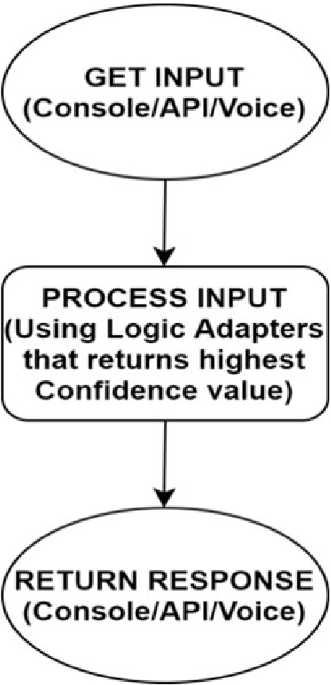

**Fig 2. Flow chart of the proposed model**

**4. Merits and Demerits**

4.1 ADVANTAGES

* For the User, there is no need to visit the college personally to enquiry about the college related information.
* This system aids the students to be updated with college related activities.
* This system is developed aiming at reducing the time for the student, parents as well as the faculty at the institution.

4.2. DISADVANTAGES

* The response will be slow if too many users try to access the chatbot at the same time.
* This Application need **Continues** Internet Connection.

4.3. APPLICATIONS

* college enquiry chatbots help students to the right sources of information.
* Not Only college enquiry chatbot any chatbot will provide them an instant as well as accurate response.
* These are the computer program you can talk to through messaging apps, chat windows, or voice calling apps.

**5.HARDWARE AND SOFTWARE REQUIREMENTS**

* HARDWAREREQUIREMENTS

* Processor : IntelCorei5
* Hard Disk : 500GB
* RAM : 4GB
* SOFTWAREREQUIREMENTS
  + - Operating System : Windows 7 and above
    - Coding language : Python
    - Framework : PyCharm, [Google Colab](https://colab.research.google.com/)

**6.EXPERIMENTS AND RESULTS**

6.1 EXPERIMENT

The proposed system was successfully tested to denote its effectiveness and achievability. It basically reduces the paperwork, manpower and time for any individual. In this paper we had developed a system which will interact with the users by means of reducing their time in visiting the college to enquire about the details/information regarding it. The user can chat with the chatbot of any format. The user/student and the admin are interacted through a chatbot. When a user begins asking queries in the chatbot Graphical Use Interface (GUI). The query is searched in the database. If the response is found in the database it is displayed to the user.

6.2 RESULT

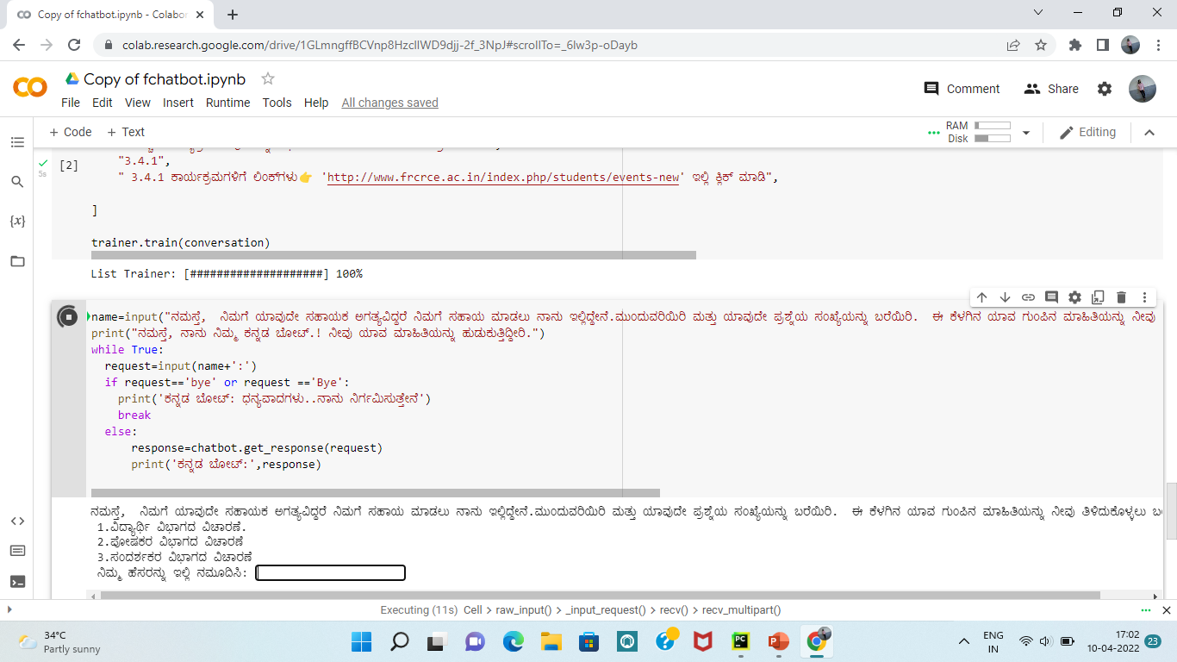

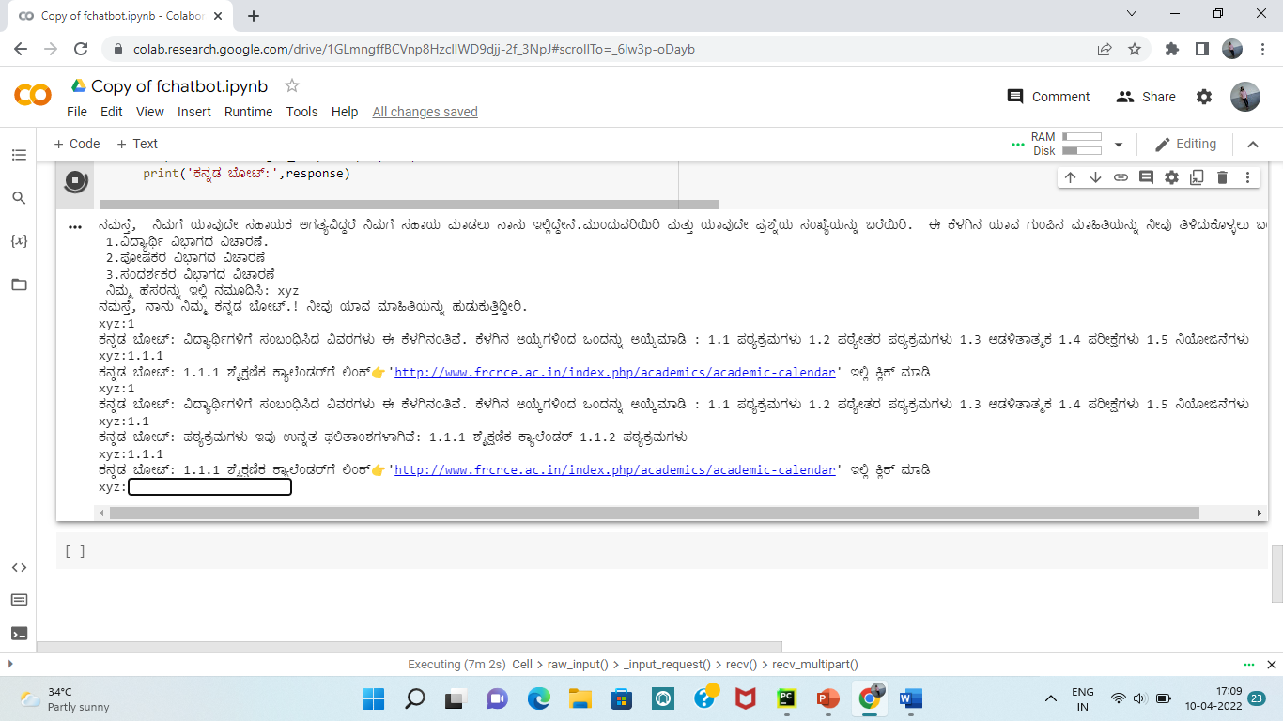

6.3 FUTURE SCOPE

In the future enhancement of our project, we can include speech-based questions and responses. The users just need to provide voice-based input and the developed bot will provide the text-based output and while giving it, it will provide a voice-based output as well. Just by means of adding speech-to-text and text-to-speech we can improve the functionality

to our project.

**7. CONCLUSION**

The main objectives of the project were to develop an algorithm that will be identify the answers associated with user submitted queries. A chatbot in an educational institute or university will be efficient enough to resolve the various queries from the students or any end users. However, making these bots more intelligent and rational to deal with different types of questions is actually a challenging task. A chatbot, typically being a machine, cannot predict all possible queries and questions from the users and that is where it faces the uncertainty. The proposed system is also one such kind of machine which answers the questions based on the pattern matching. it can answer several pre-defined questions by searching the matching answer to the specific question.

**8. REFERENCES**

1. <https://github.com/Candida18/College-Enquiry-Chatbot/blob/main/CRCE%20Bot/chatbot.py>
2. https://medium.com/analytics-vidhya/building-a-simple-chatbot-in-python-using-nltk-7c8c8215ac6e
3. [https://github.com/huzaifsayed/coronabot-chatterbot/blob/master/app.py#L5](%20https://github.com/huzaifsayed/coronabot-chatterbot/blob/master/app.py#L5)
4. <https://youtu.be/LdmAxUrR0lM>
5. <https://keyua.org/blog/how-to-make-a-chatbot-in-python/>
6. <https://youtu.be/RNEcewpVZUQ>
7. Payal Jain, “College Enquiry Chatbot Using Iterative Model”, International Journal of Scientific Engineering and Research (IJSER), ISSN (Online): 2347-3878, Volume 7 Issue 1, January 2019, pp 80-83.