**Electric Vehicle Market Segmentation in India**

**Prathibha bharathi s d**

**Abstract**

This project presents a comprehensive analysis of India's electric vehicle market, focusing on segmentation derived from sales data, customer reviews, and technical specifications. The study highlights the robust growth trajectory of India's two-wheeler market, establishing it as a primary revenue source. Utilizing behavioral variables from customer reviews, a rigorous market segmentation analysis was conducted employing the standard k-means algorithm. The analysis effectively partitioned the market into four distinct segments.

Segment 1 emerges as the cornerstone of our strategy, constituting a substantial 39% of the consumer base. This segment not only represents a substantial market opportunity but also serves as the optimal target for our venture. The analysis guides the recommendation of specific electric two-wheeler technical specifications tailored to meet the preferences of Segment 1 consumers.

The recommended specifications, seamlessly integrating with the demands of this segment, are pivotal to our approach. Moreover, the price range aligns closely with the median values, ensuring affordability and competitiveness. This strategic alignment with Segment 1, identified as the potential early market customer base, positions our venture optimally within India's electric vehicle landscape.

**Fermi estimation (problem breakdown):**

* **Define the Problem:** Start by clarifying the overarching goal of the project: "Segment the EV market"
* **Identify Key Metrics:** What are the specific metrics or criteria used to segment the market? These could include factors like vehicle type (e.g., passenger cars, trucks), geographic regions, customer demographics, or any other relevant variables.
* **Data Requirements:** Estimate the amount of data needed to effectively segment the market. This would include both the quantity and quality of data. For instance, you might estimate the number of EV sales records required, the diversity of data sources, and the level of data cleanliness needed.
* **Data Collection:** Estimate the time and effort required to collect and preprocess the necessary data. This might involve web scraping, data cleaning, merging datasets, and dealing with missing values.
* **Feature Engineering:** Consider the complexity of feature engineering. Estimate the number of relevant features that need to be created or extracted from the raw data. This could include engineering features from vehicle specifications, user behavior, or external factors like weather or economic indicators.
* **Algorithm Selection:** Estimate the time and computational resources needed to choose and implement suitable machine learning algorithms for market segmentation. This could involve clustering, classification, or regression techniques.
* **Model Training:** Estimate the time and computational resources required to train the machine learning models on the prepared dataset. This can be influenced by the size of the dataset and the complexity of the chosen algorithms.
* **Hyperparameter Tuning:** Estimate the time needed for hyperparameter tuning to optimize the performance of the models. This is an iterative process that involves adjusting model parameters to improve accuracy.
* **Model Evaluation:** Estimate the effort required to evaluate the models' performance using appropriate metrics such as accuracy, precision, recall, or F1-score. Consider cross-validation and validation set preparation.
* **Interpretation and Visualization:** Estimate the time and effort needed to interpret and visualize the results of market segmentation. How will the segments be presented and communicated to stakeholders?

**Data Sources and Collection**

For this project, data was gathered from three distinct sources. The primary dataset, obtained from the Society of Manufacturers of Electric Vehicles, spanning 2017 to 2023, catalogues sales figures of electric two-wheelers, three-wheelers, four-wheelers, and buses1. This dataset provides a comprehensive view of market trends and customer preferences over time.

The second dataset, extracted from bikewale.com, comprises electric two-wheeler customer reviews, offering vital behavioural and psychographic insights2. These qualitative inputs proved invaluable in understanding customer behaviour.

Lastly, the third dataset from bikewale.com presents detailed technical specifications and pricing information of electric two-wheelers2. This data allowed us to assess the technical feasibility and price points crucial for our market segmentation strategy.

By integrating these datasets, a robust understanding of the electric vehicle market was developed. Real sales data, customer sentiments, and technical specifics formed the foundation of our analysis, ensuring a data-driven, market-relevant segmentation approach.

**Data Pre-processing**

The data pre-processing phase of this project involved a systematic approach facilitated by Python libraries including numpy, pandas, matplotlib, seaborn, and nltk. The first task was handling the sales data, initially distributed across 10 separate sheets in Excel format. Utilizing pandas, the data sheets were merged into a unified dataset, setting the foundation for subsequent analysis. A key focus was placed on ensuring the accuracy of electric vehicle maker names, achieved through meticulous replacement operations.

Following the data consolidation, essential aggregation operations were performed on electric two-wheeler sales data. This step provided a detailed perspective on market trends. The subsequent phase centered on data preparation for market segmentation. Customer reviews and responses were merged with corresponding electric vehicle technical specifications. To maintain data integrity, null values were handled using specific logical values, ensuring a complete dataset.

Sentiment analysis of customer reviews was conducted using the natural language processing capabilities of nltk. This analysis provided valuable qualitative insights into customer sentiments. Subsequently, behavioral variables such as Visual Appeal, Reliability, Performance, Service Experience, Extra Features, Comfort, Maintenance Cost, and Value for Money were isolated and meticulously prepared. These variables were fundamental in laying the groundwork for the market segmentation analysis, providing a nuanced understanding of customer preferences and attitudes toward electric vehicles.

**Segment Extraction**

**Using Sales Data**

In this segment, a detailed analysis was conducted based on three significant figures representing India's electric vehicle market.

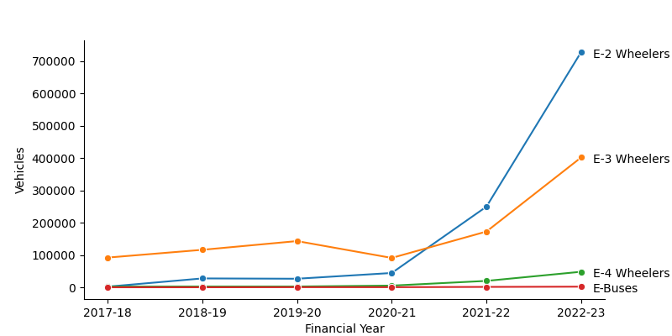

**India’s electric vehicle market**

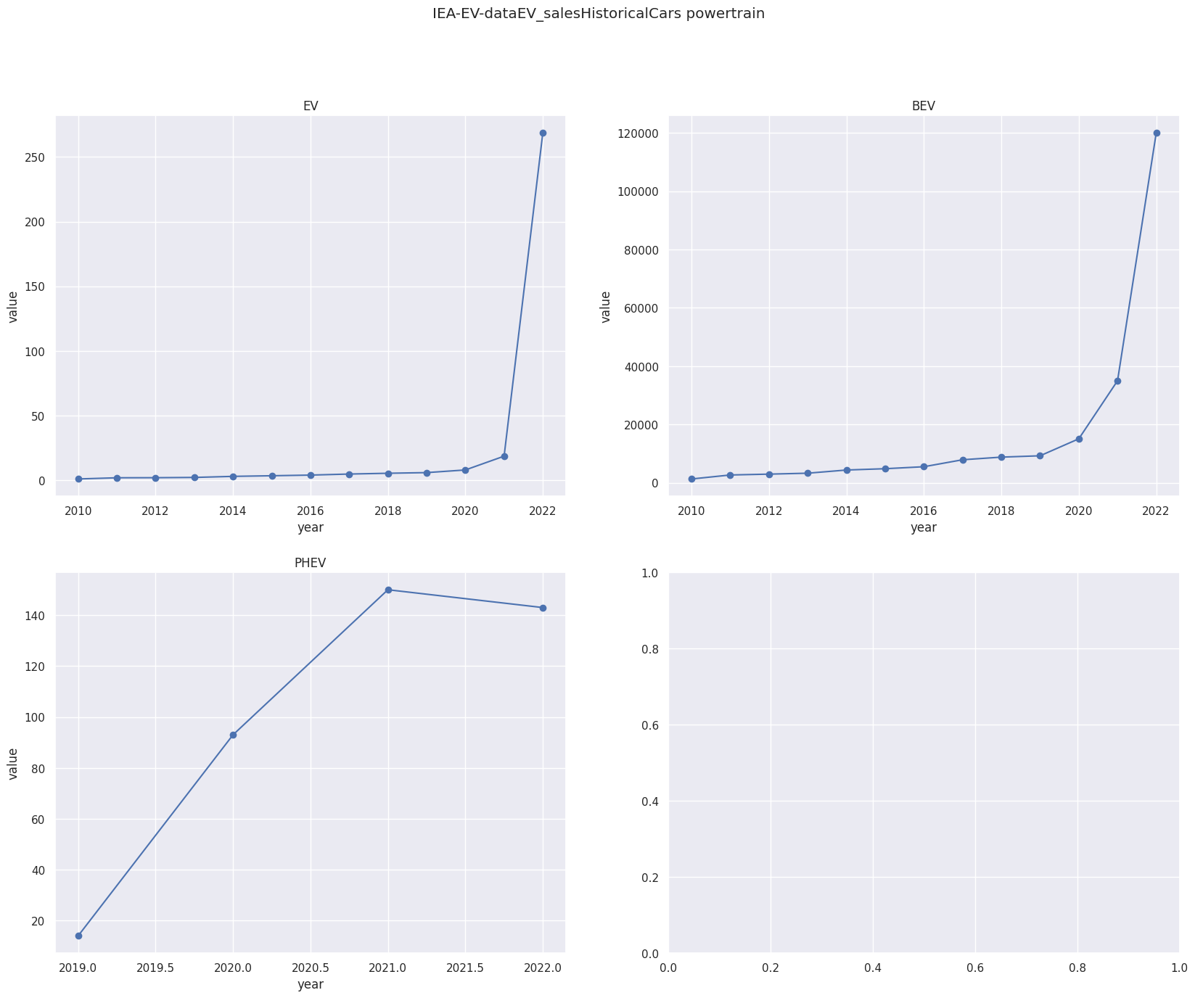

**India’s electric vehicle market for second dataset**

**Using k-Means**

In this subsequent analysis, the standard k-means algorithm was applied to explore market segmentation possibilities within the electric two-wheeler customer reviews data. Solutions were systematically tested for two to eight market segments. The decision-making process was significantly guided by the scree plot Figure 5.4, revealing a distinct elbow at four segments. This marked point indicated a substantial reduction in distances, signifying the optimal number of segments for our analysis. By incorporating insights from these analyses, our focus remained finely tuned on the electric two-wheeler segment, ensuring precision and relevance in our market segmentation approach.

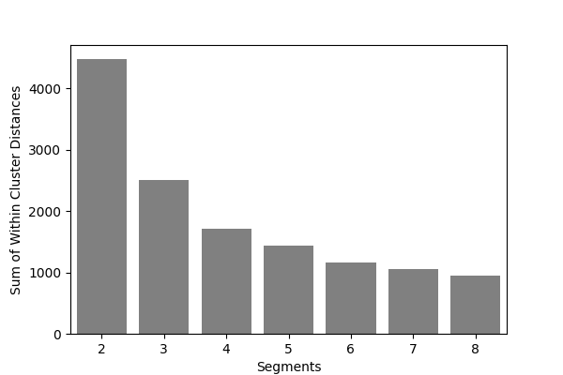

**Profiling and Describing Segmentation**

**Profiling Segments**

This section presents a detailed analysis of our consumer segments, as illustrated in Figure 6.1. The graph visually captures the diverse perceptions among different segments. Segment 0, representing 15% of consumers, values the electric two-wheeler vehicle for its visual appeal, reliability, performance, service experience, and comfort. Conversely, Segment 1 (39% of consumers) expresses dissatisfaction across all aspects, marking them as the largest but least satisfied group. Segment 2 (33% of consumers) appreciates visual appeal, reliability, service experience, comfort, and notably, perceives a strong value for money. Lastly, Segment 3 (13% of consumers), the smallest segment, values visual appeal, reliability, performance, service experience, extra features, and maintenance cost, showcasing distinct perceptions, particularly on features and costs.

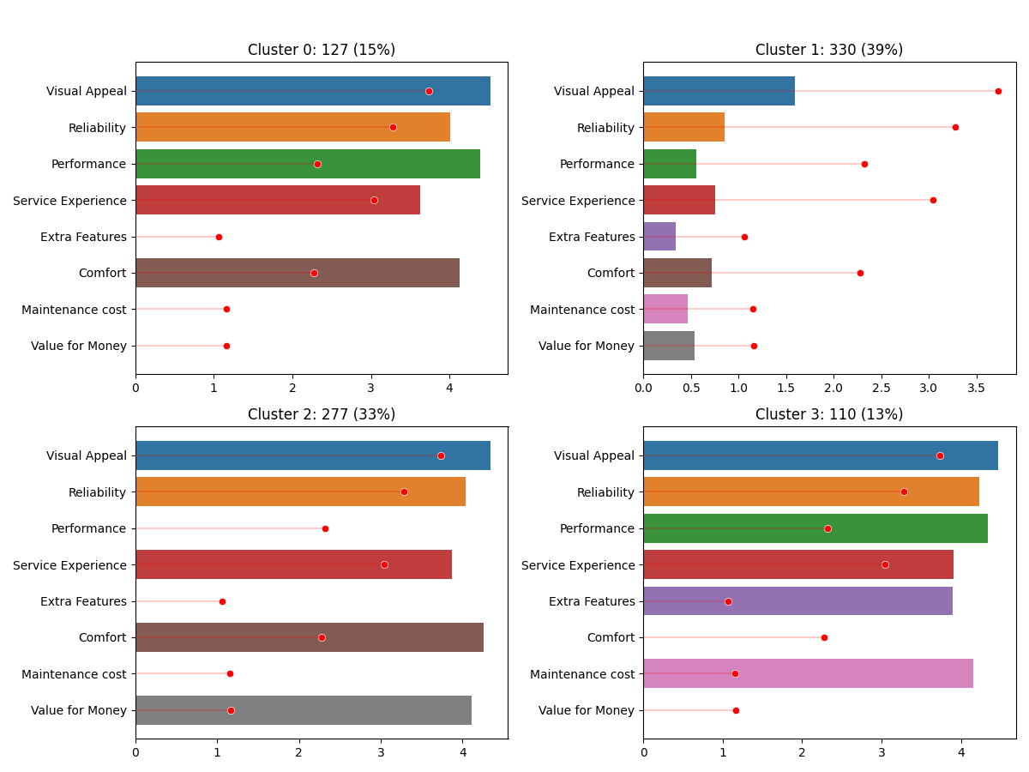

**Segment profile plot for the four-segment solution**

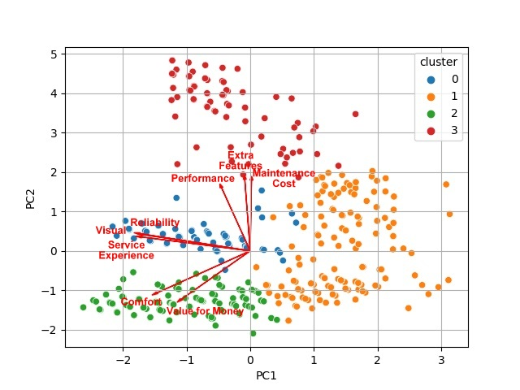

**Segment separation plot using principal components 1 and 2**

In analyzing the technical specifications of electric vehicles across segments, distinct patterns emerge. Segment 0 showcases a higher price range, emphasizing a preference for premium electric vehicles within this group. This is reflected in Figure a parallel box and whisker plot representing the price range. Conversely, Segment 1 exhibits a lower price range, indicating a focus on more budget-friendly options. Segment 2 and Segment 3 also emphasize affordability, albeit with slight differences. These findings align with consumer preferences, highlighting varied economic considerations within the market.

Moving to riding range, Segment 0 stands out with a higher average riding range, suggesting a preference for electric vehicles with extended range, portrayed in Figure In contrast, Segment 1 and Segment focus on moderate ranges for daily commuting. Segment 3 falls between, catering to consumers desiring slightly longer distances, highlighting nuanced commuting needs.

Considering top speed, Segment 0 and Segment 3 opt for vehicles with higher speeds, while Segment 1 and Segment 2 prioritize lower speeds suitable for city commuting. These trends are depicted in Figure

Weight plays a pivotal role, where Segment 0 and Segment 1 favor slightly heavier vehicles, as represented in Figure Segment 2 and Segment 3 lean towards lighter options, accommodating diverse user preferences for vehicle weight.

Lastly, battery charging time demonstrates a noteworthy difference. Segment 0 and Segment 3 opt for slightly longer charging durations, depicted in Figure, emphasizing the convenience of overnight charging. Segment 1 and Segment 2 prioritize faster charging, catering to users seeking quicker turnaround times for their electric vehicles.

These technical specifications, visually represented in respective figures, underscore the nuanced preferences and priorities of each segment, shaping the landscape of the electric vehicle market in India.

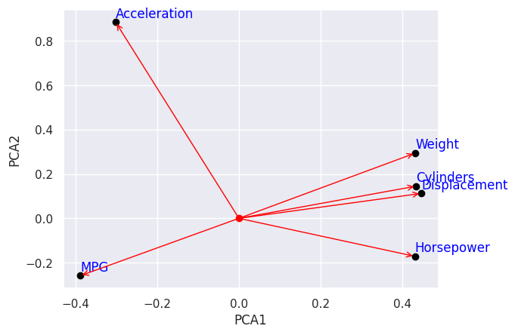

**Segment separation plot using principal components for second dataset**

In the case of the PCA graph, the principal components are the weight, number of cylinders, displacement, horsepower, and MPG. The weight, number of cylinders, displacement, and horsepower are all positively correlated with each other. This means that cars with higher values for these features tend to have lower MPG.

The MPG is in the opposite direction to the other features because it is negatively correlated with them. This means that cars with higher MPG tend to have lower values for the other features.

The reason for this is that the weight, number of cylinders, displacement, and horsepower all affect the fuel efficiency of a car. A heavier car will require more fuel to move, and a car with more cylinders will also require more fuel. A larger displacement engine will also require more fuel, and a car with more horsepower will also require more fuel.

The MPG, on the other hand, is a measure of how far a car can travel on a gallon of fuel. So, a car with higher MPG will be able to travel further on a gallon of fuel than a car with lower MPG.

In general, cars with smaller engines and lighter weight will have higher MPG. This is because they require less fuel to move. However, there are other factors that can affect MPG, such as aerodynamics and the type of transmission.

**Selection of Target Segment**

In the strategic selection of our target segment for the electric vehicle market, Segment 1 and Segment 2 stand out as potential focal points. Segment 1, encompassing 39% of consumers, represents a vast market base with diverse perceptions and preferences. This segment's varying sentiments, as revealed through our analysis, signify their specific demands and priorities. Understanding their unique perceptions, such as dissatisfaction across multiple aspects, presents an opportunity. Addressing these concerns directly can lead to improved customer satisfaction and brand loyalty within this significant market share.

Segment 2, comprising 33% of consumers, presents another enticing opportunity. Their distinct perceptions, including valuing visual appeal, reliability, service experience, and comfort, shape their expectations. This segment's feedback provides invaluable insights, aiding in the customization of our electric vehicles to align with their specific perceptions. By catering to their preferences, such as emphasizing value for money, our offerings can create a strong resonance within this consumer group.

Upon careful analysis, Segment 1 offers a unique challenge and opportunity. By comprehensively addressing their dissatisfaction points and crafting electric vehicles that specifically counter these concerns, our strategy can yield remarkable results. Simultaneously, understanding Segment 2's positive perceptions provides a foundation for enhancing these features further, ensuring a positive customer experience and reinforcing brand loyalty.

Incorporating these perceptions within the respective segments, our strategy will focus on refining existing features, addressing dissatisfaction points, and enhancing positive elements. By aligning our electric vehicles with the distinct expectations of Segment 1 and Segment 2, our approach will be finely tuned to meet the specific needs of these segments, ensuring a competitive edge and sustained market growth.

**Customizing the Marketing Mix**

In our electric vehicle market strategy, customizing the marketing mix is paramount for appealing to Segment 1 and Segment 2, our identified target segments. For Product Customization, we plan to enhance features tailored to the specific desires of each segment. Addressing dissatisfaction points, such as improving performance and service experience for Segment 1, and emphasizing visual appeal and value for money for Segment 2, is central to product refinement. Diverse offerings within each segment ensure a broad spectrum of choices, aligning with varied tastes and budgets.

Price Customization involves setting competitive and flexible pricing structures. Segment 1 will benefit from affordable options, while Segment 2 might accept a slightly higher price point for value-added features. Promotion Customization demands targeted advertising, focusing on reliability and service improvements for Segment 1, and aesthetics and affordability for Segment 2. Tailored promotional events and online campaigns further engage these segments effectively.

In terms of Place Customization, we'll establish accessible distribution channels in urban areas for Segment 1 and in suburban and semi-urban regions for Segment 2. Strengthening our online presence ensures seamless online purchasing experiences, emphasizing virtual showrooms and customer support platforms. Additionally, People and Process Customization involves training customer service representatives to address segment-specific concerns empathetically. Efficient processes, streamlined for customization requests and service appointments, enhance customer satisfaction and brand loyalty. This tailored approach ensures our electric vehicles resonate with the distinct needs of Segment 1 and Segment 2, fostering market relevance and customer preference.

**Most Optimal Market Segments**

In the context of selecting the most optimal market segment for our electric two-wheeler vehicles, thorough analysis and evaluation have pointed to Segment 1 as the ideal choice. Representing 39% of consumers, this segment boasts significant opportunities and a large customer base, making it a strategic target for market penetration. Its substantial market potential, coupled with its balanced blend of technical specifications and price range, positions it as the most promising market segment for our electric vehicles.

The recommended technical specification range for Segment 1, presented in Table, ensuring alignment with the diverse needs and preferences of the market:

**Technical specification of electric vehicle two-wheeler for segment 1**

|  |  |
| --- | --- |
| **Specification** | **Recommended Range (in INR)** |
| Price | 70,688 – 1,29,063 |
| Riding range | 89 - 180 km |
| Top speed | 58 - 116 kmph |
| Weight | 76 - 120 kg |
| Battery charging time | 3 - 5 hours |
| Rated power | 1200 - 5500 W |

This comprehensive analysis ensures our market entry strategy is finely tuned to cater to the demands and expectations of the chosen segment, setting the stage for a successful and sustainable venture into the electric vehicle market.

**Conclusion:**

**Develop an EV for the Indian market:** The Indian market has unique needs and requirements. Developing an EV that is specifically designed for the Indian market could be a successful business venture.

**Focus on the low-cost segment:** The average Indian consumer is price-sensitive. Focusing on the low-cost segment of the EV market could be a way to reach a large number of potential customers.

**Partner with a government agency:** The Indian government is promoting the adoption of EVs. Partnering with a government agency could help you to get access to funding and other resources.

**Target fleet operators:** Fleet operators, such as taxi companies and delivery services, are potential customers for EVs. Targeting fleet operators could help you to reach a large number of vehicles.

**Offer after-sales service and support:** The lack of after-sales service and support is one of the biggest barriers to the adoption of EVs in India. Offering after-sales service and support could help you to overcome this barrier.

**The government support:** The Indian government is promoting the adoption of EVs. This could provide you with access to funding and other resources.

**The market size and growth potential:** The EV market in India is still small, but it is growing rapidly. This means that there is a lot of potential for growth in the market.

**The competition:** The EV market in India is becoming increasingly competitive. You will need to find a way to differentiate your startup from the competition.

**The regulatory environment:** The regulatory environment for EVs in India is constantly changing. You will need to stay up-to-date on the latest regulations in order to comply with them.

**The funding requirements:** Starting an EV startup in India can be expensive. You will need to secure funding in order to bring your startup to market.