**DATAWAREHOUSE ASSESSMENT2**

1A) Number of dimensions:6

Number of facts:1

1B) Cardinality

* Year – Month -> One to Many
* Month – Time -> One to Many
* Time – Sales Facts -> One to Many
* Customer – Sales Facts -> One to Many
* Store – Sales Facts -> One to Many
* Products – Sales Facts -> One to Many

1C) SELECT YearID, Customer_Key, StoreKey, Product_key, Dollars FROM SALES FACTS SF, TIME T WHERE SF.TimeKey = T.TimeKey;

1D)

* YEAR - SALES_FACT -> ONE TO MANY
* MONTH - SALES_FACT->ONE TO MANY
* PRODUCT- SALES_FACT ->ONE TO MANY
* STORE – SALES_FACT -> ONE TO MANY
* CUSTOMER- SALES_FACT -> ONE TO MANY
* TIME -SALES_FACT ->ONE TO MANY

**Sales Facts**

TimeKey

CustomerKey

StoreKey

ProductKey

MonthKey

YearKey

Dollars

Year

Month

Product

Time

Customer

Store

1 N

1 N

1 N

1 N

1 N

1 N

5. Make a list of differences between DW and OLTP based on Size, Usage, Processing and Data Models.

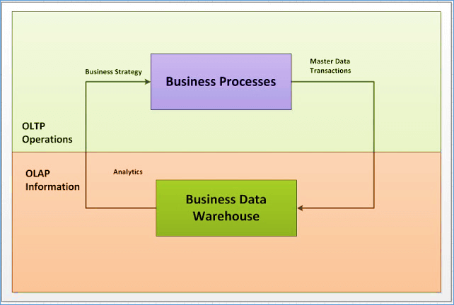

|  |  |
| --- | --- |
| OLTP | DW |
| Data is volatile | Data is non volatile |
| Support business transactions | Support decision making process |
| Holds current data | Holds historical data |
| Contains detailed data | Contains summarized data |
| Has normalized data | Has denormalised data |
| Designed for running business | Designed for analyzing business |
| Clerical/End user access | Managerial access |
| E-R Modelling | Dimensional Modelling |

| **BASIS FOR COMPARISON** | **OLTP** | **OLAP** |
| --- | --- | --- |
| Basic | It is an online transactional system and manages database modification. | It is an online data retrieving and data analysis system. |
| Focus | Insert, Update, Delete information from the database. | Extract data for analyzing that helps in decision making. |
| Data | OLTP and its transactions are the original source of data. | Different OLTPs database becomes the source of data for OLAP. |
| Transaction | OLTP has short transactions. | OLAP has long transactions. |
| Time | The processing time of a transaction is comparatively less in OLTP. | The processing time of a transaction is comparatively more in OLAP. |
| Queries | Simpler queries. | Complex queries. |
| Normalization | Tables in OLTP database are normalized (3NF). | Tables in OLAP database are not normalized. |
| Integrity | OLTP database must maintain data integrity constraint. | OLAP database does not get frequently modified. Hence, data integrity is not affected. |

2 Circular Joins can be avoided by making use of Aliases for the repetitive dimension table.