SE LAB 3
SRN: PES2UG24CS371
Name: Prathik M Nambiar
Section G

1. Component Diagram
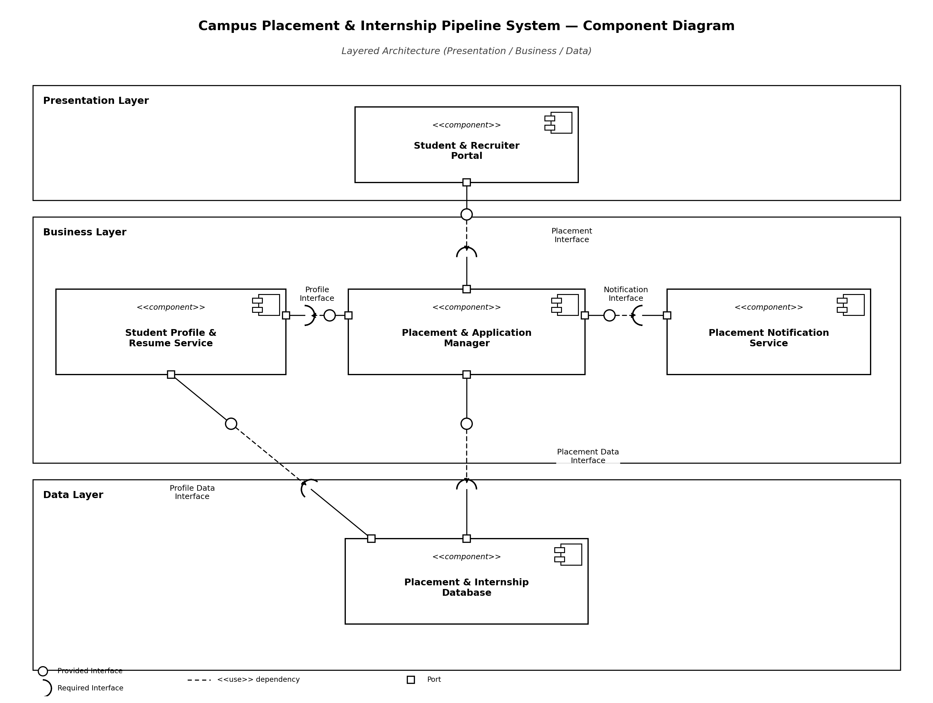

2. Written Justification – Campus Placement and Internship System
The Campus Placement and Internship System uses a Layered Architecture consisting of three main layers: the Presentation Layer, Business Layer, and Data Layer. This architectural style was selected because it separates the system into components with clearly defined responsibilities, making the system easier to develop, maintain, and modify.
The Presentation Layer contains the Student and Recruiter Portal component. This component provides the user interface through which students and recruiters can interact with the system. Users can view placement opportunities and submit applications through the Placement Management Interface.
The Business Layer contains the main application logic. The Student Profile and Resume Service manages student profiles and resumes. The Placement and Application Manager manages placement opportunities and student applications. It retrieves profile and resume information through the Profile and Resume Interface and sends application updates through the Notification Interface. The Placement Notification Service is responsible for sending notifications to users regarding application updates and placement-related information.
The Data Layer contains the Placement and Internship Database. The Placement and Application Manager communicates with this component through the Placement Data Interface to store and retrieve placement and internship information. The Student Profile and Resume Service also interacts with the database to store and retrieve profile and resume data.
The use of interfaces between components reduces direct dependency and provides clear communication paths. This improves modularity because individual components can be modified or replaced with minimal impact on other parts of the system. The layered architecture also improves maintainability and separation of concerns, as user interface functions, business logic, and data management are organised independently.
Overall, this architecture is suitable for the Campus Placement and Internship System because it supports clear component responsibilities, structured data flow, and easier future expansion.
Architecture Selection: We chose Layered Architecture for the Campus Placement and Internship System.
Reason 1 — Clear Separation for a Multi-Stakeholder System
The system serves three distinct user groups — students, recruiters, and the Training & Placement Office (TPO) — each interacting through the same portal but with different needs. A Layered Architecture cleanly separates the Student and Recruiter Portal (Presentation Layer) from the core placement logic such as eligibility checks, application routing, and notifications (Business Layer), and from persistent records such as student profiles, resumes, and placement data (Data Layer). This separation lets the UI evolve without touching business rules or the schema, which matters because a college placement cell frequently requests interface changes each recruitment season.
Reason 2 — Centralized, Consistent Business Rules
Placement eligibility (CGPA cut-offs, branch restrictions, backlog limits) and application deadlines must be enforced identically whether a student applies from the portal or a recruiter reviews applicants. Keeping this logic in a single Business Layer (Placement and Application Manager, Student Profile and Resume Service, Placement Notification Service) guarantees one consistent rule set is evaluated for every request, instead of duplicating validation logic across multiple independently deployed services as a microservices split would require.
Security Advantage
The Data Layer is never exposed directly to the Presentation Layer. All access to sensitive records — resumes, personal contact details, and placement data — is mediated through the Business Layer's Profile and Resume Interface and Placement Data Interface, which enforce authentication and role-based authorization (student vs. recruiter vs. TPO admin) before any database query executes. This prevents a compromised or malicious client request from reaching student data directly, confining the attack surface to a single, auditable layer.
Performance Benefit
Placement season traffic is bursty (e.g., hundreds of students applying right before a deadline) but each request is a straightforward CRUD or matching operation, not a computationally heavy workload. The Business Layer can cache frequently read, slow-changing data — such as active placement opportunities and eligibility criteria — in one place, cutting redundant Placement and Internship Database calls during peak load. This keeps response times low without the network-hop latency and cross-service coordination overhead that a microservices architecture would introduce for this scale of application.

