**PHASE 4:**

**DOCUMENTATION:** Credit Card Fraud Detection in loading and preprocessing the dataset The IMDb dataset typically includes a variety of features that describe different aspects of a movie. While the exact features can vary depending on the dataset and the source, here are some common features you might find in an IMDb dataset: The Credit card fraud detection dataset extracted from kaggle platform accurately consists of 31 columns with 2 lakhs+ entries.

COLUMN NAMES

>Time

>V1-V28

>Amount

>Class

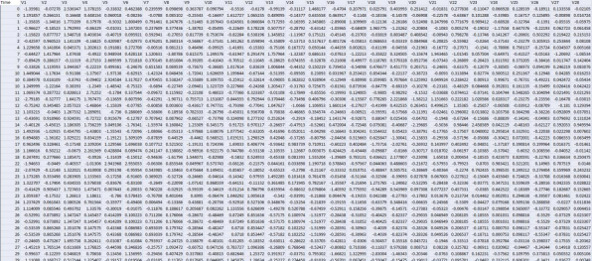

**NOTE:** The initial columns from the dataset is displayed above for you perusal**.**

**MODEL DEVELOPMENT**

**Feature Engineering:**

Feature engineering is a crucial step in creating a successful fraud detection model. It involves selecting, transforming, and creating relevant features that help the model distinguish between genuine and fraudulent transactions.

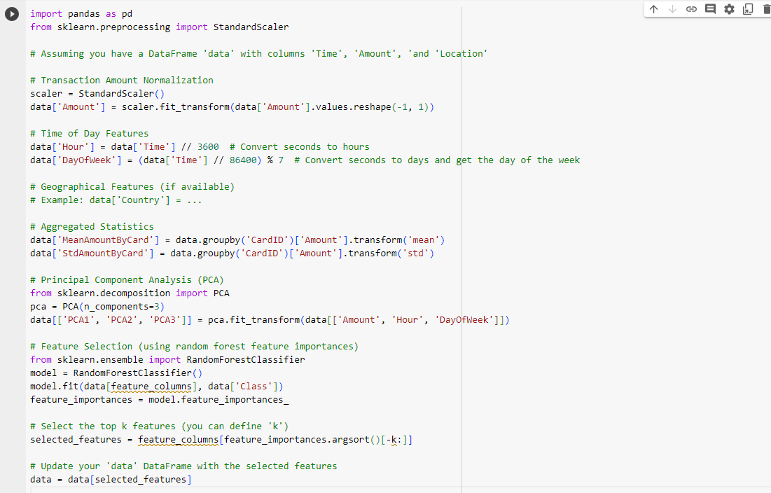

**Model Training:**

Here we can use various machine learning algorithms for this, but ensemble methods and deep learning models tend to work well for fraud detection tasks.

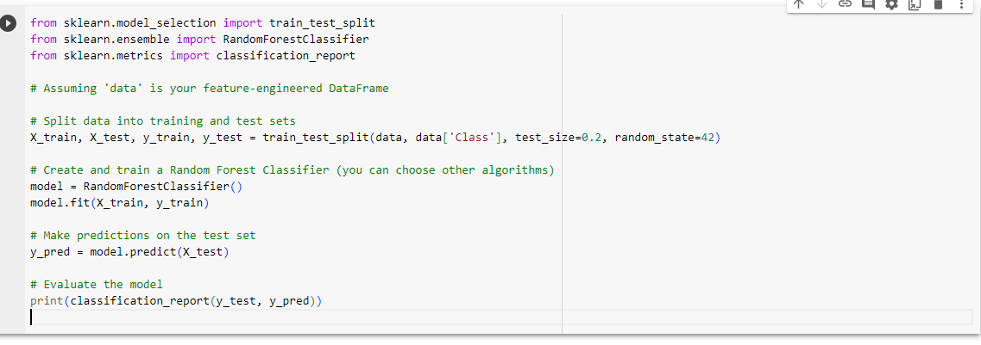

**Evaluation:**

After training your models, it's essential to evaluate their performance. Since fraud detection is an imbalanced classification problem, standard accuracy is not the best metric.

