BUILDING A PERSONAL FIREWALL USING PYTHON

Internship Project Report

Submitted By
Name: Prathiksha H Kotian
Internship Domain: Cyber Security
Organization: Codec Technologies
Project Title: Building a Personal Firewall using Python

Project Objective
The objective of this project is to develop a Personal Firewall application using Python. The application provides a simple command-line interface through which users can perform basic firewall operations such as blocking and allowing IP addresses. This project helps in understanding firewall concepts, network security, and Python programming while demonstrating the basic working principle of a firewall.

Project Description
A firewall is an important network security system that monitors and controls incoming and outgoing network traffic based on predefined security rules. It acts as a protective barrier between a trusted system and untrusted networks.
In this project, a Personal Firewall application was developed using Python in the Kali Linux environment. The application provides a menu-driven interface that allows users to perform basic firewall operations. The user can choose to block an IP address, allow an IP address, or exit the application. The application continuously displays the menu until the user chooses to terminate the program.
The project demonstrates the basic workflow of a firewall and provides practical experience in Python programming and Linux-based security environments.

Software Requirements
- Operating System: Kali Linux
- Programming Language: Python 3
- Development Tool: Terminal
- Virtualization Platform: Oracle VirtualBox

Project Implementation
The Personal Firewall application was implemented using Python programming language.
The application performs the following operations:
- Displays the firewall menu.
- Accepts user input.
- Blocks an IP address.
- Allows an IP address.
- Exits the application.
The application continuously runs until the user selects the Exit option.

Source Code
complete firewall.py program.
import os
print("===================================")
print(" Personal Firewall System ")
print("===================================")
while True:
print("\nMenu")
print("1. Block an IP Address")
print("2. Allow an IP Address")
print("3. Exit")
choice = input("Enter your choice: ")

if choice == "1":
ip = input("Enter IP Address to block: ")
os.system(f"sudo iptables -A INPUT -s {ip} -j DROP")
print(f"{ip} has been blocked successfully.")

elif choice == "2":
ip = input("Enter IP Address to allow: ")
os.system(f"sudo iptables -D INPUT -s {ip} -j DROP")
print(f"{ip} has been allowed successfully.")

elif choice == "3":
print("Exiting Personal Firewall...")
break

else:
print("Invalid choice. Please try again.")

Execution Steps

Step 1: Creating the Project Folder
A project folder named Personal_Firewall_Project was created in Kali Linux to store all project files.

Step 2: Verifying Python Installation
Python installation was verified using the following command:
python3 --version

Step 3: Creating the Python Program
A Python file named firewall.py was created to implement the Personal Firewall application.

Step 4: Executing the Program
The application was executed using the following command:
python3 firewall.py
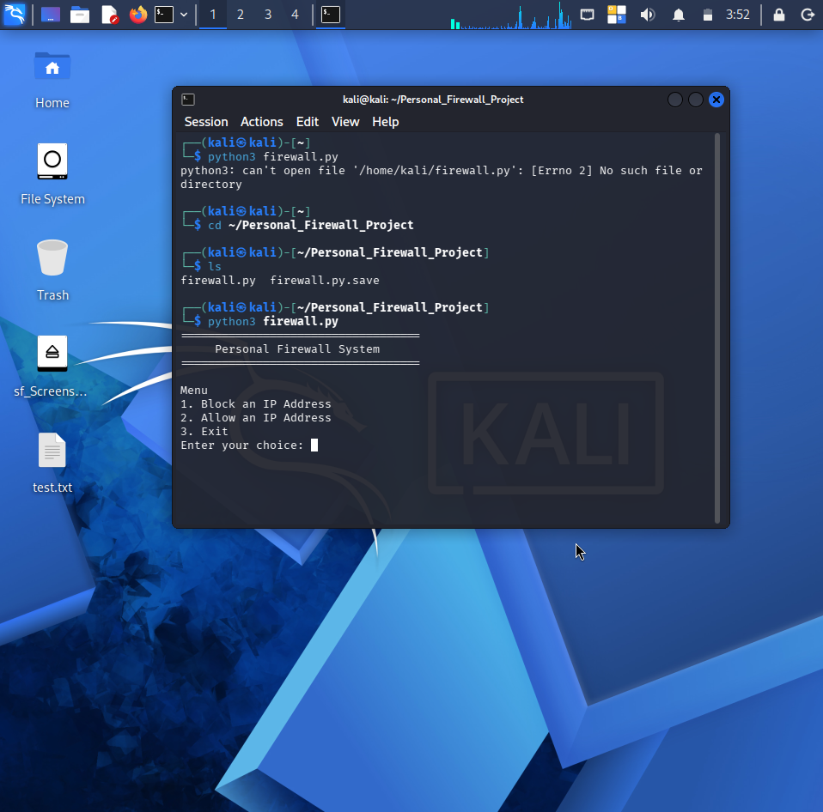
The firewall menu was displayed successfully.
Step 5: Blocking an IP Address
The Block IP Address option was selected from the menu and the IP address was entered. The application displayed a confirmation message indicating that the IP address was blocked.
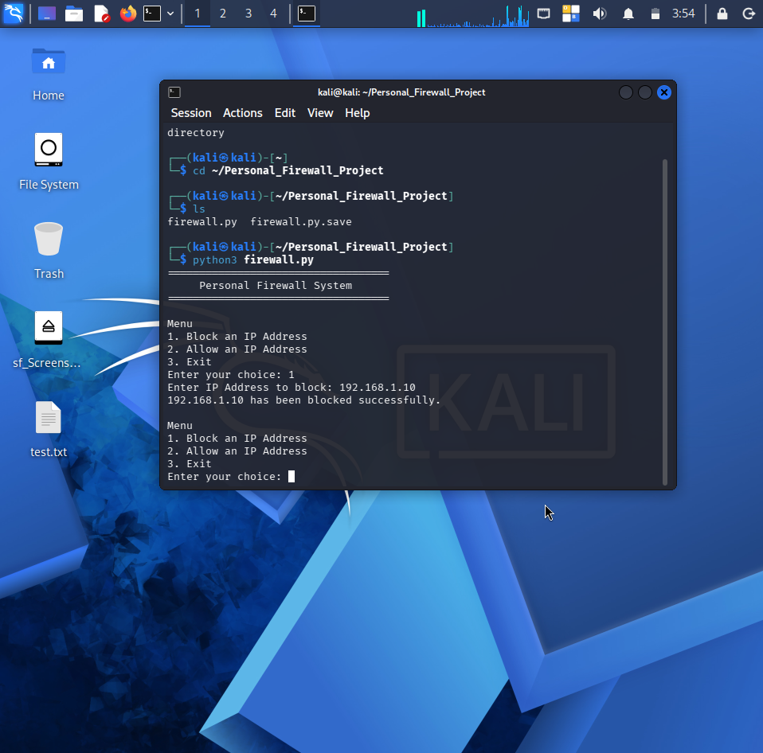

Step 6: Allowing an IP Address
The Allow IP Address option was selected from the menu and the IP address was entered. The application displayed a confirmation message indicating that the IP address was allowed.
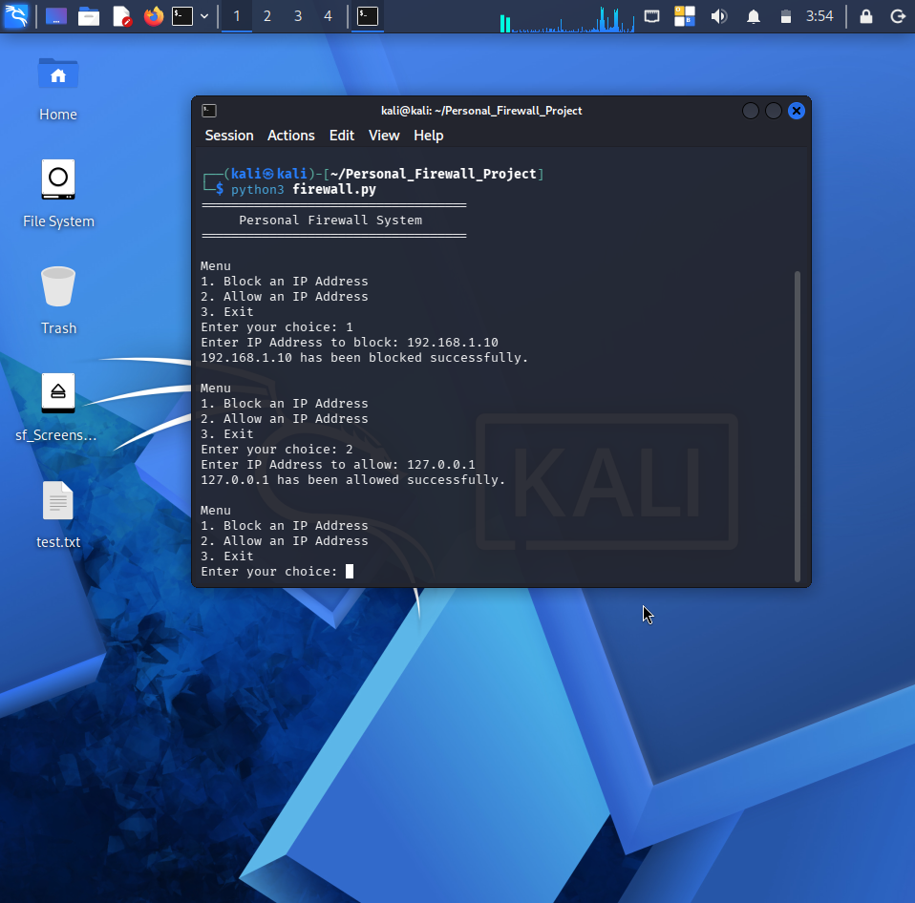

Step 7: Exiting the Application
The Exit option was selected to terminate the program successfully.
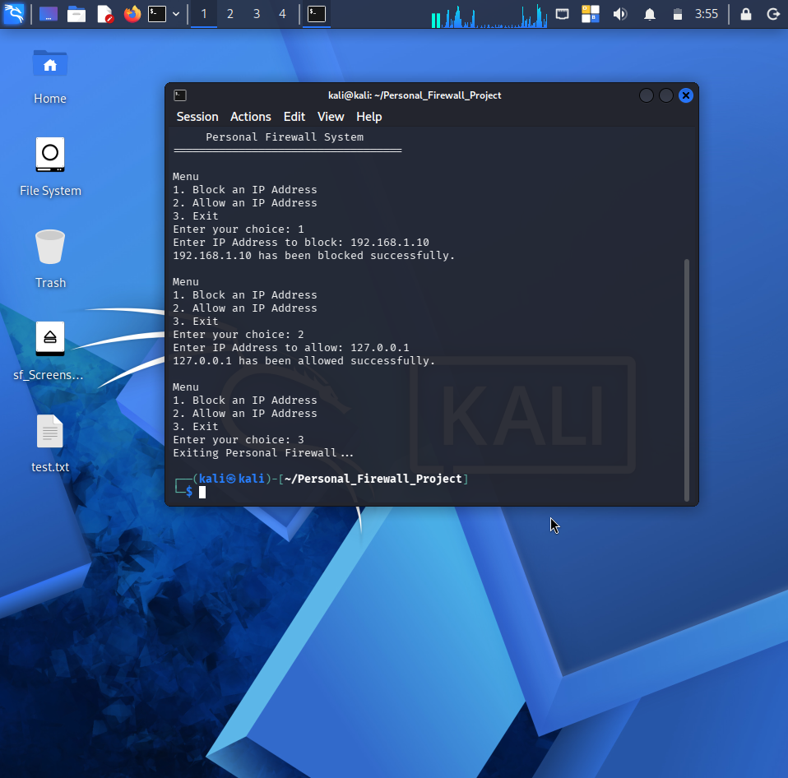

Output
The Personal Firewall application executed successfully and displayed a menu-driven interface. The program accepted user input, processed the selected firewall operations, displayed confirmation messages for block and allow operations, and terminated successfully when the Exit option was selected.

Conclusion
The Personal Firewall application was successfully developed using Python in the Kali Linux environment. The project provided practical knowledge of Python programming, firewall concepts, and Linux command-line applications. It demonstrated the basic workflow of a firewall application and improved understanding of network security concepts.

References
- Python Official Documentation
- Kali Linux Documentation
- Netfilter (iptables) Documentation
- CodeC Technologies Internship Learning Material

