SIMATS ENGINEERING (SAVEETHA SCHOOL OF ENGINEERING)
Department of Computer Science and Engineering

ASSESSMENT TOOL 1 – ARCHITECTURE / MODELING (INFRASTRUCTURE DESIGN)

Course Code: | CSA5802 | Course Title: | DEVSECOPS ENGINEERING AND APPLICATION SECURITY
CO Assessed: | CO4 – Precision (BL1, BL2, BL3) | Assessment: | Assessment Tool 1
Weightage: | 30% of CIA | Total Marks: | 100
CO4 Statement: | Design Secure Infrastructure Architecture using DiagrammeR or Draw.io.
Student Name: | Prathiksha SN | Reg. No.: | 192565090
Section / Batch: | BE CSE with CS/2025 | Date: | 19/8/2026
Instructions to Students
• Create an original secure infrastructure architecture using DiagrammeR or Draw.io.
• Clearly represent major components, network zones, trust boundaries, data flows and security controls.
• Include IAM, encryption, monitoring/logging and secure communication paths wherever applicable.
• Use clear labels, consistent symbols and professional alignment so the architecture is easy to interpret.
• Submit the editable diagram source file along with the final exported PDF through the prescribed submission platform.

Question Type | Focus Area | Questions | Marks
ARCHITECTURE / MODELING | Architecture Design | Q1 | Q1 – 100
GRAND TOTAL: |  | 100 Marks

RUBRICS FOR CALCULATION

Criteria | Wt. | Level 4 – Exemplary | Level 3 – Proficient | Level 2 – Developing | Level 1 – Beginning
Infrastructure Architecture Design | 20% | Designs a comprehensive, logically structured and technically accurate secure infrastructure architecture with all essential components | Designs a clear and technically sound infrastructure architecture with only minor component or structural omissions | Designs a basic infrastructure architecture with limited components or noticeable structural gaps | Provides an incomplete, unclear or technically inaccurate infrastructure architecture
Security Controls and Network Segmentation | 30% | Correctly integrates layered security controls, network segmentation, trust boundaries and secure communication paths throughout the architecture | Integrates appropriate security controls and segmentation with only minor gaps | Includes basic security controls but shows limited segmentation or incomplete trust-boundary representation | Includes insufficient or inappropriate security controls with poor network segmentation
IAM, Data Protection and Monitoring | 20% | Accurately represents IAM, encryption, secure data storage, logging and monitoring mechanisms with clear component relationships | Represents most IAM, data-protection and monitoring mechanisms correctly with minor omissions | Represents basic IAM, data-protection or monitoring elements but several important mechanisms are missing or unclear | Provides limited or incorrect representation of IAM, data protection and monitoring mechanisms
Diagram Quality and Tool Utilization | 20% | Uses DiagrammeR or Draw.io effectively to produce a professional, readable and well-organized architecture diagram with clear labels and connections | Produces a clear and organized diagram with effective tool usage and only minor presentation issues | Produces a basic diagram with inconsistent layout, labeling or tool utilization | Produces a poorly organized or difficult-to-understand diagram with inadequate tool utilization
Documentation and Technical Justification | 10% | Clearly documents architecture components and provides strong technical justification for security design decisions | Provides clear documentation and appropriate justification with minor gaps | Provides basic documentation with limited technical justification | Provides incomplete or unclear documentation with little or no technical justification
\

Secure Infrastructure Architecture for Online Examination System
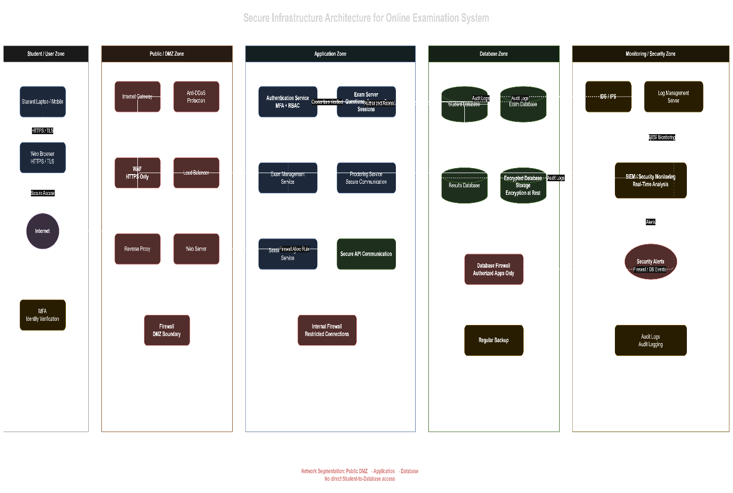

1. Introduction
The Secure Infrastructure Architecture for an Online Examination System is designed to provide a safe, reliable, and controlled environment for conducting online examinations. The architecture protects student information, examination questions, answers, and results from unauthorized access, cyberattacks, and service disruptions. It uses multiple security mechanisms such as Anti-DDoS protection, Web Application Firewall (WAF), authentication, network segmentation, internal firewalls, encryption, IDS/IPS, SIEM monitoring, and regular backups.
The architecture is divided into five major zones: Student/User Zone, Public/DMZ Zone, Application Zone, Database Zone, and Monitoring/Security Zone. Dividing the infrastructure into separate zones reduces the impact of a security breach and prevents direct access between untrusted users and sensitive resources.
2. Student/User Zone
The first section of the architecture is the Student/User Zone. Students use a laptop or mobile device with a web browser to access the online examination system. The communication between the student's browser and the examination system is protected using HTTPS/TLS.
HTTPS ensures that information transmitted between the student and the server is encrypted. This helps protect login credentials, examination responses, and other sensitive information from being intercepted during transmission.
The student first connects to the Internet, and the request is then passed through the security controls in the Public/DMZ Zone. The student is not allowed to directly communicate with the application database. This is an important security principle because databases contain highly sensitive information.
The architecture also includes Multi-Factor Authentication (MFA). MFA provides an additional layer of identity verification after the student enters their username and password. This reduces the risk of unauthorized access if login credentials are compromised.
3. Public/DMZ Zone
The next layer is the Public/DMZ Zone (Demilitarized Zone). This zone acts as a security boundary between the public Internet and the internal application infrastructure.
The first major security component is Anti-DDoS Protection. Distributed Denial-of-Service (DDoS) attacks attempt to send a large amount of traffic to a server in order to make the service unavailable. Anti-DDoS protection identifies and filters abnormal traffic before it reaches the examination infrastructure. This is especially important during examinations because a large number of students may access the system simultaneously.
After Anti-DDoS protection, traffic passes through the Web Application Firewall (WAF). The WAF examines HTTP/HTTPS requests and blocks suspicious or malicious web traffic. It can help protect the system from common web attacks such as SQL injection, cross-site scripting, and malicious requests.
The Load Balancer distributes incoming requests among available application or web servers. This improves performance and availability when many students are taking examinations at the same time.
The Reverse Proxy receives requests from users and forwards valid requests to the appropriate internal service. It hides the internal server structure from external users and provides another layer of security.
The Web Server handles web-related requests and communicates with the application services. A firewall is placed around the DMZ to restrict unauthorized communication between the public-facing systems and the internal network.
4. Application Zone
The Application Zone contains the main services responsible for operating the online examination system. This zone is separated from the public-facing DMZ to prevent direct access to important application components.
The Authentication Service verifies student credentials and handles authentication mechanisms such as MFA and Role-Based Access Control (RBAC). RBAC ensures that users can access only the functions permitted for their role. For example, students can attend examinations and view their permitted results, while administrators may have additional management privileges.
The Exam Management Service manages examination-related operations such as exam schedules, questions, student enrollment, and examination sessions.
The Exam Server is the core component that delivers examination questions to students, receives their answers, manages examination sessions, and controls the examination process. It communicates with the database through restricted and secure connections.
The architecture also contains a Proctoring Service. The proctoring service supports examination monitoring and helps detect suspicious activities during the examination. Communication between the examination server and the proctoring service is protected using secure communication mechanisms.
A Secure API Communication mechanism is used when application components communicate with each other. This prevents unauthorized services from directly accessing internal application functions.
An Internal Firewall separates the application infrastructure from more sensitive resources. Only approved connections and required ports are allowed through the firewall.
5. Database Zone
The Database Zone contains the most sensitive information in the examination system. It includes the Student Database, Exam Database, and Results Database.
The Student Database stores information related to registered students and their authentication details. The Exam Database stores examination-related information such as questions, exam details, and examination sessions. The Results Database stores student examination results and related records.
The database zone is protected by a Database Firewall. The firewall allows database connections only from authorized application services. Students and external users cannot directly access the database.
The architecture also uses Encryption at Rest to protect stored data. Even if unauthorized individuals obtain access to stored database files, encryption makes the information difficult to read without the required encryption keys.
Regular backups are also maintained. Regular Backup helps recover important student, examination, and result data in case of accidental deletion, hardware failure, system compromise, or other incidents.
6. Monitoring and Security Zone
The final section is the Monitoring/Security Zone, which continuously monitors the infrastructure for security threats and abnormal activities.
The IDS/IPS (Intrusion Detection System/Intrusion Prevention System) monitors network traffic and identifies suspicious or malicious activities. An IDS can generate alerts when unusual behavior is detected, while an IPS can take preventive action against certain threats.
The Log Management Server collects logs generated by different infrastructure components. These logs can include authentication attempts, firewall events, application activities, database access, and security events.
The SIEM (Security Information and Event Management) system collects and analyzes security logs from different parts of the architecture. It provides real-time monitoring and helps security administrators identify suspicious patterns. For example, multiple failed login attempts, unusual database access, or abnormal network traffic can generate security alerts.
The Security Alerts component notifies administrators when important security events are detected. These alerts allow the security team to investigate and respond to potential threats quickly.
7. Network Segmentation and Security
A major feature of the architecture is network segmentation. The infrastructure is separated into DMZ, Application, Database, and Monitoring/Security zones. Each zone has a specific purpose and access restrictions.
Network segmentation follows the principle of least privilege, where a component receives only the access required to perform its function. For example, students can access the examination application, but they cannot directly access the database.
The architecture therefore provides multiple layers of protection. If an attacker successfully compromises a public-facing web component, network segmentation and internal firewalls make it more difficult for the attacker to reach the application and database systems.
8. Overall Working of the Architecture
The overall communication flow starts when a student accesses the examination system using a web browser. The request travels through HTTPS/TLS → Internet → Anti-DDoS Protection → WAF → Load Balancer → Web Server/Application Services.
The student is authenticated through the Authentication Service, including MFA where required. After successful authentication, the student can access the examination through the Exam Server.
During the examination, the Proctoring Service supports monitoring of the examination session. The Exam Server communicates with the appropriate databases to retrieve examination information and store answers and results.
All important activities generate logs that are forwarded to the Log Management Server and SIEM. IDS/IPS systems monitor network activity and security alerts are generated when suspicious behavior is detected.
9. Conclusion
The proposed architecture provides a secure, segmented, and monitored infrastructure for an Online Examination System. Anti-DDoS protection improves availability, while WAF and firewalls protect the system from malicious network and web traffic. Authentication, MFA, and RBAC protect user accounts, while network segmentation prevents direct access to sensitive resources.
The database layer is protected through restricted access and encryption, while regular backups provide data recovery capabilities. Finally, IDS/IPS, centralized logging, and SIEM provide continuous security monitoring and alerting.
Overall, the architecture follows a defense-in-depth approach, where multiple security layers work together to protect the examination system, student data, examination content, and results from unauthorized access and cyber threats.

Rubrics:
Criteria | Weightage | Q5 (10) | Total  Marks  (50)
Infrastructure Architecture Design | 25%
Security Controls and Network Segmentation | 30%
IAM, Data Protection and Monitoring | 20%
Diagram Quality and Tool Utilization | 15%
Documentation and Technical Justification | 10%
Total per Question | 100 Marks

────
100

