SIMATS ENGINEERING (SAVEETHA SCHOOL OF ENGINEERING)
Department of Computer Science and Engineering

ASSESSMENT TOOL 2 – ARCHITECTURE / MODELING (SECURE INFRASTRUCTURE)

Course Code: | CSA5802 | Course Title: | DEVSECOPS ENGINEERING AND APPLICATION SECURITY
CO Assessed: | CO4 – Precision (BL1, BL2, BL3) | Assessment: | Assessment Tool 2
Weightage: | 30% of CIA | Total Marks: | 100
CO4 Statement: | Design secure DevSecOps infrastructure by developing architecture diagrams, modelling deployment workflows, Identity and Access Management (IAM) relationships, and GitOps workflows.
Student Name: | Prathiksha SN | Reg. No.: | 192565090
Section / Batch: | CSE with CS/2025 | Date: | 24/8/2026
Instructions to Students
• Design all architecture diagrams, deployment workflows, IAM relationships, and GitOps workflows originally and clearly.
• Use DiagrammeR or Draw.io for architecture modelling and maintain consistent labels, trust boundaries, data flows, and security controls.
• Clearly represent IAM roles/permissions, Infrastructure as Code (IaC), GitOps flow, and DevSecOps security integration wherever applicable.
• Include editable source files for diagrams, IaC/configuration files, methodology documentation, and all supporting project artifacts.
• Submit the GitHub repository link and final PDF report through Google Classroom before the specified deadline; verify that the repository is accessible and complete.

Question Type | Focus Area | Questions | Marks
ARCHITECTURE / MODELING | Design and Application Based | Q1 | Q1 – 100
GRAND TOTAL: |  | 100 Marks

RUBRICS FOR CALCULATION

Criteria | Wt. | Level 4 – Exemplary | Level 3 – Proficient | Level 2 – Developing | Level 1 – Beginning
IAM Model and Access Control Design | 20% | Designs a comprehensive IAM model with clearly defined identities, roles, permissions, authentication and least-privilege access controls | Designs an appropriate IAM model with most roles and access controls correctly represented and only minor gaps | Provides a basic IAM model with limited role definition, permissions or access-control details | Provides an incomplete or inaccurate IAM model with weak or inappropriate access controls
Infrastructure as Code (IaC) Modelling | 30% | Accurately models infrastructure provisioning through IaC with reusable, consistent and secure configuration components | Models IaC workflow correctly with appropriate configuration structure and only minor omissions | Provides a basic IaC model with limited automation, structure or security considerations | Provides an incomplete or incorrect IaC model with poor configuration and automation representation
GitOps Workflow and Version Control | 20% | Clearly models a complete GitOps workflow including repository changes, review, automated synchronization, deployment and desired-state management | Models the GitOps workflow correctly with most stages represented and minor workflow gaps | Provides a basic GitOps workflow with missing stages or unclear repository-to-deployment relationships | Provides an incomplete or inaccurate GitOps workflow with weak version-control integration
Security Integration and Workflow Automation | 20% | Effectively integrates IAM, IaC and GitOps with security validation, approvals, automation and auditable workflow controls | Integrates appropriate security and automation controls with only minor gaps | Shows basic security integration and automation but several controls or workflow relationships are missing | Shows limited or incorrect integration of security controls and workflow automation
Documentation and Workflow Clarity | 10% | Clearly documents IAM, IaC and GitOps components and presents the complete workflow with strong technical justification | Provides clear documentation and workflow explanation with minor clarity or justification gaps | Provides basic documentation with limited explanation of workflow components and relationships | Provides incomplete or unclear documentation with little technical justification

Rubrics:
Criteria | Weightage | Q5 (10) | Total  Marks  (50)
IAM Model and Access Control Design | 25%
Infrastructure as Code (IaC) Modelling | 30%
GitOps Workflow and Version Control | 20%
Security Integration and Workflow Automation | 15%
Documentation and Workflow Clarity | 10%
Total per Question | 100 Marks

────
100

Secure CI/CD Pipeline for a Web Application

- Architecture Diagram
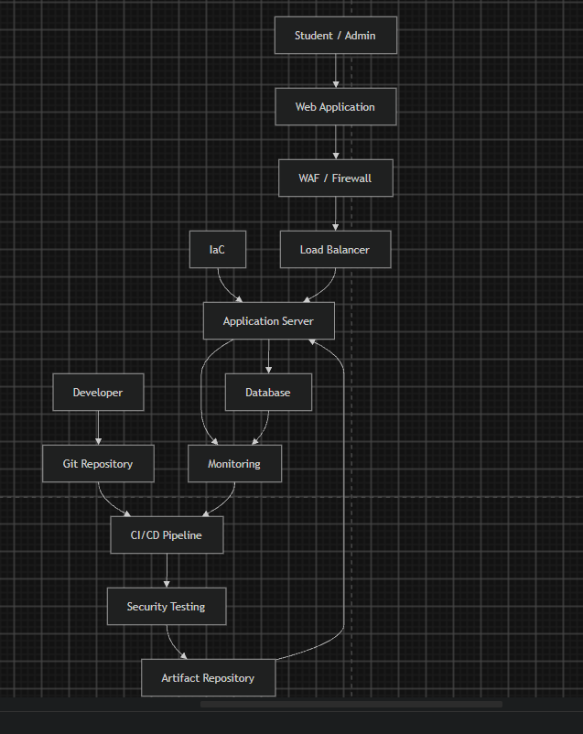

- Deployment Workflow
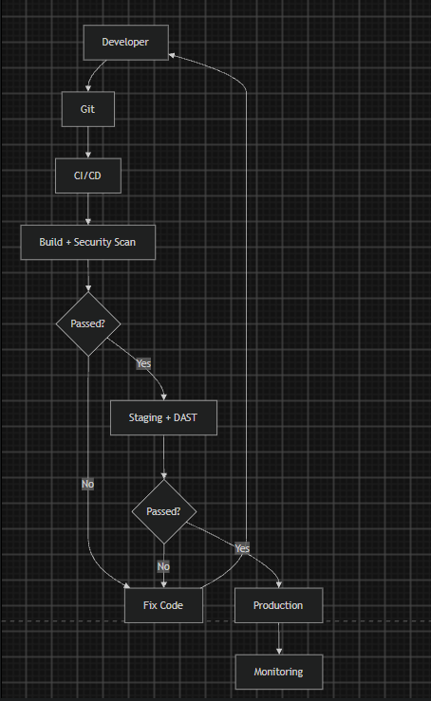

- IAM Relationships
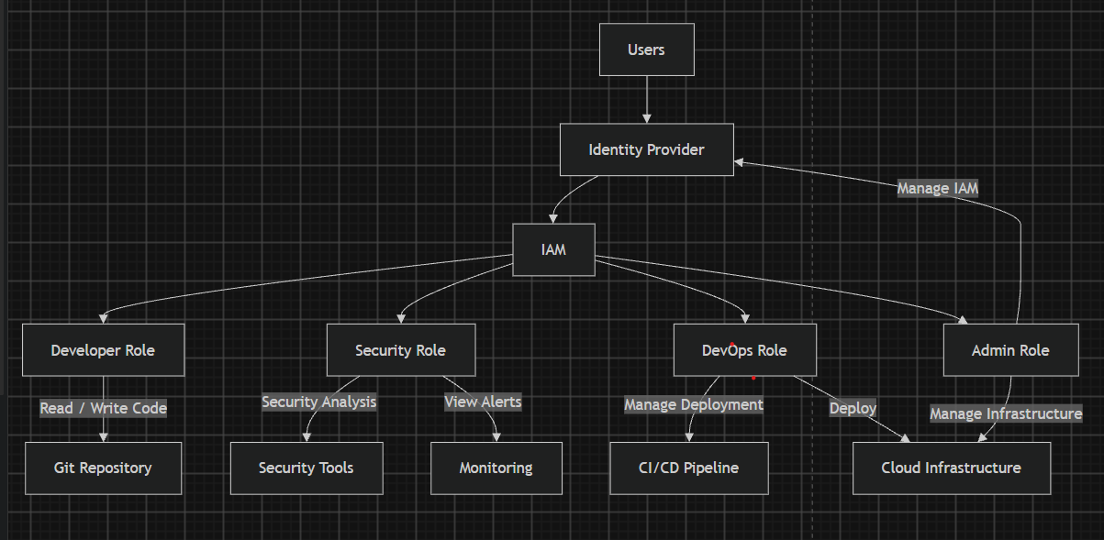
4 GitOps Workflow
