**Title:** Prompt-Based Text Generation using GPT-2

**Model Used:** GPT-2 from Hugging Face

**Platform:** Google Colab

**Prompts Used:**

"Once upon a time in India,"

"Artificial Intelligence will"

**Outputs:** 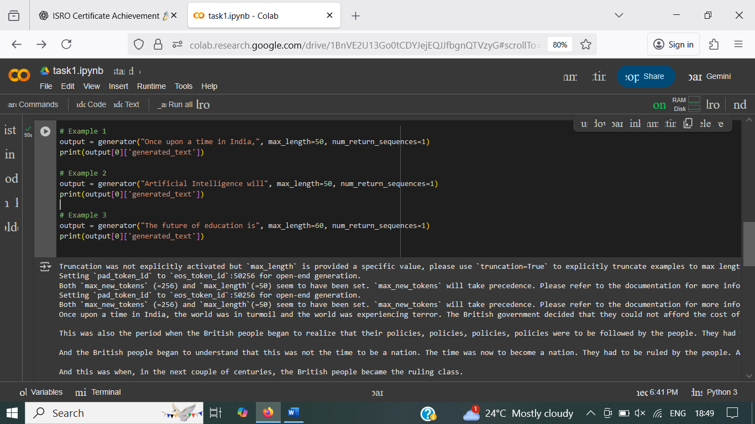

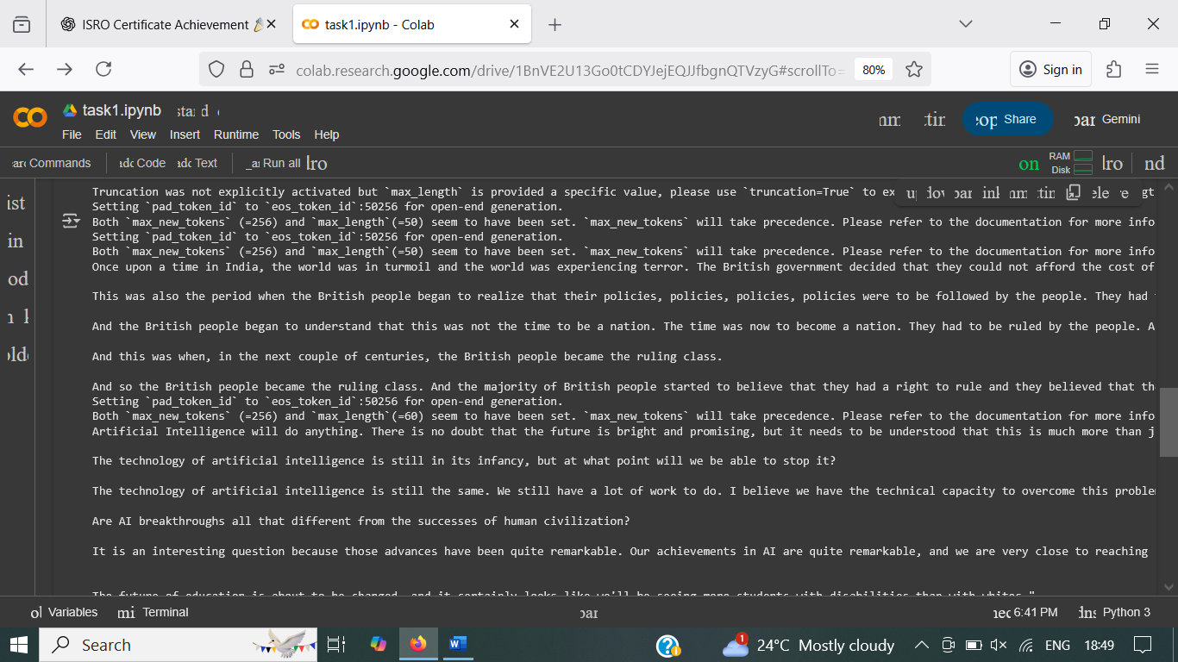

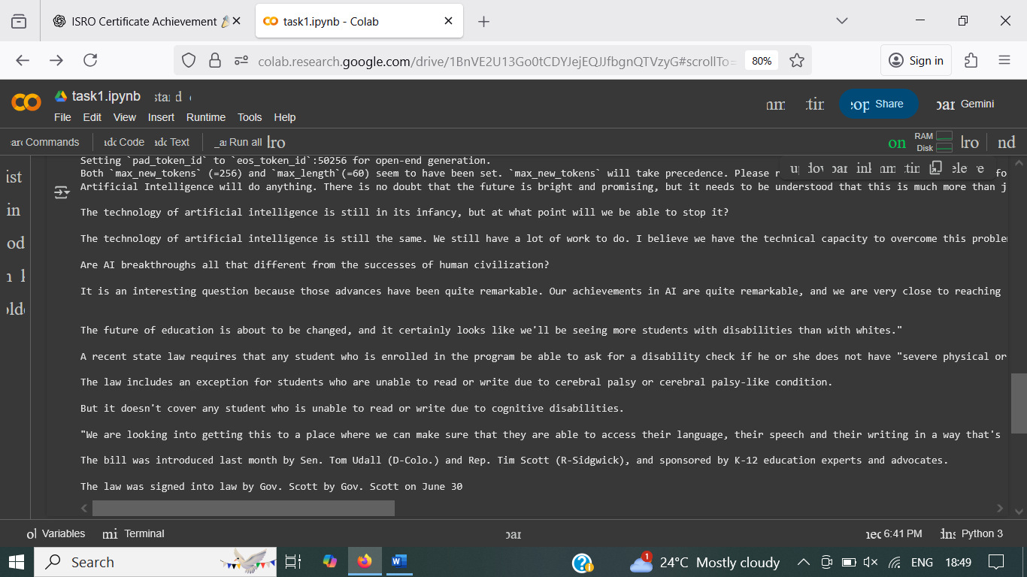

**Brief Summary:**

Used a pre-trained GPT-2 model to generate text responses based on custom prompts. This showed how language models predict and continue text sequences in a meaningful way.