**Title:** GAN for Handwritten Digit Generation

**Dataset:** MNIST  
**Model:** Simple GAN with 3-layer Generator & Discriminator

**Summary:**

Implemented a basic GAN using PyTorch. Trained on MNIST for 3 epochs to generate digit-like outputs. Observed progressive learning by the generator to mimic digit shapes.

**Screenshot:**

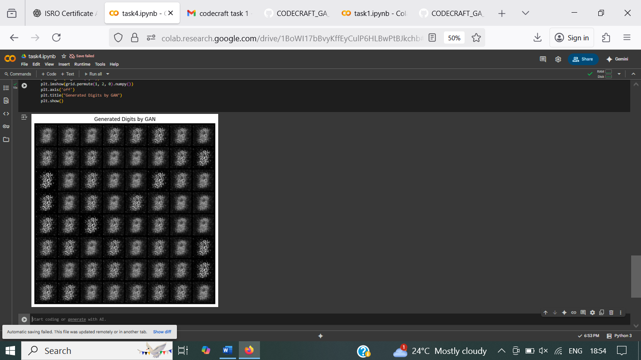

**Platform:** Google Colab