**CHAPTER 1**

**ABSTRACT**

The internship period was from March 8th to June. Its schedule includes Training, Product development and new recruiters into live company projects.

The Internship started with training which is a 2-month intensive yet fun filled unique training program that is conducted with a motive of training young talented engineers as industry ready leaders. Each day offers some insuperable challenges to the new recruits, who go through some intense sessions and emerge out as highly confident, business professionals .Each week will be scheduled with a new trending technology with an assignment challenging us.

The training will be followed by a product development program for 2-months where the new recruiters will be grouped into a group of 4 and asked to build a product.

Post which the new recruiters will be put into the live company projects .On successful completion of the following the new recruiter will be converted into a full-time employee.

**CHAPTER 2**

**COMPANY INFORMATION**

**2.1 PROFILE**



Figure : OneTrust logo

OneTrust is the leading privacy management software platform to operationalize data privacy compliance and privacy by design. OneTrust is the #1 [fastest-growing](https://www.inc.com/magazine/202009/tom-foster/onetrust-kabir-barday-fastest-growing-company-2020-inc5000.html) company on Inc. 500 and the category-defining enterprise platform to [operationalize trust](https://onetrust.com/trust-platform/). More than 10,000 customers, including half of the Fortune 500, use OneTrust to make trust a competitive differentiator, implementing central agile workflows across privacy, security, data governance, GRC, third-party risk, ethics and compliance, and ESG programs.

They are specialized in building innovative software products which mainly include

* OneTrust Privacy -Privacy Management Software
* OneTrust DataDiscovery - AI-Powered Discovery and Classification
* OneTrust DataGovernance - Data Intelligence Software
* OneTrust Vendorpedia - Third-Party Risk Exchange
* OneTrust GRC - Integrated Risk Management Software
* OneTrust Ethics - Ethics and Compliance Software
* OneTrust PreferenceChoice - Consent and Preference Management Software
* OneTrust ESG – Environmental, Social & Governance Software

**2.2 OVERVIEW**

OneTrust is a software development company, which provides the regulatory intelligence, automation, and flexibile solutions that you need to operationalize your privacy program.It complies with CCPA, GDPR, LGPD, and hundreds of the world’s privacy laws and frameworks. They build deep tech SAAS products and platforms. Our experts in Analytics, Machine Learning & Integrations, build upon learning’s and frameworks from a decade of launching 200+ products. We understand the process, passion and hard work it takes to launch and support a growing product. It has 500+ team members, 200+ products and 150+ clients.

**SaaS Ecosystem Partners**

**Redislabs** ::::

The only consulting and implementation partner in Asia Pacific.Widely used NoSQL database for caching & In-memory optimization tool.

**Heroku**:

Salesforce consulting partner with expertise in Heroku platform. PAAS Expertise with Heroku connects to build seamless applications.

**AWS partner Network:**

A decade of AWS Experience, with 60+ AWS certified engineers, providing best in class cloud offerings and digital technology support.

**2.3 VISION AND MISSION STATEMENTS**

**Powering Digital transformation for large enterprise**

It is not easy to create a path for digital transformation with existing business process and software assets. One of the biggest challenges for enterprises is the expensive, slow-moving, legacy incumbents. The success of digital solutions depends on implementing the right technology at the right time to meet the specific business requirements.

To keep up with the dynamic requirements of the business, development teams therefore need an adaptive and agile platform. A reliable, secure, and scalable digital platform can speed up innovation and support the development of digital applications. SaaS based solutions can also provide enterprises with easy access to an on-demand platform that can be used as per requirement. Some of the must-have features for legacy apps include Modern User Interface, Single Sign-In, Audit Logs, Role Based Access Control, Integrations, Analytics, and Feature Gates.

**2.4 ACHIEVEMENTS AND AWARDS**

“OneTrust is leading the worldwide data privacy market outright and is showing no signs of slowing down or stopping” as per the IDC Market Share report. OneTrust is the faraway leader with 40% of the privacy management market share which is more than all other leaders combined, for the second year in a row. OneTrust has Professional personal life balance provides a great learning curve with beneficial hands-on new technologies.

OneTrust is awarded as winner of Best Data Privacy Solution for the year 2021 by RegTech Insight and #1 Fastest Growing for the year 2020 by Inc 500.

**  **



Figure :Awards and recognition

**CHAPTER 3**

**PRODUCTS**

**3.1 Meetnotes.com**

Capture.PNG

Figure : Meetnotes

A meeting assistant to run meetings that get things done. Drive productivity while working remotely. Meeting based on smart collaboration tools.

Your documents, plans, tasks status reports all live in one place and shared with all team members so you can spend more time doing the work then shuttling between tools.

MeetNotes sends automated follow up emails, updates, status and summary to all team members to make sure everyone is on same page. MeetNotes is designed for automation. It will send automated follow up when something look like its going to slip. Save your time from follow-ups and use it to get things done. Keep records of activity, tasks, important decisions and notes from all your meetings organized at one place for easy look-up and reference later on.

**3.2 RDBTools.com**



Figure : RDBTools

A complete package to view, manage and optimise Redis.

Redis RDB Tool, an open source memory profiling tool for redis that parses redis dump files (.rdb files) and generates a memory profile in a variety of formats. This tool gave us visibility into memory usage, and helped us solve several problems our customers were facing. At some point though, the tool was “good enough”, and we didn’t improve it much. Several other developers and especially RedisLabs stepped in and contributed in a variety of ways.

**CHAPTER 4**

**SERVICES**

A software development company, with a difference. They build deep tech SAAS products and platforms. Our experts in Analytics, Machine Learning & Integrations, build upon learning’s and frameworks from a decade of launching 205+ products. We understand the process, passion and hard work it takes to launch and support a growing product. Analytics & Technology driven decision making for product and marketing. Amazing user experiences design based on research and understanding .Create interfaces and systems to provide ongoing value to users.

They have 100+ customers in various field like IT, healthcare, Hospitality, Media, E-commerce, Automation etc.

**CHAPTER 5**

**TRAINING PROGRAM**

**5.1 HASHEDIN UNIVERSITY**

Every Hasher goes through an intense entrepreneurial corporate Boot camp that is conducted with a motive of training young talented engineers as industry ready leaders. It is a 8 week intense boot camp to make fresher into industry ready Hashers.

The training program included various trending technologies like Python, React, Flask etc and also soft skills training like Communication track, Tech marketing etc. Training apart it was also included with fun activities, sports, and section and team lunch.

**5.2 OVERVIEW OF 1ST MONTH**

The first month was scheduled with 4 Tracks with an Assignment for every Track.

**5.2.1. HTML &CSS Track**

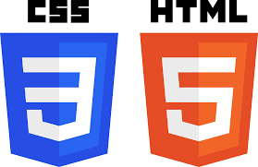

Figure : HTML & CSS logo

First few days of week 1 includes training on Basic of Git, Github ,account creation various operation like fork, clone ,commit ,push pull. Next few days was about the Docker, creation of Docker image, containers, deployment etc.

Proceeding we had sessions on Basics of HTML and CSS, flex and grid. Post sessions we had a mini and major Assignment which were supposed to be submitted on the specified deadline which were evaluated for our full-time conversion. In this we were supposed to create a UI based on the requirement provided by making use of the concepts done in the sessions.

**Assignment Developed UI’s**

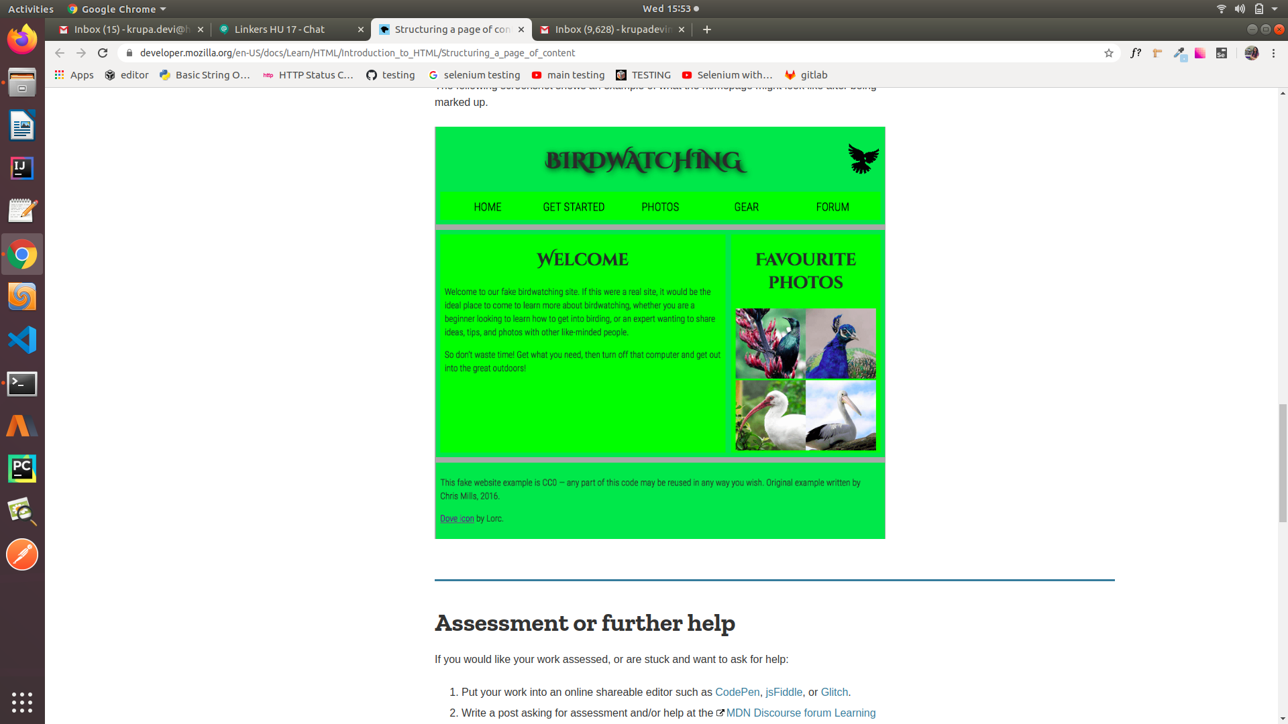

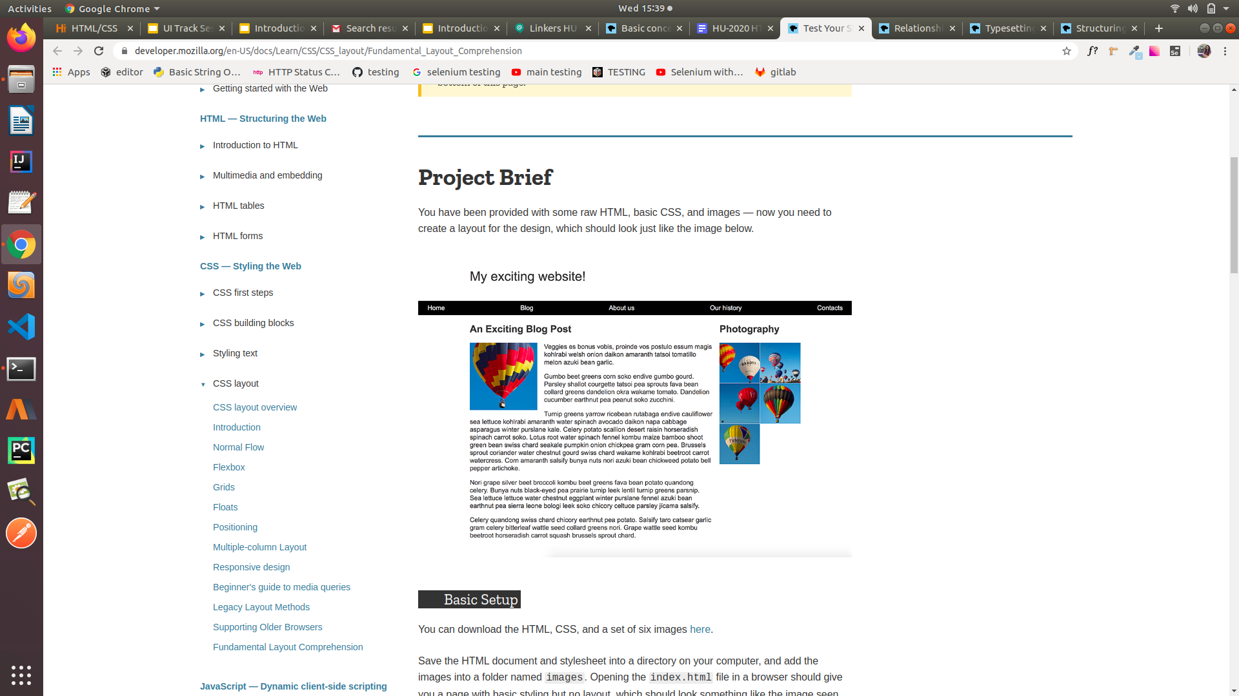 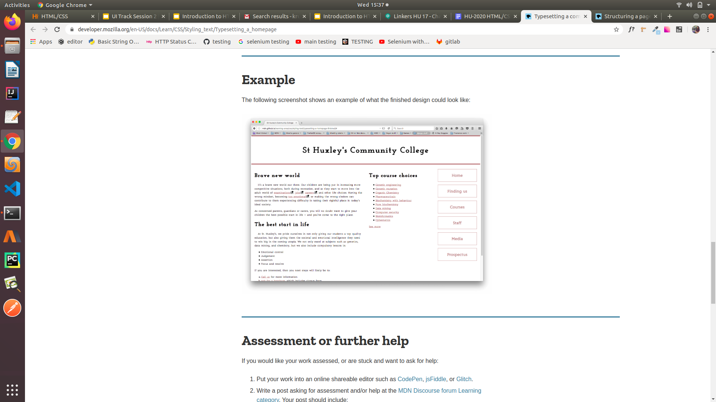

Figure 6 :UI Designed in HTML CSS track

**5.1.2. React Tract**

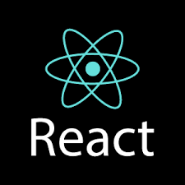

Figure : React logo

**React** (also known as **React.js** or **ReactJS**) is a JavaScript library] for building user interfaces. React is a tool for building UI Components

Week-2 started with the sessions on Basic of JavaScript, Typescript for React, Introduction to React, React concepts like States, Props, Hooks etc. Post sessions we had one mini and one major assignment.

**Timesheet Assignment**

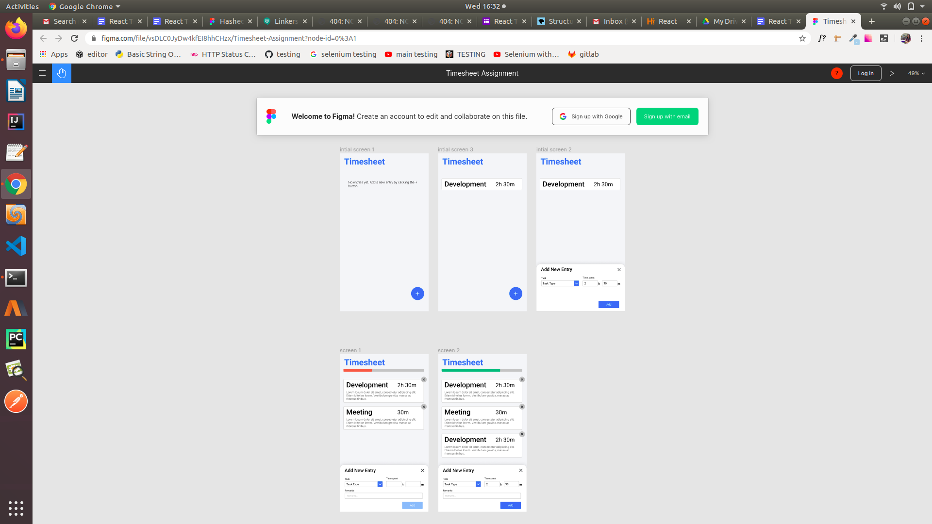

Figure : UI designed in React track

**5.1.3. Python/Flask Track**



Figure : Flask Logo

**Flask** is a web framework. This means **flask** provides you with tools, libraries, and technologies that allow you to build a web application. This web application can be some web pages, a blog, a wiki or go as big as a web-based calendar application or a commercial website.

The week-3 was about backend development using Python /Flask .It started with session on Python, Flask, REST API’s etc .We had a mini assignment related to retrieval and updating of data using CSV files and a major assignment based on REST API.

**5.1.4. Software Testing**

**Software testing** is a process, to evaluate a **software** application with an intent to find whether the developed software functions based on the requirement specified.

The track started with the introduction to basic types of software testing, frontend and backend testing, how to write test cases and test scenarios, testing using python followed by the assignment related to the topics discussed.

**5.2 OVERVIEW OF 2ND MONTH-MARCH**

**5.2.1 Automation Testing**

Automated testing or test automation is a method in software testing that makes use of special software tools to control the execution of tests and then compares actual test results with predicted or expected results. Automation is used to to add additional testing that may be too difficult to perform manually.

**5.2.2 Python Pytest**

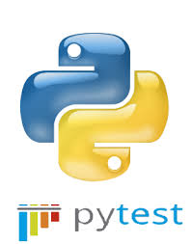

Figure : Python Pytest Logo

Pytest is a testing framework which allows us to write test codes using python. You can write code to test anything like database , API, even UI if you want. But pytest is mainly being used in industry to write tests for APIs.

**5.2.3 Selenium Automation Testing**



Figure : Selenium Automation testing

**SELENIUM** is a free (open-source) automated testing framework used to validate web applications across different browsers and platforms. You can use multiple programming languages like Java, C#, Python etc to create Selenium Test Scripts. Testing done using the Selenium tool is usually referred to as Selenium Testing.

**CHAPTER 6**

**PERSONAL ROLES AND OBSERVATION**

**5.1. PERSONAL ROLES**

The Training as a an intern for 2-months was an intense training where each intern role was to learn new technology every week and apply those knowledge to complete the assignment given. Now just learning new technology but also to understand how life will in the corporate world, communication skills ,how to apply knowledge to solve the real world scenario problem etc.

Each day offers some insuperable challenges to the new recruits, who go through some intense sessions and emerge out as highly confident, business professionals and as a industry ready leaders.

**5.2.OBSERVATION**

The observations made during this program are how project are carried out working in teams, applying the knowledge learnt during the academics and the sessions carried out during the training to solve the real scenario problem and to build the product based on the requirement., the stages involved during the development of the product, hands-on experience, how to manage deadlines, communication skills with some new technologies. The internship was also good to find out what my strengths and weaknesses are. This helped me to define what skills and knowledge I have to improve in the coming time. Some of the intakes are:

**Critical and Analytical Thinking:** To organize our tasks and assignment, we need to analyze our problems and assignment, and to formulate a good solution to the problem. We would have to set contingency plan for the solution.  
  
**Time Management**: As overall technician and programmer are always racing against tight timeline and packed schedule, a proper time management will minimize facing overdue deadlines. An effective time management always needed.  
  
**Goal Management**: It is better to sub-divide the goals to a few achievable tasks, so that we will be gaining more confidence by accomplishing those tasks.   
  
**Colleague Interactions**: In working environment, teamwork is vital in contributing to a strong organization. Teamwork is also essential in reaching the goals of the organization as an entity. Thus, communicating and sharing is much needed in the working environment. Therefore, we should be respecting each other in work, and working together as a team, instead of working alone. This is because working together as a team is easier in reaching our targets, rather than operating individually.

**CHAPTER 7**

**CONCLUSION**

On the whole, this internship training was a useful experience. I gained new knowledge, skills and met many new people. I achieved several of my learning goals. The industry exposure that I received during my internship will also be a valuable guide in my future. The advices given whenever there were a mistake were useful guidance for me to change myself and avoid myself making the same mistakes again. Overall it was a wonderful experience filled with learning new technologies, fun activities, team lunch etc.

**CHAPTER 8**

**REFERENCES**

<https://git-scm.com/downloads>

<https://www.w3schools.com/whatis/whatis_react.asp>

<https://flask.palletsprojects.com/en/1.1.x/>

<https://www.guru99.com/software-testing-introduction-importance.html>

<https://developer.mozilla.org/en-US/docs/Web/HTML>

<https://developer.mozilla.org/en-US/docs/Learn/HTML/Introduction_to_HTML/Structuring_a_page_of_content>

<https://developer.mozilla.org/en-US/docs/Learn/CSS/Introduction_to_CSS>

<https://developer.mozilla.org/en-US/docs/Learn/CSS/Introduction_to_CSS/Fundamental_CSS_comprehension>

<https://developer.mozilla.org/en-US/docs/Learn/CSS/CSS_layout/Fundamental_Layout_Comprehension>

<https://www.w3schools.com/python/>

<https://docs.pytest.org/en/latest/getting-started.html>

<https://www.guru99.com/introduction-to-selenium.html>

<https://www.w3schools.com/js/>

<https://hashedin.com/about-us/>