**SHNEKA. S**

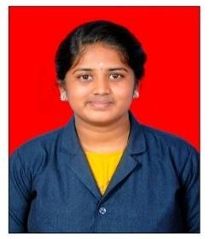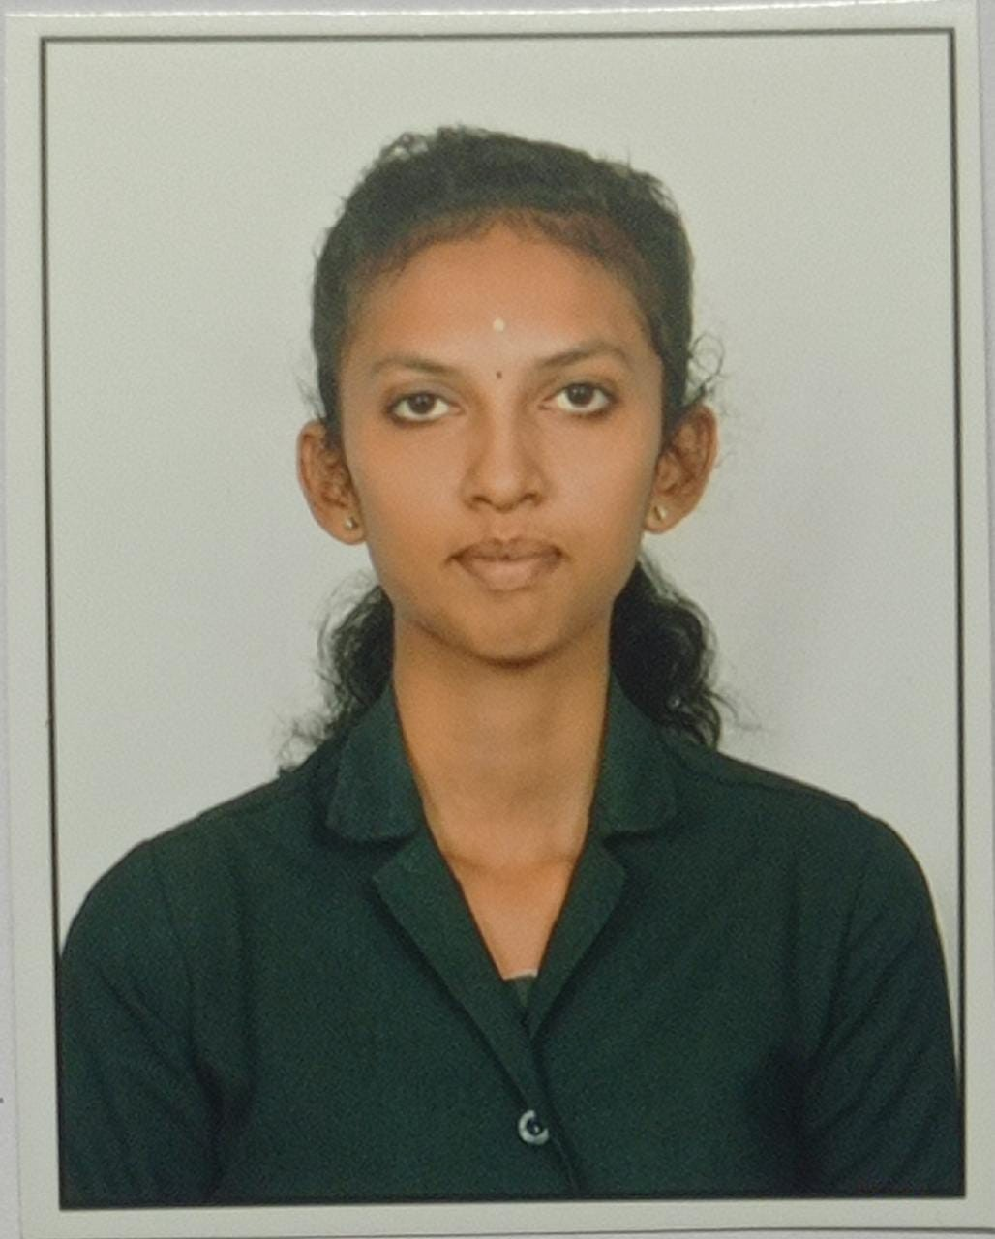

✉[suganthi152003@gmail.com](mailto:shnekayuvarani@gmail.com)

✉9344347170

zzzzzzzzzzzzzzzzzzz

# CAREER OBJECTIVE

* Ambit to work and learn in real professional and vying ambience.
* That enables me to cope up with the emerging and latest technologies.
* The scope for widening of my knowledge in Accounting & Finance.

# EDUCATIONAL QUALIFICATION

|  |  |  |  |  |
| --- | --- | --- | --- | --- |
| **QUALIFICATION** | **NAME OF THE INSTITUTION** | **BOARD/ UNIVERSITY** | **YEAR OF PASSING** | **PERCENTAGE**  **%** |
| B. Com.,  (B &I) | Vivekanandha College of Arts and Sciences for Women (Autonomous) | Periyar University | 2023* | 78  (Up to 4th  semester) |
| HSC | G.V Higher Secondary School  , Mettur. | State Board | 2020 | 73 |
| SSLC | Malco vidhyalaya  Matric.Hr.Sec. School, Mettur. | State Board | 2018 | *75* |

**FIELD OF SPECIALISM**

* Principles Of Marketing Tally
* International Buisness
* Tally

# PROFICIENCY

* Computer proficiency - MS Office
* Accounting software -Tally

# COCURRICULAR ACTIVITIES

* + Attended 10th international conference conducted by DHAKA INTERNATIONAL UNIVERSITY Bangladesh.
  + Participated in national Conference on “RECOVERY STRAGIES FOR

BUISNESS SUSTAINABILITY”-post covid-19.

* + Participated in "IMPORTANCE OF YOGA IN DAILY LIFE" national

scheme by INDIAN COUNCIL OF PHILOSOPHY RESEARCH,New Delhi.

# EXTRA CURRICULAR ACTIVITIES

* + Inplant training in PACS(Primary Agriculture Co-Operative Society).

# PERSONAL PROFILE

Father’s Name DOB

Address

: Rathinavel. A

: 01.05.2003

: 1/1-1,Chinnaiya reddy street,T.M.P Nagar,Mettur dam-2.

Gender : Female

Marital Status : Unmarried

Hobbies Languages Known

: Drawing and Craftworks.

: Tamil and English.

# DECLARATION

I solemnly declare that all the information is furnished above is true to the best of my

belief.

Place: Salem Yours sincerely,

Date:

[SUGANTHI.R]