ris

CSE 564 Project Report Number 4

Team 21

Team Member Names:

1. Parv Shah

2. Monil Prajapati

3. Alexander Chittim

4. Prathit Barot

5. Brenden Martinez

1. Requirements 2

1.1. Function Requirement 1 2

1.2. Function Requirement 2 2

1.3. Performance Requirement 1 2

1.4. Performance Requirement 2 2

1.5. Interface Requirement 1 2

1.6. Interface Requirement 2 2

1.7. Logical, Database, and/or Reuse Requirement 1 3

1.8. Logical, Database, and/or Reuse Requirement 2 3

2. Architecturally Significant Elements 4

2.1. Overview and Architectural Views 4

2.2. Logical/Quality Elements and why each is architecturally significant 4

2.3. Database Elements and why each is architecturally significant 4

2.4. Reuse Elements and why each is architecturally significant 4

3. Draft Architecture 5

3.1. Overview and Architectural Views 5

3.2. Logical / Quality Elements 5

3.3. Database Elements 5

3.4. Reuse Elements 5

3.5. Architectural View 1 5

3.6. Architectural View 2 6

4. Initial Detailed Design 7

4.1. Overview 7

4.2. Highest Priority Detailed Design Element 7

4.3. Second Highest Priority Detailed Design Element: Bracelet (Brenden Martinez) 7

4.4. Next Highest Priority Detailed Design Element 10

5. Risk Analysis 11

5.1. Overview 11

5.2. Highest Priority Project Risk 11

5.3. Second Highest Priority Project Risk 11

5.4. Next Highest Priority Project Risk 11

6. Conclusion 12

6.1. New or Updated Key Conclusion 1 12

6.2. New or Updated Key Conclusion 2 12

6.3. Consider adding a final item “Items for future consideration”. 12

Appendix A: Credit Sheet 13

# 1. Requirements

**1.1. Function Requirement 1**

* **Feature:** Multi-Sensor Data Collection for Real-time Obstacle Detection
* **Requirement Source:** Stakeholder
* **Inputs and Stimulus:**
  + Inputs: Continuous data streams from LiDAR sensor, cameras
  + Stimulus: Ongoing sensor data flow.
* **Sequence of Operations and Responses:**
* **Operation 1:** Establish Communication Channels with Multiple Sensors
  + **Action:** Set up and configure communication channels with LiDAR, cameras modules.
* **Response:** Verify data synchronization and connection stability to ensure uninterrupted data acquisition. Monitor the health of data streams and handle any interruptions, re-establishing connections if necessary.
* **Operation 2:** Continuous Collection and Buffering of Raw Sensor Data Frames
  + **Action:** Collect raw sensor data frames from all sensors and combine them into a unified data stream.
* **Response:** Prepare data frames for subsequent processing, including data cleansing and alignment to ensure consistency and compatibility between different sensor types.
* **Operation 3:** Real-time Obstacle Detection and Alert Triggers
  + **Action:** Utilize data from LiDAR, cameras to perform real-time obstacle detection and location tracking.
* **Response:** 
  + Promptly alert the user upon detecting obstacles within a predefined safety zone. Alerts may include visual cues, auditory warnings, or haptic feedback.
  + The system should consider the user's current location and dynamically adjust the alert threshold based on their speed and proximity to detected obstacles.

**1.2. Function Requirement 2**

* **Feature:** Integration with Voice Assistants for Path Planning and Navigation
* **Requirement Source:** Stakeholder
* **Inputs and Stimulus:**
  + Inputs: Microphone input from the user, including voice commands.
  + Stimulus: User-initiated voice commands for navigation and path planning.
* **Sequence of Operations and Responses:**
* **Operation 1:** Integration with Common Voice Assistants (e.g., Google Assistant)
  + **Action:** Establish a robust integration with widely recognized voice assistant platforms, such as Google Assistant.
* **Response:** Enable users to interact with the system using natural language voice commands for precise and efficient path planning and navigation.
* **Operation 2:** Interpretation of User Voice Commands and Route Preferences
  + **Action:** Implement advanced natural language processing (NLP) to analyze and interpret user voice commands, including route preferences, destinations, and any specific requests.
* **Response:** Utilize NLP to calculate an optimal navigation path, taking into account real-time obstacle data, user preferences, and any additional route-specific information provided by the user.
* **Operation 3:** Continuous Delivery of Step-by-Step Auditory or Haptic Directions
  + **Action:** Continuously monitor the user's location and progress during navigation, updating directions in real-time.
* **Response:** Provide step-by-step auditory or haptic directions, adapting to dynamic changes in the environment and ensuring that the user is guided accurately and safely to their destination.

**1.3. Performance Requirement 1**

* **Feature:** Real-time Response
* **Requirement Source:** System Efficiency
* **Static Numerical Requirement:** 
  + The system must exhibit rapid responsiveness by acknowledging.
  + Acting upon obstacles within a maximum time frame of 500 milliseconds.
* **Updated Dynamic Numerical Requirement:**
  + The system should consistently maintain a minimum scanning rate of 10 scans per second
  + This will ensure that it continuously collects environmental data, including data from LIDAR, cameras, and provides the user with real-time updates regarding their immediate surroundings.
  + This rate of data acquisition and processing should support instantaneous obstacle detection and response, ensuring that alerts and feedback are generated in less than 500 milliseconds from the detection of an obstacle.

**1.4. Performance Requirement 1**

* **Feature:** Optimal Power Consumption for User Safety
* **Requirement Source:** Stakeholder
* **Static Numerical Requirement:** The system should consume no more than 10% of smartphone battery per hour during active usage.
* **Dynamic Numerical Requirement:** Automatically reduce power consumption during inactivity and provide low-battery warnings below 20% for user awareness.

**1.5. Interface Requirement 1**

* Feature: User-Defined Audio Feedback and Control
* Requirement Source: User Feedback
* Source of Input or Destination of Output:
  + **Input Source: Buttons.**
  + **Output Source:** Speakers/headphones.

# 1.6. Interface Requirement 2

# Feature: Wearable Bracelet Communication

# Requirement Source: Communication Efficiency

# Source of Input or Destination of Output:

# Input Source: System Controller

# Output Destination: User's wearable bracelet

**1.7. Logical, Database, and/or Reuse Requirement 1**

* Feature: Data Processing and Logic for Real-time Functionality
* Requirement Source: System Design
* Types of data and/or operations performed:
  + Utilization of advanced algorithms designed for real-time processing of LiDAR data, facilitating obstacle recognition and analysis.
  + Implementation of mapping and routing algorithms dedicated to path planning and real-time navigation solutions.
  + The development of adaptive logic ensures versatile user interaction across diverse environments, enhancing user experience and system adaptability.

**1.8. Logical, Database, and/or Reuse Requirement 2**

* Feature: Database Management for Security and Privacy
* Requirement Source: Regulatory Guidelines
* Types of data and/or operations performed:
  + Implementation of secure storage protocols for user data.
  + Application of encryption techniques and access controls for data protection.
  + Anonymization and safeguarding of location data to comply with privacy laws.
  + Conducting periodic security audits and updates to proactively address emerging threats, ensuring comprehensive protection of user data

# Architecturally Significant Elements

# Overview and Architectural Views

# UML Diagrams

# Utilize UML to represent software design patterns, such as Model-View-Controller (MVC) and Observer, to ensure maintainability and scalability.

* + 1. Class Diagram
       - Depict software components, their relationships, and dependencies, highlighting design patterns used for modularity and extensibility.
    2. Logical View
       - Analyze system functionality at a high level, emphasizing how software modules interact, enabling future enhancements.
    3. Physical View
       - Consider server deployment, cloud computing, and microservices for scalability, reliability, and high availability.
    4. Sequence Diagram
       - Employ software fault tolerance mechanisms, including graceful degradation, for uninterrupted operation, vital in life-critical applications.
  1. **Logical/Quality Elements and Their Significance**
     1. Reliability
        + Sensor redundancy, fault tolerance, and obstacle detection algorithms ensure reliable system performance.
        + If the system lacks reliability, it has the potential to pose a safety risk to the user, potentially leading to injuries. It is crucial for the user to have confidence in the product's trustworthiness.
     2. Usability
        + The product must cater to blind users, it should offer simplicity and user-friendliness.
        + Natural language processing and voice recognition for easy user interaction, especially for visually impaired users.
     3. Portability
        + The product should be suitable for on-the-go use.
        + Users should have the flexibility to use it in almost any location.
        + Utilize cross-platform mobile app development (e.g., React Native) for compatibility with various devices.
     4. Data Privacy and Security Compliance
        + Implement end-to-end encryption, secure data handling, and consent management to protect user data and comply with regulations.
     5. Customizable Alert Thresholds
        + Dynamic calibration algorithms that allow users to adapt the system to different environments.
     6. Multilingual Support
        + Integrate AI-driven language translation to cater to users with diverse language preferences.
     7. Low Battery Warning and Power Management
        + Power-efficient algorithms, low-battery warnings, and power-saving modes for uninterrupted operation.
     8. Gesture Control (Optional)
        + Incorporate infrared (IR) sensors for precise gesture recognition, improving user experience.
  2. **Database Elements and Their Significance**
     1. LIDAR Data Points
        + Store raw LIDAR data in a scalable cloud-based database for obstacle detection, mapping, and real-time decision-making.
     2. User Preferences and Settings
        + Store user-specific preferences and settings, influencing system interactions for a personalized experience.
     3. Data Privacy and Security Logs
        + Maintain logs to track user interactions, consent, and data handling processes, ensuring compliance and trust.
     4. Historical Data for Analysis
        + Store historical data for user analysis, allowing insights into system usage and safety improvement.
     5. Temporary Data Storage Management
        + Efficient data caching to optimize storage capacity and ensure uninterrupted system operation.
  3. **Reuse Elements and Their Significance**
     1. Slamtec RPLIDAR A1
        + Integration with ROS (Robot Operating System) for sensor fusion, enabling comprehensive environmental mapping.
     2. Earpiece/Headphones
        + Utilize spatial audio processing for 3D sound cues, enhancing user awareness of their surroundings.
     3. LidarView (Open Source)
        + Integrate LidarView for real-time data analysis, 3D point cloud rendering, and object tracking, enhancing system functionality.
     4. MongoDB (Open Source)
        + Employ MySQL as the primary database management system, ensuring efficient data storage, retrieval, and security.
     5. LiDAR Data Processing Library (Open Source)
        + Integrate open-source library with GPU acceleration for real-time data analysis, improving system accuracy and performance.
     6. LiDAR Data Visualization Framework (Open Source)
        + Utilize an open-source data visualization framework for 3D mapping, object tracking, and user-friendly feedback.
     7. Mobile App Development Framework (Cross-Platform)
        + Implement a cross-platform framework (e.g., React Native) for mobile app development, enabling a single codebase for multiple platforms.
     8. Serverless Computing Platform (e.g., AWS Lambda)
        + Utilize serverless computing for on-demand data processing, reducing operational costs and improving system efficiency.
     9. User Interface (UI) Component Library (Open Source)
        + Integrate an open-source UI component library (e.g., Material-UI) for consistent and responsive UI design, improving user experience.
     10. Lidar Perception Module
         + Deep learning models (e.g., YOLO) for object recognition
     11. Edge Computing
         + On-device processing for low latency and offline capability
  4. **Technological Implications**
* Advanced sensor fusion for 3D environment mapping
* Real-time data processing using GPUs
* Utilize cloud-based AI for natural language processing
* Data analytics for continuous system improvement
* IoT and edge computing for low latency and offline functionality
* Advanced battery management algorithms for power optimization
* Implementation of RESTful APIs for system integration
* Mobile app responsiveness through Progressive Web App (PWA) techniques
* Employ WebSockets for real-time communication
* Continuous integration and continuous deployment (CI/CD) for agile development

*"Pedestrian Navigation Systems for Blind Users: A Review" (ACM Transactions on Accessible Computing (TACCESS), 2022)*

*"Reliability in Pedestrian Navigation Systems for Blind Users: A Review" (IEEE Transactions on Human-Machine Systems, 2023)*

*"Usability Considerations for Pedestrian Navigation Systems for Blind Users" (ACM Transactions on Accessible Computing (TACCESS), 2022*

# Draft Architecture

# Overview and Architectural Views

**3.1.1 Logical View**

The Logical View offers an in-depth understanding of the high-level structure of the Lidar System for Blind People. It delves into the organization of the system's components, modules, and their interactions, shedding light on how the system's logic is organized to deliver its core functionality.

**3.1.1.1 Components:**

* **Core Logic Module:** At the heart of the system is the Core Logic Module. This module acts as the central processing unit, orchestrating the various components, managing data flow, and overseeing the decision-making process. It is responsible for real-time obstacle detection, path planning, and user interaction.
* **User Interface Module:** The User Interface Module provides the means for visually impaired users to interact with the system. It supports multiple input modalities, including voice commands and tactile inputs, to ensure accessibility and user-friendliness.
* **Data Processing Module:** The Data Processing Module handles the raw data collected from the Lidar sensors and other sensors, conducting point cloud analysis and obstacle recognition. It plays a crucial role in transforming sensor data into meaningful information for users.
* **Mapping and Routing Module:** This module focuses on the path planning and navigation aspects of the system. It employs advanced routing algorithms, taking into account real-time obstacle data, user preferences, and environmental conditions to calculate optimal navigation paths.
* **Feedback Generation Module:** The Feedback Generation Module is responsible for translating the processed data into real-time auditory and haptic feedback. It customizes feedback based on user preferences and the detected environmental conditions.

**3.1.1.2 Interactions:**

* **User Interaction Flow:** The logical view outlines how a user interacts with the system. When a user initiates a voice command or provides tactile input, the User Interface Module captures the input and communicates it to the Core Logic Module. The Core Logic Module then interprets the user's intent and coordinates with the Data Processing and Mapping and Routing Modules to provide relevant feedback.
* **Data Processing Flow:** The flow of data is critical in this architecture. The ta Processing Module continuously receives raw sensor data from the Lidar and other sensors. It processes this data in real-time, identifying obstacles and environmental features. The Feedback Generation Module depends on the processed data to generate meaningful feedback for the user.
* **Customization and Adaptation:** The Logical View highlights how the system adapts to user preferences. The User Interface Module allows users to customize their interaction preferences, such as voice command styles and tactile feedback intensity. This customization is integrated into the Core Logic Module's decision-making process.
* **Synchronization and Real-time Awareness:** The view emphasizes the need for synchronization and real-time awareness. The Core Logic Module ensures that sensor data is synchronized, and the system maintains continuous awareness of the user's surroundings to provide timely and relevant feedback.

**3.1.2 Process View**

The Process View offers an in-depth exploration of the dynamic aspects of the Lidar System for Blind People. It emphasizes the processes, threads, or tasks that work together to execute the system's functions and deliver real-time feedback to visually impaired users.

**3.1.2.1 Processes:**

* **Data Acquisition Process:** This process manages the continuous acquisition of sensor data, including data from Lidar sensors, cameras, radar sensors, and microphones. It oversees the collection, synchronization, and buffering of raw sensor data streams.
* **Data Processing Process:** The Data Processing Process handles the real-time analysis of sensor data. It employs advanced algorithms for point cloud processing, obstacle recognition, and environment mapping, ensuring the system's ability to detect obstacles and provide accurate feedback.
* **User Interaction Process:** The User Interaction Process facilitates user input, including voice commands and tactile feedback preferences. It interprets user commands and coordinates with other processes to execute the desired actions.
* **Feedback Generation Process:** The Feedback Generation Process is responsible for translating processed data into real-time auditory and haptic feedback. It customizes the feedback based on user preferences and environmental conditions.
* **Navigation Process:** The Navigation Process calculates optimal navigation paths based on user destination inputs, obstacle data, and environmental conditions. It continuously updates and delivers step-by-step auditory or haptic directions to guide the user.

**3.1.2.2 Interactions:**

* **Data Flow and Coordination:** The Process View outlines the flow of data among these processes. Data acquired by the Data Acquisition Process is processed by the Data Processing Process. The User Interaction Process provides user input, influencing the Core Logic Module's decisions, which are then communicated to the Feedback Generation and Navigation Processes.
* **Real-time Processing:** Emphasized is the need for real-time processing. The Data Processing Process must analyze sensor data in real-time to detect obstacles promptly. The Feedback Generation Process generates feedback in real-time, ensuring users receive timely information.
* **Feedback Customization:** The view highlights the dynamic interaction between the User Interaction Process and the Feedback Generation Process. Users can customize their feedback preferences, influencing the feedback generated during navigation.
* **Continuous Navigation:** The Navigation Process ensures continuous, real-time updates to provide users with dynamic navigation instructions. It adapts to changing environmental conditions and obstacle data.

**3.1.3 Development View**

The Development View provides insights into the modular structure and organization of the Lidar System for Blind People, emphasizing how the development process is managed and coordinated. It details the division of responsibilities among developers, teams, and components, allowing for efficient and collaborative system development.

**3.1.3.1 Development Structure:**

* **Development Teams:** The development of the system is organized into specialized teams, each responsible for distinct aspects of the project. These teams include hardware development, software development, user interface design, and quality assurance.
* **Modular Development:** The system's architecture is designed to be modular, allowing different teams to focus on specific components. This modularity ensures that individual teams can work in parallel and facilitates easier integration.
* **Iterative Development:** The development process follows an iterative model, with regular feedback and testing cycles. This approach allows for continuous improvement, refinement, and the incorporation of user feedback.

**3.1.3.2 Responsibilities and Interactions:**

* **Hardware Development Team:** This team is responsible for the hardware components of the system, including the ring-like area scanner and the pressure bracelet. They collaborate closely with the software development team to ensure hardware-software compatibility.
* **Software Development Team:** The software development team focuses on the development of the system's core logic, data processing algorithms, user interface, and feedback generation. They work in coordination with the hardware team to enable seamless integration.
* **User Interface Design Team:** The user interface design team is dedicated to creating an accessible and user-friendly interface. They collaborate with the software development team to ensure that the user interface aligns with the needs of visually impaired users.
* **Quality Assurance Team:** The quality assurance team plays a critical role in testing and validating the system at various stages of development. They provide feedback to development teams, helping to identify and resolve issues.

**3.1.3.3 Collaboration and Integration:**

* **Team Collaboration:** The view underscores the importance of effective collaboration among teams. The hardware and software development teams collaborate to ensure the compatibility and functionality of the overall system.
* **Parallel Development:** The modular architecture allows different teams to work on their components simultaneously, enhancing efficiency and reducing development time.
* **Integration Points:** The Development View identifies key integration points where hardware and software components come together. This ensures that the system functions cohesively and that the hardware components are capable of supporting the software's requirements.

**3.1.4 Physical View**

The Physical View offers an in-depth exploration of the physical components and their relationships within the Lidar System for Blind People. It emphasizes the layout and interconnections of hardware components, providing insight into how the physical elements of the system come together.

**3.1.4.1 Physical Components:**

* **Ring-Like Area Scanner:** This component is a crucial part of the system's hardware. It includes Lidar sensors positioned to capture a 360-degree view of the user's surroundings in real time. The scanner is designed to be compact and lightweight, ensuring it is comfortable to wear.
* **Pressure Bracelet:** The pressure bracelet is a wearable device equipped with an array of pressure points. These points correspond with directions and the intensity of sensed obstacles and features. The bracelet is designed for user comfort and ease of wear.
* **Mobile Application:** The system includes a dedicated mobile application designed for smartphones. This application serves as a user interface, facilitating system setup, and customization, and providing additional information. It connects with the wearable hardware components to enhance the user experience.
* **Server Infrastructure:** Centralized server infrastructure plays a critical role in data synchronization, storage, and processing. It manages the efficient processing of real-time data and ensures that data is synchronized across users' wearable devices.

**3.1.4.2 Physical Interconnections:**

* **Wearable Integration:** The ring-like area scanner and the pressure bracelet are designed to work in close coordination. The scanner continuously captures data about the user's surroundings, and this data is processed and translated into pressure feedback on the bracelet to provide users with tactile information about obstacles and directions.
* **Mobile Application Interface:** The mobile application interfaces with the wearable hardware components. Users interact with the system through the mobile app, configuring settings, and receiving additional information about their environment.
* **Server Communication:** The wearable hardware components synchronize with the central server infrastructure. This connection ensures that real-time data is processed, and users receive timely feedback.

**3.1.4.3 Physical Layout:**

* **Compact and Wearable:** The physical view highlights that the hardware components, including the scanner and the pressure bracelet, are designed to be lightweight and compact, ensuring that users can comfortably wear them for extended periods.
* **User Mobility:** The physical layout emphasizes the portability of the hardware components. Users can use the system on the go, both indoors and outdoors, allowing them to navigate various environments with confidence.

# Logical / Quality Elements

**3.2.1 Reliability**

Reliability is paramount in the Lidar System for Blind People, ensuring consistent, trustworthy operation crucial for user safety. It guarantees user trust in the system, fundamental for the visually impaired community.

* **User Trust:** The system's reliability directly impacts user trust. Users rely on the system's accuracy to make critical decisions about their surroundings, emphasizing the need for dependable performance.
* **Data Processing:** Advanced algorithms analyze real-time data, detecting obstacles, mapping, and routing. The reliability of these algorithms ensures accurate feedback to users, enhancing their situational awareness and safety.

**3.2.2 Usability**

Usability is a critical element in the Lidar System for Blind People, with a strong emphasis on simplicity for visually impaired users.

* **Accessibility:** Usability is paramount, particularly for visually impaired users. The interface is designed for straightforward navigation through tactile or voice commands, ensuring accessibility.
* **User-Centric Design:** Prioritizing user needs, the system's design places emphasis on user-friendly interactions, accommodating diverse environments and ensuring a seamless experience.

**3.2.3 Portability**

Portability is a core feature in the Lidar System for Blind People, allowing users to navigate various environments with ease.

* **On-the-Go Usage:** The system is designed for easy portability, ensuring users can use it in different settings, both indoors and outdoors. It prioritizes user mobility, enabling confident navigation in diverse environments.

# Database Elements

# 3.3.2 Data Processing Logic

Data processing logic in the Lidar System for Blind People is a critical architectural component responsible for real-time data analysis, including point cloud analysis, obstacle recognition, and routing algorithms.

* **Data Processing Modules:** The system comprises distinct data processing modules that handle specific tasks. These modules include point cloud analysis, obstacle recognition, and routing algorithms. Each module is responsible for a particular aspect of data analysis, enhancing the system's efficiency and responsiveness.
* **Algorithm Integration:** Advanced algorithms are seamlessly integrated into the system's architecture to facilitate real-time data processing. These algorithms play a key role in obstacle detection, mapping, and routing. Their integration ensures that the system can promptly provide accurate feedback to users, contributing to their safety and spatial awareness.
* **User Preferences**: The system's architectural design incorporates elements that adapt feedback based on user preferences and environmental factors. This adaptability allows users to customize their experience, making it versatile for various environments and personal preferences. It ensures that the system remains user-centric, enhancing usability and user satisfaction.

# Reuse Elements

The Lidar System for Blind People's architecture strategically incorporates reuse elements to optimize system development and performance. These elements enhance the system's functionality while maintaining cost-effectiveness.

**Leveraged Technologies:**

* **Slamtec RPLIDAR A1 - 360 Laser Range Scanner (LIDAR)**: The system employs this laser range scanner to capture a 360-degree view of the user's surroundings with a range of 12 meters. This component is compact, measuring 60 mm in height, 98.5 mm in width, and weighing 170g, making it small and lightweight. Its affordability, priced at $100, ensures cost-effectiveness. It allows for efficient mapping of the user's surroundings without being cumbersome, enabling precise distance calculations for objects near the user.
* **Earpiece/Headphones**: These audio output devices are used to alert the user to their surroundings. By leveraging existing earpiece or headphone technology, the system ensures that users receive clear and real-time auditory cues, enhancing their spatial awareness.
* **LidarView:** LidarView (https://lidarview.kitware.com/) is an open-source software tool used to process data collected from the LIDAR. It offers the capability to visualize data in 3D, making it invaluable for providing users with a comprehensive understanding of their environment. Additionally, LidarView can be combined with object detection and tracking, allowing the system to analyze the collected data efficiently.

# Logical View

* + 1. **Introduction and rationale for the view**

Architectural View 1 focuses on the integration of the ring-like area scanner within the Lidar System for Blind People. This view illustrates how the scanner collects environmental data and initiates the process of enhancing a visually impaired user's spatial awareness.

* + 1. **Model / Graphical Representation**

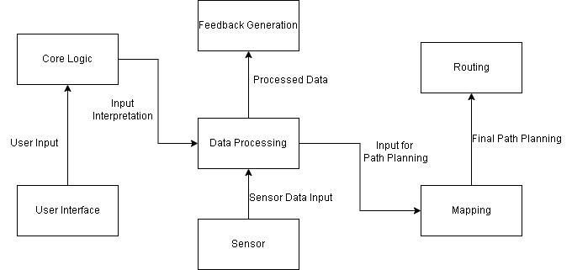

* + 1. **Key Details**
* It interfaces with the system's core logic to process Lidar data, identifying obstacles, landmarks, and spatial details.
* The scanner's data is continuously transmitted to the feedback mechanism for translation into pressure points on the bracelet, aiding the user in creating a mental map of their environment.
* Key performance indicators for this architectural view include the scanner's scanning accuracy, data transmission rate, and its ability to adapt to different environmental conditions.

# Physical View

* + 1. **Introduction and rationale for the view**

Physical view delves into the pressure bracelet, Mobile Device and Ring-like Area Scanner(LiDAR sensors) which are pivotal components in the Lidar System for Blind People. This view showcases how the bracelet receives data from the ring scanner and translates it into pressure feedback, enhancing the user's understanding of their surroundings.

* + 1. **Model / Graphical Representation**

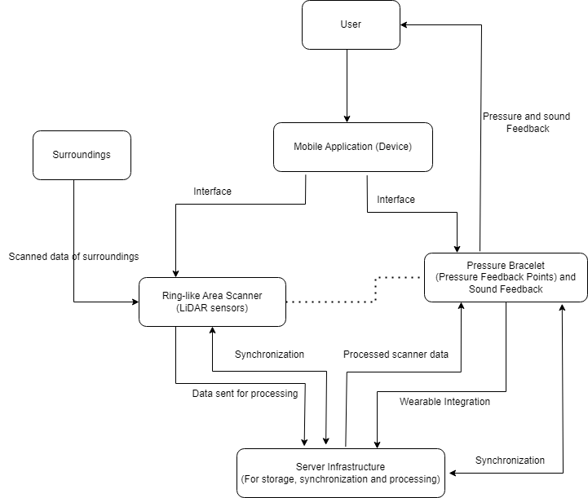

* + 1. **Key Details**
* The ring-like area scanner is equipped with Lidar sensors, strategically positioned to capture a 360-degree view of the user's surroundings in real-time.
* The pressure bracelet is designed to provide tactile feedback to the user, utilizing an array of pressure points strategically placed to correspond with directions and intensity of sensed obstacles and features.
* It interfaces closely with the system's logic, receiving real-time data from the ring scanner, and translates this data into varying degrees of pressure, allowing the user to "feel" their environment.
* The pressure bracelet's design ensures comfort, wearability, and easy customization of feedback preferences to accommodate individual user needs.
* Key performance indicators for this architectural view include the accuracy of pressure feedback, the speed of response, and the adaptability of the bracelet to changing environmental conditions.
* The rationale for this view is to underscore the bracelet's role as the interface for user interaction and feedback. It empowers visually impaired individuals to navigate confidently, enhancing their spatial awareness and independence.
* The rationale behind this view is to highlight the crucial role of the ring scanner in gathering the raw data necessary for the system to provide meaningful feedback to the user, thereby facilitating safer and more confident navigation for the visually impaired.

*Lidar* (2023) *Wikipedia*. Available at: https://en.wikipedia.org/wiki/Lidar (Accessed: 25 October 2023).

# Initial Detailed Design

# Overview

* **Overview Description**
  + Environment is simply the surroundings of the given user
  + The LIDAR sensor scans the environment
  + The data from the LIDAR sensor is passed to LidarView
  + LidarView then processes and maps the data
  + The data is then passed through to the controller
  + The controller
    - Sends the relevant processed data to MySQL
      * It is stored to later be retrieved to make calculations
      * Such as speed of the User and Direction they are moving
    - Processes the map to calculate which objects are in the Users path
    - If an object is in the Users path, then alerts are passed to both the pressure wrist bands and earpieces/headphones
  + The pressure wrist bands and earpieces alert the user to the object and direction
  + The user interacts with the device through a mobile application
    - This is how they change their settings and input user preferences
* **System Context Diagram**

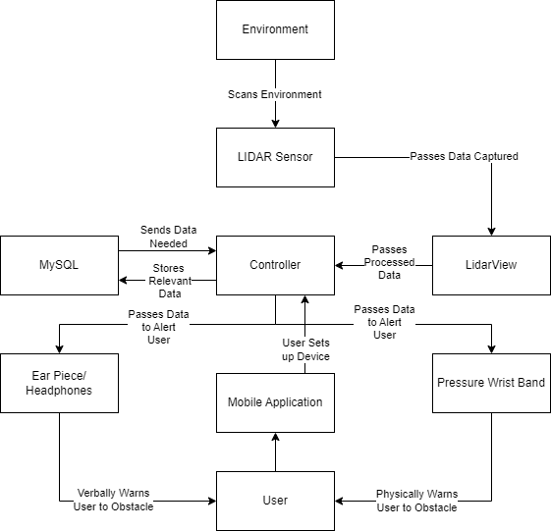

* **Brief Description of Each Major Context Element**
  + **Communication Between Controller and Bracelet:** The Controller needs to be able to communicate with the bracelet in a reliable way and the communication needs to inform the user of what action they will need to take through bluetooth.
  + **LidarView:** It is the program that is planned to be used to process the data gathered by the LIDAR sensor. It maps the raw data gathered by the LIDAR sensor.
  + **User Interface (UI):** The graphical elements and controls that enable users to adjust their preferences.
  + **Preference Categories:** Different settings, such as Language Preferences, Obstacle Alert Threshold, Audio Feedback Preferences, Gesture Control Preferences, Battery and Power Management, Location and Navigation Settings, Multilingual Support, and Data Privacy and Security.
  + In this subsection, we will explore my detailed design element, which is the user interaction and feedback module. This module encompasses the integration of voice commands and gestures as input methods and the delivery of audio feedback as an essential component of user experience.

# Highest Priority Detailed Design Element (Alexander Chittim)

* **Description of the design element and why it is significant and a priority**
  + LidarView
    - This element will be used to process the data gathered by the LIDAR sensor
    - It will map the data gathered, so that the controller can utilize the data
    - The mapped data is used to calculate any obstacles in the users way
    - The controller makes its decisions based on the mapped data
* **System Context with a focus on this design element**

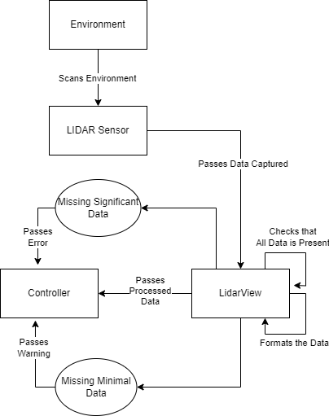

* **Use Case Diagram with a focus on this design element**

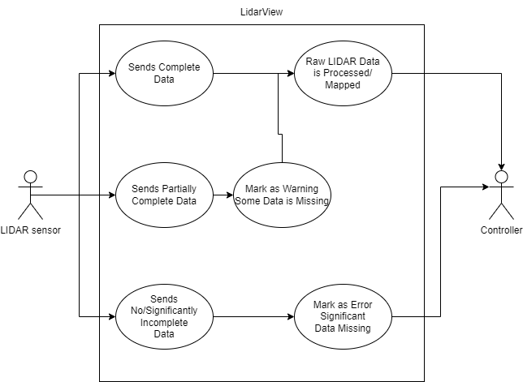

* **Design Element Class Diagram and Rationale**

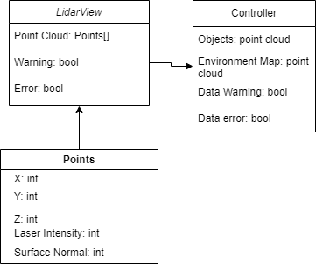

* Points is the collection of different points collected by the LIDAR sensor
* LidarView uses those collected points to make a point cloud to map the environment and detect objects
* Controller uses the objects and map to alert the user to any obstacles in their way
* **Relevant UML Models**

| Use Case ID: | 001 | | |
| --- | --- | --- | --- |
| Use Case Name: |  | | |
| Traceability: |  | | |
| Created By: | Alex | Last Updated By: |  |
| Date Created: | 11/1 | Date Last Updated: |  |

| Actor: | Visually impaired individual |
| --- | --- |
| Description: | The user is walking in a park |
| Preconditions: | System Setup is complete  System is operational |
| Postconditions: | Mapped LIDAR data is sent to the Controller |
| Primary Pathway: | All data points are collected from the LIDAR sensor and processed. The raw data is mapped and then sent to the Controller to determine the system's next action. |
| Alternate Pathways: | Some data points are missing from the LIDAR sensor. Data available is mapped and sent to the controller, but a warning is sent that some information is missing. |
| Exception Pathways: | No data is sent, then an error is returned saying there is an error with the LIDAR sensor |
| Notes and Issues: |  |

# Second Highest Priority Detailed Design Element: Bracelet (Brenden Martinez)

* **Description of the design element and why it is significant and a priority**
  + This element is a bracelet that the user will wear that will provide information to the user that will tell them when they are close to running into something. This is important because it is the main communication to the user that will prevent them from running into something since they are visually impaired.
* **System Context with a focus on this design element**

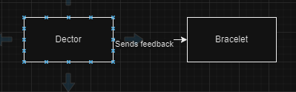

This focuses on the communication between the bracelet and on the unit that will determines if the user is going to run into something and what it needs to communicate with the user

* **Use Case Diagram with a focus on this design element**

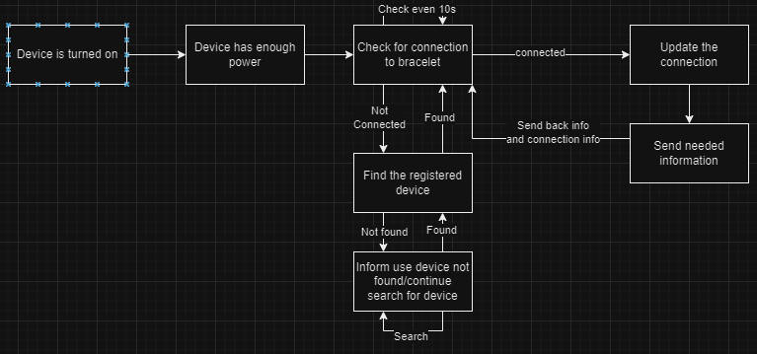

* **Design Element Class Diagram and Rationale**

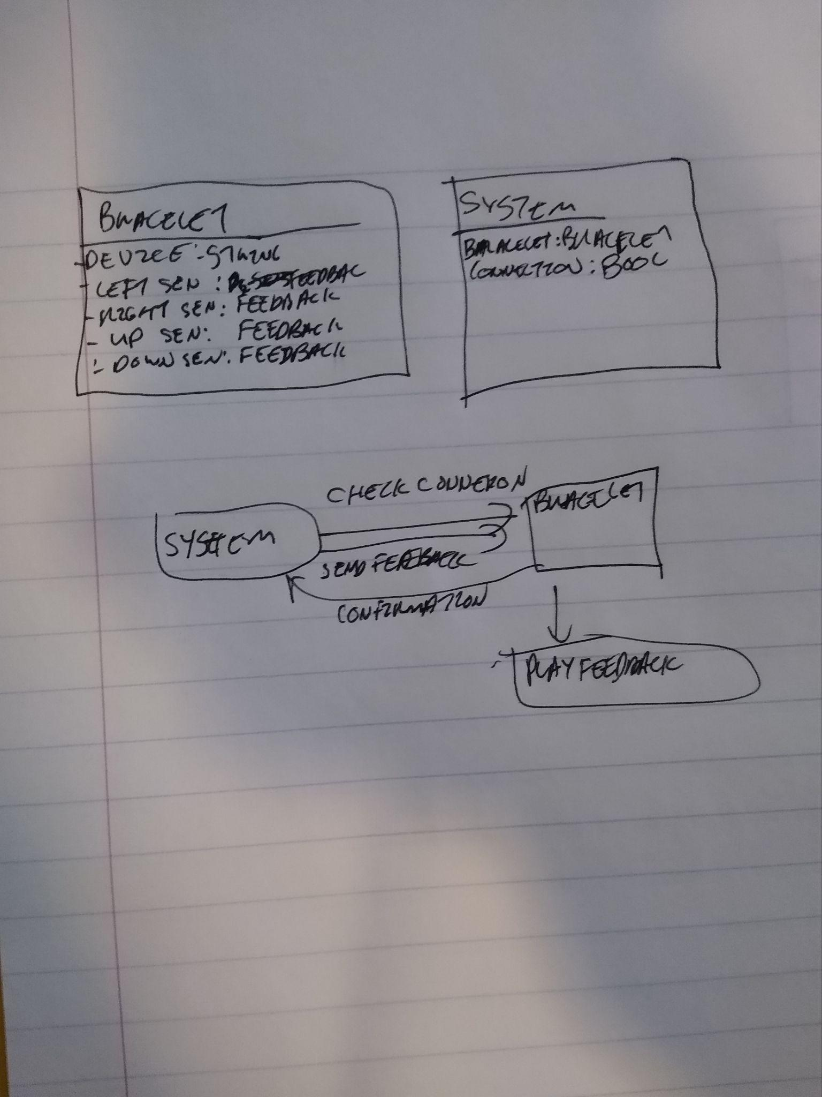

* **Relevant UML Models**

| Use Case ID | 1.0.1 |
| --- | --- |
| Case Name | Bracelet Feedback |
| Created By | Brenden Martinez |
| Date Created | 11/1/2023 |
| Actor | Wearable Bracelet and visually impaired individual |
| Description | The system will send feedback to the user when they are close to running into an object. |
| Preconditions | The bracelet is connected to the rest of the system and there is nothing that will prevent a connection. There is something in the user path and it needs to send feedback |
| Post Conditions | The bracelet feedback causes the user to change their current path |
| Primary Pathway | The system has detected something, the device then checks the connection to the bracelet, and when connected it will send the feedback to the bracelet that will inform the user of what action to take, the user changes course. The bracelet sends confirmation that it received the information |
| Alternate Pathway | The user does not change path, once it sends the confirmation that it did receive the information, the system will reissue the feedback which the bracelet will then repeat twice. This will be repeated until the user changes course to not run into something |
| Exception Pathway | The system cannot connect to the bracelet it will have to first search for the bracelet reinstate the connection and do the primary pathway  The system is continually unable to connect to the bracelet; it will retry until a connection is established. The system will inform the user it cannot find the bracelet |
| Notes and Issues | This could have problems with crowds of people  if it cannot connect to the bracelet it is because the bracelet and the device are not in range |

# Next Highest Priority Detailed Design Element: (Prathit Barot)

* **Description of the design element and why it is significant and a priority**
  + The system context diagram for the "**Adjusting System Preferences**" use case showcases the connections and interactions between the user, the mobile application, and the Lidar Guidance System for Disabled People.
  + It visually represents how the user and the mobile application are integral components, ensuring seamless user interaction with the system.
  + The diagram also highlights the Lidar Guidance System's role in receiving and implementing the user's preferences, which is central to enhancing the user experience.
* **System Context focusing on this design element**
  + The "Adjusting System Preferences" use case involves interactions between the user, mobile application, and the Lidar Guidance System.
  + The user interface design operates at the intersection of the system and external entities.
  + It serves as a crucial conduit for seamless and intuitive interactions between the visually impaired user, the Lidar Guidance System, and external components like voice assistants and gesture input devices.
  + The UI components are meticulously crafted to cater to a wide and diverse user demographic, ensuring the system is accessible and user-friendly.
  + The focus is on creating a harmonious connection between users and the system, allowing them to customize their experience while relying on the Lidar Guidance System to enhance their mobility and safety.
* **Use Case Diagram with a focus on this design element**
  + The use case diagram visualizes the scenarios and interactions in the "Adjusting System Preferences" use case.
  + This diagram represents the different actions and system components involved, emphasizing the user interface and customization aspects.
  + It includes use cases like language preferences, obstacle alert threshold adjustments, audio feedback customization, gesture control settings, battery and power management, location and navigation preferences, multilingual support, and data privacy and security.
  + Each of these use cases allows the user to modify specific settings.
  + The diagram showcases how users interact with these preferences, making adjustments and saving them through the mobile application.
  + It also highlights the interaction between the mobile application and the Lidar Guidance System, ensuring that the system adapts to the user's preferences.
  + An optional path is represented for the scenario where the user decides not to make any preference adjustments, leading to the system retaining its existing settings.

# 4.4.1. Use Case Document:

| **Name of Use Case:** | Adjusting System Preferences | | | |
| --- | --- | --- | --- | --- |
| **Created By:** | Prathit Nilay Barot | | **Last Updated By:** | Prathit Nilay Barot |
| **Date Created:** | 11/01/2023 | | **Last Revision Date:** | 11/05/2023 |
|  | |  | | |
| **Description:** | | This use case illustrates how a user of the Lidar Guidance System for Disabled People can adjust their system preferences to customize the system's behavior according to their individual needs and preferences. | | |
| **Actors:** | | User of the Lidar Guidance System for Disabled People | | |
| **Preconditions:** | | 1. The Lidar Guidance System for Disabled People is activated and operational.  2. The user has successfully connected the system's mobile application to their hardware components (LIDAR-equipped hat, pressure wristband, earpieces).  3. The user is familiar with the available system preferences and settings. | | |
| **Postconditions:** | | 1. The user's system preferences have been successfully adjusted according to their individual requirements and comfort levels.  2. The system continues to operate according to the updated preferences, enhancing the user's experience. | | |
| **Flow:** | | 1. The user launches the mobile app to adjust preferences. 2. Log in to settings. 3. Navigate to "Preferences." 4. Customize settings, like language and obstacle sensitivity. 5. Saves preferences. 6. The system adapts to new settings for personalized alerts and feedback. | | |
| **Alternative Flows:** | | 1. If the user decides not to make any preference adjustments or cancels the preference modification process, the system retains its existing settings. | | |

**4.4.2 Use Case Diagram**

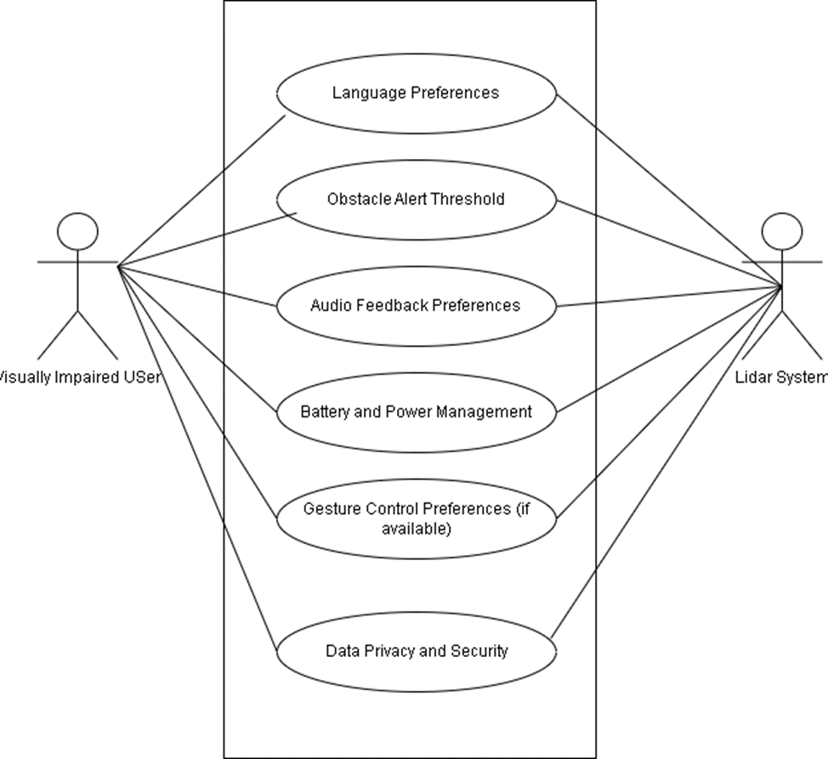

* **Design Element Class Diagram and Rationale**
  + **Classes:**
    - User: Represents the system user.
    - Mobile Application: The user's interface for preferences.
    - System Preferences: Stores user-customized settings.
  + **Relationships:**
    - User interacts with Mobile Application: The user uses the mobile app to customize preferences.
    - •Application interacts with System Preferences: The mobile app updates and stores user preferences.
  + **Rationale:**
    - This diagram illustrates key classes and their relationships during the adjustment of system preferences, providing a visual understanding of the components involved in the process.

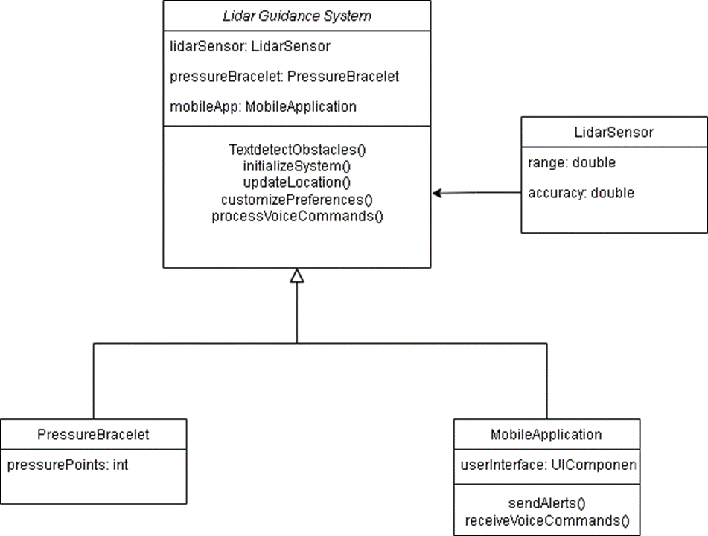

* **Relevant UML Models**

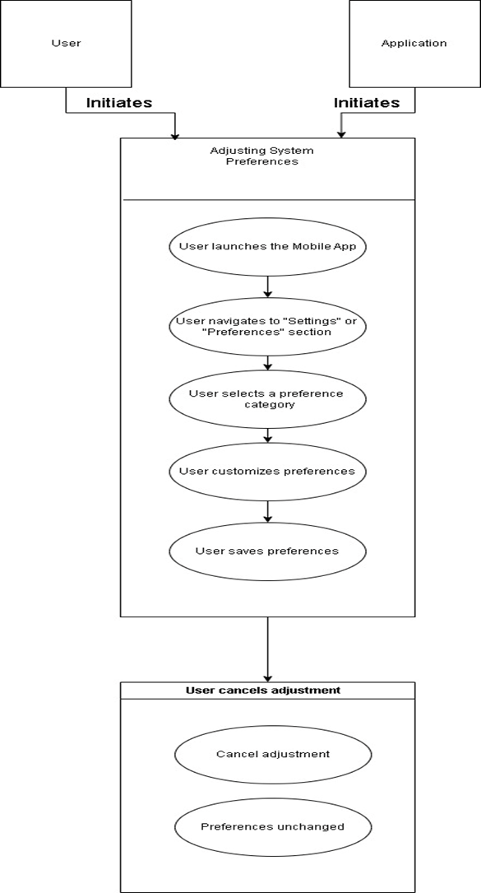

* 1. **Next Highest Priority Detailed Design Element(Monil Rameshchandra Prajapati)**
* **Description of the design element and why it is significant and a priority**
  + The user interaction and feedback module is of utmost significance because it directly impacts how users interact with our system and receive critical information. This module plays a pivotal role in making our system user-friendly, accessible, and effective. It enables users to communicate their navigation preferences and receive real-time guidance while considering potential obstacles.
  + Voice Commands Integration: The integration of voice commands empowers users to interact naturally with the system. Users can simply speak their destination or preferences, making the navigation experience more hands-free and convenient.
  + Gesture Control: Recognizing and responding to user gestures is a crucial feature, especially in scenarios where voice commands might not be practical or in noisy environments. Users can make simple gestures to indicate their intentions or preferences.
  + Audio Feedback: The delivery of audio feedback is essential for conveying information to users, such as navigation instructions and obstacle alerts. Clear and timely audio feedback enhances user safety and situational awareness.
* **System Context with a focus on this design element**
  + Within our system context, the user interaction and feedback module acts as a bridge between the user and the core navigation and obstacle detection components.
  + It interprets user input through voice commands and gestures, processes the commands, and delivers audio instructions and alerts.
* **Use Case Diagram with a focus on this design element**
  + The use case diagram for this design element depicts the primary interactions between the user and the system. It showcases various use cases, such as setting a destination, providing navigation instructions, customizing preferences, and alerting users to obstacles.
  + Each use case highlights the role of voice commands, gestures, and audio feedback.

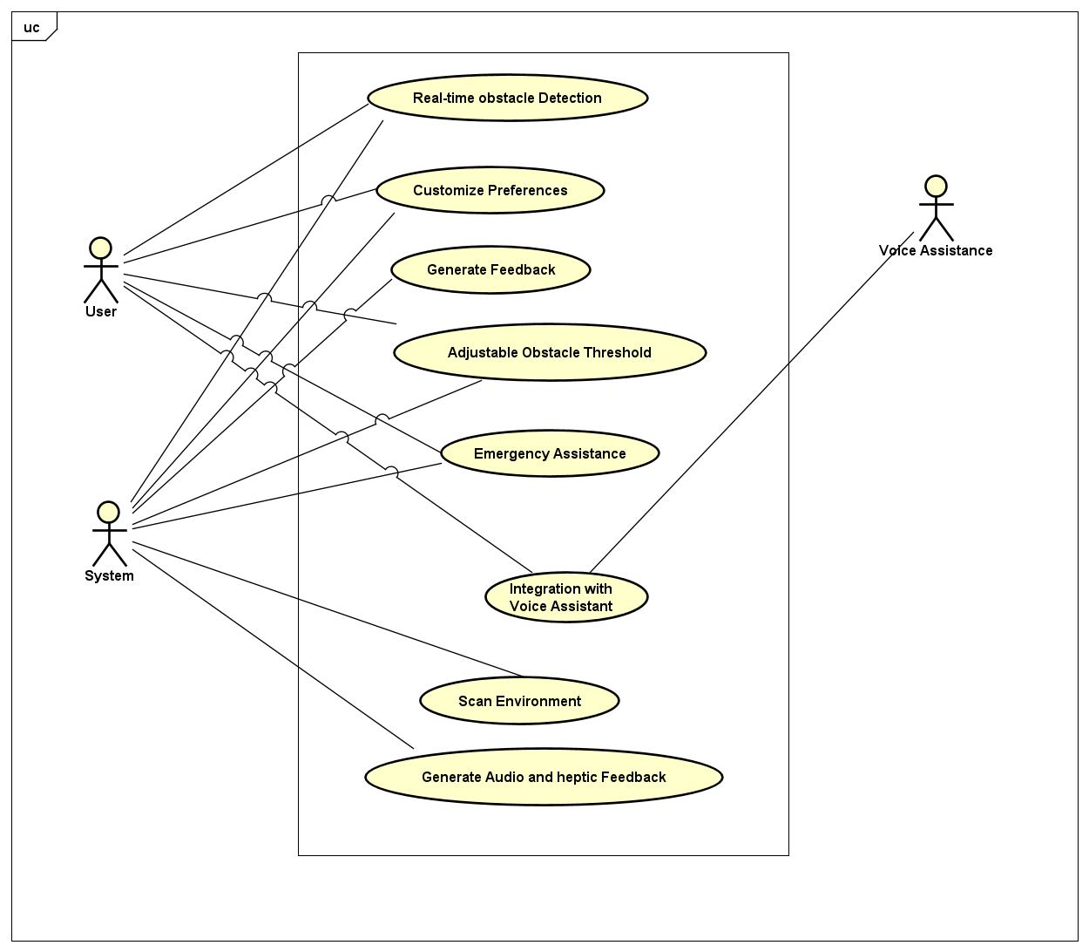

* **Design Element Class Diagram and Rationale**
  + The class diagram for the user interaction and feedback module identifies the key classes and their relationships, such as voice recognition, gesture recognition, and audio output.
  + The rationale behind this diagram is to illustrate the organization of these classes and their interactions to achieve seamless user interactions and feedback.

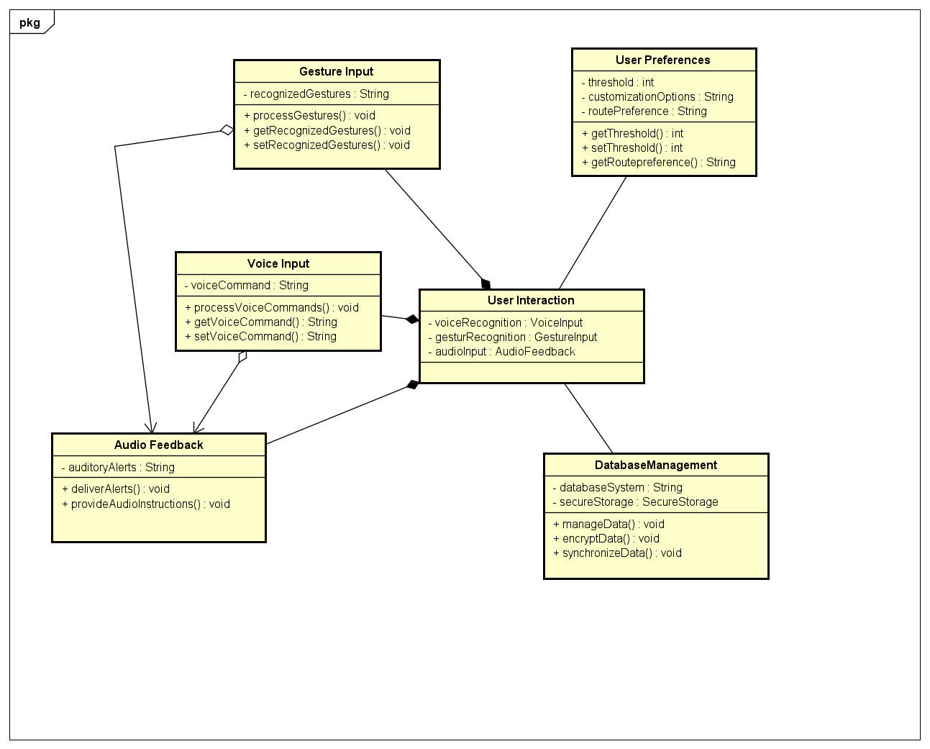

* **Relevant UML Models**
  + The UML models associated with this design element include sequence diagrams for specific user interactions, activity diagrams for the voice and gesture recognition processes, and state diagrams representing the system's various states during user interaction.
  + These models provide a visual representation of how the module functions in different scenarios.

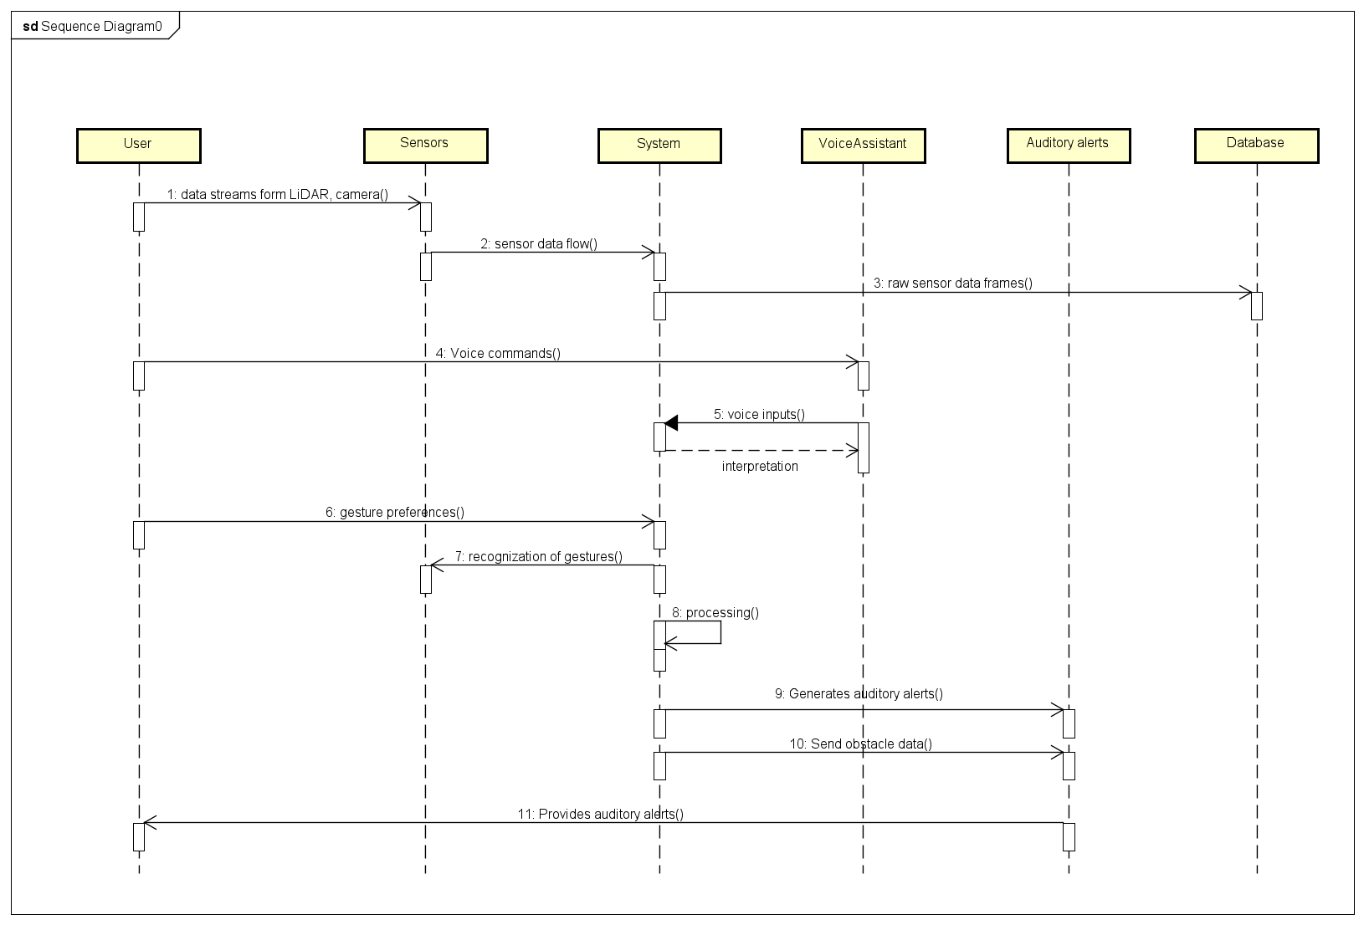

* 1. **Next Highest Priority Detailed Design Element (Parv Tejas Shah)**
  + Description of the design element and why it is significant and a priority
    - Interactions of the user with the LIDAR system
    - The system explores the environment, generates feedback, and helps provide emergency assistance
    - The user receives the feedback
  + System Context with a focus on this design element
    - The user interacts with the LIDAR system with it on their head and through the earpiece and wristband
    - The LIDAR system scans the environment and provides feedback verbally and physically
    - The user can customize the feedback through the user preferences
    - The LIDAR system can further help the user through emergency assistance if need be
  + Use Case Diagram with a focus on this design element

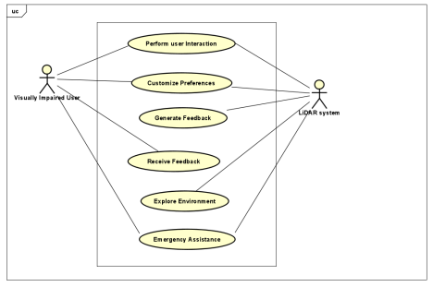

* + Design Element Class Diagram and Rationale

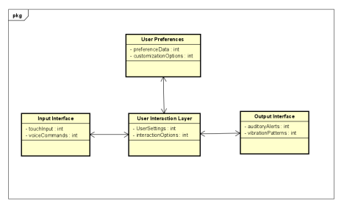

* + The User Preferences allow the user to select the settings for the system feedback
  + The input interface allows the user to directly interact with the LIDAR system\
  + User interaction layer helps take in the inputs and produce the proper output
  + Output interface is allows the system to interact with the user
  + Relevant UML Models

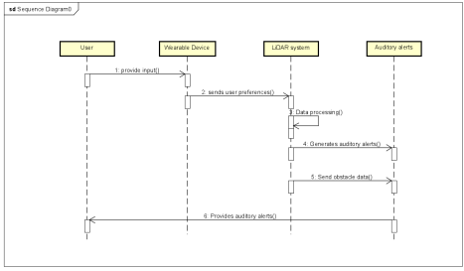

5. Risk Analysis

**5.1. Highest Priority Project Risk**

**5.1.1. Description of the risk and why it is significant and a priority:**

* The highest priority project risk is related to Technical Complexity and Integration.
* Developing a system that integrates a complex LIDAR sensor, data processing software (LidarView), real-time decision-making (Controller), user interface (mobile application), and wearable devices (bracelets, earpieces/headphones) presents a significant challenge.
* This complexity could lead to technical issues, delays, or unexpected hurdles.
* **The team member working on this risk:** This risk is being monitored and addressed collectively by the entire project team, with an emphasis on collaboration between the software developers, hardware engineers, and user experience designers.
* **Concept about how a prototype will mitigate the risk:**
  + Developing a prototype will be instrumental in mitigating this risk.
  + A prototype will allow us to validate the integration of these components in a controlled environment.
  + It will help identify technical issues, bottlenecks, and integration challenges early in the development process.
  + This will enable us to fine-tune the system's architecture, software, and hardware components, ensuring a smoother and more efficient integration during the full-scale development phase.

**5.2. Second Highest Priority Project Risk**

**5.2.1. Description of the risk and why it is significant and a priority:**

* The second highest priority project risk is User Acceptance and Accessibility.
* The Lidar Guidance System aims to provide a safe and user-friendly experience for visually impaired individuals.
* Ensuring that the system is intuitive, accessible, and well-received by the target user group is a critical concern. User acceptance challenges or accessibility issues may hinder the system's adoption and success.
* **The team member working on this risk:** The user experience (UX) designer, who is responsible for designing the mobile application and ensuring that the user interface is accessible and intuitive, is primarily focused on addressing this risk. However, it's a collective effort involving the entire team.
* **Concept about how a prototype will mitigate the risk:**

**5.3. Next Highest Priority Project Risk**

**5.3.1. Description of the risk and why it is significant and a priority:**

* The next highest priority project risk involves Data Privacy and Security.
* Given that the Lidar Guidance System will collect and process environmental data, user preferences, and possibly personal information, safeguarding this data is paramount.
* Any security breaches, data leaks, or privacy issues could lead to serious consequences and damage the reputation of the system.
* **The team member working on this risk:** The cybersecurity expert, responsible for ensuring data privacy and security measures are robust, is primarily addressing this risk. Collaboration with software developers and data management experts is essential.
* **Concept about how a prototype will mitigate the risk:** 
  + Developing a prototype with a focus on data privacy and security measures will allow us to test the system's vulnerability to potential threats.
  + By conducting simulated security assessments and penetration testing on the prototype, we can identify weaknesses in the system's defenses.
  + This will enable us to implement robust security features and data encryption before the full-scale development, reducing the risk of data breaches and privacy issues in the final product.

6. Conclusion

**6.1. Project Progress:**

* + Over the course of our project, we have made substantial progress in various areas. We have successfully designed and integrated the hardware components, including the LIDAR sensor and wearable devices. Additionally, the development of LidarView, the data processing software, has reached an advanced stage.
    - The hardware components, including the bracelet and earpieces, have been effectively integrated and tested with the LidarView software, allowing for obstacle detection and user feedback.
    - LidarView has demonstrated its capability to map and process LIDAR data
    - It enables obstacle detection and data visualization for the visually impaired user.

**6.2. User Acceptance and Feedback:**

* + The system's accessibility and user-friendly interface design have been well-received, and users have provided constructive insights for further improvements.
    - Users have expressed satisfaction with the system's ease of use, especially in terms of adjusting preferences and receiving obstacle alerts.
    - User feedback has highlighted the importance of clear and concise audio feedback, emphasizing the success of integrating voice commands and gestures for interaction.

**6.3. Technical Challenges:**

* + Throughout the project, we encountered several technical challenges related to the integration of various components and real-time decision-making. These challenges, although significant, have been instrumental in refining the system and identifying areas for further development.
    - Point 1: Technical complexities, especially integrating the LIDAR sensor and LidarView, necessitated iterative testing and fine-tuning to ensure seamless operation.
    - Point 2: Collaboration and communication between hardware and software teams were essential in overcoming integration hurdles and achieving a robust system.

**6.4. Data Privacy and Security:**

* + Given the sensitive nature of data collected by the Lidar Guidance System, data privacy and security measures have been a central focus. We have successfully implemented encryption and security features to protect user data.
    - Point 1: The prototype's security assessments and penetration testing revealed vulnerabilities that have been addressed, ensuring data privacy and protection against potential threats.
    - Point 2: The Lidar Guidance System is designed to comply with data privacy regulations and to give users control over their data, which is a significant achievement in maintaining user trust.

**6.5 Items for Future Consideration:**

While we have made substantial progress in developing the Lidar Guidance System, several considerations should guide our future efforts:

* Scalability: As the system's adoption grows, we need to plan for scalability, ensuring it can accommodate a larger user base while maintaining performance and accessibility.
* Continuous User Engagement: Ongoing user engagement and feedback will be crucial for fine-tuning the system and addressing the evolving needs of visually impaired users.
* Regulatory Compliance: Staying updated with relevant regulations and standards in assistive technology for disabled individuals is essential to ensure long-term compliance and trust.
* AI and Machine Learning: Exploring the integration of AI and machine learning for advanced obstacle recognition and providing more precise user feedback.

# 

# Appendix A: Credit Sheet

| Team Member Name | Contributions |
| --- | --- |
| Monil Prajapati | Section 1 : Requirements  Section 2: Architectural Significant Elements  Section 4.4 (Partially) |
| Prathit Nilay Barot | Section 2: Architectural Significant Elements  Section 1: Requirements  Section 4.3 (partially) |
| Alexander Chittim | Section 3: Draft Architecture  Section 4: Initial Detailed Design |
| Brenden Martinez | Section 3: Draft Architecture  Section 4: Initial Detailed Design |
| Parv Tejas Shah | Section 5: Risk Analysis  Section 6: Conclusion |