CSE 564 Project Report Number 5

Team 21

Team Member Names:

1. Monil Prajapati

2. Parv Shah

3. Prathit Barot

4. Brenden Martinez

5. Alexander Chittim

**1. Problem 1**

**1.1. Problem Overview 1**

**1.2. Previous Solutions and Why They Are Unsatisfactory 2**

**1.2.1. Traditional Mobility Aids 2**

**● Example: White canes and guide dogs. 2**

**● Limitations: These aids lack the ability to provide detailed, real-time information about the immediate environment, especially in crowded or changing urban settings. 2**

**1.2.2. Assistive Technologies 2**

**● Example: Existing GPS-based navigation devices. 2**

**● Limitations: While these devices offer some assistance, they often fall short in providing comprehensive environmental awareness, particularly in scenarios where precise obstacle detection is crucial. 2**

**1.2.3. Limited Feedback Mechanisms 2**

**● Example: Devices with basic obstacle detection. 2**

**● Limitations: Current solutions may detect obstacles but provide limited proactive alerts, leaving users unaware of potential hazards in their path. 2**

**1.2.4. Incomplete Integration 2**

**● Example: Systems with disconnected hardware and software components. 2**

**● Limitations: Lack of seamless communication between the LIDAR sensor, data processing software (LidarView), and user interface components (mobile application and wearables). This fragmentation hinders the effectiveness of the overall system. 2**

**1.2.5. User Interface Challenges 2**

**● Example: Interface designs not optimized for voice and gesture interactions. 2**

**● Limitations: Current interfaces may not be intuitive for visually impaired users, hampering their ability to interact seamlessly with the assistive system. 2**

**2. Requirements 1**

**3. Architecture 3**

**3.1. Overview 3**

**3.3.1. Architecture View 1- Logical 6**

**3.3.1.1. Introduction and Rationale 6**

**3.3.1.2. Architectural Model 8**

**3.3.1.3. Logical Architectural View Key Points 10**

**● Core Logic Module: The logical architectural view highlights the core logic module as the central component orchestrating the system's functionality and decision-making processes. 10**

**● User Interface Module: The architecture emphasizes the user interface module, designed to provide accessible and intuitive interaction for individuals with disabilities, ensuring a user-centric design approach. 10**

**● Data Processing Module: The logical view underscores the data processing module, responsible for real-time analysis and interpretation of LIDAR data to provide meaningful insights to the user, enhancing their situational awareness. 10**

**● Voice Input Recognition Module: The architecture includes a voice input recognition module, enabling users to interact with the system using voice commands, enhancing the system's accessibility and usability. 10**

**● Real-Time Obstacle Detection Strategy: The logical view delineates a real-time obstacle detection strategy, ensuring timely and accurate identification of obstacles to enhance user safety and navigation. 10**

**● LIDAR Data Processing Module: The architecture incorporates a dedicated module for LIDAR data processing, facilitating the comprehensive capture and analysis of environmental data to support user navigation. 10**

**● Mapping and Routing Module: The logical view highlights the mapping and routing module, enabling the system to provide users with optimized routes and navigation assistance based on LIDAR data and user preferences. 10**

**● Feedback Generation Module: The architecture includes a feedback generation module, responsible for relaying LIDAR data to the user in a comprehensible format, fostering informed decision-making, and enhancing the user's understanding of their environment 10**

**3.3.2. Architecture View 2 - Physical 10**

**3.3.2.1. Introduction and Rationale 10**

**3.3.2.2. Architectural Model 12**

**3.3.2.3. Key Details 13**

**3.3.3. Architecture View 3 - Development 13**

**3.3.3.1. Introduction and Rationale 13**

**3.3.3.2 Architectural Model 15**

**3.3.3.3 Key Details 15**

**4. Detailed Design 18**

**4.1. Overview 18**

**4.2. System Context Diagram 19**

**4.3. Major Design Element 1: LidarView 21**

**4.3.1. High-Level Overview 21**

**4.3.2. Design Element User Case Diagram 23**

**4.3.2.1. Use Case 1 23**

**4.3.3. Design Element Class Diagram 23**

**4.3.3.1. Class Diagram 23**

**4.3.4. Other Relevant UML Diagrams 25**

**4.4. Major Design Element 2: User Interaction and Feedback Module 26**

**4.4.1. High-Level Overview 26**

**4.4.2. Design Element User Case Diagram 27**

**4.4.2.1.1. Use Case 1 28**

**4.4.3. Design Element Class Diagram 28**

**4.4.3.2. Sequence Diagram 1 30**

**4.5. Major Design Element 3: Adjusting System Preferences 31**

**4.5.1. High-Level Overview 31**

**4.5.2. Design Element User Case Diagram 34**

**4.5.2.1.1. Use Case 1 34**

**4.5.3. Design Element Class Diagram 35**

**4.5.3.2. Sequence Diagram 1 36**

**5. Risks Addressed 38**

**5.1. Overview 38**

**5.2. Technical Complexity and Integration 38**

**5.3. Size/Weight 38**

**6. Prototype 40**

**6.4. Major Function 2 - Bracelet 43**

**7. Conclusion 48**

**7.1. New or Updated Key Conclusion 1: Prototype 48**

**7.2. Problem 49**

**7.3. Consider adding a final item “Items for future consideration”. 49**

**Appendix A: Credit Sheet 50**

**Table of Contents 1**

# Problem

# Problem Overview

Lack of Accessibility for Visually Impaired Individuals in Urban Environments

Visually impaired individuals encounter significant challenges while navigating urban environments independently. Traditional mobility aids, such as canes and guide dogs, have limitations in providing real-time information about the surrounding environment. Urban landscapes pose dynamic obstacles, making it difficult for individuals with visual impairments to navigate safely.

# Previous Solutions and Why They Are Unsatisfactory

# Traditional Mobility Aids

# Example: White canes and guide dogs.

# Limitations: These aids lack the ability to provide detailed, real-time information about the immediate environment, especially in crowded or changing urban settings.

# Assistive Technologies

# Example: Existing GPS-based navigation devices.

# Limitations: While these devices offer some assistance, they often fall short in providing comprehensive environmental awareness, particularly in scenarios where precise obstacle detection is crucial.

# Limited Feedback Mechanisms

# Example: Devices with basic obstacle detection.

# Limitations: Current solutions may detect obstacles but provide limited proactive alerts, leaving users unaware of potential hazards in their path.

# Incomplete Integration

# Example: Systems with disconnected hardware and software components.

# Limitations: Lack of seamless communication between the LIDAR sensor, data processing software (LidarView), and user interface components (mobile application and wearables). This fragmentation hinders the effectiveness of the overall system.

# User Interface Challenges

# Example: Interface designs not optimized for voice and gesture interactions.

# Limitations: Current interfaces may not be intuitive for visually impaired users, hampering their ability to interact seamlessly with the assistive system.

**1.3 Organizations Affected**

The issues of accessibility faced by visually impaired individuals in urban environments impact various organizations, including but not limited to

1. Urban Planning Departments
2. Transportation Services
3. Accessibility Advocacy Groups

**1.3.1 Previous and Current Attempts by Organizations**

These organizations have made efforts to address the challenges faced by visually impaired individuals:

* Urban Planning Departments: Implementation of tactile pavement indicators and audible signals at crosswalks.
* Transportation Services: Providing traditional mobility aids and basic GPS navigation devices.
* Accessibility Advocacy Groups: Conducting awareness campaigns and advocating for inclusive urban design.

**1.3.2 Why Previous Attempts Are Unsatisfactory**

While these attempts show a recognition of the problem, they fall short due to:

1. Lack of real-time, detailed environmental information.
2. Insufficient proactive alerts and feedback mechanisms.
3. Fragmented integration of hardware and software components.
4. Limited consideration of the specific needs of visually impaired individuals in dynamic urban settings.

# Requirements

**2.1. Requirement 1**

**2.1.1. Formal statement of the requirement**

The system shall provide real-time, detailed information about the immediate environment to visually impaired users in urban settings.

**2.1.2. Requirement Source**

Adapted from the World Health Organization’s World Report on Vision [[World Vision report](https://www.who.int/docs/default-source/documents/publications/world-vision-report-accessible.pdf), Page 55]

**2.2. Function Requirement 2**

**2.2.1. Feature**

User Navigation Assistance

**2.2.2. Formal statement of the requirement**

The system shall offer navigation assistance to visually impaired users, including turn-by-turn directions, obstacle detection, and route optimization.

**2.2.3. Requirement Source**

In accordance with the International Electrotechnical Commission (IEC) Standard on Assistive Technologies [[Guide for addressing accessibility in standards](https://www.iec.ch/webstore/freepubs/isoiecguide71%7Bed2.0%7Den.pdf), Section 7]

**2.3. Requirement 3**

**2.3.1. Feature**

Voice Recognition

**2.3.2. Formal statement of the requirement**

The system shall incorporate voice recognition technology to enable users to interact with the interface using spoken commands.

**2.3.3. Requirement Source**

Based on Why we need to get more people with disabilities involved in developing technology [[World Economic Forum Report](https://www.weforum.org/agenda/2021/06/people-with-disabilities-developing-technology/)]

**2.4. Function Requirement 4**

**2.4.1. Feature**

Proactive Hazard Alerts

**2.4.2. Formal statement of the requirement**

The system shall provide proactive alerts to users about potential hazards or obstacles in their path, allowing sufficient time for preventive action.

**2.4.3. Requirement Source**

Derived from the U.S. Access Board's guidelines for Electronic and Information Technology Accessibility Standards [[508 Standards and 255 Guidelines](https://www.access-board.gov/ict/#508-chapter-1-application-and-administration), Section 508]

**2.5. Requirement 5**

**2.5.1. Feature**

Seamless Integration

**2.5.2. Formal statement of the requirement**

The system components, including LIDAR sensor, data processing software (LidarView), and user interface, shall be seamlessly integrated to ensure efficient communication and functionality.

**2.5.3. Requirement Source**

Adopted from the IEEE Standard for Accessible and Usable Design of Software Interfaces [[IEEE/ISO/IEC 26514:2022 - Systems and software engineering Design](https://www.iso.org/obp/ui/#!iso:std:77451:en), Clause 7]

# Architecture

# Overview

The interaction model for the LIDAR system designed for individuals with disabilities is meticulously crafted to offer a seamless and empowering user experience. This model integrates hardware and software components, illustrating the flow of information and interactions between users and technology.

Users engage with the LIDAR system through an accessible and user-friendly interface, ensuring effective utilization by individuals with disabilities. The hardware components, such as the LIDAR sensor and associated devices, collaborate with software to capture, process, and present environmental data in a user-understandable format.

Real-time feedback and response mechanisms are emphasized in the interaction model, enabling users to interpret LIDAR data and make informed decisions. This seamless communication fosters an inclusive experience, ultimately enhancing the independence and mobility of individuals with disabilities.

**3.2. Interaction Model**

**3.2.1.1. Interaction Model Overview**

* The interaction model for the LIDAR system designed for individuals with disabilities encompasses the seamless integration of various components to facilitate an intuitive and efficient user experience.
* The system diagram illustrates the interconnectedness of the hardware and software elements, highlighting the flow of information and the interactions between the user and the technology.
* The user interacts with the LIDAR system through a user interface that is designed to be accessible and user-friendly, ensuring that individuals with disabilities can effectively utilize the system.
* The hardware components, including the LIDAR sensor and associated devices, work in tandem with the software to capture, process, and present the environmental data in an understandable format for the user.
* The interaction model emphasizes real-time feedback and response mechanisms, enabling users to interpret the LIDAR data and make informed decisions.
* The seamless communication between the user and the system fosters an inclusive and empowering experience, ultimately enhancing the independence and mobility of individuals with disabilities.
* Overall, the interaction model underscores the holistic approach to user-system interaction, prioritizing accessibility, usability, and the seamless integration of hardware and software components to create a LIDAR system tailored to the unique needs of individuals with disabilities.

**3.2.2. Diagram**

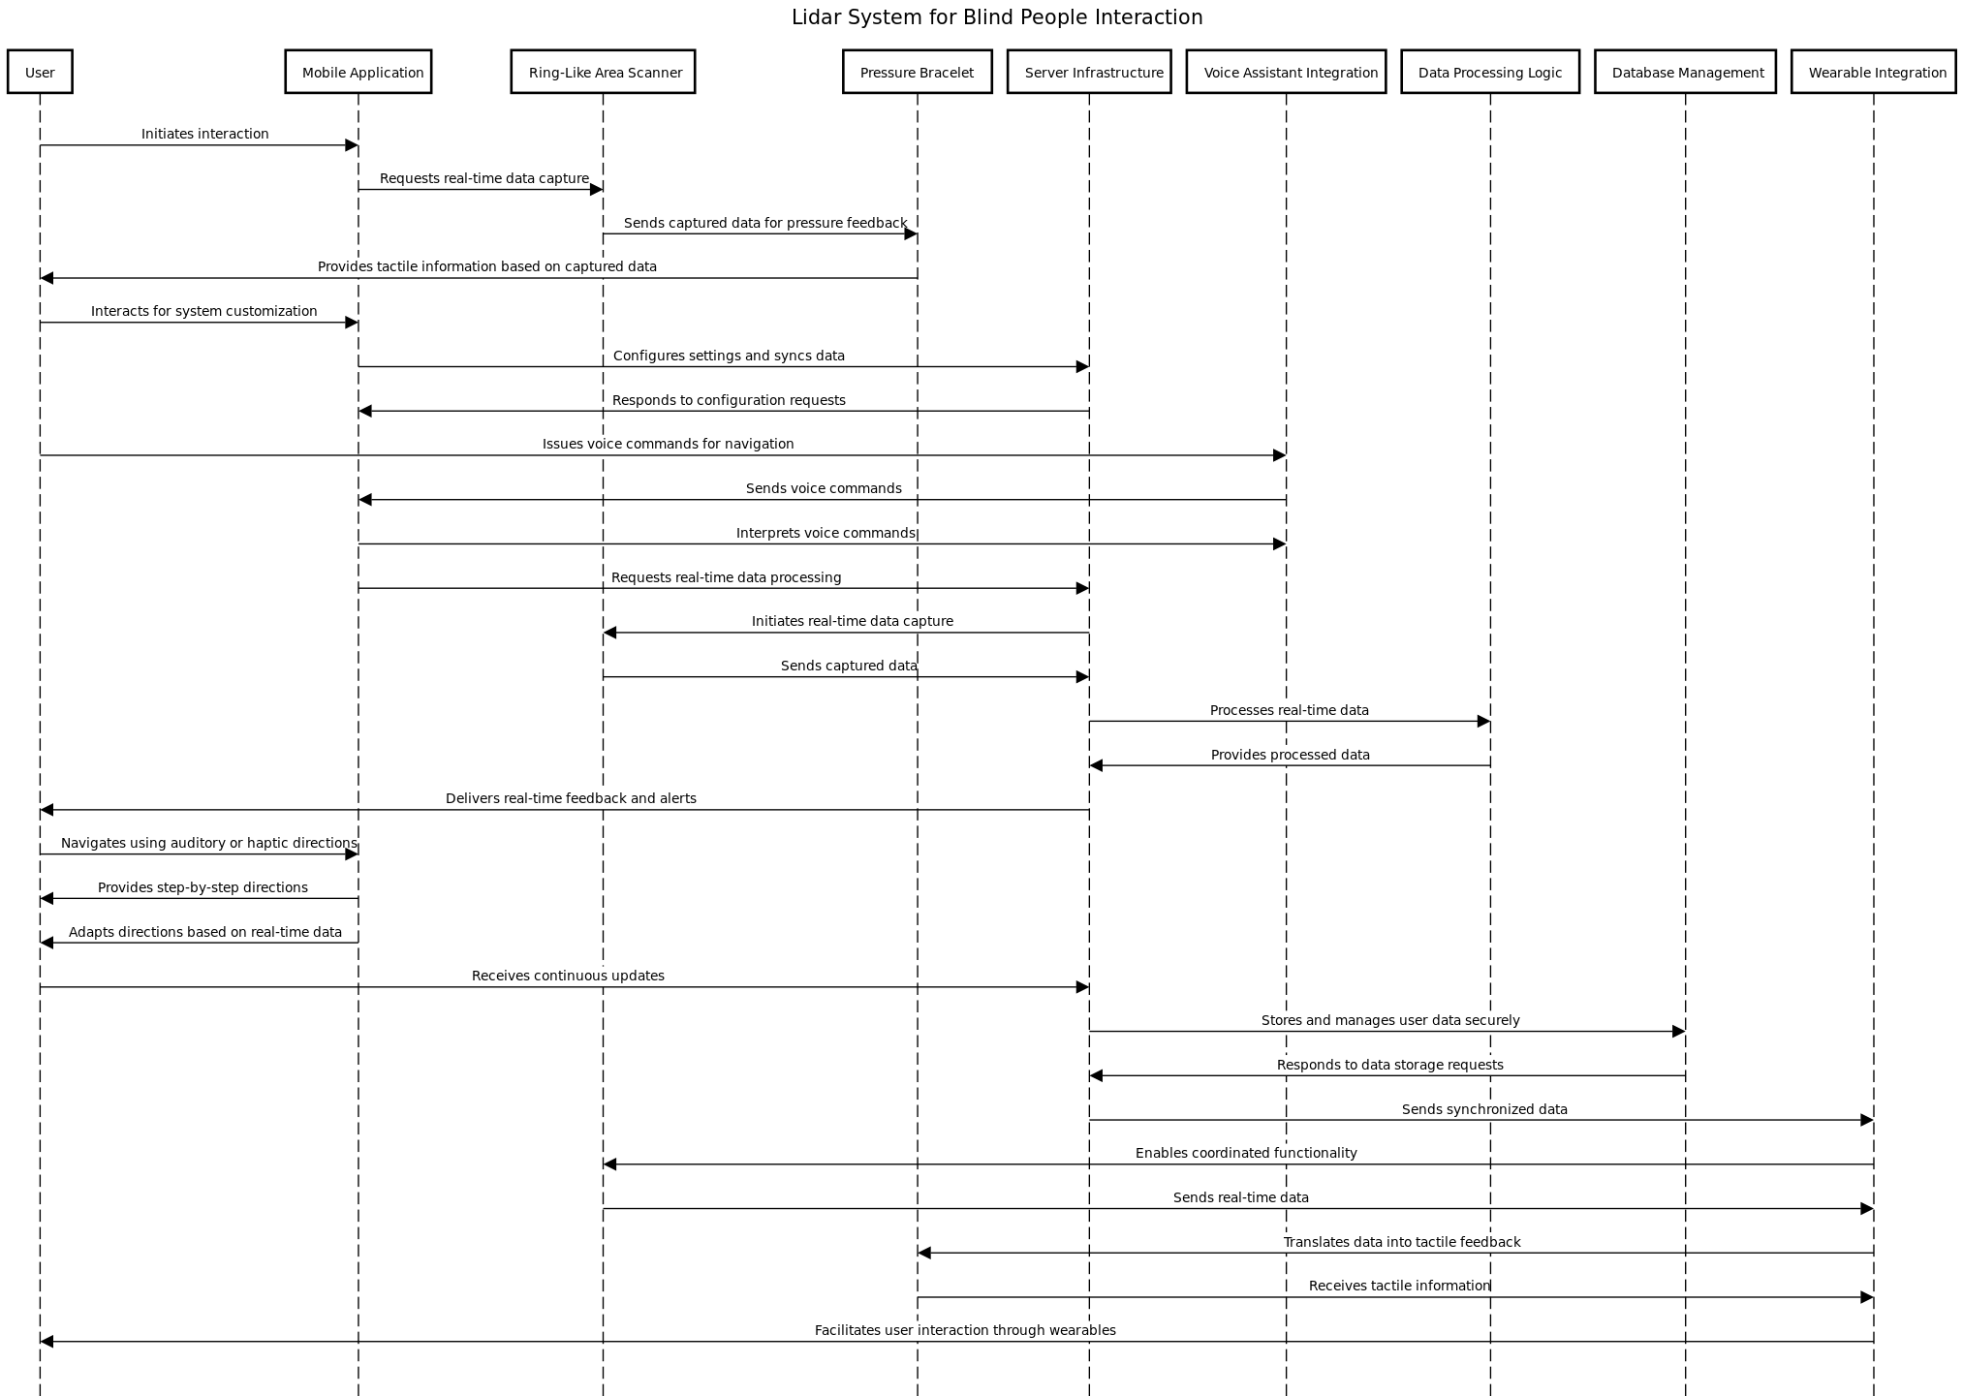

**3.2.3. Interaction Diagram Keypoints**

* The user initiates interaction via mobile application**.**
* Mobile App requests real-time data capture from a Ring-Like Area Scanner.
* A ring-Like Area Scanner sends data to the Pressure Bracelet for tactile feedback.
* The user customizes the system through the Mobile Application.
* The Mobile App communicates with the Server Infrastructure for configuration and data sync.
* The user issues voice commands for navigation via Voice Assistant Integration.
* Mobile App interprets voice commands and processes real-time data.
* Server Infrastructure provides continuous updates to the user.
* Mobile App delivers adaptive step-by-step directions based on real-time data.
* Server Infrastructure securely stores and manages user data using Database Management.
* Synchronized data exchange among Server Infrastructure, Ring-Like Area Scanner, and Wearable Integration.
* Wearable Integration translates data into tactile feedback on the Pressure Bracelet.
* Wearable Integration facilitates user interaction through wearables.

**3.3. Overview Architectural Views**

# 3.3.1. Architecture View 1- Logical

# 3.3.1.1. Introduction and Rationale

* The logical architectural view and interaction diagram for the LIDAR system designed for individuals with disabilities represent a pivotal step towards addressing the unique mobility challenges this user group faces.
* By leveraging advanced technology and innovative design principles, the LIDAR system aims to enhance the independence and safety of individuals with disabilities, particularly those visually impaired.
* The rationale behind developing this system stems from the pressing need to create inclusive solutions that empower individuals with disabilities to navigate their surroundings with confidence and autonomy.
* Traditional mobility aids often fall short of providing comprehensive environmental awareness, especially in dynamic or unfamiliar settings.
* As such, the LIDAR system serves as a progressive and adaptive solution that transcends the limitations of conventional assistive devices.
* Furthermore, the introduction of a logical architectural view and an interaction diagram underscores the systematic and meticulous approach taken in the development of the LIDAR system.
* By delineating the structural and functional aspects of the system, this documentation serves as a foundation for understanding the intricate interplay between hardware, software, and user interaction, ultimately contributing to the system's effectiveness and user acceptance.
* In essence, the logical architectural view and interaction diagram not only symbolize the technical prowess of the LIDAR system but also embody a commitment to inclusivity, accessibility, and user-centric design.
* Through this assignment, we aim to delve deeper into the intricacies of the system, elucidating its significance in revolutionizing the mobility experience for individuals with disabilities.

# 

# 

# 

# 

# 

# 

# 

# 

# 

# 3.3.1.2. Architectural Model

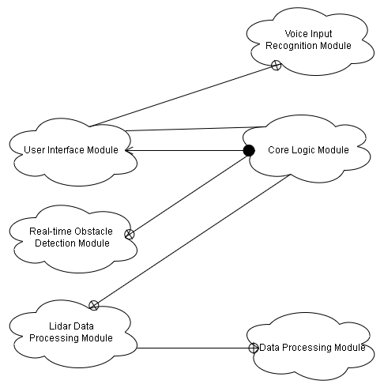

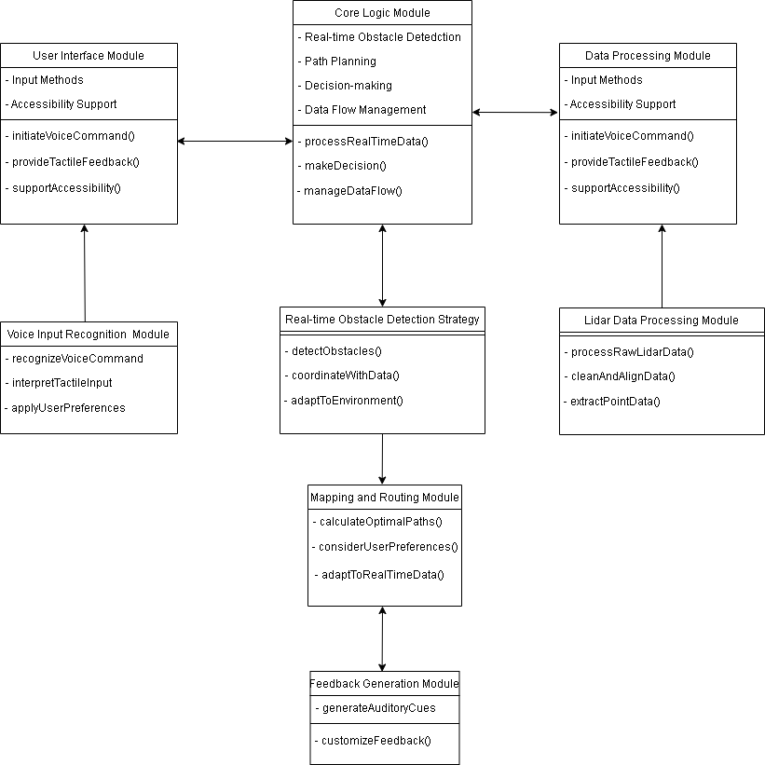

# 

# 

# 3.3.1.3. Logical Architectural View Key Points

# Core Logic Module: The logical architectural view highlights the core logic module as the central component orchestrating the system's functionality and decision-making processes.

# User Interface Module: The architecture emphasizes the user interface module, designed to provide accessible and intuitive interaction for individuals with disabilities, ensuring a user-centric design approach.

# Data Processing Module: The logical view underscores the data processing module, responsible for real-time analysis and interpretation of LIDAR data to provide meaningful insights to the user, enhancing their situational awareness.

# Voice Input Recognition Module: The architecture includes a voice input recognition module, enabling users to interact with the system using voice commands, enhancing the system's accessibility and usability.

# Real-Time Obstacle Detection Strategy: The logical view delineates a real-time obstacle detection strategy, ensuring timely and accurate identification of obstacles to enhance user safety and navigation.

# LIDAR Data Processing Module: The architecture incorporates a dedicated module for LIDAR data processing, facilitating the comprehensive capture and analysis of environmental data to support user navigation.

# Mapping and Routing Module: The logical view highlights the mapping and routing module, enabling the system to provide users with optimized routes and navigation assistance based on LIDAR data and user preferences.

# Feedback Generation Module: The architecture includes a feedback generation module, responsible for relaying LIDAR data to the user in a comprehensible format, fostering informed decision-making, and enhancing the user's understanding of their environment

# 3.3.2. Architecture View 2 - Physical

# 3.3.2.1. Introduction and Rationale

* The physical architectural view of the LIDAR system designed for individuals with disabilities represents a significant advancement in addressing the unique mobility challenges faced by this user group.
* Leveraging advanced technology and innovative design principles, the physical architectural view aims to enhance the independence and safety of individuals with disabilities, particularly those visually impaired.
* The rationale behind developing this physical architectural view stems from the pressing need to create inclusive solutions that empower individuals with disabilities to navigate their surroundings with confidence and autonomy.
* Traditional mobility aids often fall short in providing comprehensive environmental awareness, especially in dynamic or unfamiliar settings.
* As such, the physical architectural view serves as a progressive and adaptive solution that transcends the limitations of conventional assistive devices.
* Furthermore, the introduction of the physical architectural view underscores the systematic and meticulous approach taken in the development of the LIDAR system.
* Delineating the structural and functional aspects of the system, this documentation serves as a foundation for understanding the intricate interplay between hardware, software, and user interaction, ultimately contributing to the system's effectiveness and user acceptance.
* In essence, the physical architectural view not only symbolizes the technical prowess of the LIDAR system but also embodies a commitment to inclusivity, accessibility, and user-centric design.
* We aim to delve deeper into the intricacies of the physical architectural view, elucidating its significance in revolutionizing the mobility experience for individuals with disabilities.

# 

# 

# 

# 

# 

# 

# 

# 3.3.2.2. Architectural Model

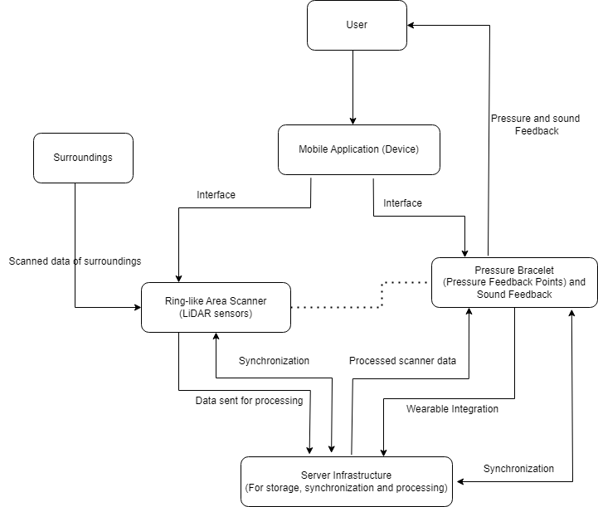

# 

# 

# 

# 3.3.2.3. Key Details

* The user is a central element of the physical architectural view, representing the individual with disabilities who interacts with the LIDAR system to navigate their surroundings.
* The inclusion of a mobile application device signifies the integration of modern technology, allowing users to access and interact with the LIDAR system through a portable and familiar interface.
* The surroundings form an integral part of the physical architectural view, encompassing the dynamic environment in which the LIDAR system operates to provide real-time environmental data and navigation assistance.
* The ring-like area scanner, equipped with LIDAR sensors, serves as a pivotal component for comprehensive environmental data capture, enabling the system to detect obstacles and provide spatial awareness to the user.
* The pressure bracelet, featuring pressure feedback points and surround feedback, enhances the user experience by providing tactile feedback based on LIDAR data, contributing to improved situational awareness and safety.
* The server infrastructure plays a crucial role in data storage, synchronization, and processing, ensuring seamless integration of LIDAR data and facilitating real-time analysis to support user navigation and decision-making.

# 3.3.3. Architecture View 3 - Development

# 3.3.3.1. Introduction and Rationale

* The development architectural view of the LIDAR system designed for individuals with disabilities represents a pivotal step towards addressing the unique mobility challenges this user group faces.
* Leveraging advanced technology and innovative design principles, the development architectural view aims to enhance the independence and safety of individuals with disabilities, particularly those visually impaired.
* The rationale behind developing this system stems from the pressing need to create inclusive solutions that empower individuals with disabilities to navigate their surroundings with confidence and autonomy.
* Traditional mobility aids often fall short in providing comprehensive environmental awareness, especially in dynamic or unfamiliar settings.
* As such, the development architectural view serves as a progressive and adaptive solution that transcends the limitations of conventional assistive devices.
* Furthermore, the introduction of the development architectural view underscores the systematic and meticulous approach taken in the development of the LIDAR system.
* By delineating the structural and functional aspects of the system, this documentation serves as a foundation for understanding the intricate interplay between hardware, software, and user interaction, ultimately contributing to the system's effectiveness and user acceptance.
* In essence, the development architectural view not only symbolizes the technical prowess of the LIDAR system but also embodies a commitment to inclusivity, accessibility, and user-centric design. Through this assignment, we aim to delve deeper into the intricacies of the system, elucidating its significance in revolutionizing the mobility experience for individuals with disabilities.

# 

# 

# 

# 

# 

# 

# 

# 

# 

# 

# 

# 3.3.3.2 Architectural Model

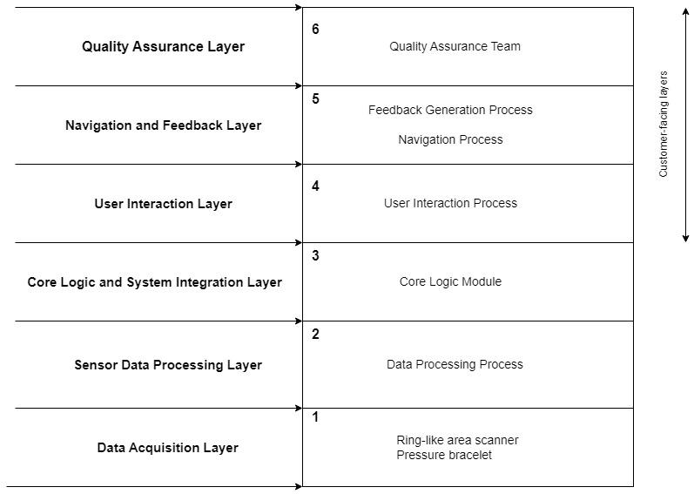

# 3.3.3.3 Key Details

* Quality Assurance Layer:
  + Components:
    - Automated testing frameworks.
    - Manual testing processes.
    - Continuous integration and deployment tools.
    - Performance testing tools.
    - Code review and analysis tools.
  + Functions:
    - Ensuring software quality and reliability.
    - Verifying compliance with coding standards.
    - Detecting and fixing bugs and vulnerabilities.
    - Monitoring and improving system performance.
* Navigation and Feedback Layer:
  + Components:
    - User interface elements (menus, buttons, etc.).
    - Navigation algorithms.
    - Feedback mechanisms (alerts, notifications, etc.).
    - User preferences and settings.
  + Functions:
    - Providing intuitive navigation paths.
    - Collecting and presenting user feedback.
    - Handling user input and interactions.
    - Customizing user experiences based on preferences.
* User Interaction Layer:
  + Components:
    - User interface components (UI).
    - User input processing.
    - User authentication and authorization.
    - User profile management.
  + Functions:
    - Facilitating user interactions with the system.
    - Managing user authentication and access control.
    - Personalizing user experiences.
    - Handling user input and requests.
* Core Logic and System Integration Layer:
  + Components:
    - Business logic components.
    - Integration interfaces and APIs.
    - Workflow management.
    - Database access and management.
  + Functions:
    - Implementing core business processes.
    - Integrating with external systems and services.
    - Managing data storage and retrieval.
    - Orchestrating system workflows.
* Sensor Data Processing Layer:
  + Components:
    - Sensor data acquisition interfaces.
    - Data preprocessing and filtering.
    - Real-time data processing algorithms.
    - Data analytics and visualization tools.
  + Functions:
    - Collecting and processing data from sensors.
    - Analyzing and extracting insights from sensor data.
    - Real-time monitoring and reporting.
    - Visualizing sensor data for users.
* Data Acquisition Layer:
  + Components:
    - Sensors and data sources.
    - Communication protocols.
    - Data acquisition devices.
    - Data storage solutions.
  + Functions:
    - Capturing data from various sources.
    - Ensuring data accuracy and reliability.
    - Managing data storage and retrieval.
    - Handling communication between devices and systems.

# Detailed Design

# Overview

* This section provides an in-depth analysis of LidarView's design components, meticulously examining its hardware, software, and essential modules like the User Interaction and Feedback Module.
* Employing visual aids such as UML diagrams, it visually narrates the system's structure, accentuating the critical role played by the LidarSensor in capturing and processing real-time data.
* It places significant emphasis on cultivating a seamless and inclusive user experience, specifically catering to individuals with disabilities.
* This focus ensures their seamless integration into the broader system design, fostering intuitive interaction and effective feedback mechanisms for enhanced user engagement.
* This section underscores the intricate integration of the User Interaction and Feedback Module within the LidarView architecture.
* It emphasizes its pivotal role in facilitating user engagement through accessible design and adaptive functionalities.
* By seamlessly blending into the system's framework, this module ensures real-time responsiveness and personalized interaction, aligning with the system's overarching goal of inclusive and intuitive engagement for all users, especially those with diverse accessibility needs.

# System Context Diagram

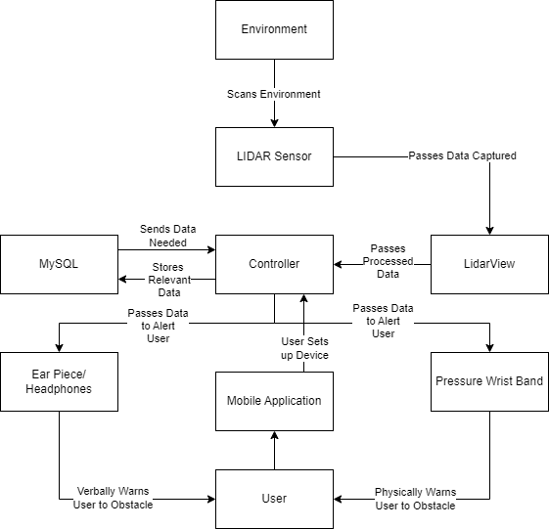

* **Environment:**
  + The physical surroundings where the LIDAR system operates. This includes both indoor and outdoor spaces where the user may navigate.
* **LIDAR Sensor:**
  + The primary hardware component responsible for emitting laser beams and capturing the reflected signals. It scans the environment to gather data about obstacles and surroundings.
* **LIDAR View:**
  + The visual representation generated by the LIDAR sensor, showcasing a real-time view of the user's surroundings. This visual data is crucial for user navigation and obstacle detection.
* **Controller:**
  + The central processing unit that orchestrates the functionalities of the LIDAR system. It manages the communication between various components, processes LIDAR data, and executes the core logic of the system.
* **MySQL:**
  + The database management system used for storing and managing user data, system configurations, and other relevant information. MySQL ensures efficient and secure data storage and retrieval.
* **Earpiece/Headphones:**
  + Audio output devices that provide auditory feedback to the user. These devices convey important information, such as navigation instructions and alerts, enhancing the user's situational awareness.
* **Mobile Application:**
  + The user interface through which the user interacts with the LIDAR system. The mobile application allows users to customize system settings, issue voice commands, and receive real-time data updates.
* **Pressure Wristband:**
  + A wearable device worn by the user, equipped with pressure feedback points. The pressure wristband translates LIDAR data into tactile feedback, providing the user with a sense of their surroundings and potential obstacles.
* **User:**
  + The end-user, an individual with disabilities, who interacts with the LIDAR system for enhanced mobility. The user issues commands through the mobile application, receives feedback through the earpiece/headphones, and wears the pressure wristband for tactile interaction.

# Major Design Element 1: LidarView

# High-Level Overview

* **System Components:**
  + Core Logic Module:
    - Responsible for orchestrating the system's functionality and decision-making processes.
    - Implements core business processes and ensures the seamless integration of hardware and software components.
  + User Interface Module:
    - Designed to provide an accessible and intuitive interaction for individuals with disabilities.
    - Facilitates a user-centric design approach, ensuring effective utilization by users with varying abilities.
  + Data Processing Module:
    - Conducts real-time analysis and interpretation of LIDAR data to provide meaningful insights to the user.
    - Enhances situational awareness by processing environmental data efficiently.
  + Voice Input Recognition Module:
    - Incorporates voice recognition technology, enabling users to interact with the system using spoken commands.
    - Enhances the system's accessibility and usability for individuals with visual impairments.
  + Real-Time Obstacle Detection Strategy:
    - Ensures timely and accurate identification of obstacles to enhance user safety and navigation.
    - Utilizes advanced algorithms for real-time obstacle detection based on LIDAR data.
  + LIDAR Data Processing Module:
    - Dedicated module for comprehensive capture and analysis of environmental data.
    - Facilitates the extraction of valuable insights from LIDAR data to support user navigation.
  + Mapping and Routing Module:
    - Enables the system to provide users with optimized routes and navigation assistance.
    - Utilizes LIDAR data and user preferences to generate adaptive step-by-step directions.
  + Feedback Generation Module:
    - Relays LIDAR data to the user in a comprehensible format, fostering informed decision-making.
    - Enhances the user's understanding of their environment through tactile and auditory feedback.
* **Integration Interfaces and APIs:**
  + User Interaction Layer:
    - Manages user authentication, authorization, and profile management.
    - Facilitates user interactions with the system through UI components and voice commands.
  + Core Logic and System Integration Layer:
    - Implements core business processes and integrates with external systems and services.
    - Orchestrates system workflows and manages data storage and retrieval.
  + Sensor Data Processing Layer:
    - Collects and processes data from sensors, ensuring real-time monitoring and reporting.
    - Visualizes sensor data for users, providing a real-time view of their surroundings.
  + Data Acquisition Layer:
    - Captures data from various sources, ensuring accuracy and reliability.
    - Manages data storage and retrieval, handling communication between devices and systems.
* **Quality Assurance Layer:**
  + Automated Testing Frameworks:
    - Implemented to ensure software quality and reliability.
    - Detects and fixes bugs and vulnerabilities, contributing to system stability.
  + Continuous Integration and Deployment Tools:
    - Facilitates continuous integration of code changes, ensuring a seamless development process.
    - Contributes to the efficiency and reliability of the LidarView system.
  + Performance Testing Tools:
    - Monitors and improves system performance, optimizing resource utilization.
    - Ensures the LidarView system operates efficiently in various scenarios.
  + Code Review and Analysis Tools:
    - Verifies compliance with coding standards, enhancing code quality.
    - Contributes to the detection and resolution of potential issues during development.

# Design Element User Case Diagram

# Use Case 1

# Design Element Class Diagram

# Class Diagram

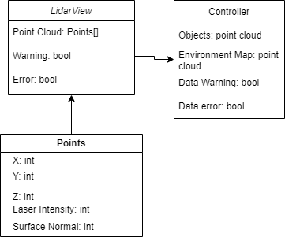

# 

# Other Relevant UML Diagrams

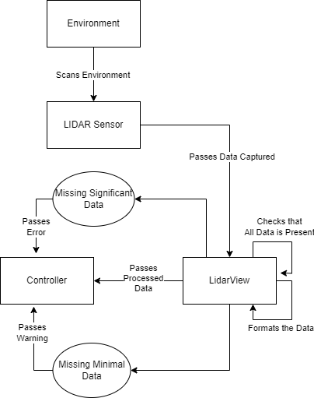

### LidarSensor Interaction with the Environment:

* Scanning Mechanism:
  + The LidarSensor emits laser beams that traverse the surrounding environment.
  + These laser beams interact with objects and surfaces, generating reflections that are captured by the sensor.
* Data Capture and Processing:
  + LidarSensor captures reflected signals and converts them into a three-dimensional point cloud.
  + The point cloud represents the spatial distribution of objects and obstacles within the sensor's range.
* Real-Time Data Transmission:
  + LidarSensor transmits the real-time point cloud data to the LidarView system for further processing.
  + The data includes information about the location, size, and distance of objects in the environment.

# Major Design Element 2: User Interaction and Feedback Module

# High-Level Overview

The User Interaction and Feedback Module within the LidarView system serves as a pivotal component, ensuring an inclusive and intuitive interaction between individuals with disabilities and the advanced LIDAR technology. This module is meticulously designed to provide a seamless and empowering user experience, focusing on accessibility, usability, and real-time engagement.

* Key Components:
  + User Interface Elements:
    - Menus, Buttons, and Navigation: Designed with accessibility in mind, these elements facilitate an intuitive interaction for users with varying abilities.
    - Adaptive Design: Responsive to different input methods, including touch gestures, voice commands, and tactile feedback.
  + Navigation Algorithms:
    - Intuitive Paths: The module incorporates navigation algorithms that generate adaptive step-by-step directions based on real-time LIDAR data.
    - Obstacle-Aware Routing: Utilizes LIDAR information to provide obstacle-aware routes, ensuring safe and efficient navigation through dynamic environments.
  + Feedback Mechanisms:
    - Tactile Feedback through Pressure Wristband: The Pressure Wristband translates LIDAR data into tactile feedback points, enhancing user situational awareness.
    - Auditory Feedback via Earpiece/Headphones: Conveys essential information such as navigation instructions and obstacle alerts, contributing to a comprehensive user experience.
  + User Preferences and Settings:
    - Customization Options: The module allows users to personalize their experience, adjusting settings based on individual preferences.
    - Voice Command Configuration: Users can tailor voice command preferences, influencing the system's response during navigation.
* **Seamless Integration with LidarView System:**

The User Interaction and Feedback Module is seamlessly integrated into the broader LidarView architecture, ensuring efficient communication and functionality. The real-time data from the LidarSensor influences the adaptive feedback and user guidance, fostering an inclusive experience. This integration emphasizes:

* Accessibility: Tailored to meet the diverse needs of users with disabilities, the module prioritizes accessibility in design and functionality.
* Usability: Through adaptive design elements and customizable preferences, the module aims to provide a user-friendly interface for effective engagement.
* Real-Time Engagement: The module's integration with the LidarSensor enables instant adaptation to changing environmental conditions, ensuring users receive timely and relevant feedback during navigation.

# Design Element User Case Diagram

# Use Case 1

# Design Element Class Diagram

* + - 1. **Class Diagram**

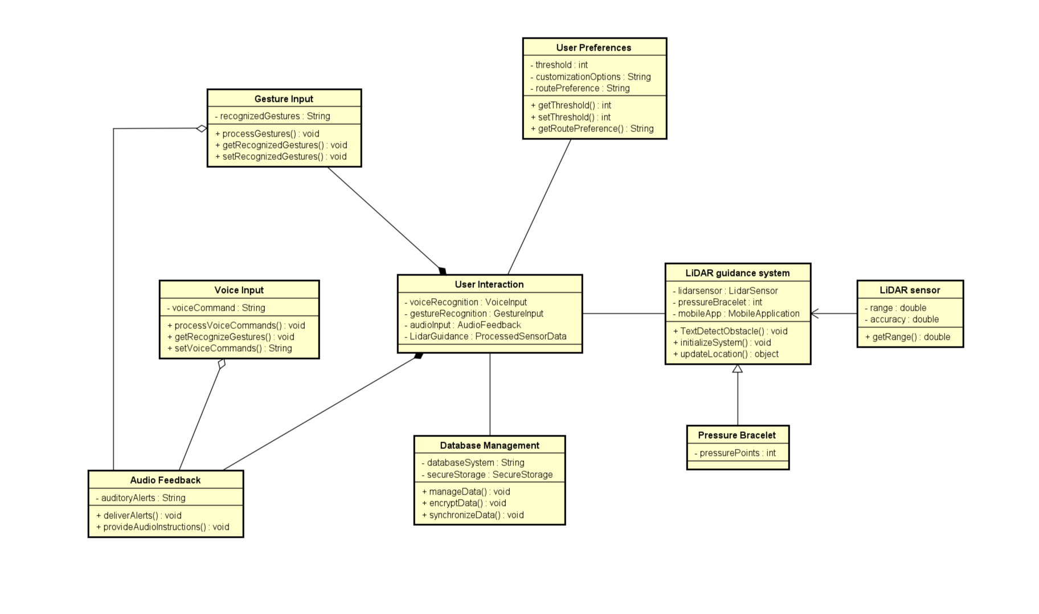

# Sequence Diagram 1

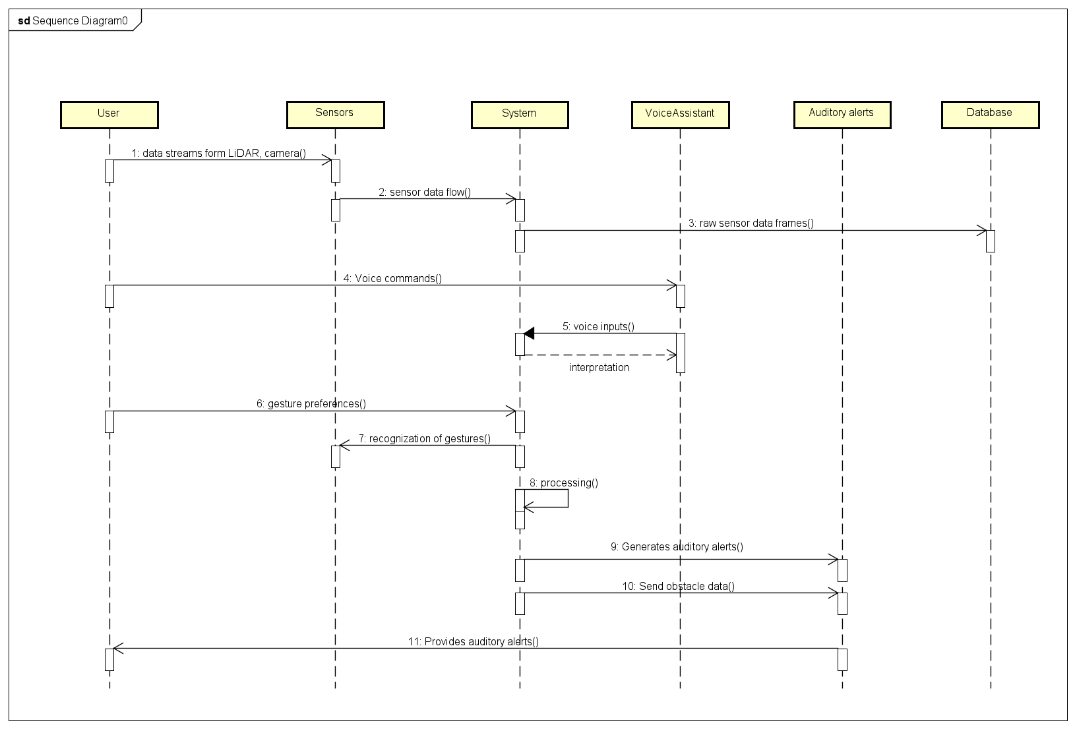

* User Initiates Interaction:
  + The sequence begins with the user initiating interaction through the LidarView Mobile Application.
  + The user issues voice commands for navigation and customization.
* Mobile App Requests Data from Sensors:
  + The Mobile Application sends a request for real-time LIDAR data to the sensors, triggering the environmental scanning process.
* Data Transmission from Sensors to System:
  + The sensors, including the LIDAR sensor, capture environmental data and transmit it to the LidarView system for analysis.
* Real-Time Data Processing:
  + The LidarView system's Data Processing Module interprets the incoming data, identifying obstacles and pathways within the user's surroundings.
* User Customization via Mobile App:
  + Simultaneously, the user can customize system settings through the Mobile Application, adjusting preferences for navigation and feedback.
* Voice Assistant Integration:
  + The Voice Assistant Integration module interprets voice commands issued by the user, facilitating seamless communication between the user and the system.
* Database Interaction:
  + The system interacts with the database to fetch user preferences and configurations, ensuring personalized responses aligned with the user's settings.
* Auditory Alerts Generation:
  + Based on real-time data and user preferences, the system generates auditory alerts, conveying essential information about obstacles, directions, and environmental changes.
* Feedback to User:
  + The auditory alerts are conveyed to the user through earpiece/headphones, enhancing situational awareness during navigation.
* Tactile Feedback through Wearable:
  + Simultaneously, the LidarView system interacts with the wearable device (Pressure Wristband), providing tactile feedback based on LIDAR data.
* Secure Database Update:
  + If there are any changes in user preferences during the interaction, the system securely updates the database, ensuring that future interactions align with the updated settings.
* Continuous User Interaction:
  + The sequence depicts a continuous loop of interaction, with the user receiving real-time feedback and being able to issue commands for ongoing navigation and customization.

# Major Design Element 3: Adjusting System Preferences

# High-Level Overview

The capability to adjust system preferences within the LidarView system stands as a fundamental aspect of enhancing user engagement and personalizing the experience for individuals with disabilities. This high-level overview delves into the key functionalities and design principles that define the Adjusting System Preferences module.

* Core Functionality:
  + Personalization Options:
    - Tailored User Experience: The module empowers users to customize various system settings, ensuring a personalized and adaptive interaction with the LidarView technology.
    - Preferences for Navigation: Users can define preferences related to navigation methods, voice command configurations, and feedback modalities.
  + Accessibility Customization:
    - Adaptive User Interface: The module facilitates adjustments to the user interface elements, making it adaptable to different input methods and accessibility needs.
    - Customizable Alerts: Users can set preferences for the type and intensity of alerts, accommodating diverse user sensitivities.
* Voice Command Configurations:
  + Personalized Voice Interactions: Users have the flexibility to configure voice command preferences, influencing how the LidarView system responds to spoken instructions.
  + Intuitive Voice Prompts: The module ensures that voice interactions are intuitive, enhancing the overall user experience.
* Integration with User Interaction Module:
* The Adjusting System Preferences module seamlessly integrates with the broader User Interaction and Feedback Module, contributing to a cohesive and user-centric design. This integration emphasizes:
* User-Centric Design: The module aligns with a user-centric approach, allowing individuals to tailor their interaction with the LidarView system according to their unique preferences.
* Real-Time Adaptation: Preferences set within this module dynamically influence the adaptive guidance, feedback, and overall user experience in real-time, ensuring instant responsiveness.
* Enhanced Accessibility: By providing customization options, the module supports enhanced accessibility, addressing the diverse needs of users with disabilities.
* User Empowerment and Inclusivity:
* The Adjusting System Preferences module embodies the LidarView system's commitment to user empowerment and inclusivity. It recognizes that each user has unique preferences and requirements, aiming to empower individuals with disabilities to navigate their surroundings with confidence and autonomy.

# Design Element User Case Diagram

# Use Case 1

# 

# Design Element Class Diagram

* + - 1. **Class Diagram**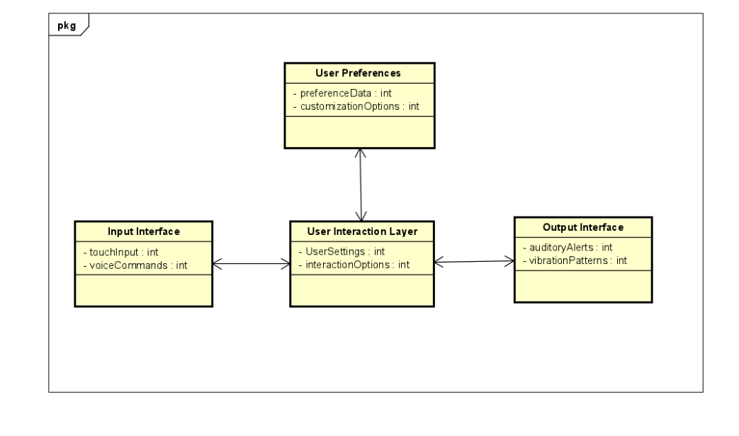

# Sequence Diagram 1

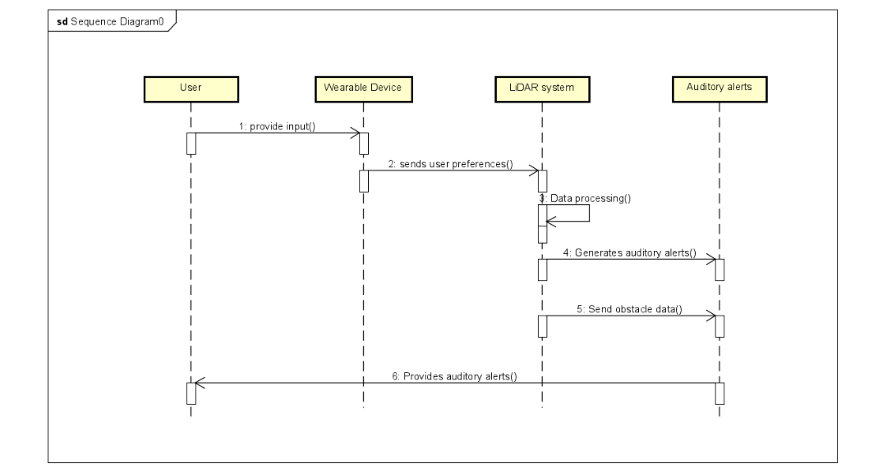

* User Initiates Preferences Adjustment:
  + The sequence begins as the user initiates adjustments to system preferences through the LidarView Mobile Application.
* Preferences Configuration Request:
  + The Mobile Application sends a preferences configuration request to the LidarView system, signaling the intent to modify user-specific settings.
* Database Interaction:
  + The system interacts with the database to retrieve the current user preferences, ensuring that the adjustments align with the existing configurations.
* Preferences Customization via Mobile App:
  + The user interacts with the Mobile Application to customize various system preferences, such as navigation methods, voice command configurations, and feedback modalities.
* Real-time Updates to Database:
  + As the user makes adjustments, the system securely updates the database, ensuring that the modified preferences are reflected in future interactions.
* Wearable Device Interaction:
  + The LidarView system communicates with the wearable device (Pressure Wristband), updating it with the modified preferences.
* Tactile Feedback Configuration:
  + The user can customize tactile feedback preferences on the wearable device, specifying how the Pressure Wristband translates LIDAR data into tactile feedback points.
* Auditory Alerts Adjustment:
  + Simultaneously, the user can configure auditory alert preferences, defining the type and intensity of alerts to be generated during navigation.
* LIDAR Data Processing:
  + The LidarView system processes LIDAR data to adapt to the newly configured preferences, ensuring that the feedback provided aligns with the user's personalized settings.
* Real-time Interaction Confirmation:
  + The Mobile Application receives real-time confirmation from the system about the successful update of preferences, providing feedback to the user.
* Adaptive User Experience:
  + The sequence illustrates the adaptive nature of the LidarView system, where preference adjustments dynamically influence the user experience, including tactile feedback and auditory alerts.

# Risks Addressed

# Overview

* Outlined within this section are the highest-priority project risks that were meticulously identified, along with a detailed understanding of their significance in relation to the system's goals. Each risk is thoroughly examined in terms of its potential impact and implications on the system's performance, reliability, and inclusivity for users with disabilities.

# Technical Complexity and Integration

* **Description of the risk and why it is significant**
  + Developing a system that integrates a complex LIDAR sensor, data processing software (LidarView), real-time decision-making (Controller), user interface (mobile application), and wearable devices (bracelets, earpieces/headphones) presents a significant challenge.
  + This complexity could lead to technical issues, delays, or unexpected hurdles.
* **Description of how the prototype mitigated or avoided the risk**
  + Shows that mapping of the environment with stationary objects is not a complex as it seems
  + Hardest part will be tracking the speed of objects
  + Found resources for communication between bluetooth devices

# Size/Weight

* **Description of the risk and why it is significant:** Size/weight
  + Size is an important factor because stakeholders who will be using it will have to wear the product.
  + There is an inherent size and weight requirement that will limit how the technology is laid out and integrated into the product.
  + This is a priority because the product will not be useful to the target demographic if it is too big and weighs them down. It is very important that the product is as compact as possible while maintaining the usefulness
  + A prototype will mitigate the risk of the size because seeing how each of the components will interact with each other will help with how things are laid out to make the product smaller.
  + Having the research of what components will need to be used and what other alternatives that will achieve the same results that could be smaller and lighter would be found in the process of creating a prototype.
* **Description of how the prototype mitigated or avoided the risk**
* The prototype shows the different parts being used and making up the components of the system
* The parts are all affordably priced
* The parts are also all small enough to make the system plausible
* The system is designed so as to not impede in the users everyday life

# Prototype

* 1. **Overview of the Prototype**
* The prototype shows a mockup of what the major components to be purchased for the product are
* It is there to help demonstrate the affordability and that it will not inhibit daily activities
* It also helps to demonstrate the communication between the separate components
  1. **Major Functions of the Prototype**
  2. **Major Function 1: Hat/Beanie with a lidar Sensor**

**Description of the function**

* The hat/ beanie function will be used to create a map of stationary objects close to the user
* This will be things like walls, street signs, and nature elements
* track objects are moving slowly within a small radius
  + example a person walking near then
* track objects that are moving at high speeds in a much larger radius
  + examples are bikers, people running, and cars
* **Screenshots showing the function in use**
* We don’t have code we have done or the actual parts so here are some mock-ups of what we are thinking

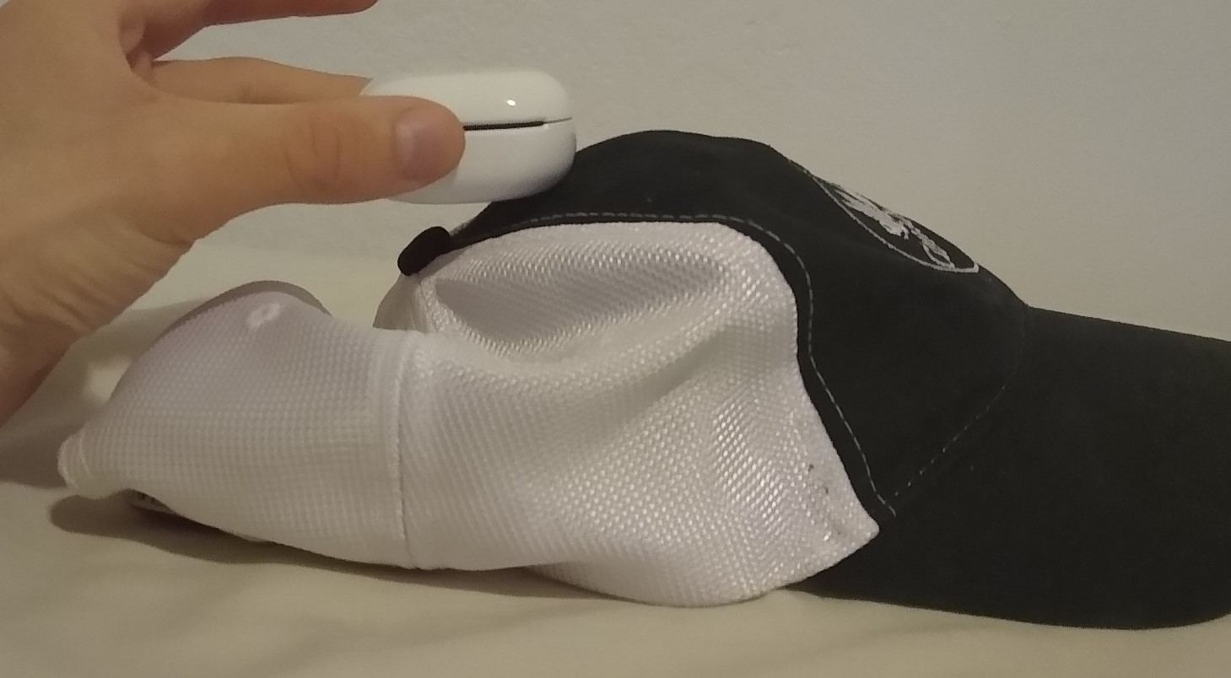

* Above shows a basic hat the user could wear
* The object being held is a stand-in for the lidar sensor and the Bluetooth chip package/module
  + Note: since we will be running a program and storing data like a map we would need something that will hold that memory but real-world testing would need to be done to determine the amount of memory needed.
* A lidar sensor we have found is: <https://www.adafruit.com/product/4010#description>
  + cost $100, width: 98.5mm (3.88in), depth: 60mm (2.36), and Weight: 170g (0.37lbs), 12m range, 0.2cm distance resolution
  + Bigger than we like but weighs less than 1 lbs, and has an appropriate range for this case
  + Ideally it is smaller is size and we can sacrifice 1 or 2 meters in range and have a worse distance resolution as a potential compromise
* For understanding how we would map the around the user
  + <https://www.youtube.com/watch?v=JbUNsYPJK1U> starting from 4:00 to end
  + This video is a simulation of a lidar sensor code for mapping the surroundings
  + would still map the surroundings
  + We would make some changes to this code
    - collect points within 9ft of user and send the needed left or right turning information to not run into them
      * realistically user would only need to react to objects within this range
    - for points between in
      * look for moving objects/points
        + done by comparing maps and looking for differences is points compared to the rest of the map
        + example of this: <https://pyimagesearch.com/2019/12/02/opencv-vehicle-detection-tracking-and-speed-estimation/>
      * based on point difference determine speed of objects
      * have check how close user is to path of moving objects and send a signal to react when needed
    - Last change will be to forget about stationary objects once they are determined to be 20m away
      * For moving objects, forget about them using an equation based on the speed and direction of the object based on the user's direction and speed and forget after the set time.
* The package also has a Bluetooth chip
  + basic Bluetooth communication example: <https://learn.sparkfun.com/tutorials/bluetooth-basics/all>
  + Bluetooth chip: <https://www.amazon.com/DA14580-smallest-bluetooth-module-Bluetooth/dp/B071VG5RMC>
  + We would use these to send to information of what vibrator to vibrate
    - signal for turn left, turn right, and vibrate both to signal stop
* **How these screenshots show prototype has mitigated or avoided the risk**
  + The video specifically shows a simple way to create a map with a simulated lidar sensor that could be used to create a map, with some additions
    - an addition is comparing creating maps based on the user to determine moving objects and their speed
  + It also provided resources to enable Bluetooth communication which is standardized for all chips
  + The points above address the Technical Complexity and Integration problem
  + This also addresses the size and weight risk because the parts found are small
    - The biggest issue was the lidar sensor but in the process of creating the prototype we found one that is one-third a pound and is relatively small
      * As noted above we believe that there are some compromises to the statistics of the lidar like range and distance resolution that could make the sensor smaller.

# Major Function 2 - Bracelet

* **Description of the function**
  + The bracelet is used to warn the user of:
    - Objects within the user's path within 3 meters
    - Fast approaching objects with 12 meters
  + The bracelet will warn the user by:
    - Vibrating the top motor for turn right
    - Vibrating the bottom for turn left
    - Both to tell the user to stop
  + The bracelet will generate these warnings based on signals sent from the controller using a Bluetooth chip
* **Screenshots showing the function in use**

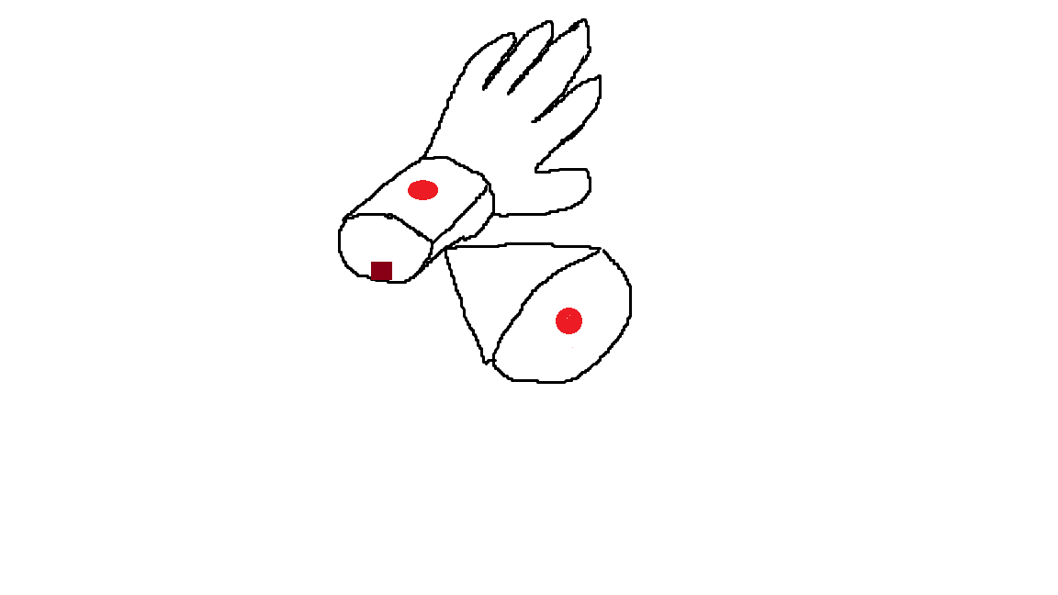

* Description of Image
  + Brown square represents the Bluetooth chip that will be used to communicate among the different components of the system
  + The two red dots are the vibration chips that will be used to communicate to the user about objects in their path

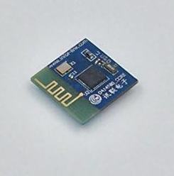

* Bluetooth chip to be utilized: <https://www.amazon.com/DA14580-smallest-bluetooth-module-Bluetooth/dp/B071VG5RMC>
  + Height = 0.511 mm, width = 2.436 mm, length = 2.436, cost = $10.35
  + It is a small, low-energy consumption chip
  + Can be easily concealed in a bracelet.

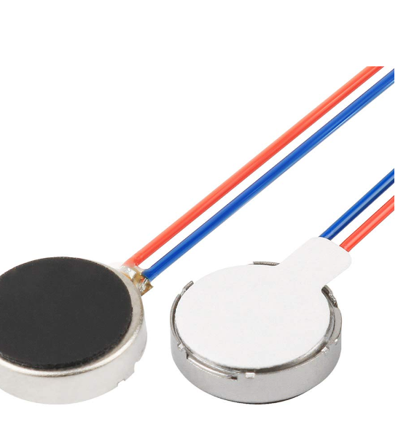

* Vibration Motors to be utilized: <https://www.amazon.com/gp/aw/d/B07Q1ZV4MJ/?_encoding=UTF8&pd_rd_plhdr=t&aaxitk=61d8218e1b3f57b4d17cbe302054003b&hsa_cr_id=5781348260601&qid=1700442140&sr=1-1-9e67e56a-6f64-441f-a281-df67fc737124&ref_=sbx_be_s_sparkle_mcd_asin_0_title&pd_rd_w=HP33t&content-id=amzn1.sym.417820b0-80f2-4084-adb3-fb612550f30b%3Aamzn1.sym.417820b0-80f2-4084-adb3-fb612550f30b&pf_rd_p=417820b0-80f2-4084-adb3-fb612550f30b&pf_rd_r=BWGRFRQJ5C06N5HXVYE1&pd_rd_wg=4ZWmu&pd_rd_r=c2f531d1-f7ce-469f-9fdf-82579b6f7561>
  + Diameter = 10 mm, height = 3 mm, cost = $14 for 20
  + Small enough to be concealed in a bracelet
  + Powerful enough to be used as a notification for a person
* **How these screenshots show prototype has mitigated or avoided the risk**
  + The screenshots show the breakdown of the bracelet device
  + Size and Weight

It shows that the components that make up the bracelet are affordable

It also shows that all the components are small enough to be concealed in a bracelet and not interfere with everyday life

* + Technical Complexity and Integration

This helps demonstrate the simplicity of the bracelet system

It also demonstrates that the system can utilize Bluetooth to simplify the connection between the bracelet and the controller

# 7. Conclusion

# New or Updated Key Conclusion 1: Prototype

* + 1. **Detail Item 1 Description:** Hat/Beanie section
* Create a detailed description of how the lidar section would work
  + ideally by putting on a hat/beanie and having the lidar spin and collect their
    - shown with a picture
  + provided a video that has code that simulates a lidar
    - described the changes and features that we would add to the code for our prototype
* Provide resources of how it would communicate using bluetooth
  + 1. **Prototype - Bracelet**
* Components of the Bracelet:
  + Vibration Motors
  + Bluetooth Chip
* Risk Mitigation
  + Size/Weight
    - The components are all affordably priced
    - Components are small enough to be concealed and not get in the way
  + Technical Complexity and Integration
    - Bracelet system and Controller can communicate through bluetooth
    - Bracelet system is not complex

# Problem

* + 1. **Previous Attempts**
* Traditional Mobility Aids
  + White Canes
  + Guide Dogs
* Assistive Technologies
  + GPS-based navigation devices
    1. **Reasons previous attempts were unsatisfactory**
* Limited consideration of visually impaired individuals
* Insufficient proactive alerts
* Fragmented integration
* Lack of real-time, detailed environmental information

# Consider adding a final item “Items for future consideration”.

* We should locate and compare distance calculation algorithms
  + same for speed calculations
* Look for more smaller lidar sensors that could be use
  + look for data on the effects of distance resolution on the map.

# Appendix A: Credit Sheet

| Team Member Name | Contributions |
| --- | --- |
| Parv Tejas Shah | Section 1: Problems  Section 2: Requirements  Section 3: Architectural Views  Section 4: Detailed Design  Section 6: Helped in finding the LIDAR prototype |
| Prathit Nilay Barot | Section 3 Logical View, Interaction Model  Section 4 Detailed Design (specifically 4.3  section 1: Problem |
| Monil Rameshchandra Prajapati | Section 3.3.2 Physical View  Section 3.3.3 Development View  Section 4.4 Major Design Element 2  Section 5: Risk Addressed |
| Brenden Martinez | Section 5: Risks Addressed  Section 6: Prototype  Section 7: Conclusion |
| Alexander Chittim | Section 5: Risks Addressed  Section 6: Prototype  Section 7: Conclusion |