Validation Analyses 13–19
Corporate Lobbying Network Research
BCZ Structural Tests | 116th Congress | 111th–117th Stability
Prathit Kurup & Victoria Figueroa
April 2026
WHAT THESE ANALYSES TEST
# | Validation | Core Question
13 | Centrality vs Agenda-Setter | Do BCZ key-players match empirical agenda-setters?
14 | Influencer Regression | What firm-level covariates predict influencer status?
15 | Cross-Sector Edges | How does influence flow across community boundaries?
16 | Within-Community Hierarchy | Who leads each sector, and is it stable 2009–2022?
17 | Quarterly Dynamics | Is influencer status stable within the 116th Congress?
18 | Payoff Complementarity | Do high-RBO pairs increase spend when partners enter?
19 | Bill Adoption Diffusion | Do followers adopt influencer bills faster if RBO is high?

Overview
These seven validation analyses test the theoretical claims underlying the RBO directed influence network. The network is built on a single premise: a directed edge A → B means A is the net first-mover on shared bills, i.e., A sets the legislative agenda that B follows. The validations examine whether this operationalization corresponds to theoretically expected behavior in three registers:

- Structure: Do firms that are structurally important in the BCZ sense (key players in the affiliation network) also function as temporal first-movers?
- Stability: Is the influence hierarchy stable across sessions (2009–2022) and within sessions (quarter-by-quarter)?
- Behavior: Do firms respond to their network partners in ways consistent with BCZ strategic complementarity — increasing spend and adopting bills when high-RBO partners act first?

All analyses use the 116th Congress (2019–2020) as the primary cross-section. Stability analyses use the 111th–117th Congress panel. Community labels are the five Leiden communities from the 116th affiliation network: Finance/Insurance (0), Tech/Telecom (1), Defense/Industrial (2), Energy/Utilities (3), Health/Pharma (4).

Validation 13: Centrality vs. Agenda-Setter

What We Tested
Whether firms identified as structurally important by BCZ-style centrality measures (BCZ intercentrality, global PageRank, within-community eigenvector, within-community PageRank on the bill-affiliation network) are also the empirical agenda-setters identified by the directed influence network (net_influence, net_strength, and within-community variants).

Research question: Is structural key-player status a reliable proxy for temporal agenda-setting? If BCZ centrality and net_influence rank the same firms, the theoretical framework has strong construct validity.

Method
- BCZ intercentrality computed via 277 node-removal Katz reruns (α = 0.85/spectral radius, unnormalized, consistent with BCZ single-parameter framework).
- Within-community PageRank run on each of 5 Leiden community subgraphs.
- Spearman ρ computed for all 14 centrality × agenda-setter pairs, full sample and top-30 restricted.
- Top-30 overlap fraction = |top-30 centrality ∩ top-30 agenda| / 30.

Results

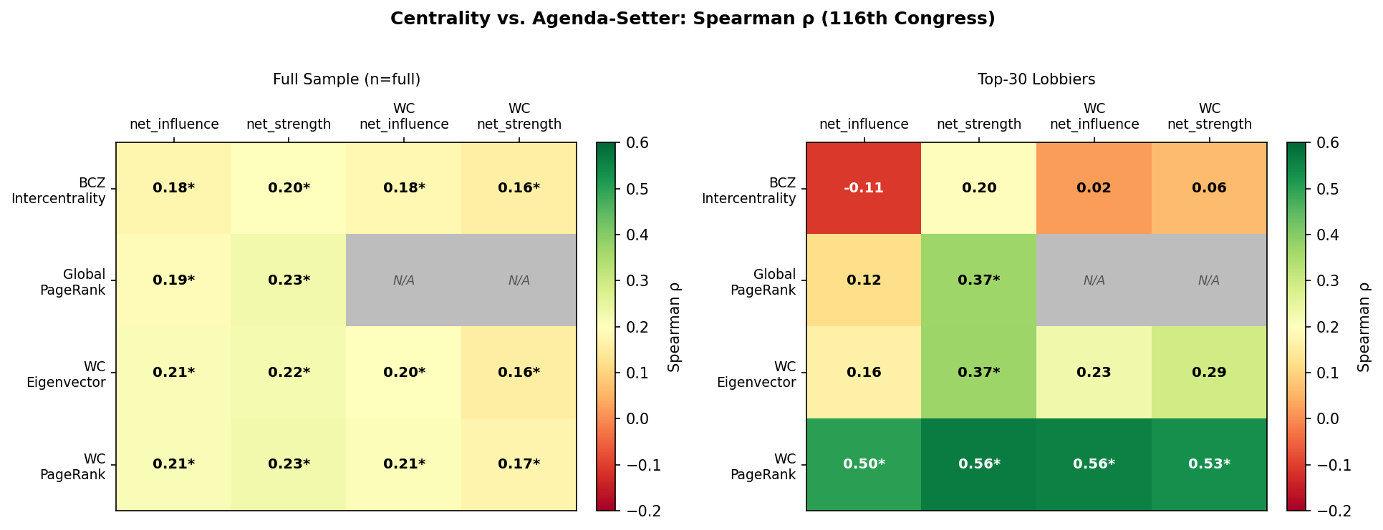
Figure 13. Spearman ρ between centrality measures and agenda-setter measures. Left: full sample; Right: top-30 firms. Stars indicate p < 0.05. WC PageRank shows strongest top-30 alignment.

Centrality | Agenda Measure | ρ Full | ρ Top-30 | Sig. (top-30)
BCZ Intercentrality | net_influence | 0.178 | −0.107 | ns
BCZ Intercentrality | net_strength | 0.202 | 0.196 | ns
Global PageRank | net_influence | 0.193 | 0.119 | ns
Global PageRank | net_strength | 0.225 | 0.366 | * (p=0.047)
WC Eigenvector | net_influence | 0.212 | 0.164 | ns
WC PageRank | net_influence | 0.212 | 0.501 | ** (p=0.005)
WC PageRank | WC net_influence | 0.208 | 0.558 | ** (p=0.001)
WC PageRank | WC net_strength | 0.172 | 0.534 | ** (p=0.002)

Interpretation
Structural key players ≠ temporal first-movers at the aggregate level. BCZ intercentrality is dominated by energy utilities (CMS Energy, DTE Energy, Exelon, Xcel) with large affiliation footprints; net_influence top-30 features diversified industrials (Cummins, Ball, Exxon, DTE). The full-sample correlations are all weakly positive but low (ρ ≈ 0.18–0.23).
Within-community PageRank is the exception: top-30 ρ with net_influence = 0.50 and with WC net_influence = 0.56 (both p ≤ 0.005). This suggests that a firm’s position within its own sector community — not its global centrality — better predicts agenda-setting. The framework’s intra-community dynamics are capturing something real; cross-community centrality is not.

Validation 14: Influencer Regression

What We Tested
What firm-level observable covariates predict influencer status (net_influence, net_strength, wc_net_strength, and binary top-quartile net_influence)? Tests whether lobbying scale, bill breadth, and structural centrality are the drivers of agenda-setting, or whether influence is orthogonal to observable firm characteristics.

Research question: Is agenda-setter status predictable from lobbying inputs (spend, breadth) and network position? Or does it reflect something structural/unobservable?

Method
- OLS cross-sections for 116th and 117th Congress independently. HC3 heteroskedasticity-robust SE throughout.
- Spec A: net_influence ~ log_spend + log_bills + katz_centrality + participation_coeff.
- Spec A2: top-quartile net_influence (binary LPM) — same regressors.
- Spec B: net_strength (RBO-weighted directional score).
- Spec C: wc_net_strength ~ wc_eigenvector + wc_pagerank (within-community only).
- log_bills deduped on (uniq_id, fortune_name) to avoid per-bill double-counting. Centrality covariates from 116th affiliation network used as structural baseline for both congresses.

Results

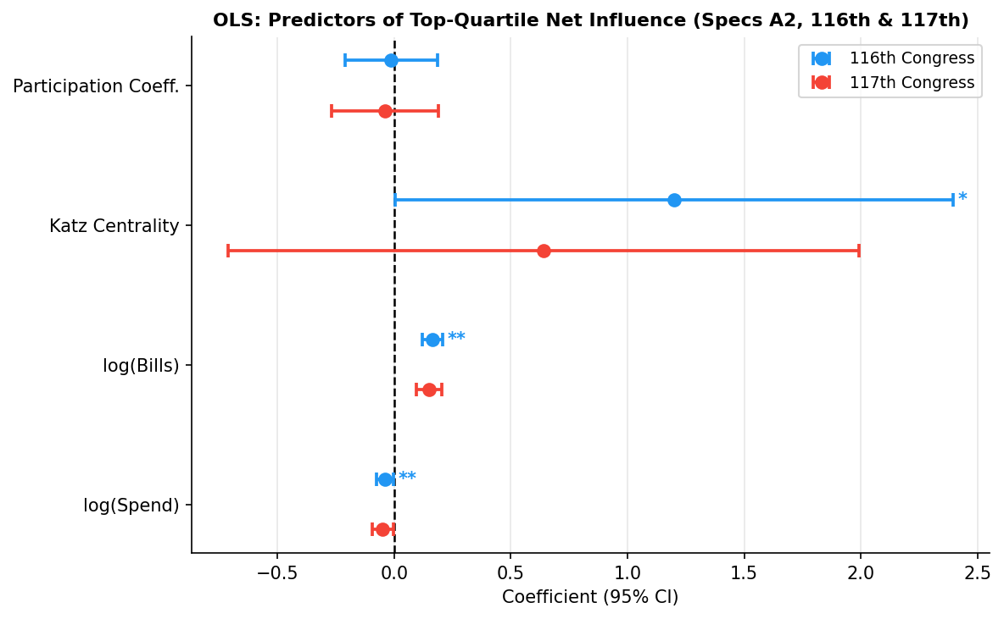
Figure 14. OLS coefficient plot for top-quartile net_influence (Spec A2), 116th and 117th Congress. Error bars = 95% CI (HC3). log_bills and log_spend replicate across both congresses.

Spec | Congress | Key Significant Predictors | R² | F-test p
A (net_influence) | 116th | None (F p=0.068 marginal) | 0.043 | 0.068
A2 (top-quartile LPM) | 116th | log_bills *** , katz ** , log_spend ** | 0.282 | <0.001
A2 (top-quartile LPM) | 117th | log_bills *** , log_spend ** | 0.190 | <0.001
B (net_strength) | 116th | F significant; log_spend marginal | 0.049 | 0.036
C (wc_net_strength) | 116th | F significant; no individual sig. | 0.061 | 0.008

Interpretation
Bill breadth (log_bills, β = 0.164***) is the dominant predictor of reaching top-quartile influencer status. Notably, log_spend is negatively signed (β = −0.039**): higher total spend is associated with lower probability of being a top-quartile agenda-setter. This is consistent with the interpretation that agenda-setters diversify across many lower-spend bills rather than concentrating resources. Katz centrality is significant in the 116th binary spec but not the continuous spec, suggesting a threshold rather than linear effect. Results replicate in the 117th Congress, supporting cross-session generalizability.

Validation 15: Cross-Sector Directed Edge Analysis

What We Tested
How influence flows across community boundaries. Are cross-sector directed edges systematically different from intra-sector edges in weight and temporal dominance? Which sectors are net cross-sector exporters of influence, and which firms bridge multiple communities?

Research question: Does the directed influence network carry inter-sector agenda-setting signals, or is influence primarily contained within sectors?

Method
- Tags directed edges as intra-/cross-sector using 116th Leiden community labels (balanced=0 only).
- Mann-Whitney U tests on RBO weight and net_temporal for cross vs. intra-sector edges.
- Community-pair flow matrix: directed edge counts and mean weights between all 5×5 sector pairs.
- Net cross-sector influence (CS-NI) per firm: cross-sector first-mover wins minus losses.
- Bridge firms: highest fraction of all edges that are cross-sector.
- Top cross-sector dyads profiled by issue cosine similarity (76 OpenSecrets issue codes).

Results

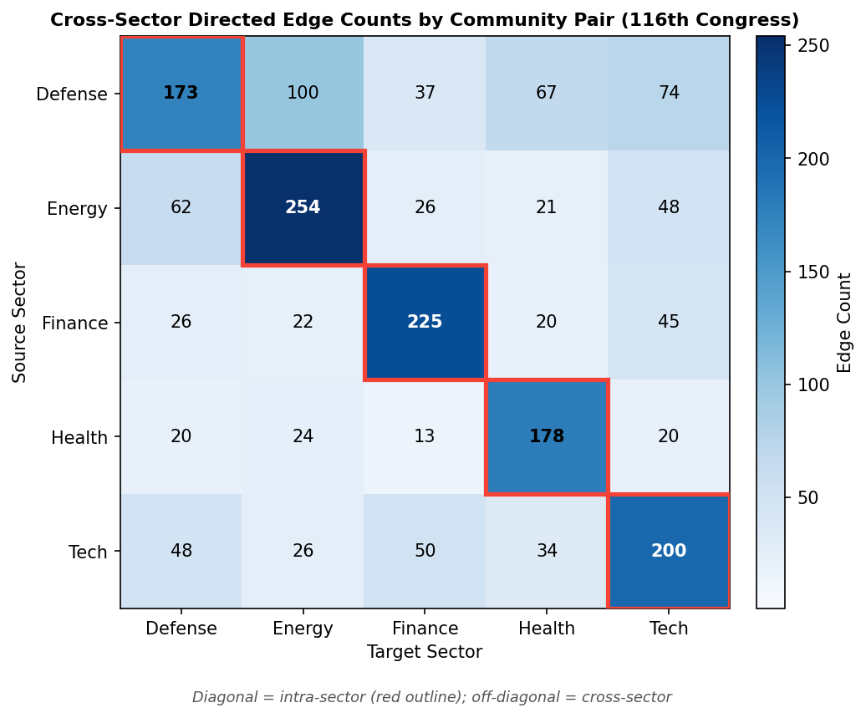
Figure 15. Cross-sector directed edge counts by community pair. Diagonal = intra-sector. Defense/Industrial is the dominant cross-sector influencer.

Finding | Value
Total directed edges (with community labels) | 1,813
Cross-sector edges | 783 (43.2%)
Intra-sector edges | 1,030 (56.8%)
Cross-sector mean RBO weight | 0.033 vs. 0.077 intra (MWU p=2.9×10⁻⁴⁵)
Cross-sector mean net_temporal | 1.25 vs. 1.63 intra (MWU p=3.3×10⁻¹⁹)
Strongest cross-sector flow | Defense → Health/Pharma (net +47 edges)
Second strongest | Defense → Energy/Utilities (net +38 edges)
Top cross-sector influencer firm | Cummins (CS-NI = 48, from Defense)
Common cross-sector issue | BUD (federal budget) shared by Defense→Health dyads

Interpretation
Cross-sector edges are systematically weaker (lower RBO, lower net_temporal) than intra-sector edges — influence attenuates when crossing community boundaries, consistent with portfolio specialization. Defense/Industrial is the dominant cross-sector agenda-setter, particularly toward Health/Pharma (via shared federal budget legislation) and Energy/Utilities. Bridge firms with high cross-sector edge fractions (e.g., Cognizant, Thermo Fisher Scientific) tend to be diversified industrials spanning multiple legislative domains.

Validation 16: Within-Community Influencer Hierarchy

What We Tested
Who are the persistent within-sector agenda-setters across the seven congressional sessions (111th–117th, 2009–2022)? Is the hierarchy stable over time within each community?

Research question: Is agenda-setting a structural, persistent property of specific firms within their sectors, or does leadership cycle through the community?

Method
- Within-community net_influence per firm per congress: restricted to intra-community directed edges, using 116th Leiden partition as community proxy throughout all 7 sessions.
- Top-5 leaderboard per community per congress.
- Kendall’s W (chi-squared approximation, Siegel & Castellan 1988) on firms present in all 7 congresses.
- Adjacent-congress Spearman ρ for year-over-year stability.
- Persistent leaders: firms in top-5 in ≥4 of 7 congresses.

Results

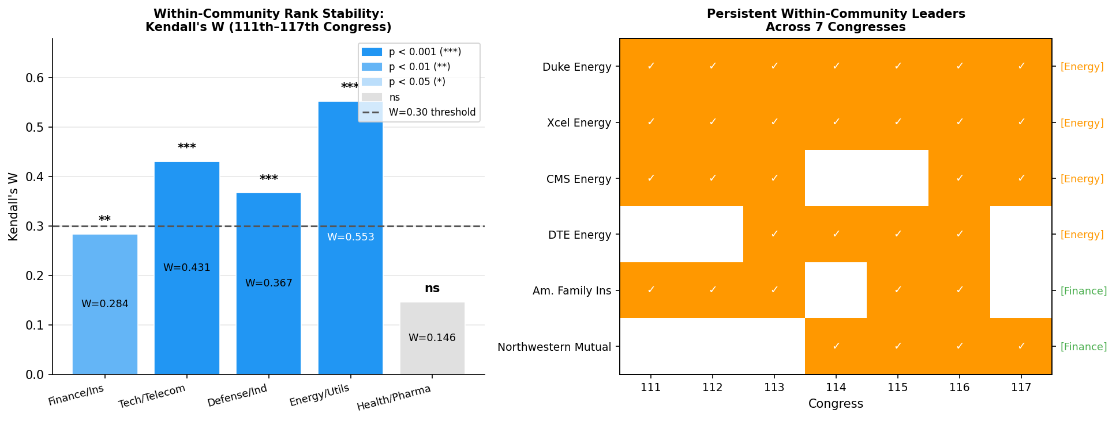
Figure 16. Left: Kendall’s W by community (higher = more stable hierarchy). Right: Persistent leaders — firms in top-5 for ≥4 of 7 congresses. Energy/Utilities has by far the most stable leadership.

Community | Stable Firms | Kendall’s W | p-value | Interpretation
Finance/Insurance | 27 | 0.284 | 0.002 | Weak but significant
Tech/Telecom | 25 | 0.431 | <0.0001 | Significant concordance
Defense/Industrial | 21 | 0.367 | 0.0001 | Significant concordance
Energy/Utilities | 23 | 0.553 | <0.0001 | Highest concordance
Health/Pharma | 14 | 0.146 | 0.428 | Not significant

Community | Persistent Leaders | Sessions
Energy/Utilities | Duke Energy, Xcel Energy | 7/7 each
Energy/Utilities | CMS Energy | 5/7
Energy/Utilities | DTE Energy | 4/7
Finance/Insurance | American Family Insurance Group | 5/7
Finance/Insurance | Northwestern Mutual | 4/7
Health/Pharma | None | —

Interpretation
Energy/Utilities has the most stable hierarchy (W = 0.553, p < 0.0001): Duke Energy and Xcel Energy appear in top-5 in all 7 congresses, reflecting the regulated utility sector’s stable legislative engagement profile. Health/Pharma is the most volatile community (W = 0.146, ns), with leadership cycling through biologics, insurance-adjacent, and specialty pharmacy firms as the legislative environment shifts. Community size matters: Health/Pharma’s 14-firm stable set provides less statistical power for W.

Validation 17: Quarterly Dynamics

What We Tested
Whether influencer status is stable within the 116th Congress (Q1–Q8, 2019–2020), or whether the top-10 net influencers change substantially quarter by quarter.

Research question: Is the congress-wide aggregate a fair summary of influence, or does the hierarchy shift enough within a session to undermine aggregation?

Method
- Recomputes the full RBO directed influence pipeline independently for each of Q1–Q8, restricted to that quarter’s report_type prefixes.
- Within-quarter first-mover resolved by report_type ordinal (base report < amendment). Balanced pairs excluded from net_influence.
- Adjacent-quarter Jaccard similarity: |top-10(t) ∩ top-10(t+1)| / |top-10(t) ∪ top-10(t+1)|.
- Spearman ρ on full net_influence ranks for all firms appearing in both quarters.
- Focal firms: in top-10 in ≥3 quarters. Bump chart and z-scored heatmap produced.

Results

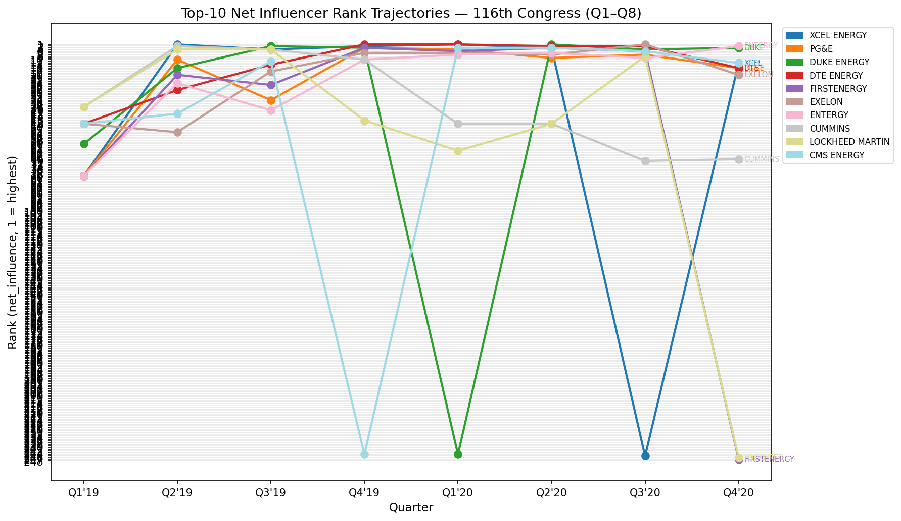
Figure 17a. Rank trajectories of the 10 focal firms (top-10 in ≥3 quarters) across Q1–Q8. Energy/Utilities firms dominate, clustered in 2020.

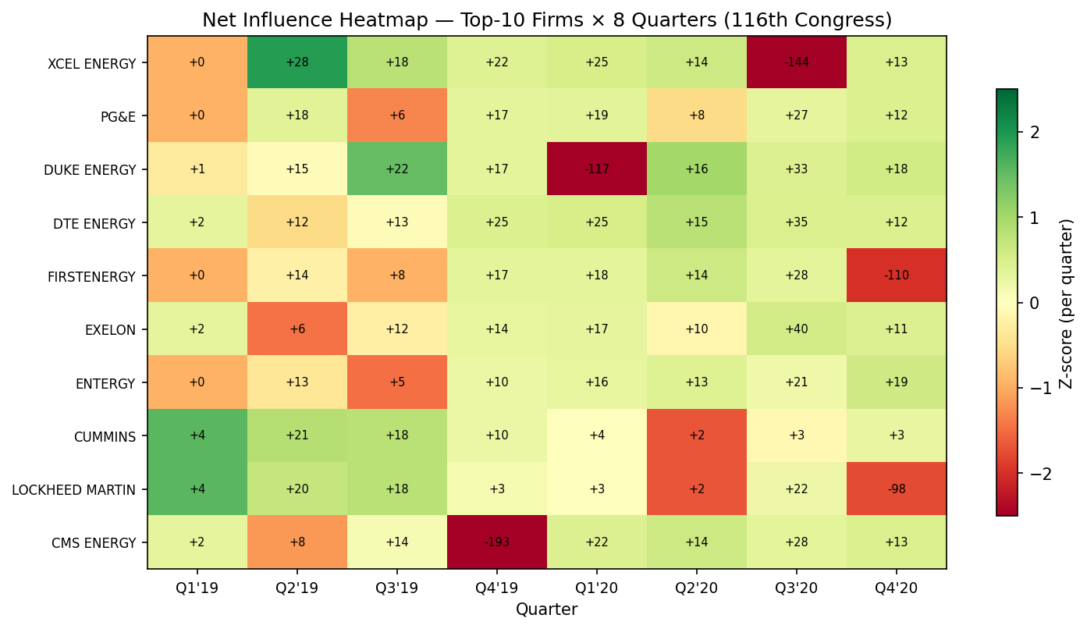
Figure 17b. Z-scored net_influence heatmap. Raw net_influence values annotated. Q1 is notably sparse; 2020 quarters (Q5–Q8) show higher Energy utility dominance.

Quarter Pair | Top-10 Intersection | Jaccard | Spearman ρ | p
Q1→Q2 | 0 | 0.000 | 0.296 | <0.001
Q2→Q3 | 6 | 0.429 | 0.548 | <0.001
Q3→Q4 | 3 | 0.176 | 0.419 | <0.001
Q4→Q5 | 5 | 0.333 | 0.406 | <0.001
Q5→Q6 | 7 | 0.538 | 0.461 | <0.001
Q6→Q7 | 7 | 0.538 | 0.443 | <0.001
Q7→Q8 | 2 | 0.111 | 0.550 | <0.001
Mean | — | 0.304 | 0.446 | —

Interpretation
Influencer status is partially stable within the congress: all adjacent-quarter Spearman correlations are significant (mean ρ = 0.446), but top-10 membership turns over meaningfully (mean Jaccard = 0.30). Q1 is structurally distinct — it shows zero top-10 overlap with Q2, likely because Q1 2019 has the smallest network (211 firms) and fewer shared bills. The congress-wide aggregate is appropriate as the primary analytical unit, and the partial stability validates the aggregation. 8 of the 10 focal firms are Energy/Utilities, clustered in late 2019 through mid-2020.

Validation 18: Payoff Complementarity Test

What We Tested
Whether firm i increases lobbying spend on bill b when RBO-linked firm j newly enters bill b, and whether that response is larger for high-RBO pairs. This is the micro-level behavioral prediction of BCZ strategic complementarity: best-response spending increases in partner spending, amplified by the complementarity parameter (here proxied by RBO edge weight).

BCZ prediction: In a BCZ game, the equilibrium action of each player increases in partners’ actions, weighted by the complementarity parameter βᵢⱼ. High RBO ≈ high βᵢⱼ → larger cross-partial derivative → stronger spending response.

Specification
Δlog_spendᵢᵇₜ₊₁ = β₁ entry_jᵇₜ + β₂ rboᵢⱼ + β₃ (entry_jᵇₜ × rboᵢⱼ) + αᵢᵇ + γₜ + ε

- entry_j = 1 if quarter t is firm j’s first quarter lobbying bill b (0 = continuing lobbyist).
- Panel includes ALL active firm_j on bill b at quarter t (not only entrants) — essential for within-group variation in entry_j after firm-bill FE absorption.
- αᵢᵇ = firm-bill fixed effects via within-transformation; γₜ = quarter fixed effects; HC3 SE.

Results

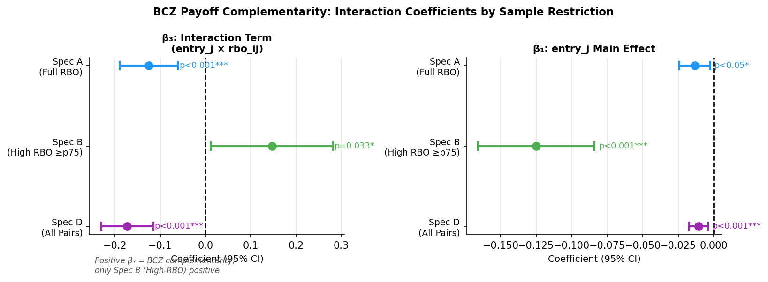
Figure 18. Left: β₃ (interaction) across Specs A, B, D. Right: β₁ (entry_j main effect). Only Spec B (high-RBO pairs, green) shows positive β₃, consistent with BCZ.

Spec | Sample | N | β₃ coef | SE | p | BCZ?
A | Full RBO-linked | 67,194 | −0.125 | 0.033 | <0.001 | No (crowd-out)
B | High-RBO (≥ p75) | 16,845 | +0.147 | 0.069 | 0.033 | Yes (p<0.05)
C | Low-RBO (< p25) | 16,796 | −8.001 | 2.979 | 0.007 | No (scale tiny)
D | All pairs (rbo=0) | 147,341 | −0.173 | 0.029 | <0.001 | No (crowd-out)

Interpretation
BCZ payoff complementarity is present but concentrated at the high end of the RBO distribution (Spec B, top-quartile pairs). For the average pair, a co-lobbyist’s entry is associated with spending restraint (significantly negative β₁), possibly reflecting wait-and-see behavior or competitive positioning. Only among the most structurally similar firms (top-quartile RBO weight ≥ 0.131) does a partner’s entry trigger the additional spending amplification predicted by BCZ (β₃ = +0.147, p = 0.033). Spec C’s large negative coefficient is an artifact of the tiny rbo scale in the low-RBO subsample; the predicted marginal effect at mean low-RBO weight is economically negligible.

Validation 19: Bill Adoption Diffusion

What We Tested
Whether follower firm B is more likely to first lobby a bill X that influencer A has lobbied in a prior quarter, and whether that adoption probability is amplified for high-RBO (A, B) pairs. This tests whether the directed RBO edge captures actual agenda-setting diffusion: does A’s bill portfolio propagate to B?

Research question: If A→B is a directed influence edge and A newly enters bill X in quarter t, is B more likely to join X in quarters t+1 through t+3 when rbo_AB is high?

Method
- For each directed (A→B) edge (balanced=0 only), enumerate (A, B, bill) triples where A first lobbies bill X at quarter t and B had not yet lobbied X at or before t. N = 80,384 candidate rows.
- Outcome: binary B adopts bill X within k quarters of A (k = 1, 2, 3).
- Horizon observability: excluded when a_entry_q + k > 8.
- Logit and LPM: log(rbo), log(n_firms_bill), a_net_influence, b_net_influence, a_entry_q_norm.
- Unique-entry robustness: restricts to bills where A is sole first-entrant (∼25K rows), isolating cases where B can attribute the signal to A specifically.

Results

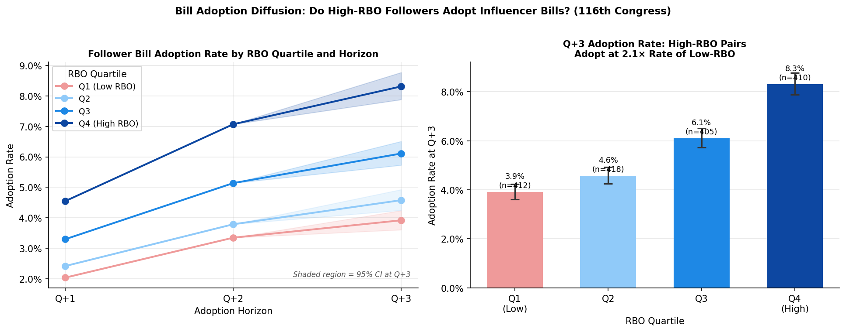
Figure 19. Left: Adoption rate by RBO quartile across Q+1, Q+2, Q+3 horizons. Q4 (high-RBO) consistently adopts faster. Right: Q+3 adoption rates by quartile with 95% CI — Q4 adopts at 2.1× the rate of Q1.

Horizon | Overall rate | Q4 (high RBO) | Q1 (low RBO) | Ratio | χ² p
Q+1 | 3.1% | 4.6% | 2.0% | 2.23× | <0.001
Q+2 | 4.8% | 7.1% | 3.4% | 2.09× | <0.001
Q+3 | 5.7% | 8.3% | 3.9% | 2.13× | <0.001

Model | Horizon | log(rbo) coef | p | Unique-entry coef | p
Logit | Q+1 | 0.163 | <0.001 | 0.235 | <0.001
Logit | Q+2 | 0.160 | <0.001 | 0.230 | <0.001
Logit | Q+3 | 0.169 | <0.001 | 0.205 | <0.001
LPM | Q+1 | 0.004 | <0.001 | 0.002 | <0.001
LPM | Q+2 | 0.006 | <0.001 | 0.003 | <0.001
LPM | Q+3 | 0.008 | <0.001 | 0.003 | <0.001

Interpretation
High-RBO followers adopt influencer bills at roughly 1.7–2.1× the rate of low-RBO followers, and this advantage is stable across all three horizons — it does not erode from Q+1 to Q+3. log(rbo_weight) is positive and significant (p < 0.001) in every Logit and LPM spec, and replicates in the unique-entry robustness subset. This provides direct behavioral evidence that the RBO directed edge captures a real agenda-setting signal: B’s bill adoption is structurally shaped by A’s prior entry, amplified by their RBO similarity.
Together with Validation 18, this gives a two-level BCZ story: (1) high-RBO partners increase spending when the other enters (V18, Spec B), and (2) high-RBO followers are more likely to enter influencer bills (V19). Both effects operate in the same direction and reinforce the BCZ complementarity interpretation.

Summary: What the Validations Establish

Validation | Central Finding | Status
13 – Centrality | WC PageRank aligns with agenda-setting at top-30 (ρ=0.50–0.56); global/BCZ measures do not. | Partial support
14 – Regression | Bill breadth predicts top-quartile status (***); spend is negatively associated (**). Replicates 116th→117th. | Supported
15 – Cross-sector | Cross-sector edges are systematically weaker. Defense/Industrial dominates cross-sector influence. | Supported
16 – Hierarchy | Energy/Utilities is the most stable community (W=0.55); Duke & Xcel lead all 7 congresses. Health/Pharma volatile. | Supported
17 – Quarterly | Congress-wide aggregate is appropriate (all Spearman ρ significant); Q1 is an outlier (Jaccard=0). | Supported
18 – Complementarity | BCZ complementarity holds for top-quartile RBO pairs only (β₃=+0.147, p=0.033); crowd-out for average pairs. | Conditional support
19 – Bill adoption | High-RBO followers adopt influencer bills at 1.7–2.1× rate; stable over Q+1–Q+3; replicates in unique-entry sample. | Strongly supported

The strongest evidence for the BCZ framework comes from Validations 18 and 19, which document behavioral responses to network structure. The centrality-agenda disconnect (V13) is theoretically important: it shows that the RBO directed network captures something distinct from standard network centrality, namely the temporal dynamics of bill adoption rather than static affiliation.

