Cross-Congressional Stability of Directed RBO Influence Networks
111th-117th Congress (2009-2022)
Fortune 500 firms present in all seven sessions (n = 135 stable firms)

1. Overview
This document reports four stability analyses of the RBO directed influence network across seven consecutive congressional sessions (111th-117th Congress, 2009-2022). The analysis restricts to the 135 Fortune 500 firms present in the directed influence graph in all seven sessions (the stable set). The RBO-directed influence edge between two firms is drawn when both lobbied on at least one common bill; the temporal direction is assigned to the firm that first filed that bill in its lobbying report. Four properties are tested: (1) direction consistency of pairwise edges, (2) magnitude stability of the net temporal score per pair, (3) firm-level net_influence rank stability, and (4) firm-level net_strength rank stability.

2. Network Coverage
Table 1 summarises the number of Fortune 500 firms, total edges, directed edges, and balanced (tied) pairs for each congress.

Table 1. Per-congress network coverage (stable-set firms)

Congress | Firms | Total edges | Directed | Balanced pairs
111th (2009-10) | 246 | 6,165 | 3,837 | 1,164
112th (2011-12) | 253 | 6,267 | 3,529 | 1,369
113th (2013-14) | 259 | 6,148 | 3,445 | 1,351
114th (2015-16) | 257 | 7,418 | 4,215 | 1,601
115th (2017-18) | 260 | 5,528 | 3,080 | 1,224
116th (2019-20) | 259 | 3,869 | 1,890 | 989
117th (2021-22) | 255 | 3,558 | 2,007 | 775

The stable set of 135 firms is the intersection of firms present in all seven sessions. Of the 6,783 canonical firm-pairs with at least one edge across any session, 277 appear in all seven sessions. Session-count distribution: 1:1978 2:1514 3:1176 4:868 5:618 6:352 7:277.

3. Analysis 1 - Direction Consistency
Method. For each firm-pair that appears in directed form in at least two sessions, direction consistency is the fraction of directed sessions in which the same firm leads. A binomial test with H0: p = 0.5 assesses whether the observed consistency exceeds chance.

Results. Of the 2,830 firm-pairs with >= 2 directed sessions, the mean consistency is 0.77 (median 0.75). 45.1% of pairs achieve >= 0.80 consistency, and 41.2% are perfectly consistent (1.00) across all their directed sessions. Under the null, 73.9% of pairs show a majority direction vs. the expected 50%, indicating a strong directional hierarchy. Only 2.4% of pairs reach binomial significance (p < 0.05) individually, consistent with the large number of low-frequency pairs.

Table 2. Top 10 most direction-consistent firm-pairs (n directed >= 3)

Firm A | Firm B | Consistency | n (directed) | p (binomial)
BALL | IBM | 1.000 | 5 | 0.0312
CHARLES SCHWAB | STATE FARM INSURANCE | 1.000 | 3 | 0.1250
CVS HEALTH | EBAY | 1.000 | 3 | 0.1250
BANK OF AMERICA | BEST BUY | 1.000 | 3 | 0.1250
BALL | USAA | 1.000 | 3 | 0.1250
CVS HEALTH | ELI LILLY | 1.000 | 3 | 0.1250
CVS HEALTH | INTEL | 1.000 | 3 | 0.1250
ALPHABET | HOME DEPOT | 1.000 | 3 | 0.1250
DEERE | LOCKHEED MARTIN | 1.000 | 3 | 0.1250
ALLSTATE | INTEL | 1.000 | 3 | 0.1250

BALL / IBM is the only pair with perfect consistency across five directed sessions and the only pair achieving binomial significance (p = 0.031).

4. Analysis 2 - Magnitude Stability (net_temporal)
Method. For each firm-pair present in both congresses of a given pair, the net_temporal score (wins minus losses weighted by RBO similarity) is compared across sessions using Spearman rho. Kendall's W is computed for pairs with data in >= 3 sessions.

Table 3. Pairwise Spearman rho matrix (net_temporal, stable-set pairs). * p < 0.05

 | 111 | 112 | 113 | 114 | 115 | 116 | 117
111 | 1.000 | 0.101* | 0.112* | 0.074* | 0.098* | 0.124* | 0.091*
112 | 0.101* | 1.000 | 0.070* | 0.052* | 0.074* | 0.147* | 0.089*
113 | 0.112* | 0.070* | 1.000 | 0.119* | 0.044 | 0.037 | 0.050
114 | 0.074* | 0.052* | 0.119* | 1.000 | 0.103* | 0.088* | 0.093*
115 | 0.098* | 0.074* | 0.044 | 0.103* | 1.000 | 0.074* | 0.064*
116 | 0.124* | 0.147* | 0.037 | 0.088* | 0.074* | 1.000 | 0.218*
117 | 0.091* | 0.089* | 0.050 | 0.093* | 0.064* | 0.218* | 1.000

Results. All pairwise Spearman correlations are statistically significant except some involving the 113th Congress. Correlations are low (range 0.037-0.218), indicating that the precise magnitude of the net temporal score per pair is not strongly conserved across sessions. The highest correlation is 116-117 (rho = 0.218). Kendall's W = 0.125 (p = 1.00, n = 3,291 pairs) is degenerate due to large-scale zero-imputation and should be discounted.

5. Analysis 3 - Firm net_influence Rank Stability
Method. Each stable firm is ranked by net_influence (total firsts minus total losses) within each congress. Adjacent-congress Spearman rho is computed on the 135-firm rank vectors. Kendall's W measures concordance across all seven sessions.

Table 4. Adjacent-congress Spearman rho (net_influence ranks, n = 135 firms)

Congress pair | rho | p-value | n | Sig. (p<0.05)
111-112 | 0.1998 | 0.0202 | 135 | Yes
112-113 | 0.2987 | 0.0004 | 135 | Yes
113-114 | 0.1340 | 0.1213 | 135 | No
114-115 | 0.2855 | 0.0008 | 135 | Yes
115-116 | 0.2465 | 0.0040 | 135 | Yes
116-117 | 0.3104 | 0.0002 | 135 | Yes

Results. Five of six adjacent-congress pairs are statistically significant. The 113-114 transition is the only non-significant pair (rho = 0.134, p = 0.12). Kendall's W = 0.343 (p < 0.0001, n = 135) confirms statistically significant global concordance: a stable tier of dominant agenda-setters and reactive followers persists across all seven sessions.

Table 5. Top 10 most consistently influential firms (mean net_influence, 111th-117th)

Firm | 111th | 112th | 113th | 114th | 115th | 116th | 117th | Mean
LOCKHEED MARTIN | 112 | 76 | 49 | 135 | 49 | 27 | 57 | 72.1
IBM | 144 | 24 | 81 | 41 | 59 | 48 | 19 | 59.4
XCEL ENERGY | 90 | 68 | 45 | 77 | 34 | 17 | 44 | 53.6
CMS ENERGY | 53 | 83 | 46 | 42 | 36 | 31 | 34 | 46.4
DUKE ENERGY | 90 | 81 | 42 | 10 | 27 | 27 | 41 | 45.4
AT&T | 38 | 57 | 12 | 91 | 54 | 31 | 19 | 43.1
DTE ENERGY | 11 | 60 | 48 | 90 | 30 | 43 | 17 | 42.7
MICROSOFT | 30 | 96 | -30 | 55 | 40 | 23 | 55 | 38.4
NORTHWESTERN MUTUAL | 27 | 35 | 44 | 76 | 55 | 24 | 7 | 38.3
BOEING | 58 | 41 | 2 | 68 | 49 | 13 | 33 | 37.7

Table 6. Top 5 most consistently following firms (mean net_influence, 111th-117th)

Firm | 111th | 112th | 113th | 114th | 115th | 116th | 117th | Mean
CONSOLIDATED EDISON | -114 | -179 | -17 | -49 | -10 | 3 | -20 | -55.1
AMEREN | -40 | 0 | -60 | -124 | -34 | -20 | -60 | -48.3
CENTERPOINT ENERGY | -58 | -101 | 35 | 2 | -1 | -95 | -83 | -43.0
ALLY FINANCIAL | -99 | 3 | -135 | -33 | -7 | 1 | 2 | -38.3
BAXTER INTERNATIONAL | -50 | -9 | -15 | -48 | -12 | -6 | -8 | -21.1

Lockheed Martin (mean 72.1) and IBM (59.4) are the most persistently dominant firms. Xcel Energy, CMS Energy, and Duke Energy follow, all electric utilities with long-horizon legislative agendas. Consolidated Edison (mean -55.1), Ameren (-48.3), and Centerpoint Energy (-43.0) are the most consistently reactive firms.

6. Analysis 4 - Firm net_strength Rank Stability
Method. Mirrors Analysis 3 but ranks firms by net_strength (the RBO-similarity-weighted directed score) rather than raw win/loss count, capturing the quality of influence as well as its count.

Table 7. Adjacent-congress Spearman rho (net_strength ranks, n = 135 firms)

Congress pair | rho | p-value | n | Sig. (p<0.05)
111-112 | 0.0600 | 0.4898 | 135 | No
112-113 | 0.0716 | 0.4091 | 135 | No
113-114 | 0.1189 | 0.1696 | 135 | No
114-115 | 0.2500 | 0.0035 | 135 | Yes
115-116 | 0.1971 | 0.0219 | 135 | Yes
116-117 | 0.1791 | 0.0376 | 135 | Yes

Results. Only the three most recent transitions (114-115, 115-116, 116-117) reach significance. Kendall's W = 0.273 (p < 0.0001, n = 135) confirms global concordance at a somewhat lower level than the unweighted net_influence measure. Xcel Energy leads on net_strength (mean 2.21) ahead of Lockheed Martin (2.05) and Duke Energy (1.80), reflecting that these utilities' agenda-setting edges are concentrated on high-overlap bill pairs.

Table 8. Top 10 highest mean net_strength firms (111th-117th)

Firm | 111th | 112th | 113th | 114th | 115th | 116th | 117th | Mean
XCEL ENERGY | 4.103 | 2.247 | 1.825 | 3.865 | 1.253 | 1.122 | 1.082 | 2.214
LOCKHEED MARTIN | 3.353 | 1.608 | 2.067 | 3.165 | 0.914 | 0.318 | 2.950 | 2.054
DUKE ENERGY | 2.688 | 4.195 | 2.480 | 0.990 | 1.058 | 0.295 | 0.915 | 1.803
MICROSOFT | 0.793 | 3.857 | -0.555 | 1.866 | 2.110 | 1.437 | 1.347 | 1.551
NORTHWESTERN MUTUAL | 0.191 | 1.096 | 1.496 | 3.558 | 1.551 | 1.437 | 0.737 | 1.438
CMS ENERGY | 1.661 | 1.368 | 2.022 | 1.684 | 0.724 | 1.761 | 0.438 | 1.380
AT&T | 0.735 | 0.793 | 0.350 | 3.122 | 3.252 | 0.671 | 0.269 | 1.313
DTE ENERGY | -0.924 | 1.377 | 1.195 | 3.293 | 0.967 | 0.703 | 1.568 | 1.169
BOEING | 3.209 | 0.753 | 0.503 | 1.806 | 0.620 | 0.121 | 0.691 | 1.100
UNITED AIRLINES HOLDINGS | 0.286 | 3.003 | 0.621 | 0.487 | 0.763 | 0.472 | 1.519 | 1.021

Table 9. Top 5 lowest mean net_strength firms (111th-117th)

Firm | 111th | 112th | 113th | 114th | 115th | 116th | 117th | Mean
ALLY FINANCIAL | -2.711 | 0.146 | -2.813 | -1.499 | -1.050 | -0.116 | 0.286 | -1.108
CENTERPOINT ENERGY | -0.710 | -4.872 | 1.022 | 0.036 | -0.064 | -0.674 | -1.389 | -0.950
CISCO SYSTEMS | -2.454 | 0.000 | -3.024 | 1.832 | -1.321 | -1.624 | 0.090 | -0.929
CONSOLIDATED EDISON | -1.631 | -2.733 | 0.352 | -0.185 | -0.583 | 0.110 | -1.580 | -0.893
AMEREN | -0.204 | 0.268 | -1.958 | -1.828 | -0.254 | -0.582 | -1.599 | -0.880

7. Summary Figure
Figure 1 shows all four stability metrics in a single panel: (top-left) direction consistency distribution, (top-right) Analysis 2 Spearman rho heat-map, (bottom-left) Analysis 3 adjacent-congress Spearman bars, (bottom-right) Analysis 4 adjacent-congress Spearman bars.

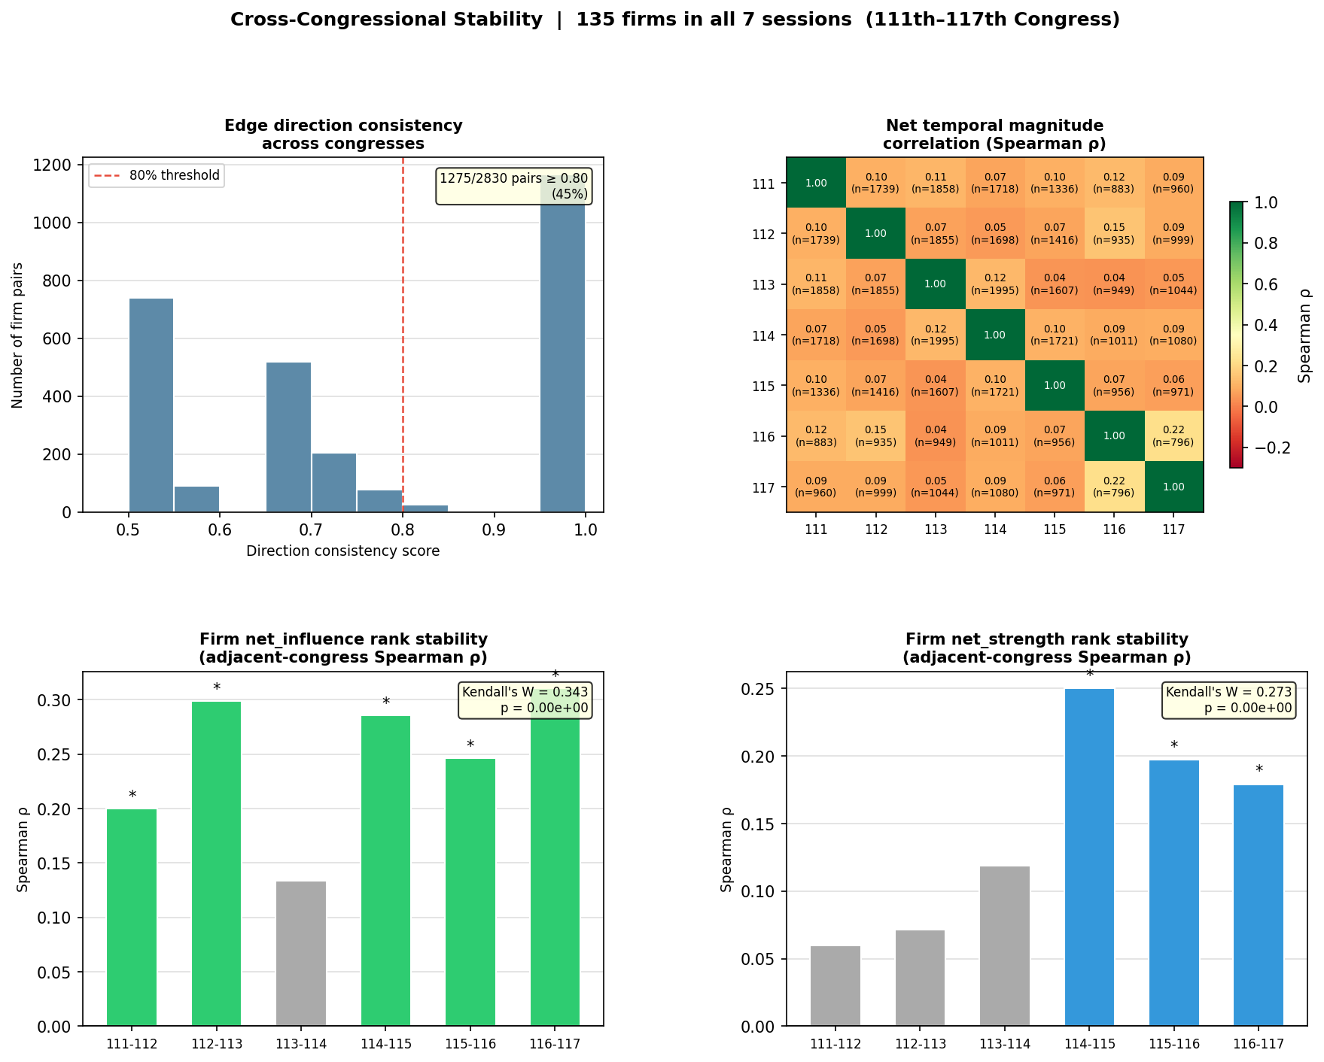

Figure 1. Cross-congressional stability -- 111th through 117th Congress.

8. Conclusions
Across all four analyses, the RBO directed influence network exhibits moderate but statistically robust structural stability over the 2009-2022 period. Direction consistency (mean 0.77) and the majority-direction rate (73.9%) indicate that the directional hierarchy between firm pairs is not random. Firm-level net_influence ranks achieve Kendall's W = 0.343 (p < 0.0001), confirming a stable tier of dominant agenda-setters concentrated in defence contracting (Lockheed Martin, Boeing, General Dynamics), technology (IBM, Microsoft), and electric utilities (Xcel Energy, Duke Energy, CMS Energy). Net_strength ranks show lower but still significant global concordance (W = 0.273). The low magnitude correlations in Analysis 2 suggest that while directional structure and relative firm positions are stable, the precise intensity of any given pair's interaction varies session-to-session, consistent with issue-cycle-driven lobbying intensity rather than fixed bilateral relationships.

