EntitySearch — Architecture & Technical Guide
EntitySearch Team
2025-09-29
Table of contents

1. Overview
EntitySearch researches people/companies across the web, extracts structured facts via an LLM, consolidates results, and ranks sources. It streams live progress to the UI.
- Backend: FastAPI, Async I/O, Playwright, SQLite, SSE
- LLM: Google Gemini via OpenAI-compatible SDK
- Frontend: React (Vite), Tailwind, Framer Motion, React Router

2. System Architecture

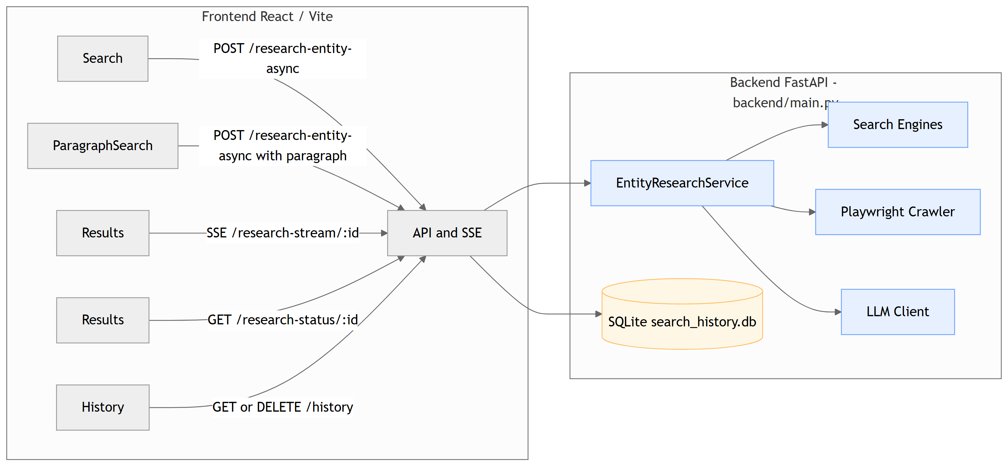

Key backend files:
- backend/main.py — API, SSE, orchestration
- backend/app/services/entity_research_service.py — search, crawl, extract, consolidate, rank
- backend/app/services/llm/gemini_client.py — Gemini integration
- backend/app/services/crawler/base.py — Playwright crawler
- backend/app/services/search_engine/ — Google/Bing/Yahoo engines
- backend/app/database/history.py — SQLite persistence

3. End-to-End Async Flow

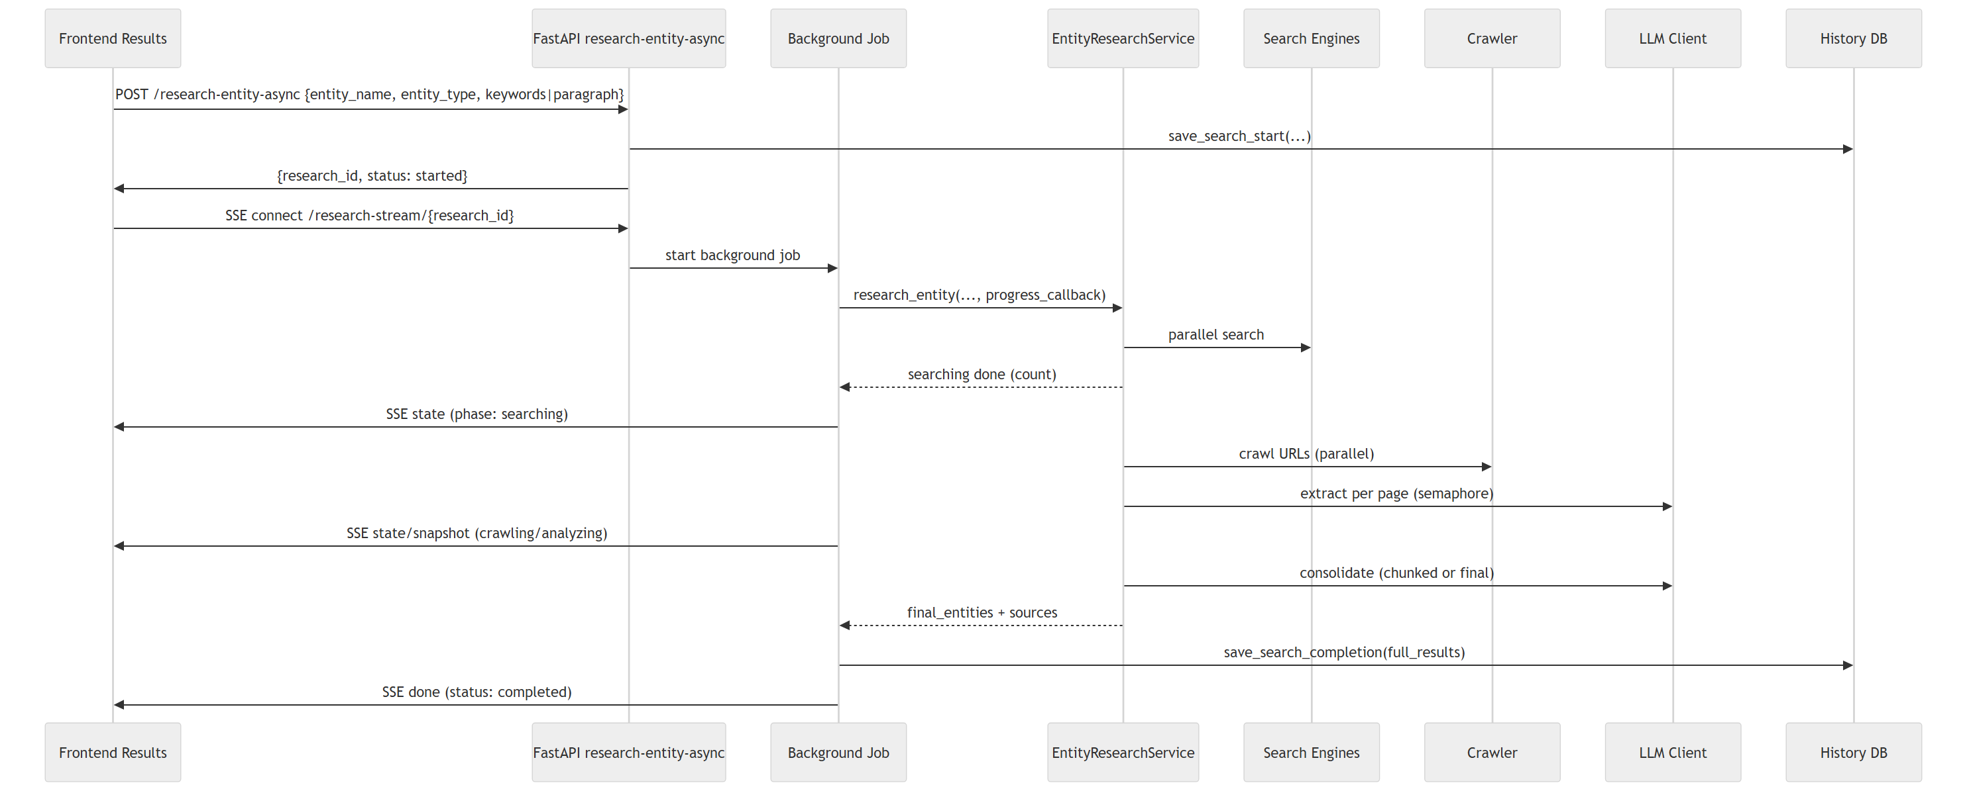

4. Core Components

4.1 API Layer (backend/main.py)
- POST /research-entity-async starts a background job and returns a research_id.
- GET /research-stream/{id} streams SSE with state, snapshot, and done events.
- GET /research-status/{id} polling fallback for status and partial results.
- History endpoints: GET /history, GET /history/{id}, DELETE /history/{id}.

4.2 Research Orchestrator (entity_research_service.py)
- Parallel search across Google/Bing/Yahoo.
- Crawl pages with Playwright and sanitize DOM to text.
- LLM extraction per page (bounded concurrency via semaphore).
- Consolidation: chunked LLM combine with local fallback _local_consolidate().
- Produces final_entities.entities[] with combined_fields and ranked field_sources.

4.3 LLM Client (gemini_client.py)
- Generates search queries from a name/keywords or a full paragraph.
- Extracts structured fields with strict name matching and normalized date fields.
- Consolidates profiles into entities with canonical_name, same_as_query, and confidence.

4.4 Crawler (crawler/base.py)
- Chromium headless with HTTP/2 fallback + aggressive fallback.
- Strips scripts/styles and returns clean text content.

4.5 Persistence (database/history.py)
- SQLite search_history.db storing lifecycle, metrics, and full_results JSON.

5. Data Contracts

5.1 Search Request (POST /research-entity-async)
{
"entity_name": "Jane Doe",
"entity_type": "individual",
"keywords": ["CEO", "New York"],
"paragraph": "Jane Doe is the CEO of Acme in NYC..." // optional
}

5.2 SSE: state Event Payload (typical)
{
"status": "in_progress",
"phase": "analyzing",
"progress": {"pages_crawled": 5, "pages_analyzed": 4, "pages_total": 10, "current_page": "https://example.com/..."},
"events": [{"timestamp": "2025-09-29T09:00:00Z", "phase": "crawling", "message": "Crawled 5/10"}],
"entity_name": "Jane Doe",
"started_at": "2025-09-29T08:58:00Z",
"live_results": {
"final_entities": {"entities": []},
"sources": []
}
}

5.3 Final Results (summary)
{
"entity_name": "Jane Doe",
"search_queries": ["Jane Doe CEO New York", "Jane Doe Acme"],
"search_results_count": 24,
"crawled_pages_count": 12,
"clusters": {"query_name": []},
"profiles": [{"source_url": "https://...", "extracted_info": {}}],
"final_entities": {
"entities": [
{
"canonical_name": "Jane Doe",
"same_as_query": true,
"name_similarity_to_query": 0.96,
"consolidation_confidence": 0.9,
"combined_fields": {"age": "55 (as of 2024)", "occupation": "CEO"},
"field_sources": {"age": [1,2], "occupation": [1]},
"member_profile_indexes": [0, 3],
"sources": ["https://...", "https://..."]
}
]
},
"per_field_sources": {"age": [1,2]},
"sources": [{"source_id": 1, "url": "https://...", "title": "Article", "status_code": 200, "success": true}]
}

6. Field Source Ranking Logic
For each entity field, member sources are scored and ranked (see entity_research_service.py).
- Exact match to combined value: +5.0
- Partial/substring match: +2.0
- Field present in profile: +2.0
- Confidence: +(confidence × 1.5)
- Name similarity: +(name_similarity × 1.0)
- Date-based fields preference (age, date_of_birth, year_of_birth):
  - Explicit mention bonus: +3.0 (e.g., “(from article)”, “(as of 20XX)”, “(stated)”, “(mentioned)”)
  - Calculated/inferred penalty: -1.0 (e.g., “(calculated)”, “(computed)”, “(derived)”, current date calc)
This ensures explicitly stated values outrank computed ones.

7. Paragraph-Based Search
When paragraph is provided in the request:
- Backend uses GeminiClient.generate_search_queries_from_paragraph(...) to create focused queries.
- Normal research flow continues with these queries; UI remains the same.

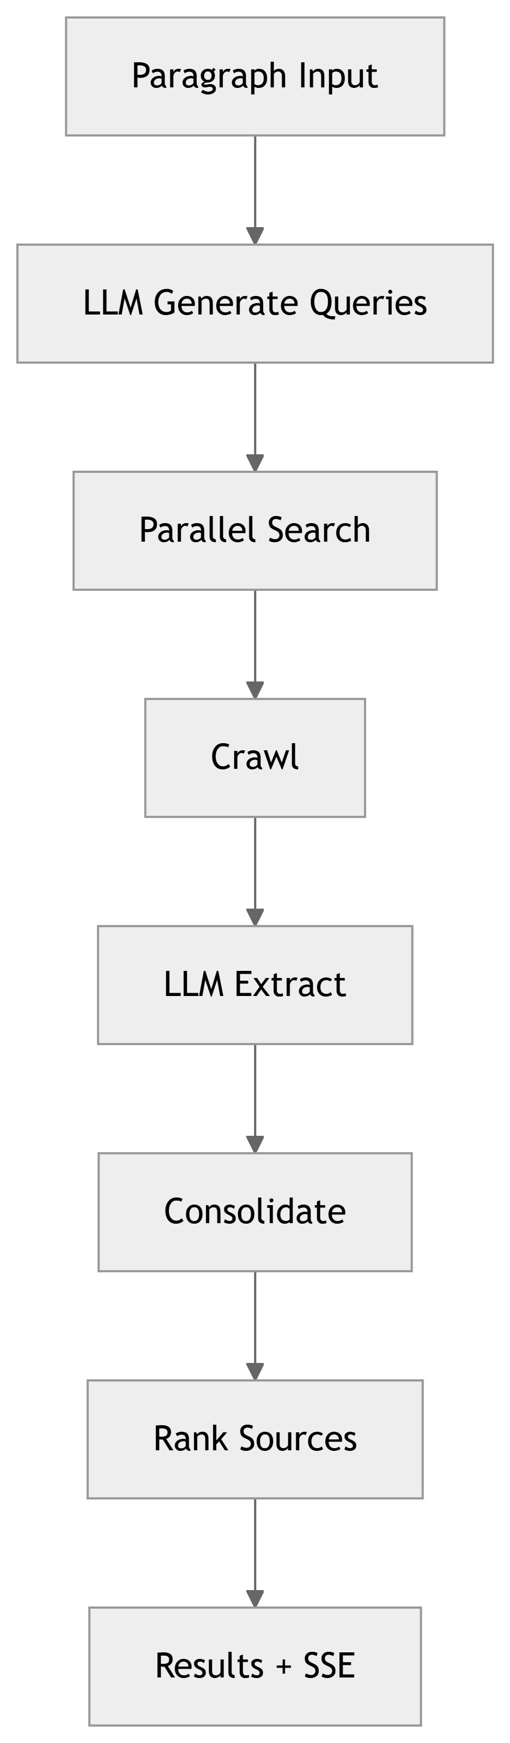

8. Non-Functional Highlights
- Performance: parallel search/crawl, bounded LLM concurrency, chunked combine, early-stop.
- Reliability: SSE live updates + polling fallback; graceful cancellation.
- Security: API key rotation; recommend restricting CORS and adding auth for production.
- Observability: research.log, persisted full_results.

9. Detailed Pipeline Stages
- [Search]
  - Inputs: entity_name, entity_type, keywords[] or paragraph.
  - Action: Generate queries (LLM if enabled) and fan out across Google/Bing/Yahoo in parallel (_search_all_engines).
  - Output: Deduplicated, crawlable result URLs.
- [Filter]
  - Non-crawlable filter via _is_crawlable_url() (social, wiki, auth-required, binary assets).
  - Caps per engine to distribute results fairly.
- [Crawl]
  - Playwright Chromium with 3-tier fallback: normal → http2-disabled → aggressive flags.
  - DOM sanitized to text (scripts/styles/images removed), title + headers preserved.
- [Extract]
  - LLM per-page extraction (bounded concurrency via semaphore).
  - Strict name matching, normalized date fields; returns per-profile metrics (confidence, name similarity, keyword alignment) and extracted_info.
- [Consolidate]
  - Chunked LLM consolidate_clusters(); fallback _local_consolidate() ensures deterministic merge by name buckets.
  - Computes final_entities.entities[] with combined_fields and initial field_sources.
- [Rank Sources]
  - For each entity field, rank member sources with weighted signals: exact/partial match, presence, confidence, name similarity, and explicit-vs-calculated preference for age/DOB/YOB.
- [Report & Persist]
  - SSE state/snapshot/done to UI.
  - History DB writes: lifecycle, durations, counts, and full_results (JSON).

10. Configuration & Environment
- LLM
  - GEMINI_API_KEY: API key (rotated via app/utils/api_key_rotator.py).
  - LLM_QUERY_GENERATION: true|false to use LLM for query generation.
  - LLM_CONCURRENCY: max simultaneous LLM extractions (default 8).
  - USE_LLM_CONSOLIDATE: toggle final LLM consolidation.
- Consolidation & Early Stop
  - NAME_MATCH_THRESHOLD (e.g., 0.9) for same-as-query detection.
  - EARLY_STOP_FIELDS: required fields list to allow early stop.
  - Paragraph alignment threshold (if paragraph flow enabled).
- Server
  - HOST, PORT (e.g., 0.0.0.0:8000).
  - CORS allowlist (currently *; lock down for prod).

11. Error Handling & Resilience
- Search: per-engine timeout (60s per query). Failures logged and skipped.
- Crawler: tiered fallbacks catch protocol errors (HTTP/2, empty responses), then aggressive mode; returns error metadata if all fail.
- LLM: retries via _chat_completion_with_retry; chunked consolidation limits blast radius.
- SSE: if disconnected, the UI falls back to GET /research-status/{id} polling.
- Cancellation: POST /research-cancel/{id} sets cancel flag; long operations check cooperatively.

12. Performance Tuning
- Parallelism: search fan-out, crawl concurrency, LLM semaphore.
- Chunking: consolidation in batches (e.g., 15) plus final pass.
- Early Stop: when target fields are satisfied for a high-confidence match, combine and stop extra work.
- Time bounds: engine queries 60s, crawler waits for domcontentloaded with selectors capped at ~30s.

13. Security & Privacy
- CORS: restrict origins for production.
- Secrets: do not commit API keys; rely on environment variables / secret stores.
- PII: treat extracted personal attributes carefully; consider masking/log scrubbing.
- Robots/ToS: filter non-crawlable endpoints; respect site policies.

14. Testing & Local Dev
- Backend: run uvicorn main:app --reload (single worker recommended with Playwright). Ensure playwright browsers installed.
- Frontend: npm run dev (Vite). Configure API base as http://localhost:8000.
- Quick sanity: start an async search from Search.jsx, watch SSE on Results.jsx, and confirm history entry in /history. # Appendix: File References
- API: backend/main.py
- Orchestrator: backend/app/services/entity_research_service.py
- LLM: backend/app/services/llm/gemini_client.py
- Crawler: backend/app/services/crawler/base.py
- Search: backend/app/services/search_engine/
- DB: backend/app/database/history.py

