# Lesson 1:

**Fun with Anna**

Hey, Meet Anna. She is Elsa’s sister, Princess of Arendelle. She loves adventures. Today she wants to skate in her kingdom in zigzag route. Let’s go on skating with Anna as long as you want.

**Expected result:**

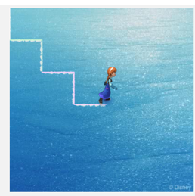

**Actions required:**

* Open the link: <https://studio.code.org/projects/frozen/74-8yvoPmfR4sdE5euqhUWcpbFlhq1b4Z_TKyh6TUt0>
* Click on ‘How it works’
* Click on ‘Remix’
* Click on ‘Rename’ and give your project a suitable name.
* This is the code that you will see

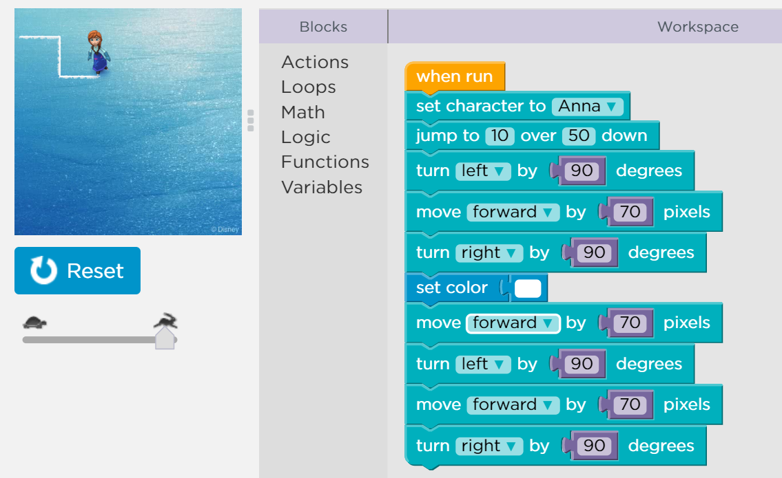

* Add your code to complete the zigzag route for Anna to skate.
* Run the code
* Once satisfied, click on share and upload the link on your dashboard.

**Hint**

Half of the code has already been done for you. Observe the code carefully and try to understand what each block is doing. You need to repeat the same code to complete the zigzag path.

Drag the required blocks from the toolset and drop to the workspace area. Set the length to 70 pixels and angle to 90 degrees.

**Solution:**

Set colour - Move forward by 70 pixels – Turn right by 90 degree Move forward by 70 pixels – Turn left by 90 degrees - Move forward by 70 pixels