# Lesson 2:

**Sticker Art with Loops**

Try something on your own using sticker arts.

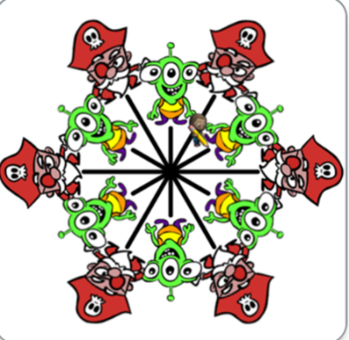 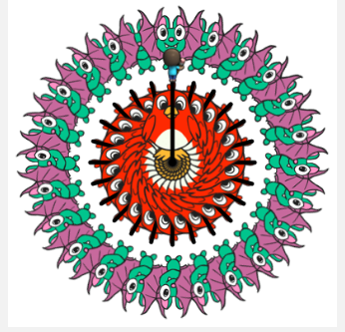 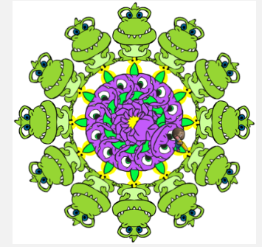

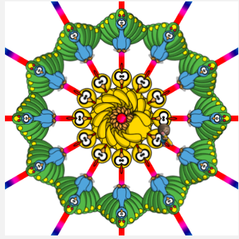 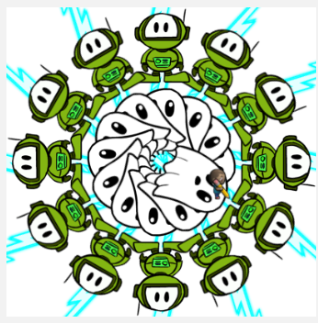

**Actions required:**

* Open the given link to make your own art: <https://studio.code.org/projects/artist/vvWp6_LojG-boCe_-x-ecZelxuhgOApOzg4PDd6ne5A>
* Click on Remix
* Save the project with a suitable name by clicking on Save
* Start working on the sticker of your choice
* Click on share to get the sharable link and upload it on your dashboard.

**Hint:**

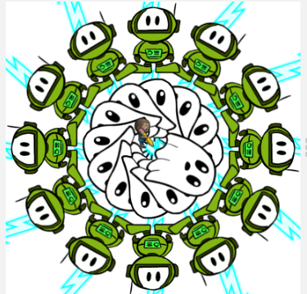

Here, Raj wants to draw 3 set of stickers overlapping each other- First set is a lightening pattern, next are ghosts and last are robots. Now for each set he wants 12 stickers. So first set pattern and move forward by 250 pixels. Jump back to middle centre position. Draw a ghost sticker. Jump forward by 100 pixels and draw a robot sticker.

For looping, he wants to draw 12 stickers in each set. Hence set the repeat block to 12.

360 divided by 12= 30 which will be our turning angle.

**Solution:**

