# Lesson 3:

**Anna on skates!!**

Princess Anna is out skating and wants to leave behind beautiful impressions. Let’s create snowflakes using angles and loops that we have learnt so far.

**Expected result:**

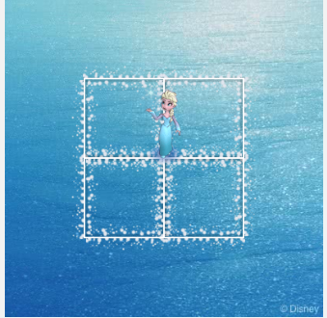

**Actions required:**

* Open the link : <https://studio.code.org/projects/frozen/lkZEUCxjRZhcA21gSIw8_rAOpHN9T94RRwXbxU9DJjw>
* Click on how it works
* Click on Remix
* Add the blocks for Anna to complete the square.
* Save the project by clicking on Rename
* Click on share to get the link of the project and upload this link in your dashboard.

**Hint:**

Draw a square first using single repeat loop. After drawing the square turn right by 90 degrees. Repeat the entire code 4 times to draw 4 squares.

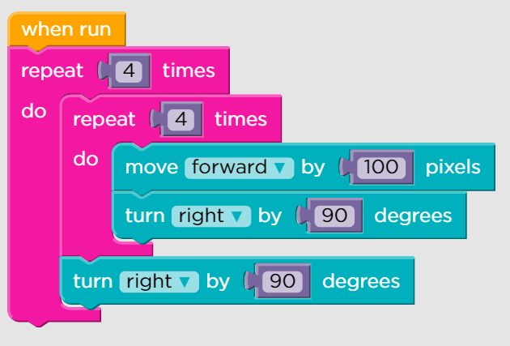

You can use your creativity and draw any shape/snowflake of your choice. Few examples are:

