# Lesson 5:

**Art using variables**

Meet our photographer John. He has clicked a beautiful picture of a peacock. He wants to frame it and gift it to his friends. Draw 2 colourful squares using length variable and place the sticker of Peacock inside it.

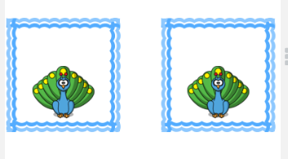

**Actions required:**

* Open the given link: <https://studio.code.org/projects/artist/lWN4FSuXtVxd4VIqPQWyZZzCDUIvP9mXHyB2IUB4ew0>
* Click on how it works
* Click on Remix
* Add the blocks for your code and run it till you get the desired output.
* Save the project by clicking on Rename
* Click on share to get the link of the project and upload this link in your dashboard.

**Hint:**

Draw a square using repeat block and length variable. As the peacock needs to be in the centre of the square, move forward by half the length of the sides, turn to the required direction and draw the peacock sticker. Jump forward by length variable and draw the other square with sticker by placing the previous code inside another repeat block.

