# Lesson 2:

**Draw a square**

Raj has been assigned homework to draw a square. Let’s help him finish the homework

Actions required:

* Open the given link:

<https://studio.code.org/projects/artist_k1/9luvVfzFcyhR4xvu1bHXl591rM-zkYp2d5QFBA_x-3g>

* Click on How it works
* Click on the Remix Button
* Click on Rename and give a suitable name to your project

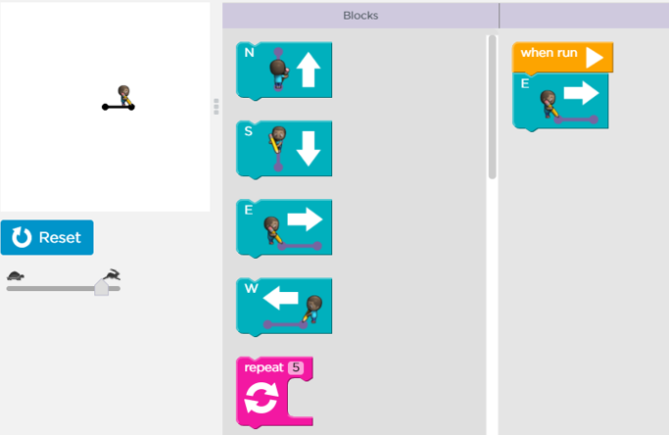

* Add the blocks to complete the square.
* Once complete, click on share and upload the link to your dashboard.

**Solution:**

