# Lesson 3:

**C for Coding!**

As you have shown great interest in learning Computers and coding, today you will write the letter ‘C’ in Artist lab.

**Expected outcome:**

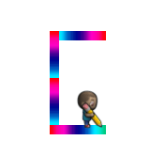

**Actions required:**

* Open link: <https://studio.code.org/projects/artist_k1/6L8fvDtJsBHPp92T_NPQ7DdWNbVTT_p18iRZAIaYnXc>
* Click on ‘How it works’
* Click on ‘Remix’
* Click on ‘Rename’ and give your project a suitable name
* Notice block has been used which will draw colourful lines
* Add code to complete the letter C🡪 West- South- South-East
* Click on ‘Share’ and upload the link on your dashboard.

**Solution:**

