# Lesson 4:

**Dog House**

Joe has got a new dog on his birthday. He wants to build a small pet house for his dog. Can you help me complete the code using Loops concept learned in the class?

**Draw sticker** block is used to get the pet in play area. Here small portion of the pet house is completed.

**Expected outcome:**

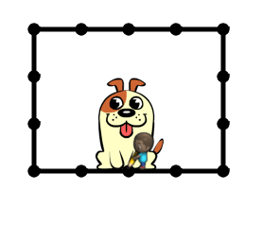

**Actions required**:

* Open the below project link:

https://studio.code.org/projects/artist_k1/XAK8MOmuL6XoSkbqHqBK7TvklQ-KMGtAj9NUnNEryU0

* Click on ‘How to Run’.
* Click on Remix

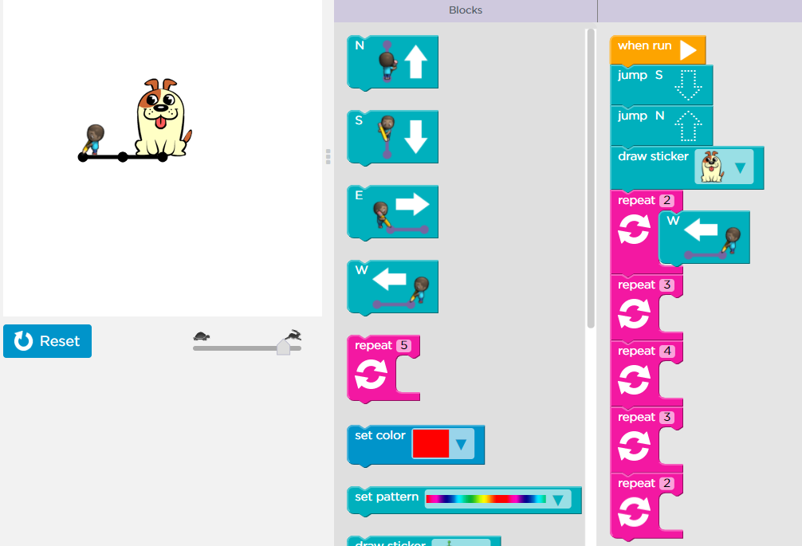

* Click on Rename and give your project a suitable name
* Add the code to finish the house
* Once done, click on share and upload the link on your dashboard.

**Solution:**

Half of the code has already been done for you. You just need to complete the rectangle by placing direction blocks inside the repeat loops.

You are free to use your imagination and draw something else. You can even change the sticker or use a different pattern for the House. Give it a try !

