# Lesson 5:

**Orange Hut**

Our Artist wants to draw something with using loops. So, he has decided to draw a hut. Let’s help him to complete his hut.

Top of the hut has been drawn for you in the form of a triangle.

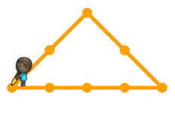

You need to complete the hut by drawing a rectangle below it.

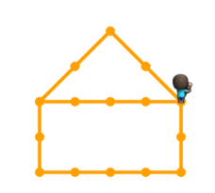

**Actions required:**

* Open the given link- https://studio.code.org/projects/artist_k1/fQcxGq6JrFZZ2ZBfB3tG_2Rf64dTVAd50GtHcpl2amE
* Click on how it works.
* Click on ‘Remix’
* Click on Rename and give your project a suitable name
* Add the code to complete the hut.
* Once satisfied, click on share and upload the link on your dashboard.

**Solution:**

1. Half portion of the hut is completed.
2. Draw the blocks using repeat loops in the given format
3. South – South –East – East – East – East – North - North

Run the code.

