# Lesson 2:

**Debug the path**

Elsa is learning skating in the snow. She thought of drawing a square snowflake, but ended up drawing something else. Can you spot the mistake and correct the code?

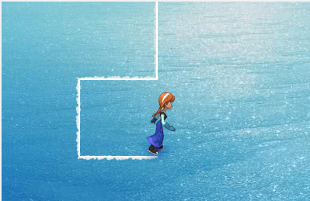

**Actions required:**

* Open the given link-

https://studio.code.org/projects/frozen/w5MnX0TRL7BgK9lTlZ0Uh-LqK_ShmCKNIOhEwYWBGVk

* Click on how it works
* Click on Remix
* Run the code to spot the missing/incorrect blocks.
* Change the blocks for Anna to create SQUARE snowflake.
* Save the project by clicking on Rename
* Click on share to get the link of the project and upload this link in your dashboard.

Hint: Check the turning directions. She needs to turn in the same direction to complete a square.

