# Lesson 3:

**Getting Loopy**

Do you remember the square snowflake you created after the first session? Here is the code for it.

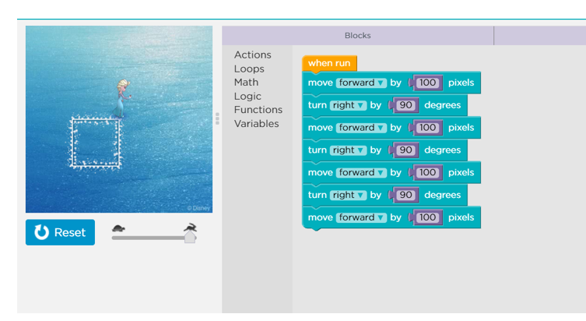

Can you make it shorter using loops? Think !! Think !!

**Actions required:**

* Open the given link:

https://studio.code.org/projects/frozen/bLsr4E0g2WF4je7EK1z8_sf1Fwq26r729DndgBuUhew

* Click on how it works.
* Click on Remix.
* Add the blocks for Elsa to complete the square using repeat loop.
* Save the project by clicking on Rename
* Click on share to get the link of the project and upload this link in your dashboard.

Hint: Look at the repeated code in the above screenshot of creating a square. Put the repeated code inside a repeat block. Count the number of times the code is repeated. Put the same number in the repeat loop.

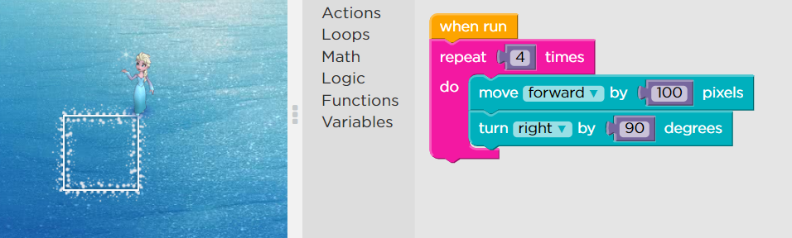

Going one step further can you try to create 4 rectangles using loops? Or any different shaped snowflakes like hexagon, rectangle? Give it a try and upload the link of the final project on your dashboard.