# Lesson 4:

Rise like a STAR

Artist Alex is doing a great job. Let’s give him a star for his excellent performance. Draw a colorful Star shape by using set pattern block.

**Actions required:**

* Open the link: <https://studio.code.org/projects/artist/Xsoau4XPdQMo-EF2y1MvHWGjRDCVwLQ2GNmXhee61Sk>
* Click on how it works
* Click on Remix
* Add the blocks to complete the star.
* Save the project by clicking on Rename
* Click on share to get the link of the project and upload this link in your dashboard.

**Expected outcome:**

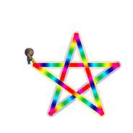

**Hint:**

Each side of the star is of 200 pixels and the turning angle is 144 degrees to the right.

As 5 sides of star are need to be drawn set the repeat block to 5. Blocks inside repeat block are : Move forward by 200 pixels – Turn right by 144 degrees

