# Lesson 5:

**Sticker Art**

Try something on your own using sticker arts.

For example:

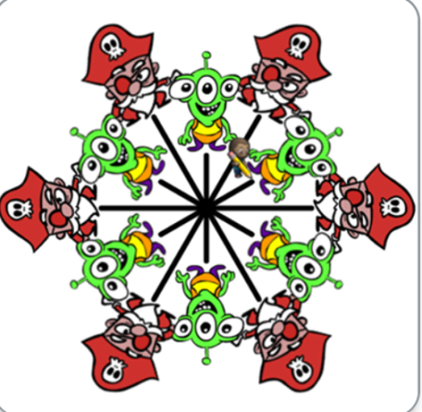 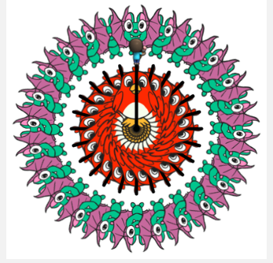 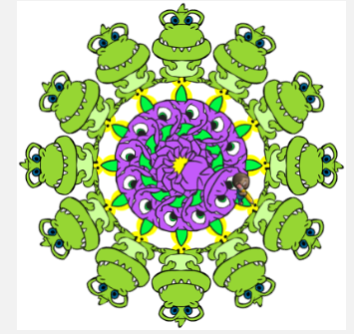

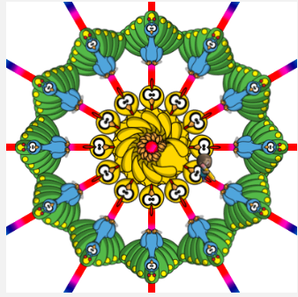 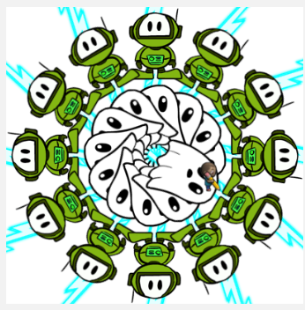

**Actions required:**

Open the given link to make your own art.

* <https://studio.code.org/projects/artist/vvWp6_LojG-boCe_-x-ecZelxuhgOApOzg4PDd6ne5A>
* Click on ‘How it works’
* Click on Remix
* Save the project with a suitable name by clicking on Save
* Start working on the sticker of your choice