# Lesson 6:

**ICE AGE**

Have you seen the movie Ice Age? Do you remember what was it all about?

Its set during the ice age when glaciers covered most of the earth. The film centres around three animals who come across a human baby. They bond together to return human baby to its family.

So, who are these three animals?

1. Manny 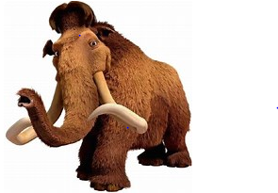
2. Diego 
3. Sid 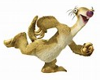

The movie also features two more characters Granny and Scrat.

Create a project based on 3 main characters- Manny, Diego and Sid.

**Actions Required:**

* Open the given link <https://studio.code.org/projects/iceage/X44Zq89N1t9qBHbMTVm9DNbZosyBcKWF4jjZwE1Nv0E>
* Click on ‘How it Works’.
* Click on the ‘Remix’ button
* Add your code to create an interesting story
* Click on ‘Rename’ and save your project with a suitable name
* Click on ‘Share’ and upload the link on your dashboard.

**Hint:**

This is just a sample project. We expect you to use your own creativity and create a fantastic story. We are creating a story in which Diego is moving up and down. Manny is trying to catch him. Every-time he touches Diego, he scores a point.

* Set the background as icy.
* Make 2 characters Manny, Diego.
* Make each of the character say something
* Make Diego move up and down in repeat forever block
* Add right and left arrow key movements to actor 1 – Manny
* Add when touched block- score a point and play a sound

