* Current trajectories (I beta vs I alpha)

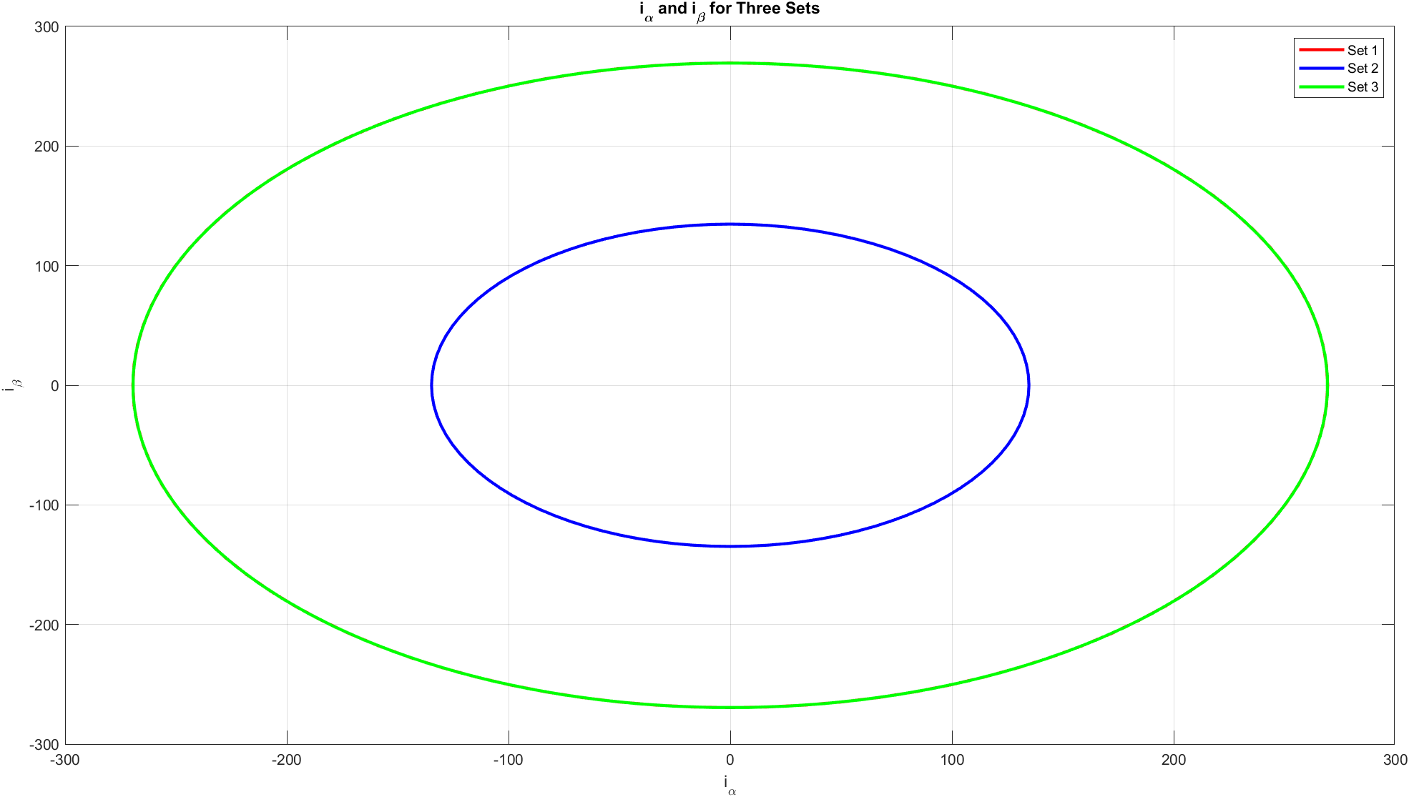

* Slope Psi 1 vs time

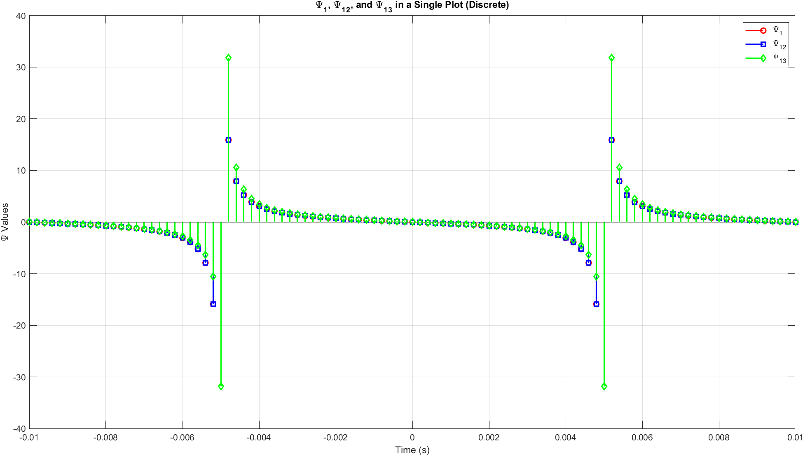

* Slope Psi2 vs time

