CrimeVista: An Integrated Platform for Urban Crime Data Analytics and Spatial Exploration
Authors: Author names to be supplied
Affiliation: To be supplied

ABSTRACT
CrimeVista is a web application for filtering and exploring structured crime records through an integrated dashboard, area summaries, temporal charts, an incident map, and downloadable reports. This paper documents the implementation in the checked-in repository and evaluates its behavior against the bundled data and available tests. The system uses a React and TypeScript client, a FastAPI service, SQLAlchemy persistence, and a single `Crime` table. In the inspected snapshot, the CSV and local SQLite database each contain 16,000 records dated from January 2022 through June 2025. All records have coordinate pairs accepted by the import validator, but victim age and gender are missing in 31.6% of rows and weapon information is missing in 88.3%. Dataset provenance and licensing are not documented, so these counts are treated as properties of the supplied dataset rather than official crime statistics. The implemented analytics are descriptive: filters, distributions, monthly totals, rolling-period comparisons, and areas ranked by incident count. The system does not implement predictive modeling, infer severity, or perform formal spatial hotspot analysis. Five backend unit tests passed; isolated API and report checks and a frontend production build also succeeded. The paper contributes a reproducible account of an integrated crime-data exploration system and identifies the data, spatial, operational, and privacy evidence still needed before the outputs can support high-stakes decisions.
Keywords: crime data analytics, geospatial visualization, decision support, descriptive statistics, data quality, web information systems

I. INTRODUCTION

A. Background and motivation
Crime records combine dates, classifications, administrative areas, and sometimes geographic coordinates. Reviewing these attributes across separate spreadsheets or tools makes it difficult to apply a consistent filter, compare time periods, inspect where records are located, and prepare a summary for later review. A common interface can reduce this operational friction, provided that users can see what the numbers mean and where the source data is uncertain.
CrimeVista addresses this information-management problem with a browser-based application that places record filtering, descriptive summaries, map-based inspection, and report export behind one service. The system is designed for exploration of an uploaded or preloaded dataset; it does not replace source systems or provide an automated policing recommendation.

B. Problem statement
The engineering problem is to make a tabular crime dataset searchable across dates, incident types, severity labels, and areas while exposing the same selected subset through charts, a map, area profiles, and exports. The platform must also separate public read access from administrator-only dataset replacement and report generation. These requirements concern consistent data access and presentation. They do not, by themselves, establish that a pattern is statistically significant, predictive, or representative of unreported crime.

C. Research gap and objectives
Crime mapping literature distinguishes the choice of spatial unit, time window, crime type, and hotspot method because those decisions change the resulting pattern [1], [2]. CrimeVista does not attempt to resolve these methodological questions with a new spatial statistic. Its narrower contribution is an implementation account of how a single relational record model and a shared filter interface feed multiple descriptive views and exports. This is an engineering gap within the project, not a claim that existing crime analytics platforms are absent.
The objectives are to: (1) document the actual data and software architecture; (2) describe the implemented filtering and summaries precisely; (3) validate the current snapshot and software paths without changing production data; and (4) state the conditions and limitations that constrain interpretation.

D. Contributions
This paper makes three bounded contributions. First, it describes the end-to-end path from CSV validation to persisted records, API aggregation, map/chart presentation, and report generation. Second, it provides a verified profile of the bundled dataset and reports functional checks that can be reproduced. Third, it distinguishes the implemented count-ranked area view from formal spatial hotspot analysis and identifies missing data provenance, denominators, validation, and privacy controls as prerequisites for stronger claims.

E. Organization
Section II positions the work relative to crime concentration and hotspot mapping. Sections III–VII document the architecture, data, analytics, implementation, and interface. Sections VIII–X present evaluation, results, and ethical considerations. Sections XI–XIII state limitations, future work, and conclusions.

II. RELATED WORK

A. Crime mapping and spatial concentration
Crime mapping is not a neutral act of placing points on a basemap. Results depend on the spatial unit, time interval, crime definition, and display or analysis technique. Chainey, Tompson, and Uhlig examine hotspot mapping methods and their utility for spatial crime patterns [1]. Weisburd discusses crime concentration at micro-geographic places and the implications of studying crime at place [2]. These works motivate caution when interpreting a ranked list of areas as a spatial phenomenon: area sizes, population exposure, reporting practices, and the unit of aggregation all matter.

B. Hotspot analysis and decision support
Research on hot-spot policing evaluates interventions and their outcomes, which is distinct from generating a descriptive map or ranking [3]. CrimeVista's hotspot page returns the areas with the largest record counts under the current filters. It does not estimate spatial intensity, account for area population or land area, test a null model, forecast risk, or evaluate an intervention. Consequently, the paper uses “count-ranked areas” when explaining the computation and reserves “hotspot” for the existing interface and API label.

C. Positioning of CrimeVista
CrimeVista is positioned as an integrated exploration and reporting application. Its contribution is the assembly of a normalized-enough incident record, shared filters, ordinary relational queries, descriptive aggregations, point visualization, and exports into a single web workflow. It is not a novel geospatial algorithm. It has no documented comparison against commercial systems, no expert-user study, and no evidence that the supplied dataset is complete or representative. This scope keeps system functionality separate from scientific validation.

III. SYSTEM OVERVIEW AND ARCHITECTURE

A. Requirements and design
The implementation supports four practical tasks: inspect aggregate counts; narrow a dataset with common filters; inspect geocoded rows and area summaries; and produce portable reports. A web client permits different views to share one stateful filter selection. A typed API boundary makes the server operations explicit, while SQLAlchemy allows the local SQLite configuration and production PostgreSQL configuration to use the same ORM model [4]–[6]. These are implementation-fit rationales, not measured performance advantages.

B. Overall architecture
The application has a browser client, FastAPI routers and services, SQLAlchemy persistence, and a relational database. The same FastAPI process serves the built frontend in the configured deployment. The CSV importer is the data-loading boundary. The map tile service is external to the application; incident coordinates come from stored rows. Authentication protects administrative operations, while the dashboard and analytic read endpoints are public in the current route configuration.
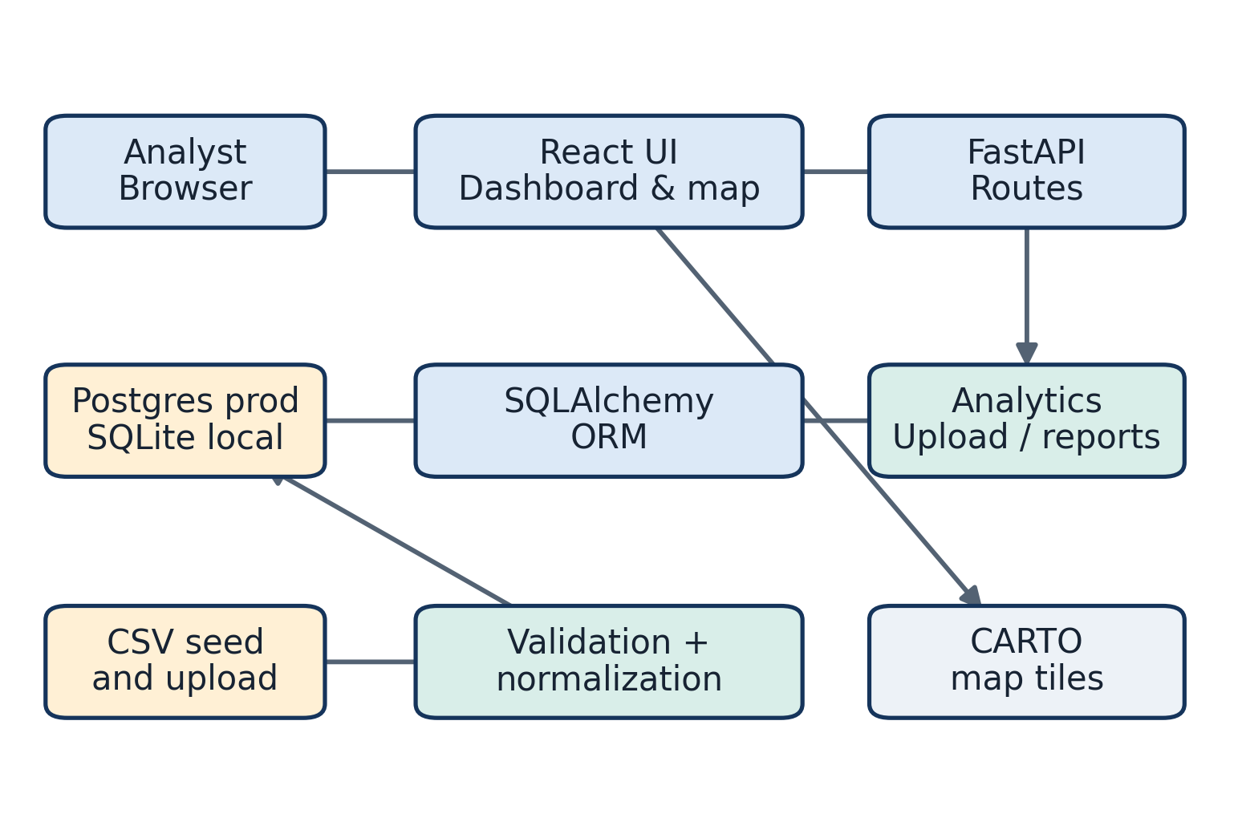
Fig. 1. CrimeVista system architecture, from browser views through API services and relational storage, with map, report, and administrator paths.

C. Frontend and API
The client is implemented with React and TypeScript [7]. React Router maps the landing page and analysis pages to client routes. React Query manages server-state queries, and a shared Axios client sends requests to the same-origin `/api` path by default, with credentials enabled. The API is divided into routers for health, authentication, filters, dashboard, records, analytics, maps, uploads, and reports. FastAPI exposes typed request handling and an OpenAPI schema [4].

D. Persistence and data model
The ORM defines one entity, `Crime`, with `crime_id` as its primary key and no foreign-key relationships. Date, area, crime type, and severity are the required import attributes. The model includes ordinary floating-point coordinates, optional victim attributes, status, police-station label, description, and source metadata. Indexes exist on frequently filtered fields, but they do not change the fact that many application paths load full result sets before aggregation or pagination.
The project uses PostgreSQL for its configured production service and SQLite for local fallback. PostgreSQL provides a relational persistence target compatible with the same SQLAlchemy model [5], [6]. No PostGIS types or spatial indexes are used; the application stores latitude and longitude as numeric fields and performs coordinate validation in Python.
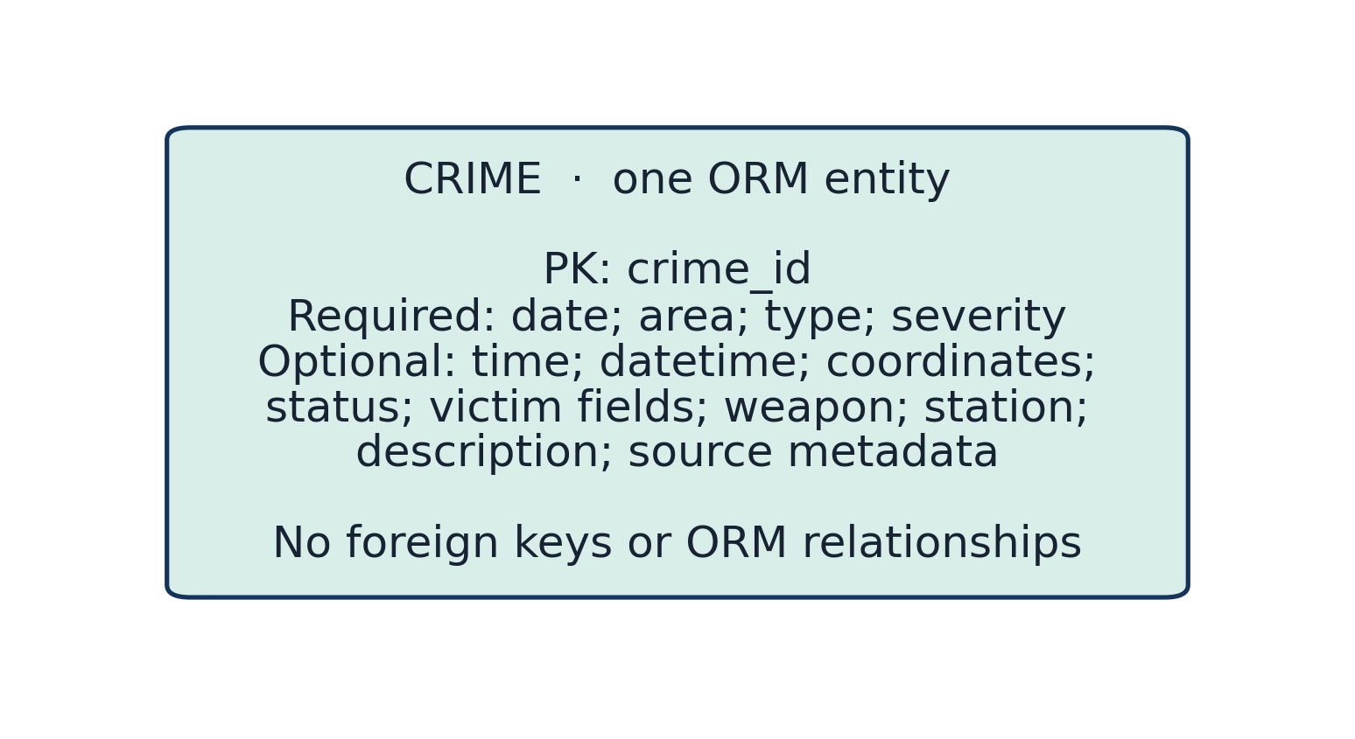
Fig. 2. The implemented relational model contains a single Crime entity with no foreign-key relationships.
FastAPI routers expose endpoints for reads, authentication, uploads, and reports. A browser request passes through a shared HTTP client, route-level dependency injection, filter/service logic, and SQLAlchemy before the response returns as JSON. The same route design supports the interactive OpenAPI schema [4].
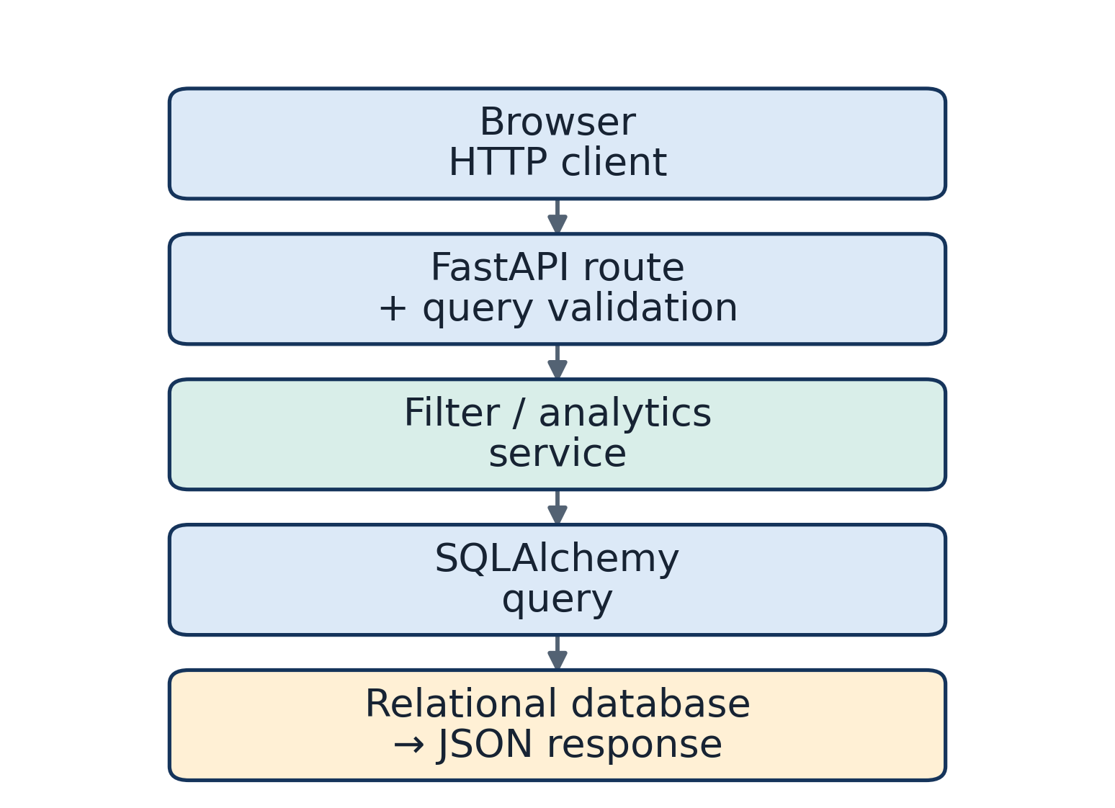
Fig. 3. Request path from the browser client through a FastAPI router and service to SQLAlchemy and the relational database.

E. Analytics and map layer
The analytics service calculates category counts, monthly totals, top areas and types, severity distributions, time-of-day bands, and adjacent 90-day comparisons. The map route returns validated coordinate pairs and caps the incident list at 3,000 records. The client renders them with Leaflet [8] over CARTO raster tiles [9], preserving provider attribution. No geocoding, administrative polygon source, or server-side spatial aggregation is configured.

F. Reports, authentication, and deployment
The report service builds PDF, CSV, and XLSX outputs from filtered database rows. Administrator sign-in compares credentials supplied through server environment variables and issues a 30-day signed cookie; an API bearer token remains supported for direct clients. Upload and report operations require authentication, while analytic read routes do not.
The Render blueprint describes one Python web service, a frontend build step, a managed PostgreSQL database, and an API health check [10]. The public-origin values in the checked-in deployment file are placeholders. The paper therefore describes configured architecture and does not claim a verified live deployment.
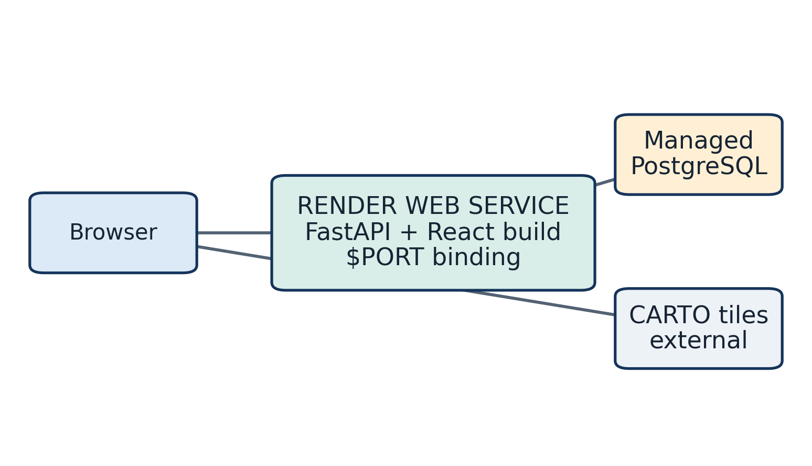
Fig. 4. Configured single-service deployment: browser traffic reaches the FastAPI service, which serves the React build and uses managed PostgreSQL; map tiles are external.
TABLE I
TECHNOLOGY STACK
Layer | Technology | Purpose
Client | React, TypeScript, Vite | Page composition, routing, browser build
Client data | React Query, Axios | Query state and HTTP requests
Charts | Recharts | Dashboard and trend visualizations
Map | Leaflet, CARTO raster tiles | Coordinate display and basemap
API | FastAPI, Pydantic | REST routes, validation, OpenAPI
ORM | SQLAlchemy | Relational persistence and queries
Database | SQLite locally; PostgreSQL configured for production | Incident record storage
Export | ReportLab, pandas, OpenPyXL | PDF, CSV, and XLSX reports
Deployment | Render blueprint | Web service and managed database configuration

IV. DATA ACQUISITION AND DATASET

A. Data sources and scope
The repository contains an initial CSV and a local SQLite database. Both contain 16,000 records in the inspected snapshot. The date field spans 2022-01-01 through 2025-06-30. The data describe one urban administrative scope in this snapshot, but the software model includes a city attribute and the upload workflow can replace the active records. The platform should not be understood as technically limited to the bundled geography.
The CSV's source field is populated but has one distinct value, and the repository does not document its provenance, collection method, reuse license, or verification status. The records are therefore analyzed as the bundled project dataset only. No claim is made that the file is an official government register, a complete count of incidents, or a representative sample.

B. Data attributes
The input contract requires an identifier, date, area, crime type, and severity. Optional columns hold time and datetime; city; latitude and longitude; status; victim age and gender; weapon; police station; description; and source identifiers. The broad schema supports multiple descriptive views but also stores fields that may be sensitive. Table II summarizes the attributes as modeled.
TABLE II
DATASET ATTRIBUTES
Attribute | Type | Description | Role
crime_id | String, primary key | Stable row identifier | Required identity
date | Date | Incident date | Required time filter
time | String | Time of day | Optional time band
datetime | DateTime | Combined timestamp | Optional ordering/metadata
city | String | Jurisdiction label | Optional filter
area | String | Administrative/local area | Required grouping
crime_type | String | Incident category label | Required grouping
latitude, longitude | Float | Supplied point coordinates | Optional map location
severity | String | Supplied severity label | Required grouping
status | String | Record/case status | Optional filter
victim_age | Integer | Victim age when available | Sensitive optional attribute
victim_gender | String | Victim gender when available | Sensitive optional attribute
weapon_used | String | Weapon descriptor when available | Sensitive optional attribute
police_station | String | Station label | Optional filter/group
description | Text | Free-text incident description | Sensitive optional detail
source | String | Source label | Provenance metadata
source_record_id | String | External/source row reference | Provenance metadata

C. Data quality and cleaning
Import code strips whitespace and a UTF-8 byte-order mark from column names, case-folds the headers, trims values, and interprets empty-like strings as missing. It parses dates, converts numeric ages, and sets coordinates outside latitude/longitude bounds to null. Rows missing any required field, containing an invalid date, or repeating an identifier within an uploaded file are rejected. Severity and crime-type values are accepted as supplied; there is no project-defined classifier or comprehensive canonicalization table.
The local database has 16,000 records and its date span and category distributions match the bundled CSV. All 16,000 rows have valid coordinate pairs in this snapshot. Victim age and gender are each missing in 5,054 rows (31.6%); weapon information is missing in 14,135 (88.3%). Missingness matters: charts that omit missing values can describe only the populated subset, not the full underlying population.

D. Processing pipeline
On startup, the service creates the ORM schema and imports the configured initial CSV only when the selected database contains no crime records. Administrator uploads accept CSV files up to 25 MB. A valid upload replaces existing rows in a transaction; if there are no valid rows, the existing dataset is left unchanged. Upload status is held in memory and polled by the browser.
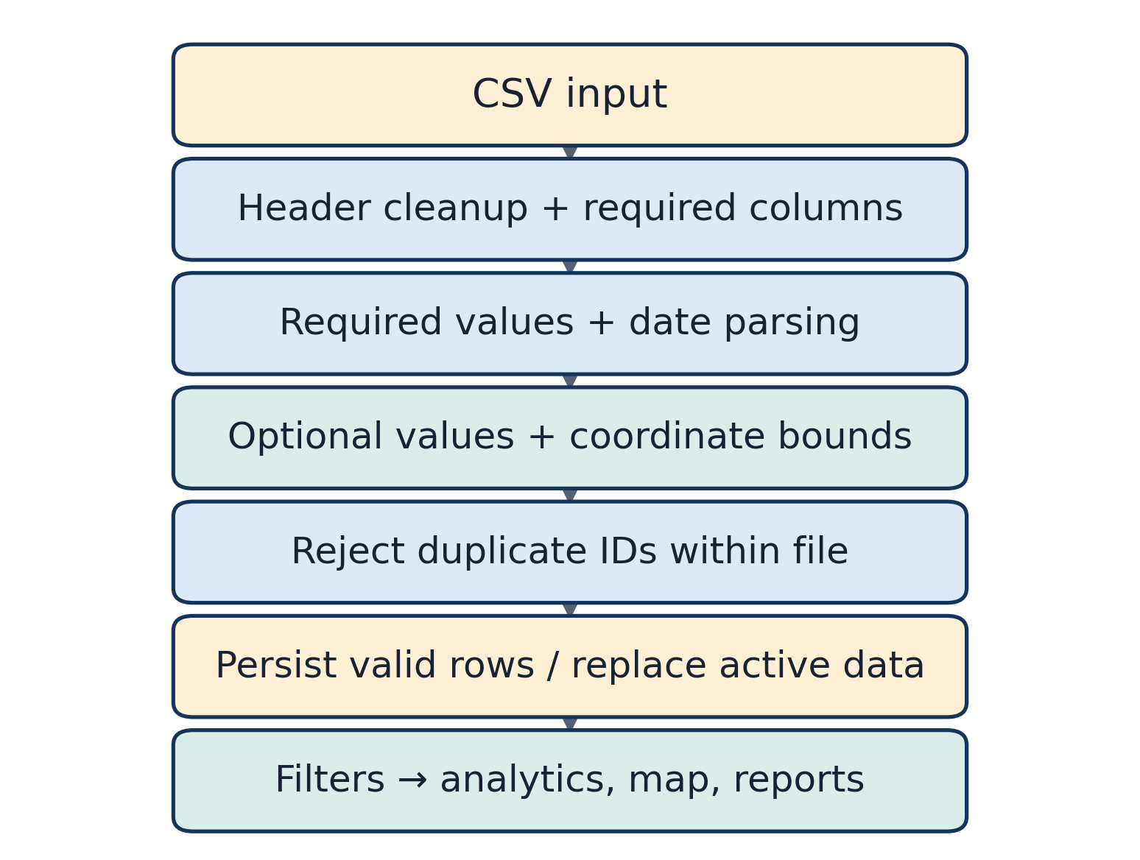
Fig. 5. Implemented CSV processing path: header cleanup and validation precede date/coordinate normalization, rejection reporting, relational persistence, and downstream views.

E. Geographic coordinate handling
The importer accepts coordinates only when latitude is within −90 to 90 and longitude within −180 to 180; malformed or missing values become null. The map route includes only rows with both valid coordinates and returns the number omitted. The bundled snapshot has no omitted coordinate pairs. This confirms coordinate syntax and range, not positional accuracy, privacy suitability, or correct placement within an administrative boundary.

F. Crime and severity categories
Crime type and severity are stored labels received from the input data. The checked-in data contain 16 crime-type labels and four severity labels: Low, Medium, High, and Critical. The backend does not infer a severity from event details. Several KPIs group High and Critical together, but the calculation compares exact label strings, so an upload with different spelling or capitalization may be counted differently.

V. DATA PROCESSING AND ANALYTICS

A. Filtering and aggregation
The backend applies inclusive ISO date bounds and exact-match filters. Comma-separated values are ORed within a dimension; filters across different dimensions are combined. Date errors return HTTP 422. Time-of-day filtering derives a band from the stored time in Python. The frontend keeps unapplied filter edits in a draft and updates shared query state after the user applies them.
After filtering, the service materializes matching ORM rows and computes descriptive aggregations in Python. The dashboard calculates filtered and total counts, the number of rows labeled High or Critical, the most common area and crime type, and distributions by crime type, area, severity, month, and time of day. Trends include monthly totals and changes between adjacent 90-day windows ending at the latest date present in the filtered records. These are record-count summaries, not population-adjusted rates.

B. Area ranking and area profiles
The hotspot endpoint counts incidents per area, returns at most 15 ranked areas, reports each area's share of filtered records, and derives a “risk level” from thresholds relative to the largest area count. The response sets `density_per_sq_km` to null. Coordinates shown for an area are the arithmetic mean of its incident coordinates. This method is a simple way to locate a ranked area's records on a map; it is not an administrative centroid or a spatial intensity estimator.
The area profile returns a selected area's distributions, monthly counts, and a comparison against leading areas. With no area polygon, population denominator, or exposure measure, a larger count cannot be interpreted as a higher per-capita risk. This distinction is central to the platform's intended use as an exploratory interface.

C. Map processing and visualization
Map coordinates originate in the dataset and are passed to Leaflet. The frontend uses circle markers and severity colors; a client-side screen-grid grouping is used when more than 200 visible points are displayed below zoom 16. Clicking a marker can select a record or zoom toward a group. This grouping only reduces visual overlap: it does not estimate a statistically meaningful cluster.
The map endpoint returns at most 3,000 points for the selected filters. Administrative boundaries are an empty array in the current route implementation. A fixed initial map viewport is a display default and is not used to generate or alter incident coordinates. CARTO tiles and browser connectivity to the external map provider are runtime dependencies [8], [9].
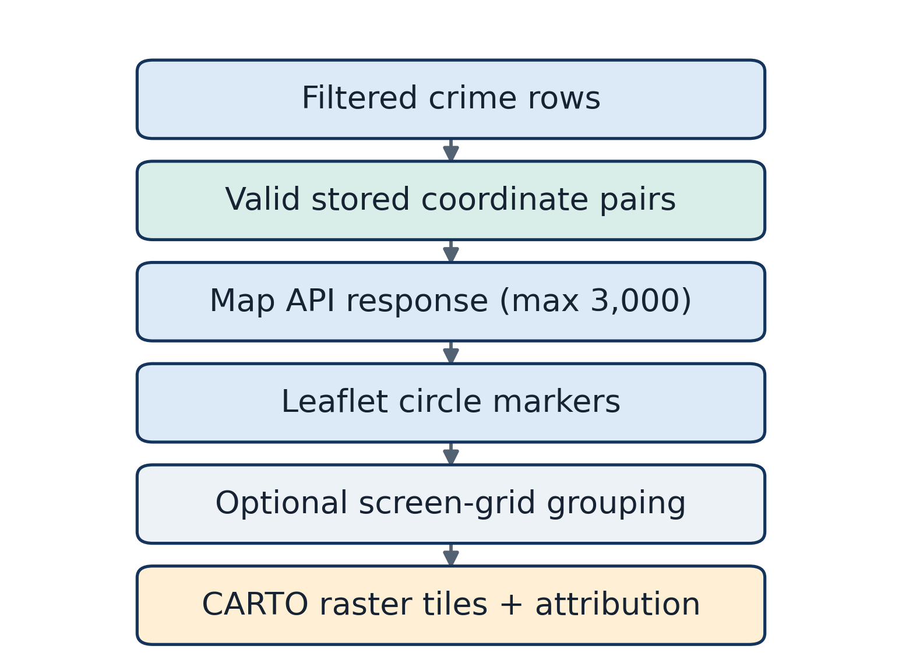
Fig. 6. Incident map data path: filtered records with valid stored coordinates are capped by the API and rendered as Leaflet markers over an external basemap.

D. Analytics workflow and interpretation
The common filter selection feeds records, dashboard aggregates, trends, area ranking, map points, and report generation. The outputs help users inspect a chosen subset; they do not identify causes or recommend a resource allocation. Table V relates implemented features to their inputs, processing, and output.
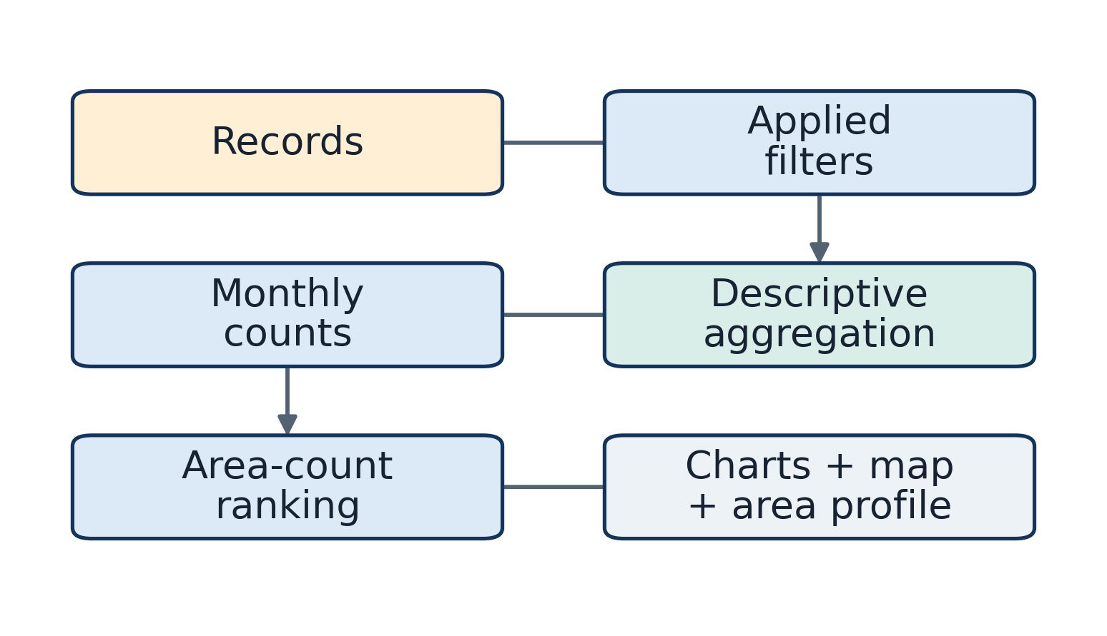
Fig. 7. CrimeVista analysis workflow, linking input records to descriptive aggregation, map/chart views, and human review.
TABLE III
BACKEND API MODULES
Module | Representative endpoint/component | Purpose
Health | `GET /api/health` | Database readiness and last-update status
Authentication | `/api/auth/login`, `/logout`, `/session` | Administrator session lifecycle
Filters | `GET /api/filters/options` | Populate category and date filters
Dashboard | `GET /api/dashboard/overview` | KPIs, insights, and chart data
Crime records | `GET /api/crimes` | Paginated filtered rows
Analytics | `/api/analytics/trends`, `/hotspots`, `/areas/{area}` | Temporal, area, and category summaries
Map | `GET /api/map/incidents` | Valid-coordinate incident points
Upload | `/api/upload`, `/upload/config`, `/upload/{id}/status` | CSV validation/import status
Reports | `/api/reports`, `/generate`, `/{id}/download` | Protected report creation and download

TABLE IV
DATABASE ENTITY
Entity | Key fields | Relationship | Purpose
Crime | `crime_id` primary key; date, area, crime type, severity; optional time, coordinates, status, victim attributes, weapon, station, description, and source metadata | No declared foreign keys or ORM relationships | Stores one incident-like row used by filters, analytics, map, and exports

TABLE V
SYSTEM FEATURES AND DATA FLOW
Feature | Input | Processing | Output
Dashboard | Filtered crime rows | Counts and distributions | KPI cards, insights, charts, record list
Trends | Filtered rows with dates | Monthly counts and adjacent 90-day comparison | Trend charts and comparison strip
Area profile | Selected area and filters | Area-specific counts and coordinate mean | Profile, charts, comparison, point map
Area ranking | Filtered rows | Sort areas by raw count; relative thresholds | Ranked list and marker map
Incident map | Filtered coordinate pairs | Range check and response cap | Leaflet markers and record details
CSV upload | Administrator CSV | Validate, normalize, reject rows, replace active data | Status and refreshed views
Reports | Filtered rows and selected sections | Server-side PDF/CSV/XLSX export | Preview, history, downloadable file
Administrator access | Server credentials or bearer token | Constant-time credential/signature comparison | Signed session cookie and protected actions

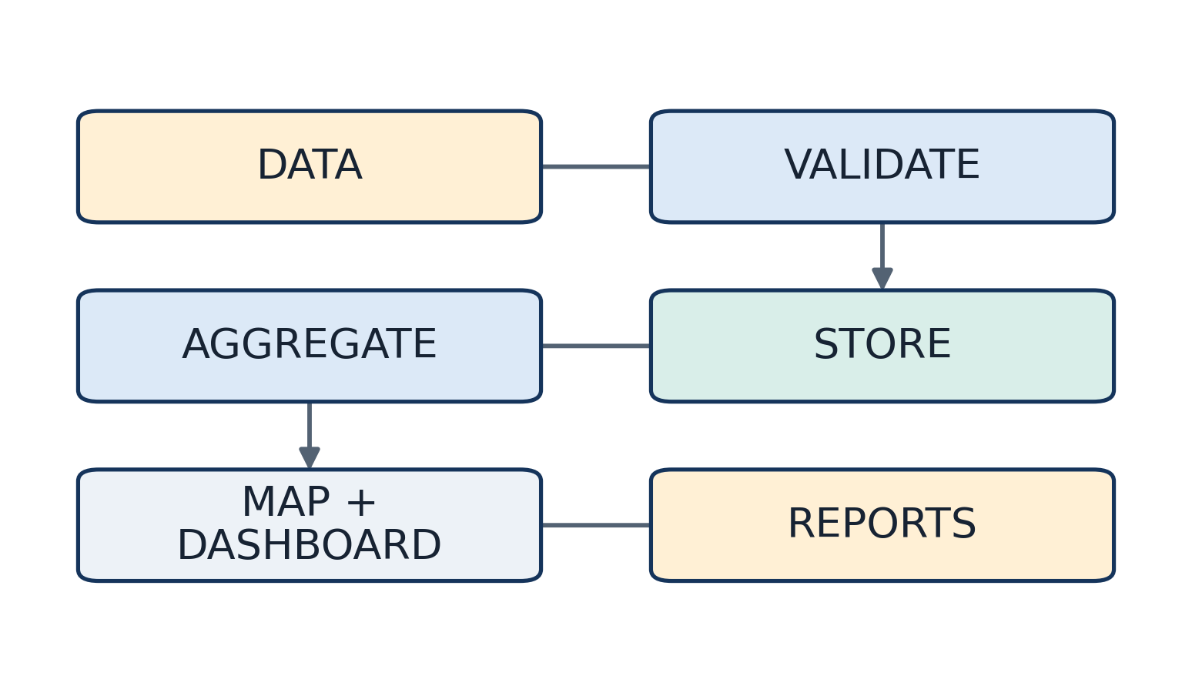
Fig. 8. End-to-end flow from CSV or preloaded records through processing, storage, descriptive analysis, maps, dashboards, and reports to human review.

VI. SYSTEM IMPLEMENTATION

A. Frontend implementation
The client has routes for a public landing page, dashboard, crime map, hotspots, trends, area explorer, data upload, reports, settings, and not-found handling. A shared filter context and API client keep filters and requests consistent across analysis views. Reusable chart, table, error, loading, and empty-state components provide common visual states. Responsive layouts and the source-level accessibility affordances are described in Section VII; no formal accessibility audit was performed.

B. REST API and database
FastAPI routers expose read operations for health, filter options, dashboard data, records, analytics, and map incidents. Administrative routes handle login/logout/session state, uploads, and reports. SQLAlchemy sessions are scoped to API operations, while data initialization creates the model table and seeds an empty database from the configured CSV.

C. Data upload
The upload API accepts CSV only, imposes a 25 MB limit, prevents concurrent uploads within one process, and schedules row processing as a background task. The browser displays upload progress and polls the status route every 1.5 seconds. This design avoids making the browser wait for validation to finish, but the task queue and status registry are in-process rather than durable. Uploading is dataset replacement, not append-only ingestion.

D. Report generation
The report request selects a title, format, sections, and filters. Server-side generation supports PDF, CSV, and XLSX. PDF output caps the optional record listing at 300 rows; CSV and XLSX record exports contain the full filtered set. Report metadata is kept in a Python list and is not persisted to the relational database. Consequently, report history and download lookup are not durable across process restarts.

E. Authentication and protected operations
There is one administrator account provisioned by environment variables; public registration is absent. A successful login returns an HttpOnly, SameSite=Strict session cookie with a 30-day lifetime; production also sets Secure. Protected routes accept the signed cookie or a bearer token. Public analytics and map APIs expose aggregate data and selected row details without a login. The implementation has no login rate limiter, and the paper makes no claim of an independent security penetration test.
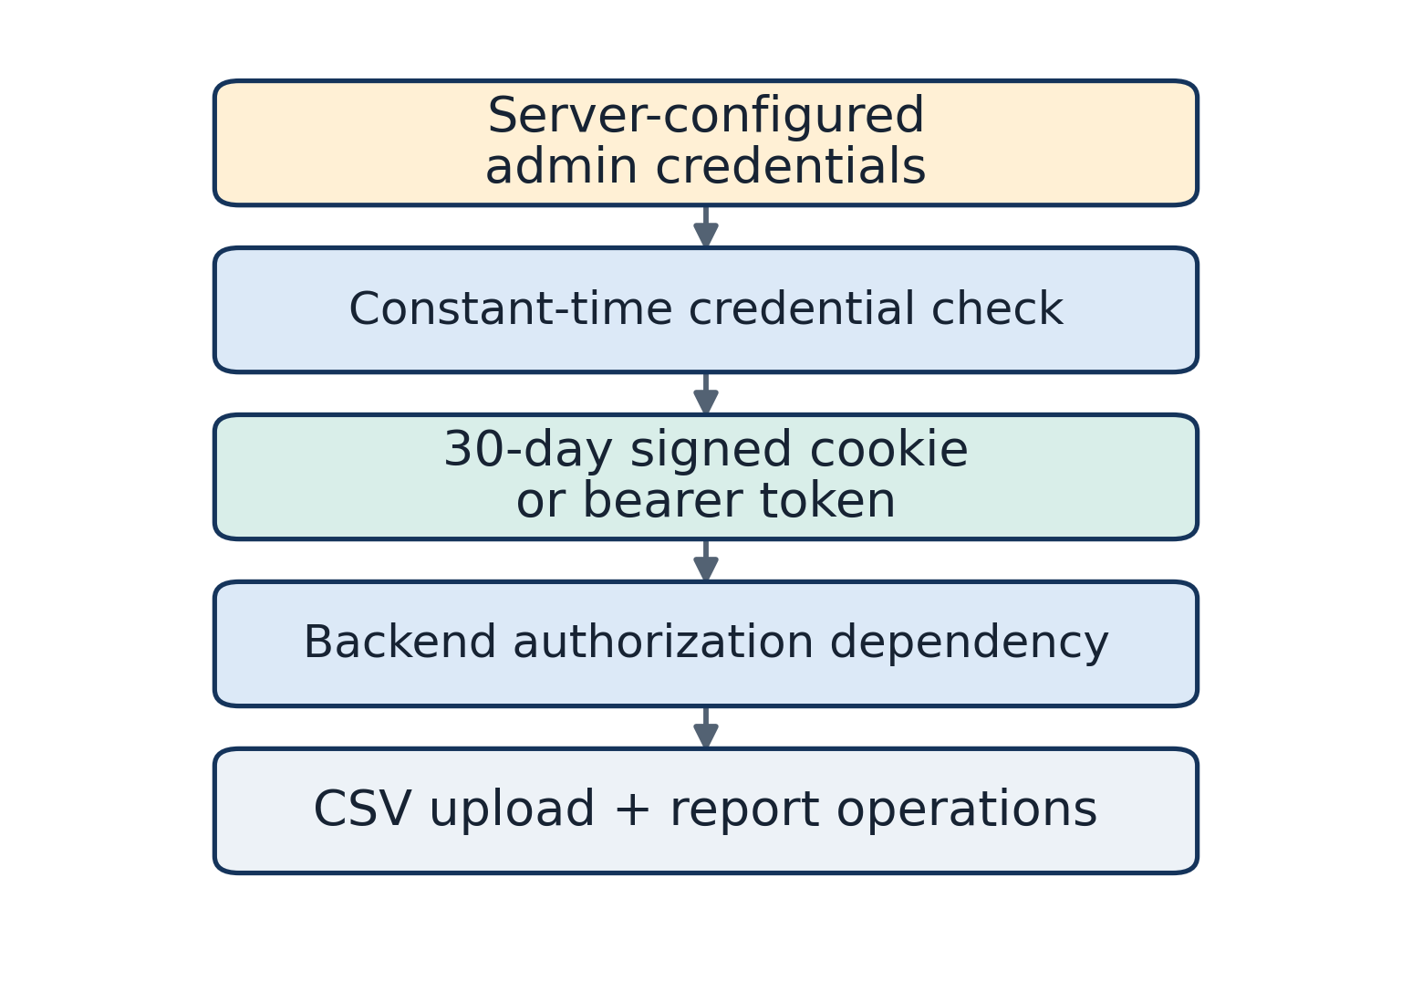
Fig. 9. Authentication and administrative flow: configured credentials establish a signed browser session or bearer access before upload and report operations.

VII. VISUAL ANALYTICS AND USER INTERFACE

A. Dashboard and charts
The dashboard composes KPI cards, a monthly trend, automatically generated descriptive insights, distributions by crime type, area, severity, and time of day, and a filtered record table. Recharts provides client-side chart rendering. These summaries are useful for navigation and comparison, but the chart labels should be read as counts from the selected data rather than estimates of population incidence.

B. Filters and user interaction
The filter panel supports date bounds, crime type, area, severity, and time-period selections. It keeps a draft until the user applies the changes; reset controls and filter chips expose active state. The same selection feeds the dashboard, map, trends, area profile, count ranking, and report request.

C. Spatial exploration
The incident map shows stored points, severity-based marker colors, an incident detail panel, and an optional display grouping switch. The area explorer presents an area-specific profile and map marker at the mean coordinate. Since polygon boundaries are not returned, the interface does not display administrative geometry or area extent.

D. Responsive and accessible design
Source code includes a desktop sidebar and mobile navigation, responsive Tailwind layouts, a skip-to-content link, labelled inputs, keyboard-operable upload controls, status announcements, and reduced-motion styles. These source-level design features are not a substitute for assistive-technology testing or a formal WCAG audit. No cross-device test was performed for this paper.

E. Reporting workflow
An administrator can choose report format and sections, generate a preview, view process-local report history, and download the generated file. The generated report is a snapshot based on the submitted filters and rows present when the request runs; it is not a live analytical artifact.
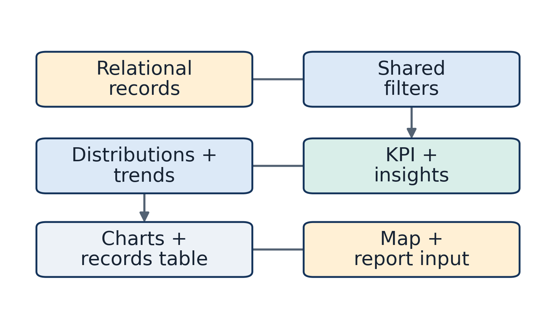
Fig. 10. Dashboard data flow from filtered rows through KPI and distribution calculations into the chart and table components.

VIII. EXPERIMENTAL EVALUATION

A. Evaluation protocol
Evaluation was limited to checks that can be reproduced from the repository. Read-only analysis profiled the supplied CSV and local database. Five checked-in backend unit tests were run. A separate smoke test launched the actual FastAPI application against a temporary SQLite database, loaded the bundled CSV, exercised public reads and an area profile, authenticated an administrator, and generated/downloaded each report format. The frontend production build was also run. No production dataset was modified.

B. Results
All five backend unit tests passed. The isolated smoke test returned HTTP 200 for health, filter options, dashboard overview, paginated crime records, trends, hotspots, map incidents, and an area profile. It confirmed 16,000 loaded rows, 16 crime types, 18 area labels, and the map response cap of 3,000 points. Authenticated PDF, CSV, and XLSX reports each generated and downloaded nonempty files. The Vite production build completed; it emitted a warning that the minified JavaScript bundle exceeds 500 kB.
These checks establish functional behavior for the exercised paths in a local test environment. They do not establish query latency, scalability, production uptime, map usability, analytical accuracy, data representativeness, or impact on crime prevention.

C. Test and evidence summary
TABLE VI
EVALUATION AND TESTING SUMMARY
Check | Evidence | Outcome | Not established
Dataset profile | Read-only CSV and SQLite queries | 16,000 rows; reported date/category/coordinate counts | Data provenance or representativeness
Authentication tests | Five tests in `test_admin_auth.py` | All passed | Penetration resistance
API functional smoke | Temporary database; eight read operations plus area profile | HTTP 200 responses and expected response shapes | Load or production reliability
Report formats | Authenticated temporary API smoke | PDF, CSV, XLSX generated and downloaded | Long-term file persistence
Frontend build | `npm run build` | Build succeeded; large-chunk warning | Browser/device usability
Predictive accuracy | No model in implementation | Not applicable / not evaluated | No prediction claim
Latency and throughput | No benchmark performed | Not evaluated | No performance guarantee
User or field study | None in repository or task run | Not performed | No usability or operational impact claim
Live deployment | Configuration inspected only | Not independently verified | No availability claim

D. Future evaluation
A later evaluation should first establish data lineage and an approved target use. It should then measure database query plans and response distributions over documented dataset sizes, verify map behavior on supported browsers and assistive technologies, test export limits and persistence across restart, and conduct a user study with appropriately authorized analysts. Any future hotspot method or forecast would need a declared unit of analysis, denominator, temporal holdout, spatial validation, uncertainty reporting, and comparison baseline before performance is claimed.

IX. RESULTS AND DISCUSSION

A. Dataset observations
The checked-in data contain 16,000 rows, 16 crime-type labels, 18 areas, and four severity labels across a date span from 2022-01-01 to 2025-06-30. Theft is the largest type group (3,390; 21.2%). Medium labels account for 6,294 rows (39.3%), Low 5,247 (32.8%), High 3,451 (21.6%), and Critical 1,008 (6.3%). High and Critical together account for 4,459 rows (27.9%). These percentages use the 16,000 record count as denominator and describe only the repository dataset.
All records have coordinate pairs that pass the configured numeric range checks. This is encouraging for rendering but does not verify geocoding accuracy. Missing victim age and gender in 31.6% of rows and missing weapon fields in 88.3% constrain any analysis based on those attributes. The missingness mechanism is unknown.

B. Implementation observations
The primary system result is integration: the same active dataset and filters drive several views and three export formats. The source-defined API and a local smoke test verify that this workflow can operate end to end. Separating the browser and API concerns while serving both from one configured service reduces the number of deployment components; its operational reliability was not measured.
The most important interpretive constraint is that the count-ranked “hotspots” use raw grouped totals. A count can reflect population size, area size, reporting access, or data collection as well as underlying event frequency. The relative risk labels do not incorporate denominators or statistical uncertainty. The UI is therefore appropriate for descriptive exploration, not individual or neighborhood risk scoring.

C. Practical usefulness and weaknesses
The filter-to-map/chart/report workflow can help an authorized user inspect a dataset without manually re-creating every summary. Explicit filters, visible record counts, and downloadable reports support repeatable review. The system also centralizes validation and prevents an entirely invalid upload from erasing the current data.
In contrast, the data source is not documented, exact point coordinates and free-text descriptions can expose sensitive information, and report/upload status is process-local. Queries materialize rows in the application, and some features have explicit caps. These issues matter before the platform is exposed to larger datasets or operational decision-making.

X. SECURITY, PRIVACY, AND ETHICAL CONSIDERATIONS

A. Access control and deployment secrets
The API uses server-provisioned administrator credentials and an HMAC-signed cookie. The cookie is HttpOnly and SameSite=Strict and is Secure in production. The direct bearer token and administrator password belong in server environment variables and must not be bundled into frontend build variables. The current design has no public registration, and protected upload/report operations are checked server-side.
The application does not apply authentication to analytics, map, or record-read routes. Therefore, any data returned by these endpoints should be treated as public to a caller who can reach the service. The map response can include coordinates and descriptions. The code review did not find a rate limiter on login, and this paper did not conduct a security penetration test. These observations do not establish exploitability; they identify controls that should be reviewed before deployment.

B. Privacy and responsible visualization
The schema contains victim age, victim gender, weapon, police-station, and free-text description fields in addition to point coordinates. Exact location combined with a rare event or narrative can create re-identification risk. The application does not implement coordinate generalization, row-level redaction, privacy thresholds, or a documented retention policy. Dataset-specific privacy review is therefore necessary before public access or broad exports.
Area rankings should not be presented as a probability that a person or place will experience crime. They are counts for the selected rows. A polished map can imply more certainty than the data support; captions, labels, and downstream decisions should preserve the distinction between recorded incidents and underlying incidence.

C. External map and operational dependencies
The client requests basemap tiles from CARTO and attributes OpenStreetMap/CARTO [9]. This makes map rendering dependent on network availability and provider terms. The optional tile key is included in browser requests and must be treated as public, restricted configuration rather than a secret. Database credentials and administrator secrets remain server-side.

XI. LIMITATIONS
The dataset's provider, license, provenance, collection process, and verification status are not documented. A single local snapshot cannot establish completeness, reporting bias, or temporal comparability. Its one-urban-scope coverage limits the empirical results in this paper even though the software has general area and city fields.
The schema is denormalized into one record table and does not model official crime taxonomies, administrative geometry, population, or source lineage as related entities. The category and severity vocabularies are not enforced. Counts are not rates, and the area ranking is not a formal spatial statistic. The average point assigned to an area may not lie within that area's actual boundary.
Several computations load filtered rows into application memory, and record pagination is applied after loading. The map response is capped at 3,000 points; PDF record listings cap at 300 rows. Upload status, upload locking, and report metadata are process-local. Generated report durability across redeployment is not verified. The checked-in deployment manifest has placeholder origins.
No live deployment validation, independent security test, performance benchmark, model evaluation, qualitative user study, or accessibility conformance audit was performed. The frontend build warning about the large JavaScript chunk remains outside the scope of this documentation-only change.
TABLE VII
LIMITATIONS AND MITIGATION
Limitation | Impact | Current handling | Future improvement
Unknown data lineage/license | Cannot claim official or representative statistics | Report only checked-in record properties | Document source, collection, rights, and validation
Missing victim/weapon fields | Attribute analyses may use incomplete subsets | Null values are tolerated | Publish field-level missingness and sensitivity checks
No population or area denominator | Raw counts are not per-capita risk | Label outputs as counts | Add vetted denominators and rate uncertainty
Count-only area ranking | Not formal hotspot detection or prediction | Relative ranking is descriptive | Implement and validate declared spatial methods
No polygons/PostGIS | No boundary overlays or spatial queries | Uses point coordinates and mean area point | Add governed boundary data and spatial database support
In-memory state and filesystem reports | History/status may not survive restart or multiple workers | Single-process deployment configuration | Durable queue, report metadata store, persistent file storage
Public read endpoints and sensitive fields | Data may be broadly accessible | Admin protection applies to writes/reports | Review access policy, minimize/redact fields, test security
Large in-memory result paths | Higher resource use as data grows | Field indexes and map/report caps | SQL aggregation/pagination and workload benchmarks

XII. FUTURE WORK
Future work should begin with data governance rather than a more complex model. A data dictionary should state the source, license, update process, identifier semantics, classification rules, and field-level privacy requirements. A quality pipeline could report missingness and schema drift before replacing an active dataset.
Spatial analysis would require trusted area boundaries, explicit spatial units, suitable denominator data, and a method chosen for a stated question. A method such as kernel density or a spatial scan statistic should be evaluated with sensitivity to bandwidth, time window, and boundary choices; visual marker grouping should remain separate from inferential analysis. Any rate should carry its denominator and uncertainty.
Operational improvements could move report metadata and upload jobs to durable storage, use database-side aggregates and pagination, and measure query and map performance at representative sizes. Security work should define which data are public, minimize sensitive fields, establish retention and audit policy, add abuse controls to administrator sign-in, and assess map-key restrictions. Accessibility and usability should be evaluated with target users and assistive technologies.
Predictive modeling, anomaly detection, real-time ingestion, and resource optimization are possible research directions, but they are not current capabilities. If pursued, each would need a clearly defined target, leakage-resistant temporal or geographic validation, baseline comparison, fairness and privacy analysis, and human oversight before operational use.

XIII. CONCLUSION
CrimeVista is an integrated web application for descriptive crime-data filtering, charting, point-map inspection, area-count ranking, and report export. The checked-in snapshot contains 16,000 rows and the inspected implementation paths passed five backend unit tests, an isolated API/report smoke test, and a frontend production build. These results demonstrate functioning software paths, not verified crime rates, predictive capability, or operational effectiveness. The most important next steps are to document data provenance and licensing, govern sensitive fields and public access, add spatial denominators and validated methods where appropriate, and test durable operation and usability. Until then, CrimeVista should be used as an exploratory reporting interface whose outputs remain subject to data-quality and interpretation limits.

REFERENCES
[1] S. Chainey, L. Tompson, and S. Uhlig, “The utility of hotspot mapping for predicting spatial patterns of crime,” Security Journal, vol. 21, nos. 1–2, pp. 4–28, 2008, doi: 10.1057/palgrave.sj.8350066.
[2] D. Weisburd, “The law of crime concentration and the criminology of place,” Criminology, vol. 53, no. 2, pp. 133–157, 2015, doi: 10.1111/1745-9125.12070.
[3] A. A. Braga, A. V. Papachristos, and D. M. Hureau, “The effects of hot spots policing on crime: An updated systematic review and meta-analysis,” Justice Quarterly, vol. 31, no. 4, pp. 633–663, 2014, doi: 10.1080/07418825.2012.673632.
[4] FastAPI, “FastAPI documentation.” [Online]. Available: https://fastapi.tiangolo.com/. Accessed: 2026-10-04.
[5] SQLAlchemy, “SQLAlchemy 2.0 documentation.” [Online]. Available: https://docs.sqlalchemy.org/en/20/. Accessed: 2026-10-04.
[6] PostgreSQL Global Development Group, “PostgreSQL documentation.” [Online]. Available: https://www.postgresql.org/docs/current/. Accessed: 2026-10-04.
[7] Meta Open Source, “React documentation: Quick start.” [Online]. Available: https://react.dev/learn. Accessed: 2026-10-04.
[8] Leaflet, “Leaflet 1.9.4 API reference.” [Online]. Available: https://leafletjs.com/reference.html. Accessed: 2026-10-04.
[9] CARTO, “CARTO basemaps.” [Online]. Available: https://carto.com/basemaps/. Accessed: 2026-10-04.
[10] Render Services, “Render documentation.” [Online]. Available: https://render.com/docs. Accessed: 2026-10-04.

