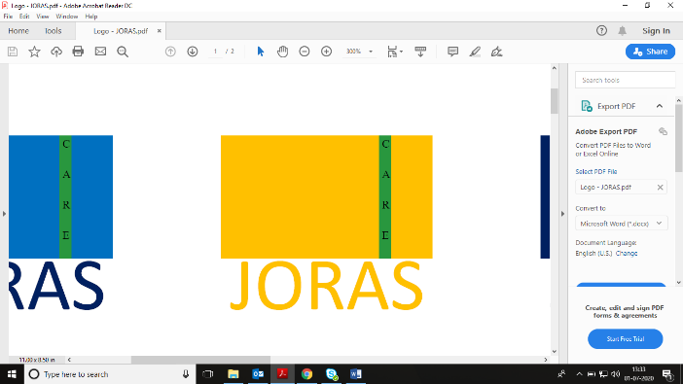 Immunity Booster Hygiene Care Hair Care Face Care About US (search) [https://cdn.shopify.com/s/files/1/3052/3952/files/newsearch.png?15477244069771701364](https://www.lather.com/cart) [https://cdn.shopify.com/s/files/1/3052/3952/files/newlog.png?15534579663268092286](https://www.lather.com/account/login)[https://cdn.shopify.com/s/files/1/3052/3952/files/newcart.png?18309462212412287252](https://www.lather.com/cart)

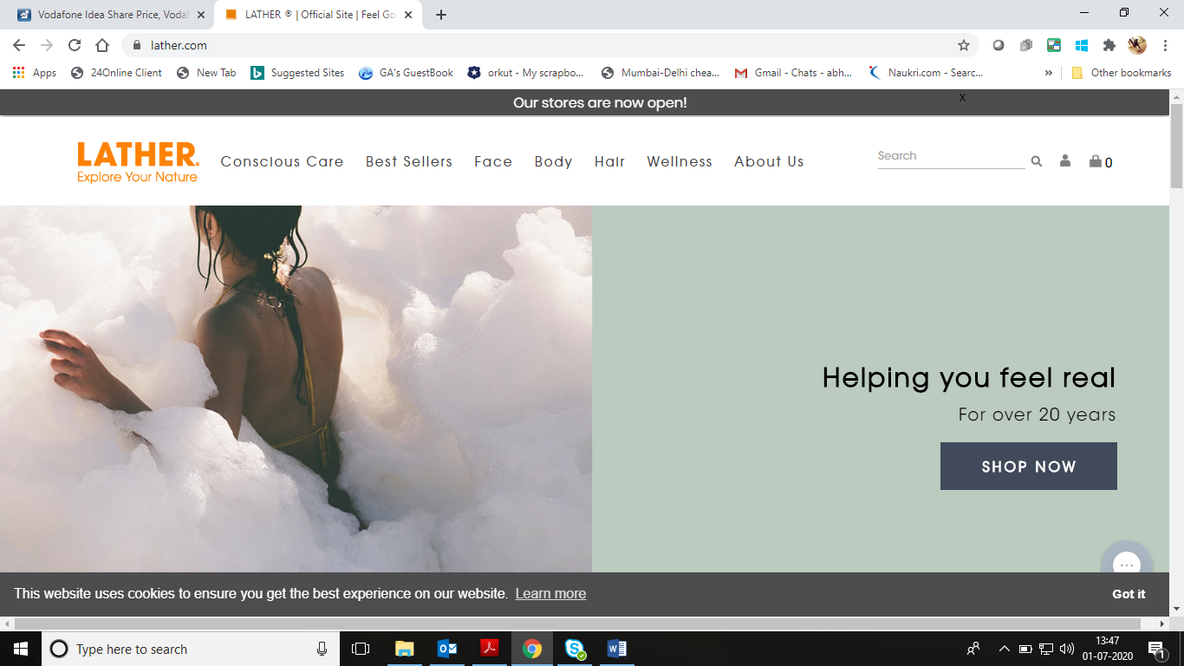Explore With Nature

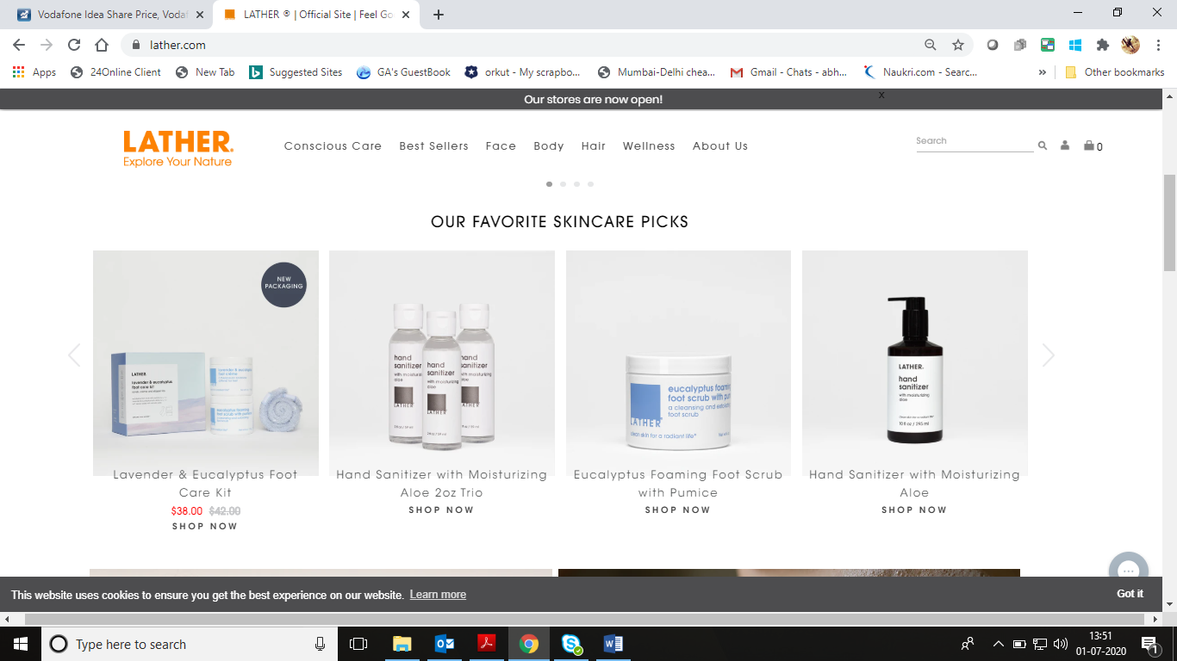(Animated 3-4 slides

1. Company page
2. Herbal importance
3. Our product snapshot
4. Best sellers

Our favorite picks

Produt 1 produt 2 product 3 produt 3

(Shop now) (shop now) (shop now) (shop now)

(Shop Immunity) (Shop Haircare) (Shop Face)

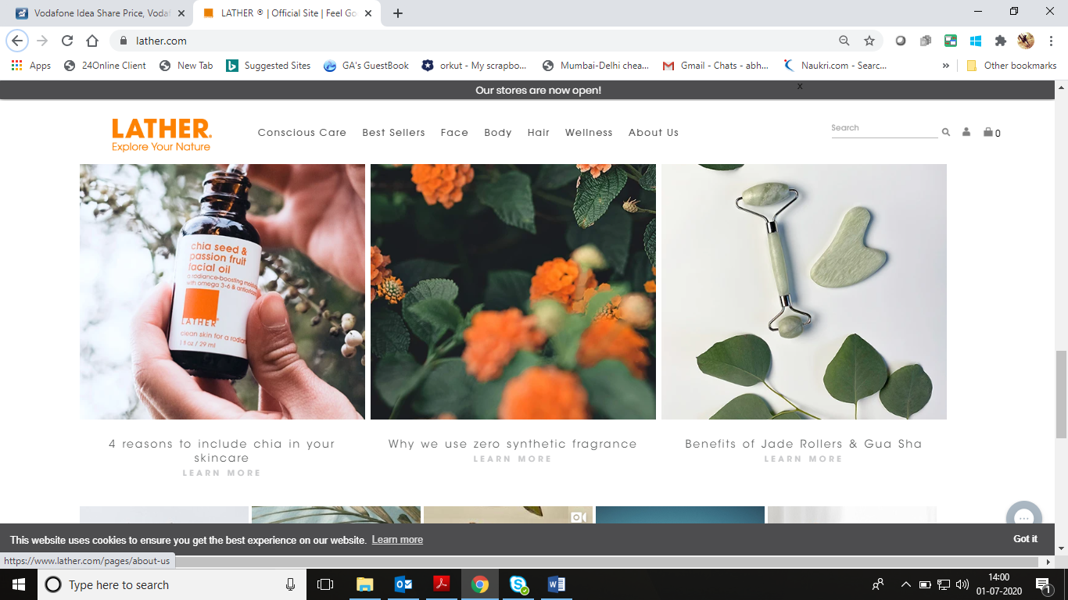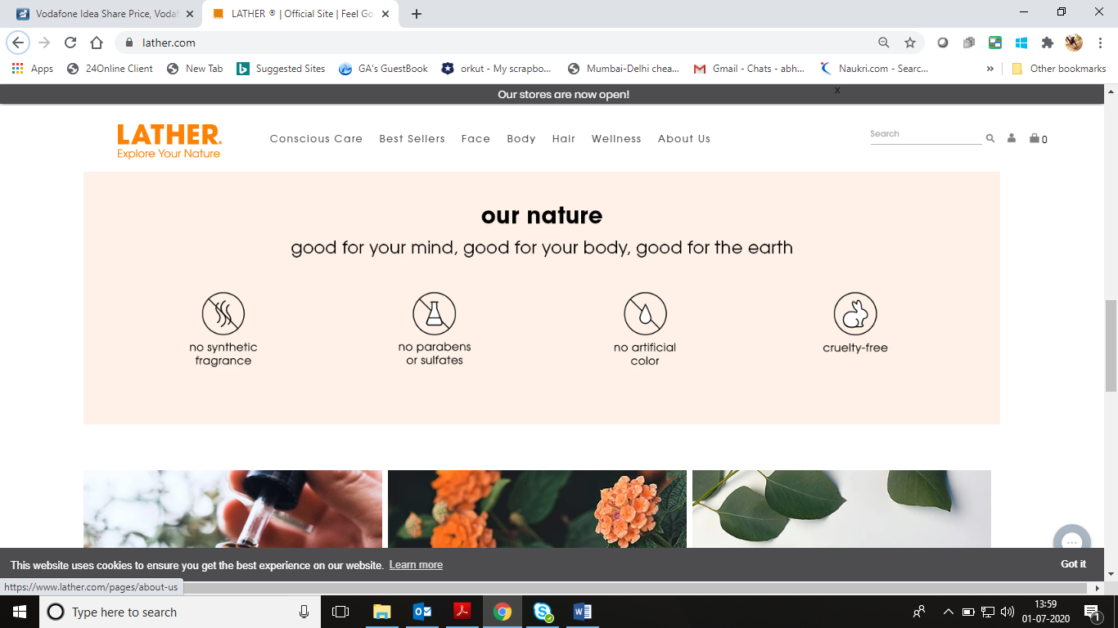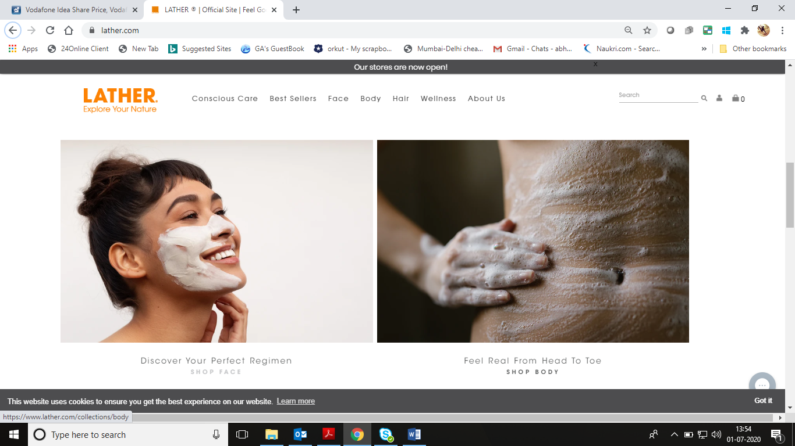Note: Corresponding product Application images with segment feature (example above)

Note: Corresponding ingredient importance with images (example above) and below we have example to add above

1. Why use coconut as a hair oil
2. Reason to use herbal products
3. Why to use zero synthetic fragrance

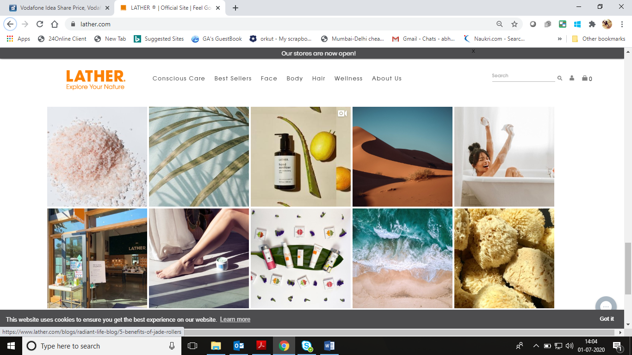Some good HD snap shots – herbal life, our products and nature images

**About Customer care Store Join Us**

* [**Joras Story**](https://www.lather.com/pages/about-us) Contact Us Locations Wholesale Sign up for our newsletter to get exclusive
* [**Ingredients**](https://www.lather.com/pages/ingredient-glossary) Shipping+returns Events Affiliates offers, store events, products and
* [**JORAScare Blog**](https://www.lather.com/blogs/radiant-life-blog) FAQ Book a charity Event personal care tips for you.
* [**Press**](https://www.lather.com/blogs/news)
* [**Careers**](https://www.lather.com/pages/careers-at-lather)
* 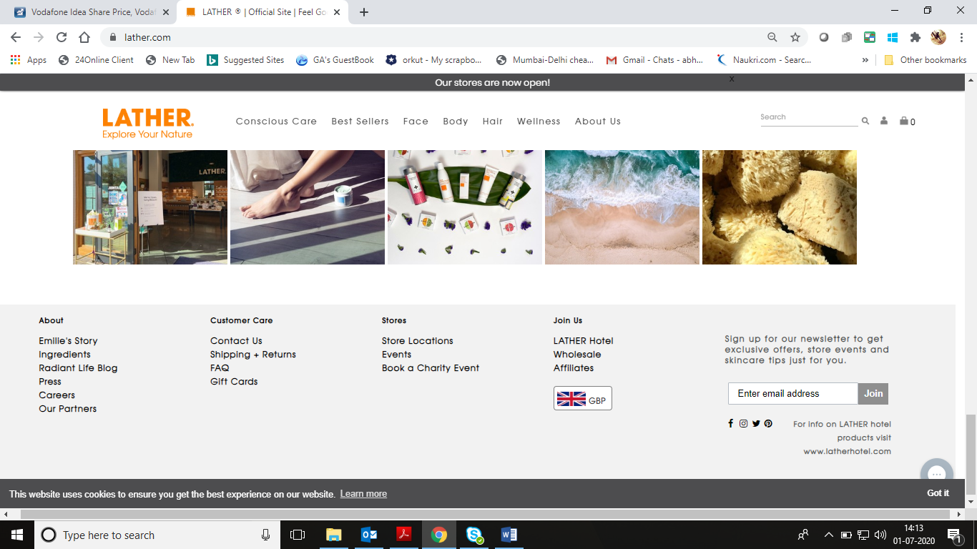[**Our Partners**](https://www.lather.com/pages/our-partners)

IND

For Info on JORAScare products visit

www.jorascare.com

Detail:

**Immunity Booster**

1. Immunity Tea
2. Aloe Vera, geloy and honey Juice
3. Honey and trifla

**Hygiene Care**

1. Sanitizer
2. Disinfectant Spray
3. Vegetable disinfectant
4. Hand Wash
5. Hand Lotion

**Hair Care**

1. Conditioning Shampoo
2. Anti-dandruff Shampoo
3. Conditioner
4. Hair tonic

**Face Care**

1. Face Wash
2. Face anti-ageing crème

**About Us**

Joras Story

Locations

Ingredients

JORAScare Blog

Our Partners

Press/News

Careers