**DOCUMENTATION: -**

**Abstract-**

**Ministry category: -**

**Ministry of Water Resources, River Development and Ganga Rejuvenation.**

**Problem category: -**

**Collection of information regrading discharge of untreated affluent in river.**

**Information and Tech.-**

* **Considering the fact that the age of EARTH is about 4.5 billion years and humans about 140 thousand. If we condense the age of earth into 24 hours then we have been here on earth for 3 seconds .**
* **3 seconds and we have made things extinct that have been here longer than us.**
* **Thus we come up with a collector bridge (i.e. mobile based application) which creates a platform to the public to rise the voice and share their pictorial updates which intends to become a AWARENESS, a NOTIFICATION TO THE AUTHORITIES & a NOTICE TO THE POLLUTORS (industries and other factors).**
* **The software links the authorized / concerned people to let know about the public’s view , environmental sectors , industrial agreement & queued work .**
* **Only with all these put together into actions lead us to live the 4th second.**

**TECHNOLOGY STACK-**

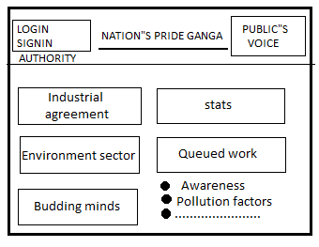 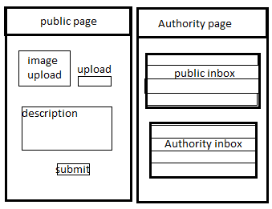

**DESCRIPTION-**

* 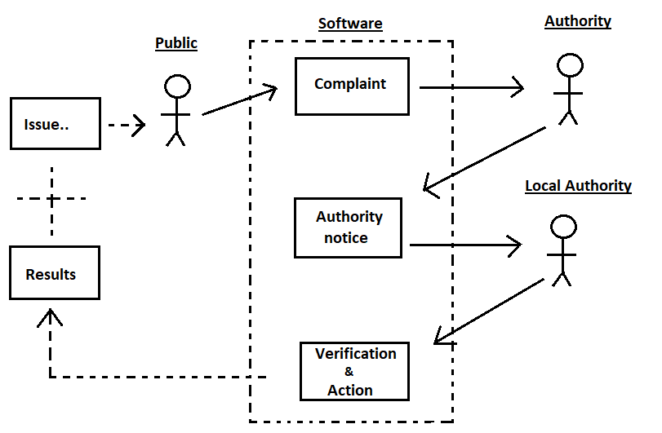**Public voice: The application   
  allows the public to upload the   
  image(geo -tagged) and   
  description about the   
  problem in a particular   
  locality.**
* **Authority’s response : When   
  the complaint is received ,   
  the authority will go through   
  the complaint details and   
  forward it to the concerned   
  local authorities and actions   
  should be taken by them.**

**local authorities response :   
the local authority will confirm   
the details and take the required  
action to solve the problem**

**INTRODUCTION:**

**The Ministry of Water Resources, and Ganga Rejuvenation is the apex body for formulation and administration of rules and regulations relating to the development and regulation of the water resources in India. This Ministry was formed in January 1985. In July 2014, the Ministry was renamed to “Ministry of Water Resources & Ganga Rejuvenation”, making it the**[**National Ganga River Basin Authority**](https://en.wikipedia.org/wiki/National_Ganga_River_Basin_Authority)**for conservation, development, management, and abatement of pollution in the river Ganges and its tributaries.**

**The water resources getting polluted and the people of india getting affected because of it is really a big problem which must be solved.**

**Our application is definitely going to be a great part of the solution of this problem.**

**System Requirements-**

**\*Android Studio**

**\*Firebase**

**\*Brackets**

**\*Programming Languages(java,html,css)**

**\*Web hosting**

**Customer requirements-**

**\*Control Over Pollution**

**\*Bridge between Public and Authority**

**\*Complaints registered should be took into actions.**

**\*Action on the complaints should be looked over immediately.**

**\*People want to build industries but not at the cost of destroying nature or water resources.**

**\*The profile of the people registering complaints should be kept anonymous.**

**\*Public support and unity to solve the problem.**

**System and software design-**



**Models -**

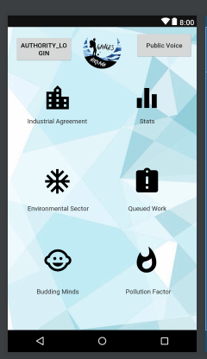

**Implementation-**

**\*Implementing the authorities about current problems being faced by people due to water contamination.**

**\*The implementation should be quick when there is high risk of water getting contaminated.**

**Results-**

**\*Bridge between public and Authority is built.**

**\*Great help to the “Ministry of Water resources and Ganga Rejuvenation.**

**\*If people understand our ideology and implement it properly they can really see good results.**