Full Stack Development Using Java
Front End

Backend
Core Java
- Basics of Core Java
Intro of Java, Installation and environment setup, writing and execution of first java program, Data Type, Control flow statement, Array, Class, Object, Method, String class and user input.
- OOPs in Java
Encapsulation, Inheritance, Polymorphism, Abstraction, Constructor, Keywords, access modifier, package and import.
- Advance Concepts in core Java
Exception handling, Threading, Collection and JDBC
Advance Java
- Servlet Technology
- JSP technology.
Spring Boot framework
- REST API Development.

Database
Mysql DB, SQL

DevOps Tools
Git
Git Hub
Maven

Software
- JDK (11-16)
- Mysql Database
- Eclipse IDE
- GIT
- Maven
- Postman

Java Setup
- Download JDK
https://www.oracle.com/java/technologies/downloads/
Download the Installer for you operating System.
- Install JDK
- Verify the Installation
  - You can verify the installation file into C:\Program File\java\<jdk-version-folder>
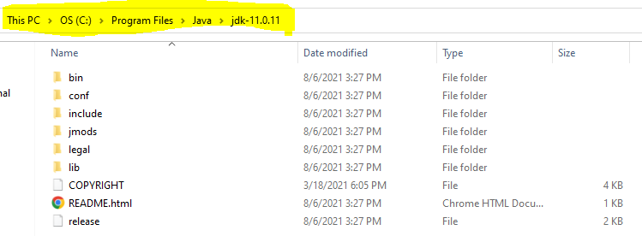
- Setup Environment Variable
  - Set JAVA_HOME
    - Go to Start and Search for “Environment” word and select the “Edit System Environment Variable” option.
    - Click on the “Environment Variable” button on the new window.
    - Select “New” Button from the ‘System Variables’ section
    - Provide the following details into text box
      - Variable Name: JAVA_HOME
      - Variable Value: <JDK-Path>
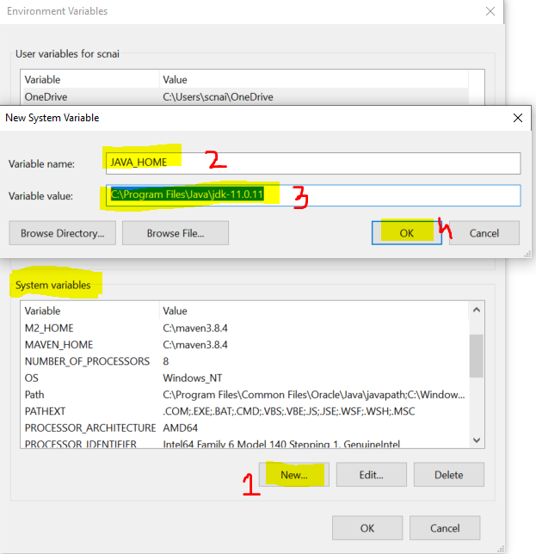
  - Set Path
    - Check for “path” variable inside ‘system variables’ section
    - Select “Path” variable and click on “Edit” Button
    - Click the “New” button on the new window
    - And set the variable value as follows
%JAVA_HOME%\bin
    - Click on “OK”
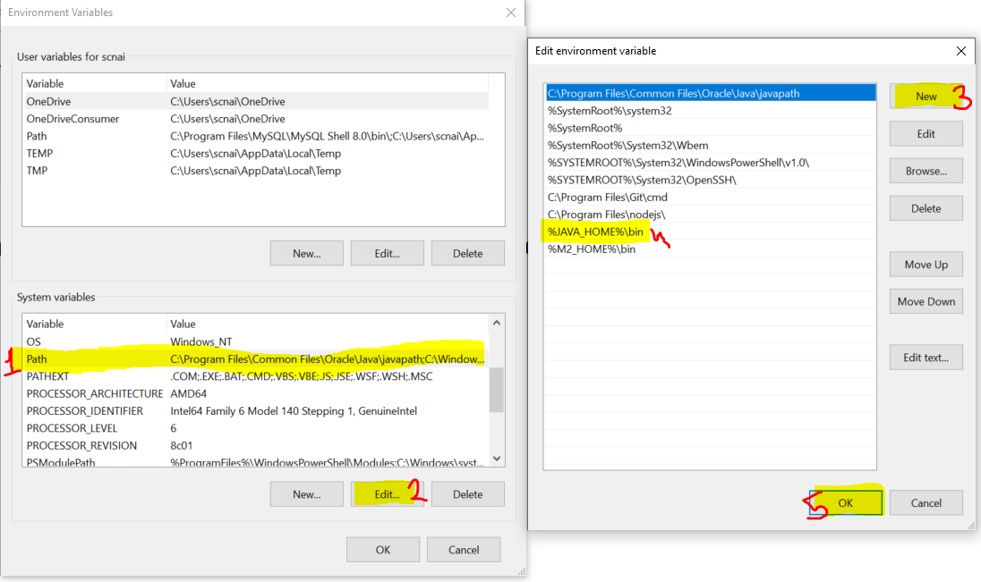
- Verify the Environment Variable Setup
  - Open CMD
  - Try the following commands
    - java -version
    - javac
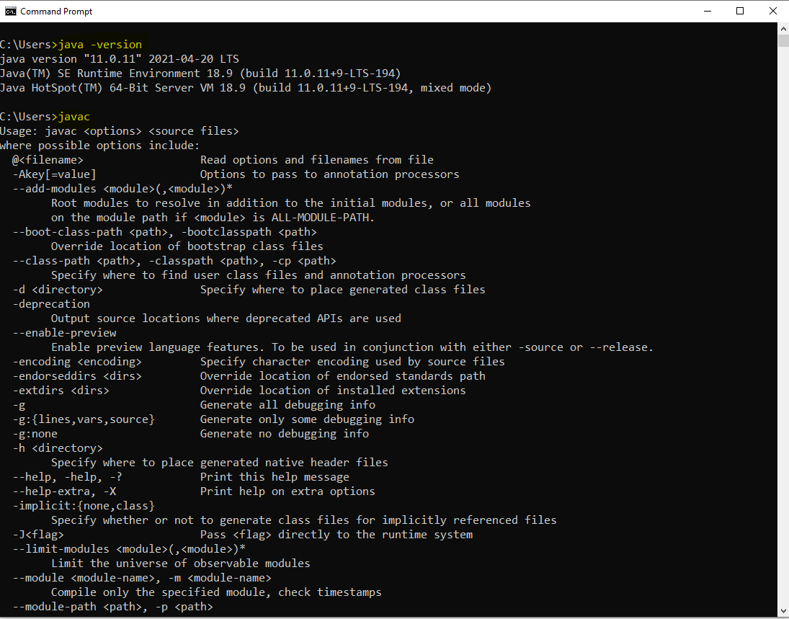

Important Components of Java
- JVM
  - JVM stands for Java Virtual Machine.
  - It is use to execute the java program, and also support the all activities required for execution such as stating up of you code, memory allocation, communicating with OS.
  - To Execute the java program JVM must be present inside you system.
- JRE
  - JRE stands for Java Runtime Environment.
  - It is consisting of JVM and APIs. Which create the runtime environment for the java program.
  - On users system JRE must be available.
- APIs
  - APIs stands for Application Programming Interface.
  - It is a set of predefine functionalities which is provided by java language.
- JDK
  - JDK stands for Java Development Kit.
  - It is a combination of JRE, JVM, APIs and some development tools.
  - You can develop the java code, compile it and execute the java code.
  - JDK has present in Developers system.

Writing and Executing First Java Program
- Writing a java code
  - You can write a using IDE or Notepad or any editor tool.
- Java Program Syntax
  - Create Java class
    - In java everything must be write inside class except import and package statement.
    - Syntax:
public class <Class_Name>
{
}
  - Cerate Main Method inside java class
    - Main method is the first method which gets executed.
    - This method is a start point of java program.
    - This method will be called internally by java (JVM) when you execute your program.
    - Syntax:
public static void main(String args[])
{
}
  - Write an executable code into method.
System.out.println(“Hello, Welcome to first java program”);
- Save File
  - File Name must be same as public class name.
  - File extension must be .java.
- Compile the java code
  - In this sept the java code will be converted into a byte code and the binary file will be created.
  - As an outcome of the compilation step the .class file will be created.
  - In this step all the syntax validation will also happens.
  - To compile a code first Open a CMD
    - The path of the CMD must be pointing to a location where you save your java class. (to do this you can go to a folder where you save your java class, click on the address bar and type “cmd” and hit enter)
    - Execute a command to compile
javac FileName.java
- Execute Java code
  - Use same CMD
  - Execute a command to run java program
java className
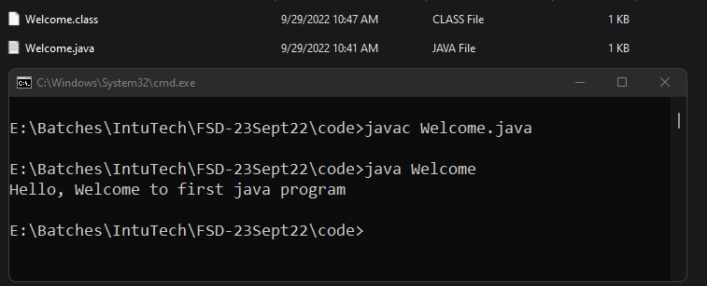
Keyword, Identifier and Literal

Keyword:
- The words which are reserve by the java language.
- There are about 52 keywords present in java language.
- Every keyword is always in small case.
- Example:
public, class, static, void, int, short, long, byte, float, double, char, boolean, private, default, protected, for, while, do, if, else, true, false, null etc.
Literal
- Literal are consider as a value. Specially a string values are called as a literal.
- Some of the values which are fixed by java and those are called as literal as well. These are also a keywords.
- Example:
null, true, false
Identifier
- These are the words which are used by a developer while writing a program.
- Identifiers are used as a variable, method, object, class name.
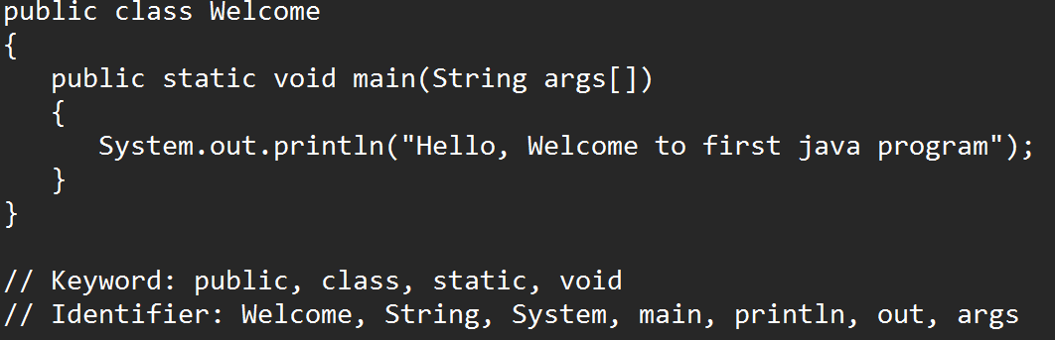
- Rules to create and use Identifier
  - Identifier must not be a keyword.
  - Identifier can contain alphabets, Number, symbol.
  - Only $ and _ symbol is allowed and no other symbol can be use in the Identifier.
  - Identifier must be start with symbol and alphabet. You cannot start identifier by number.
  - Identifier is case sensitive.
  - There is no character limit for creating Identifier. But it should be short and meaningful.

- Conventions to create method, variable and object name.
  - The name should be start with small case if it is a combination of multiple words then every word start with capital case from the 2nd word onwards.
  - Example: employeeId, studentName, printEmployeeDetails
- Convention to create class.
  - The class name should be starts with capital case and if it is a combination of multiple words then every word should be start with capital.
  - Example: Welcome, EmployeeDetails, AdminAddressDetails etc.
- Convention to create Constants:
  - Constants must be in capital case.
  - Example: GRAVITY, PI etc.

Comments in Java
- Comments are use to provide a details/documentation for the code.
- Comments are also use to skip some of the lines from the execution.
- There are 3 type of comments
  - Single Line Comments
    - Is use to comment the single line of code.
    - This comment will not be a part of compiled .class file.
    - Syntax:
// Line to comment
  - Multi line Comments
    - Is use to comment the multiple lines of code
    - This comment will not be a part of compiled .class file.
    - Syntax:
/*
Lines to Comment
*/
  - Documentation Comment
    - This is use to comment out more than one line at a time.
    - This type of comment is more useful writing a code level documentation.
    - The commented lines will be a part of .class file.
    - Syntax:
/**

*/
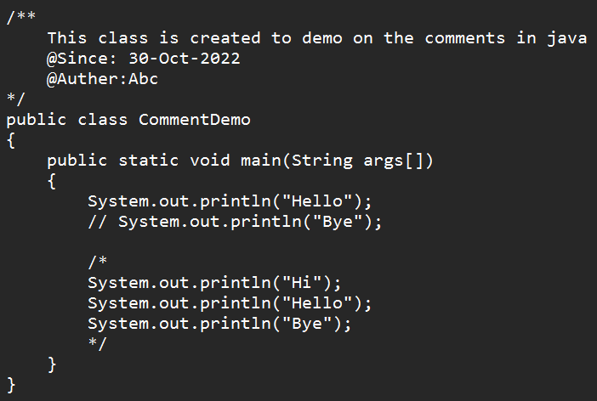

Data Type and Variable
- Data Types are use to define the type of data in java.
- On the bases of data type the memory will be allocated in the program execution.
- Data type are of 2 types
  - Primitive Data Type
    - These are in the non-object format.
    - Primitive data types has fixed size in java
  - Non- Primitive Data Type
    - These are in the object type.
    - There is no fixed size for non-primitive data type. The size will be decided on the bases of its uses.

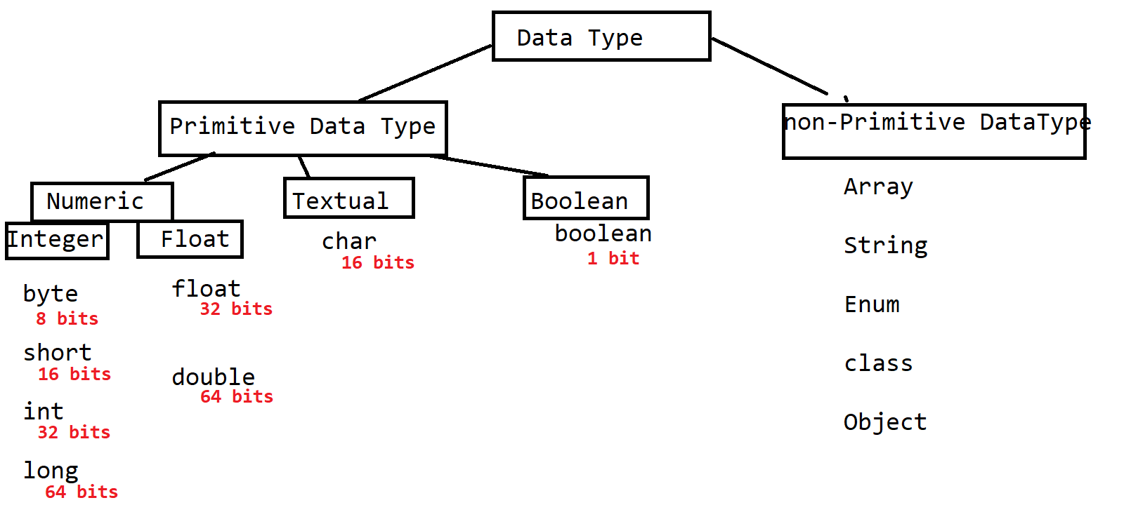

Variable
- Variables are use to store a value.
- Variables are use to display values to the user.
- Variables are used in the math expression.
- Variables are use to assign value to another variable.
- Syntax:
DataType identifier (variable_name); // variable declaration
Identifier = value; // initialization of variable
OR
DataType identifier = value;

Formula to calculate the Range of the Numeric values
-2^{n-1} to 2^{n-1} -1
Here, the n is the number of bits

Example:
byte : -2⁸⁻¹ to 2⁸⁻¹ -1
-128 to 127

Task-1
WAP to store the product value and print the value of the product.
Store the Product id, product price, product quantity
And print the product id, product price, product quantity and the total product price (price * quantity)

Rules to use Primitive Data Type
- long:
Can store a numeric values without any decimal point.
The values should be suffixed with ‘L’ or ‘l’
Example:
long contact = 9988778899L;

- float:
Can store a numeric values with decimal point
The values must be suffixed with ‘F’ or ‘f’
Example:
float salary = 34534.34F;

- char:
- Can Store single alphabet, number (non-decimal) or symbol.
- You can only store positive numeric (non-decimal) value.
- Non numeric values must be store in a single quotes (‘value’)
- The alphabet and symbols are store in the form of ASCII values.
Example:
char c1 = ‘A’;
char c2 = 65;
char c3 = ‘@’;

- Boolean:
  - Can Store values only in true and false

Primitive variable Casting
- Is a way to convert the value from one data type to another.
- There are 2 type of casting
  - Implicit Casting
    - This casting happens internally and it will be done by java.
    - This casting can be achieve without any code modification.
    - This casting is always happens from small size data type to large size data type
    - Example:
byte x = 10;
int y = x; // implicit casting
  - Explicit Casting
    - This casting has to do manually.
    - For this casting developers has add some code modifications.
    - This casting always happens from large size data type to small size data type.
    - Example:
int p = 122;
byte q = (byte) p; // explicit casting

Type of Variables
- The variable types are decided on the bases of position of the variable in a code.
- There are 3 type of variables
  - Local Variable
    - The variable which is created inside method is called as local variable
    - These variables can be access inside methods only and it cant access outside method.
    - Local Variable has initialize before use, else you will end up with a compile error.
  - Instance Variable
    - The variable which is created inside class and outside any method is called as an instance variable.
    - These variables are accessible inside all the non-static method directly. But in static method like main you have to access the instance variable using class object.
    - These variables are also accessible outside class using object.
    - These variables gets initialized by default value if you don’t provide explicitly.
  - Static/Class Variable
    - The variable created inside class and outside any method with static keyword is called as static/class variable. (global variable)
    - These variables can be access in all the method of the class directly.
    - These variables are also accessible outside class using Class Name.
    - These variables gets initialized by default value if you don’t provide explicitly.
Default Values
Data Type | Value
byte, short, int, long | 0
float, double | 0.0
char | 0 or \u0000
boolean | false
Non-Primitive | null

Note: These values are only appliable for the instance and Static variable
Operator
- Arithmetic Operator
  - This return the output in the numeric form.
  - Example: +, -, *, /, %
- Assignment Operator
  - Example: =, +=, -=, *=, /=
- Relational Operator
  - Always returns the Boolean value (true or false)
  - It is use to create a Boolean or conditional expression
  - Example: <, <=, >, >=, ==, !=
- Logical Operator
  - Can return Boolean or numeric
  - This operator is use to combine 2 or more boolean expression. and also it can work on the bit level.
  - Example: &, |, !
- Short circuit operator
  - Can return only Boolean values
  - It is used to combine 2 or more boolean expression.
  - Example: &&, ||
- Increment Decrement Operator
  - Is use to increment or decrement the values by 1.
  - There are two types of operations in this.
    - Pre increment/decrement
      - First increment/decrement the values
      - Then update the value
      - Assign a value
    - Post increment/decrement
      - First it assign a value
      - Than increment/decrement the values
      - update the value
  - Example: ++, --

- Ternary Operator
  - It is use to write a if and else condition in short.
  - ‘?’ is consider as if
  - ‘:’ is consider as else
  - Example: ?, :

Control Flow Statement
- Is use to control the execution flow of the program.
- Every program executes in a sequence by default.
- There are 3 types of control flow statement
  - Sequential execution
    - By Default every program executes in a sequence.
  - Conditional Statement
    - If you wanted to execute the block of line based on some scenario/condition then you can use this statement.
    - Example: if and its variations, switch cases
  - Looping statement
    - If you wanted to execute the block of code multiple times then you can use looping statements.
    - Example: while, do-while, for, enhance for

If condition and variations

If Condition

- You can execute a statement or block of statement based on some condition
- Syntax:
if(boolean/conditional expression) {
Statement(s)
}
Note: The Statement(s) inside the If bracket only gets executes if the condition is true

if-else
- In this type the if statements gets executed if the condition is true otherwise it will execute the statements from the else part
- Else must be followed with if only.
- Syntax:
if(boolean/conditional expression) {
Statement(s)
}
else {
Statement(s)
}

else-if (else-if ladder)
- In this structure you can apply the condition check for the else block also.
- Syntax:
if(boolean/conditional expression) {
Statement(s)
}
else if(boolean/conditional expression) {
Statement(s)
}
else if(boolean/conditional expression) {
Statement(s)
}
else {
Statement(s)
}
- In the above syntax you can add any number of else-if block. And if none of the condition matches then you can add else block.

Nested If
- When you create one if conditional structure into another structure it is known as nested conditions.
- Syntax:
if(boolean/conditional expression) {
if(boolean/conditional expression) {
Statement(s)
}
}

Task-1
Create an int variable age
Age between 1-12 – Kids Age
Age Between 13-18 – Teen Age
Age Between 19-60 – Adult Age
Age Between 61-110 – Old Age
And age other than this – Invalid Age

Switch Cases
- It is use to improve the performance of the program in case of else-if ladder.
- Switch can be use in a scenario where exact equality is checked.
- Syntax:
switch(value)
{
case label:
Statement(s)
break;
case label:
Statement(s)
break;
case label:
Statement(s)
break;
default:
Statement(s)
}
- Rules for Switch case
  - Every Case label must be unique.
  - Switch value and Case label must be of same data type.
  - Switch value must be byte, short, int, char, enum, String data type. No other data types are allowed.
  - You can combine a switch cases if multiple cases has similar execution.

While Loop
- To execute a statement or block of statement multiple times.
- Syntax:
Declaration and initialization (start point)
while(condition/Boolean expression)
{
Statement(s)
increment/decrement
}
- It is pre condition check.
- While is use in a case where number of iterations are not known.

do-while loop
- To execute a statement or block of statement multiple times.
- Syntax:
Declaration and initialization
do
{
Statement(s)
Increment/decrement
}
while(Boolean/conditional expression);
- Do while is post condition check.
- Do while loop executes at least once even if condition is not true.

For loop
- To execute a statement or block of statement multiple times.
- Syntax:
for( declaration and initialization ; condition ; Increment/Decrement/statement )
{
Statement(s)
}
- For Loop Execution steps
Task-1
Create am int variable and print the table of it. Using While, Do-while, for
Example
int num = 5;
O/P : 5
10
15
.
.
.
50

Enhance For Loop
- This loop is mainly used to iterate/loop the element from the collection/group one by one.
- Syntax:
for(variable var : collection)
{
Statement(s)
}

Nested Looping
- You can write one loop inside another loop.
- Mostly this type of structure is used for handling a matrix/Table type of data. Which is in the row and column format.
- Nested loops can be create by any of the combination such as for inside for, while inside while etc.
- Syntax:
for(declaration&initialization ; condition ; increment/decrement) // ROW
{
for(declaration&initialization ; condition ; increment/decrement) // COLUMN
{

}

}

Task :
1.W.A.P To print following pattern ((using 1 nested looping))
*
* *
* * *
* * * *
* * * * *

2. W.A.P To print following pattern (using 2 nested looping)
*
* *
* * *
* * * *
* * * * *
* * * *
* * *
* *
*

Array
- Array is a group of values or objects.
- Array is group of similar data type of values or object.
- Array is a fixed in size.
- For creating an Array you must know the data type and the size of the values.
- Array is a non-primitive data type.
- Array is indexed based.
- Indexes are always start from 0.
- Indexes are always managed internally by java.
- To set and get the values form array you have to use index.
- There are multiple types array in java such as 1-D array, 2-D, Multi-Dimensional (Jagged Array) Array
- There are 3 steps to create array
  - Array Declaration
  - Array Instantiation (Object creation)
  - Array Initialization.

1-D Array
- Data Will be store in the form of row.
- Using length function you can get the total number of values (size) present inside array.
- You can also find the last index of the array using length function.
Last index = array.length - 1
- Syntax:
Array Declaration
DataType identifier[];
Array Instantiation (Object creation)
Identifier = new DataType[Size];
Array Initialization.
Identifier[index] = value;

4 ways to create 1-D array

double percent[]; // declaration of array
percent = new double[6]; // instance creation of array (size must be provided)
percent[0] = 88.99; // initialization
percent[1] = 78.81;
percent[2] = 61.89;
percent[3] = 77.12;
percent[4] = 65.32;
percent[5] = 56.22;

double percent[]= new double[6]; // declare and instantiate
percent[0] = 88.99; // initialization
percent[1] = 78.81;
percent[2] = 61.89;
percent[3] = 77.12;
percent[4] = 65.32;
percent[5] = 56.22;

double percent[] = new double[] {88.99, 78.81, 61.89, 77.12, 65.32, 56.22};

double percent[] = {88.99, 78.81, 61.89, 77.12, 65.32, 56.22};

2-D Array
- Can store a data in the form of row and column.
- It is also known as matrix.
- Here, length function returns the total number of rows in array.
array.lengh : return the total number of rows
array[row_index].length : return the total number of values in a row
- Syntax:
Array Declaration
DataType identifier[][];
Array Instantiation (Object creation)
Identifier = new DataType[ROW_Size][COLUMN_Size];
Array Initialization.
Identifier[row_index][column_index] = value;

4 ways to create and use 2-D array

double percent[][];
percent = new double[3][6];
percent[0][0] = 66.77;
percent[1][2] = 77.0;
percent[2][4] = 81.2;

double percent[][] = new double[3][6];
percent[0][0] = 66.77;
percent[1][2] = 77.0;
percent[2][4] = 81.2;

double percent[][] = new double[][] { {34,54,65,65,34,65},
{43,45,56,65,67,87},
{76,54,76,43,76,34} };

double percent[][] = { {34,54,65,65,34,65},
{43,45,56,65,67,87},
{76,54,76,43,76,34} };

Multi-dimensional (Jagged)
- In this array you can have a fix rows and different number of columns.
- Example:
int percent[][] = {
{23,46,67,32},
{3,65},
{76,45,67,34,67,3}
};

User Input
- To accept a values from the user at run time or before the execution of the program you can use a user input.
- There are multiple ways to accept the value from the user.
  - User Input by Command line Argument
  - User Input by Scanner

User input by Command line Argument
- It is a way to accept input from the user in the execution command.(from the CMD)
- These values will be available inside a main method.
- The value which you entered using input parameter will received in String format only.
- There can be multiple values from the command line which must be separated by space.
- Every values will be available in a separate index.

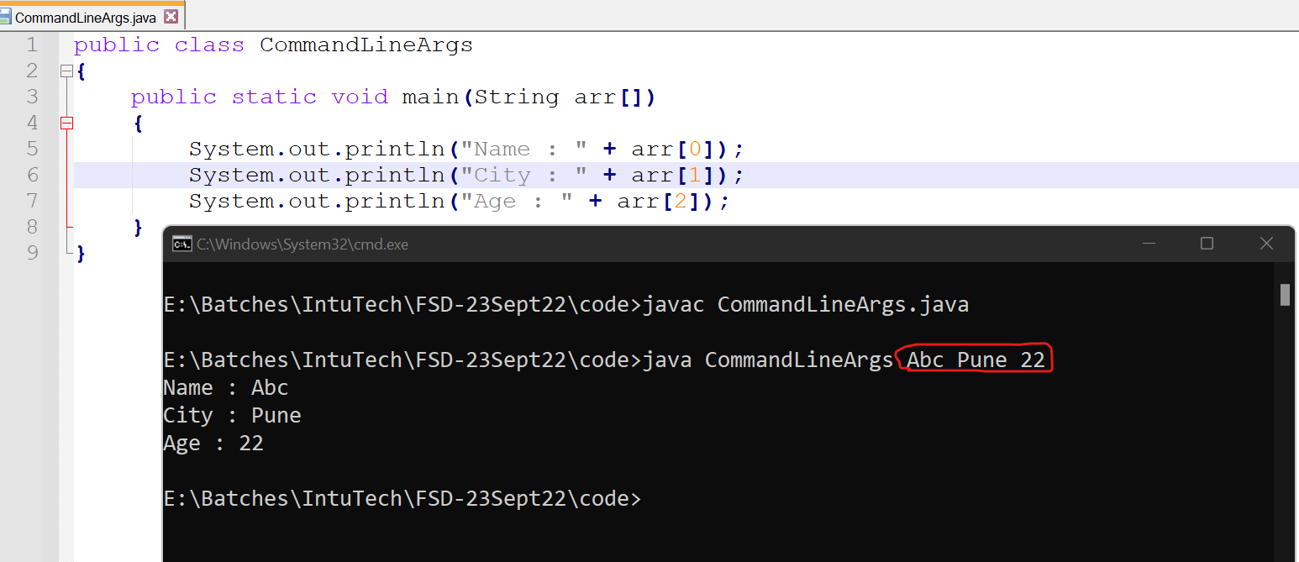

Scanner Class
- Scanner class is provided by java. That is it is build-in class.
- Scanner class is present inside java.util package.
- Scanner class can be use to accept the value from file, string or from console (CMD).
- Scanner is use to accept at the run time of the program.
- Scanner class has a nextXXX() method to accept the value from the user.

Class, Method and Object

Class
- Class is a collection of state(data member) and behavior(member function).
- Where the state is the variable and behavior is a method.
- Along with state and behavior you can also create a constructor or another class (known as inner class) inside a class.
- The data member and member function of class can be use into another class using Object.
- Syntax:
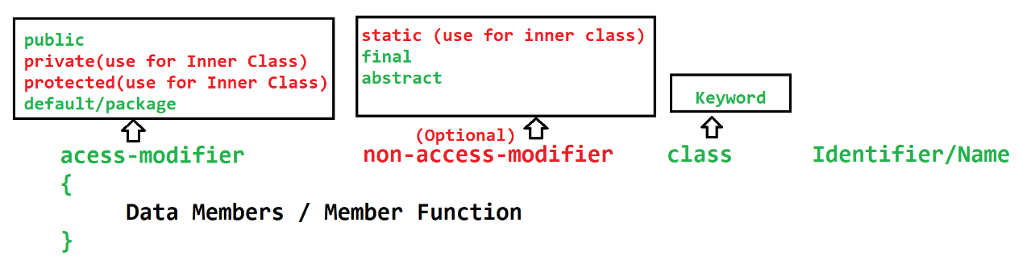

Method
- Method is a collection of variable (local variable) and executable statement.
- Method is used to write a logical code. this code can be reuse at different location of the program.
- Method also help to divide the complex login into smaller chunk.
- Methods has to call by object or class name and it will allocate the memory in JVM while execution.
- Methods can accept a value which is known as input parameter and methods can return the output outside the method.
- The value which is pass to an parameter is called as argument.
- There are 2 types of method
  - Predefine/build-in method
    - These methods are already written and provided to us for the execution
  - Custom method
    - These method has to create by developer.
- Syntax:
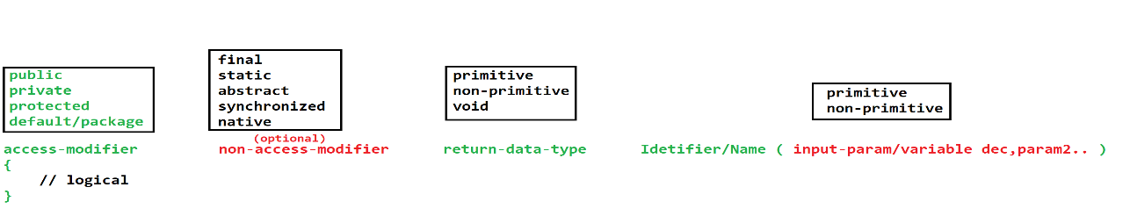

Object
- It is a representation of the class.
- Using Object you can access the properties (variable & method) of the class.
- To use the properties of the class you have to use a dot (.) operator
- You can create any number of object of the class.
- Every Object of the class has separate memory allocation. And they have separate copy of the instance variable.
- In java you can create Object using new operator.
- Syntax:

Object Creation Memory Footprint

JVM memory
- Stack Memory
  - Is use for a method execution
  - This memory clears automatically after the execution of the method.
  - It is based on the LIFO(Last In First Out)
- Heap Memory
  - Is use to create an object.
  - Heap memory will be clear automatically with the help of Garbage collection (GC) process.
  - GC process executes after a specific interval.

String In Java
- String is an array of character.
- In String you can store values in the form of array.
- String is always created in double quotes(“value”) in java.
- There are multiple option to create and perform operation on string.
  - String class
  - StringBuffer class
  - StringBuilder class

String class
- String class is use to store a string value.
- String class also has multiple method using which you can perform the operation on the string value.
- String class is a build-in class.
- String class is final class.
- String class is present inside java.lang package
- To store values inside class you have to create Object this class.
- String class Objects are immutable. Immutable means the value does not change once it is assigned, even after using a function of the string class.
- You can create Object of String class using following syntax
  - With new Operator
String str = new String(“value”);
  - Without new Operator
String str = “Value”;
- The String object created without new operator will be created inside SCP (String Constant Pool)
- SCP Create a new String object only if same string value is not already present. If same value is already present then it will allocate the same object instead of creating new one.
- If you use equal operator (==) to compare 2 object then it will compare there memory location instead of its value. To Compare the values of 2 object use equals method.
StringBuffer class
- Using this class you can store a string value
- There are multiple methods present inside this class using which you can perform operation of String value.
- StringBuffer is a build-in class.
- It is a final class and present inside java.lang package.
- Objects if StringBuffer are mutable. The original value keep on changing on the implementation of the methods.
- String Constant Pool (SCP) is applicable for StringBuffer
- To use this class you have to create Object of StringBuffer
- Syntax:
StringBuffer obj = new StringBuffer(“Value”);
- Methods of StringBuffer are synchronized.
- StringBuffer object is thread safe.
- StringBuffer is slower in the perform than StringBuilder

StringBuilder class
- Using this class you can store a string value
- There are multiple methods present inside this class using which you can perform operation of String value.
- StringBuilder is a build-in class.
- It is a final class and present inside java.lang package.
- Objects if StringBuilder are mutable. The original value keep on changing on the implementation of the methods.
- String Constant Pool (SCP) is applicable for StringBuilder
- To use this class you have to create Object of StringBuilder
- Syntax:
StringBuilder obj = new StringBuilder(“Value”);
- Methods are non-synchronized
- StringBuilder Object is non thread safe
- StringBuilder is faster than StringBuffer

Eclipse IDE (Integrated Development Environment)
Eclipse Download
https://www.eclipse.org/downloads/packages/

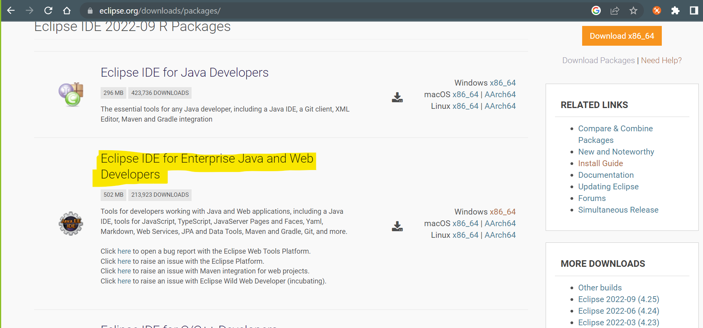
Eclipse Set up and Use
- Set a workspace in the eclipse launch screen.
- Set “Java” the perspective of the eclipse
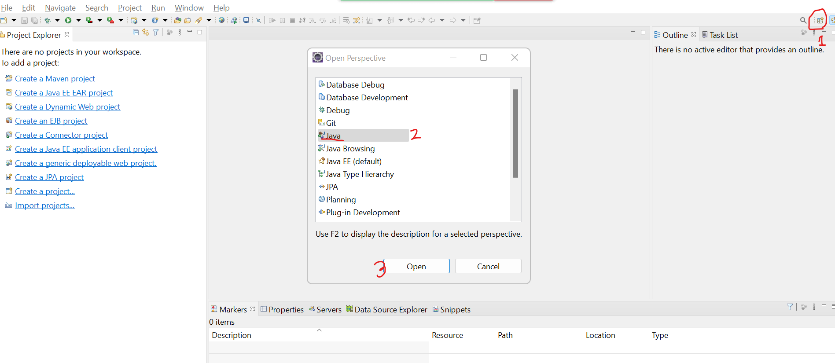
- To get any of the screen option in eclipse
  - Go to “Window” Menu -> “Show View” -> and select the screen which you wants to open
- Create Java Project in Eclipse
  - “File” menu -> “New” Option -> click on “Java Project”
  - Set Name of the project
  - Unchecked the create Module checkbox
  - Click on “Next” button -> “Finish” button
- Create Class In Project
  - Right click on “src” -> “New” option -> click on “Class” option
  - Provide Class Name and select “Public static void main(String args[])” option
  - Click on Finish
- Run Java Class
  - Right Click on editor
  - Go to “Run As” -> select “Java Application” option

Object Oriented Programming (OOPs)
- Class and Object are the base of OOPs concepts.
- There are 4 main concepts of OOPs
  - Encapsulation: Encapsulation is a wrapping of data member and member function into single unit.
  - Inheritance: Acquiring a property of one class into another.
  - Polymorphism: Single Object can be use in a multiple ways.(Single Object having multiple forms)
  - Abstraction: Hiding the complexity (complex Implementation) and showing only the required functionality.

Encapsulation
- Encapsulation is a wrapping of data member (variable) and member function (methods) into single unit.
- Class is also known as encapsulation.
- As per the java recommendations do not provide the direct access to any of the instance variable of the one class into another class instead of it use methods to access the instance variable.
- To restrict the access of instance variable outside class mark you instance variable as private.
- To access the instance variable of the class java has suggested setter and getter methods.
  - Setter methods
    - Setters methods are use to set the values for an instance variable.
    - Setter method will always accepts an value as a input parameter and does not return any thing.
    - Setter methods should be start with set word and will be followed with variable name.
  - Getter Methods
    - Getter Methods are use to get the values of the instance variable.
    - Getter Methods always return value and will never accept any input parameter.
    - Getter method should be start with get word and will be followed with variable name
- Advantages of Encapsulation
  - Using this you can follow a recommended approach to use instance variable.
  - You can control who can access what.
  - It is one of the way to achieve loose coupling (if you change one part of code it will not effect on another part).

Inheritance
- Acquiring a non-private properties (variable & methods) of one class into another class.
- Inheritance can be achieved in Java using extends keyword.
- There are 5 types of inheritance in OOP’s. Out of it 3 are directly supported by Java and 2 types are not directly supported by java which can be achieved using Interface.
- Single, Multilevel, Hierarchical inheritance types are supported in java whereas Multiple and hybrid are not support by java directly (it can be achieved by interface)
- In Java One class Cannot have more that one parent class

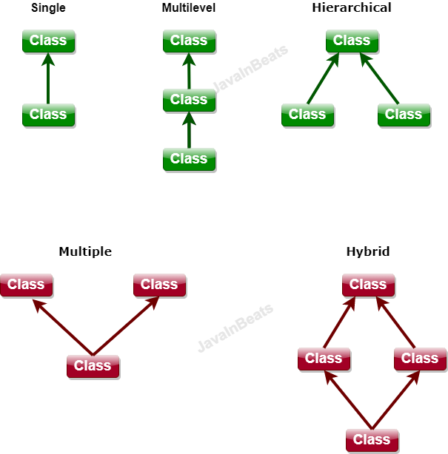
- There will is IS-A relation establish between classes by inheritance.
- By inheritance there will be parent and child relation establish on the classes where parent class also known as Super class or Base class and child class is also known as Child class and Derived Class.
- Advantage Of Inheritance
  - Extensibility
  - Reusability
  - It plays an important role in the overriding or runtime polymorphism.
- In the inheritance you can create a Polymorphic Object.
  - Polymorphic Object is an object which has a parent class reference and child class Object
Syntax: Parent ref = new Child();
  - This object is use to achieve runtime polymorphism.
  - This object is use to dynamically call the methods.

Object class
- Object class is a build-in class in java.
- This class is present in java.lang package.
- Object class is a super class of all the java classes.
- If your java class not inheriting any another class explicitly then by default java will add Object class as a super class implicitly.
- In the object class there are multiple common functionalities/methods which will be accessible in all the java classes.
- Methods are
  - equals(): is use to check if two object are equal or not.
  - hashCode(): is use to get the hashcode of the Object in Integer.
  - getClass(): is use to get the Class Object
  - toString(): is gets called whenever the object printed explicitly.
  - wait(), wait(long), wait(long, int): these method are use in the multi threading. To pause the execution of the thread.
  - notify(), notifyAll() : these method are use in multi threading to notify the thread which is in the waiting state.

Constructor
- Is use to initialized the instance Variable. It is use to assign a values to a instance variable.
- Constructor is also known as special method.
- There are rules to create and use constructor.
  - Constructor has a same name as class name
  - Constructor must not have any return data type
  - Constructor can be created using any of the access modifier such as public, private, protected, public.
  - Constructor cannot be call using Object of dot operator. Constructor will gets called at the time of Object Creation.
  - Every class has a constructor, if you do not provide explicitly then java will provide the constructor internally which is known as Default constructor, if you provided any constructor explicitly then java will not provide any constructor.
  - Every sub class constructor called super class default/No parameterized constructor internally. This is happened because of super keyword.

Keyword In Java (this, super, static, final)

this keyword
- Is refer to a current class Object.
- It is also known as current class Object.
- Using this keyword you can access the variables, methods and constructor of same class.
- Using variable of same class
  - It is required in a case where local variable has a same name as instance variable name (Showing of variable) and you wanted to use instance variable explicitly.
  - Syntax:
this.instance_varaiblename
- Using constructor of same class
  - Constructor call must be the first statement in a constructor
  - Syntax:
this(arguments)

super keyword
- Using super keyword you can access the variables, methods and constructor of super class.
- Super is not an object of Super class.
- Use Super to access variable of super class.
  - You can access the super class variable explicitly if variable with same name is already present inside sub class
  - Syntax
super.varaible_name;
- Use Super to access method of super class.
  - Super class method can be called explicitly if method with same name present inside sub class
  - Syntax:
super.methodname(argement);
- Use Super to access constructor of super class.
  - Using super keyword you can call a constructor of super class. by default every sub-class constructor calls super class default/no-param constructor.
  - If you wants to all another constructor of super class you can use super keyword which must be used from a constructor only and it must be a first line.

Static keyword
- You can create a static properties such as static method, variable, class (Inner class) or block.
- By making any property static you can access it without object using a class name.
- Mostly you can mark property as a static if it is frequently used in an application from multiple location.
- Static properties will be loaded inside the memory at the class loading step in the JVM.
- Static method
  - Static method can access only a static properties of the class.
  - You cannot access non static variable and method inside static method directly.
  - In static methods this and super keyword is not allowed.
- Static variable
  - Static variables has to create inside class. you cannot create static variable inside method.
- Static Class
  - Static class must be an inner class (One class can have another class which is called as Inner class)
- Static block
  - Static block is use to initialize the static variable.
  - Static block will be executed before constructor and it gets executed only once a program execution.

final Keyword
- Final is use to create constants.
- You can create final method, variable, class.
- Final variable
  - You make the values for the variable fix by making as a final (also known as constant).
  - Final variable can be an instance, static or local variable
- Final method
  - You make the implementation of the method fix by marking it as final.
  - Final methods cannot be override.
- Final Class
  - Final class cannot be inherited.

Package, import statement and Access Modifier
Package Statement
- It is a group of classes having a similar function.
- You organized you classes using packages.
- Package statement has to use as first statement in a file.
- Package statement must be use only once in a file.
- If the java file has multiple class then the package is applicable for all the java classes present inside file.
- There can be a package inside another package.
- Example
package packageName;
package domain.clinet.function;

Import Statement
- It is use to access the classes from one package to another package.
- Import statement has to use after package statement. You have to make sure that import statement used outside any class and inside file.
- There can be a more than one import statements in a files.
- Syntax:
import packagename.classname; Import one class from the Package.
import packagename.*; Import all the classes from the package.

Access Modifier
- Access modifier are use to manage the access of the class properties.
- Using this you can have a control on who can access the properties of class.
- There are 4 access modifiers
  - public
  - private
  - protected
  - default/package

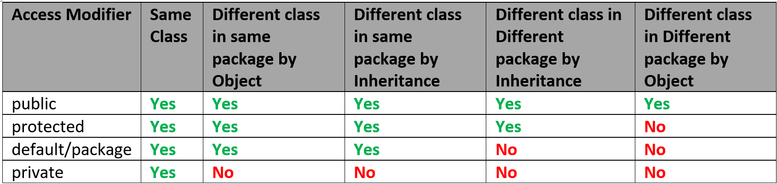

- Restriction Level from Highest to Lowest
Private default/package protected Public

Polymorphism

- Is a way in which one object can have a different form.
- There are two types polymorphism
  - Compile time Polymorphism
    - The method call is resolve at the compilation and same will be followed at the execution.
    - It can be achieved by Overloading.
  - Runtime Polymorphism
    - The method call is resolved at the execution/run time is called as runtime polymorphism.
    - It can be achieved by Overriding.

Overloading
- Overloading is a way in which you can create a method with same name and different parameter list.
- Overloading can be done in same class or in sub-class.
- There are 3 ways to change the parameter list.
  - You can change the data type of parameter.
  - You can change the number of parameters.
  - You can change the sequence of parameter.
- The access modifier may or may not be same.
- The return data type may or may not be same.
- You can overload static methods.
- You can also override final methods.
- You can throw new and broader checked exception.
- Advantage
  - You can improve the readability of the program.
  - User can use the function with same name which is having different implementation internally.

Overriding
- Overriding is a way in which you can create a method with same name and same parameter list.
- Overriding must be done is sub-class. That is, to achieved overriding there should an inheritance between classes.
- Overriding is use to change the default implementation provided by super class methos inside sub-class.
- Access Modifier can be change but it must be less restrictive.
- Return Data Type must be same if it is primitive or void. You can change the return type if it is non-primitive.
- Static methods cannot be override.
- Final Methods cannot be override.
- You cannot throw new and broader checked exception.

Task
- Different Between Overloading and overriding.

Runtime Polymorphism
- To achieve a runtime polymorphism you needs to follow 3 steps
  - You must have the more that one class and inheritance must be there between classes.
  - The methods from the parent must be overridden.
  - The overridden method call has to happen using a polymorphic object.
- Polymorphic Object.
  - Polymorphic Object is an object which has a parent class reference and child class Object
Syntax: Parent ref = new Child();
  - This object is use to achieve runtime polymorphism.
  - This object is use to dynamically call the methods.

Abstraction
- Abstraction is Hiding the complexity (complex Implementation) and showing only the required functionality.
- Abstraction can be achieve in java using 2 ways
  - Abstract Class
    - Using Abstract class you can achieve 0-100% abstraction.
  - Interface
    - Using Interface you can achieve 100% abstraction.
Abstract Class
- Abstract class is a class which can have abstract and non-abstract methods.
- Abstract methods are the methods in which only the method declaration is given without its implementation.
- Abstract classes are created using an abstract keyword.
- Abstract Class will be used as a super class or in the top level of the hierarchy.
- Abstract Class always extends on another class.
- When Abstract Class extends on another non-abstract Class in the child class you have to provide implementations (Override method) for all the abstract methods.
- When Abstract Class extends on another abstract Class in the child class it is not necessary to provide implementations (Override method) for all the abstract methods. The abstract methods will be inherited as it is in the child abstract class
- You cannot create Object of abstract class but it can be use as a reference for the polymorphic object.
- Can create constructor inside abstract class. these constructors invokes when the object of its sub-class created.
- You can create variables also inside abstract class.
- Abstract class can have static and final method but it must be non abstract.
- Abstract class or methods cannot be static or final.

Interface
- Interface is not a class. To create interface you can make use of interface keyword. Every interface has a .class file.
- Interface are use to achieve 100% abstraction.
- All the methods from the interface are implicitly public and abstract.
- All the variables inside interface are public static final.
- In the interface only public access modifier can be used no other access modifier is allowed.
- You cannot create constructor inside interface.
- Interfaces are used as a top level in the hierarchy.
- Interface implements on a class.
- If interface implements on any non-abstract class then, that class has to provide implementation for all abstract method.
- If interface implements on any abstract class, then there is no need of providing implementation for abstract methods.
- You cannot create Object of interface but it can be use as a reference for a polymorphic object.
- In the interface you cannot create static and final methods (Till Jdk 1.7)
- One interface can extends another interface and also can extends more than one interface. Using this behavior you can achieve multiple inheritance in java.
- One class can implements more than one interface
- One class can extends another class and implements more than one interfaces.

Interface In JDK 1.8 onward
- In the interface you can create implemented methods which is known as default methods.
- In the Interface you can create a static method.
- Functional interface is introduced in to achieve a functional programming.
  - The interface which has only one abstract method is called as functional interface.
  - In functional interface you can have any number of default or static method.
  - To make sure that the interface is functional interface you can use @FunctionalInterface annotation of the interfaces.

Exception Handling

Exception is an unwanted scenario occurs during the execution of the program due to which program execution terminated (stopped) abnormally.
Exception Handling is a way to restrict the abnormal termination of the program by handling the exception.

Understand an Exception

5 keywords used in Exception Handling
- try: Is a block in which you can write a statement which my throw an exception.
- catch: Is a block which catch the exception thrown from the try block, inside it you can provide the alternative code for the exception.
- finally: this block is use to execute a statement always irrespective of try and catch block.
- throw: you can raise exception manually using throw keyword.
- throws: you can propagate the exception to a caller level.

Exception throw(raise) process
- The identification of the exception scenario.
- Identifying the type of exception and create an Object of Exception class.
- Throw (raise) the object of exception.

Try
- Try block is a collection of statement which may throw exception.
- Try block has to write with the catch block, finally block or both.
- Syntax
try {
Statement(s)
}

Catch
- Catch block is use to catch the exception thrown from the try block.
- Inside catch block you can provide an alternative execution if exception occurs.
- In a catch block you have specify a type of exception handle by catch block.
- In a catch block the Object of exception will be catch and available.
- Catch block must have to write with try block only.
- Syntax:
catch(Exceptionclass ref)
{
Statement(s)
}
- One try block can have multiple catch block.
finally
- Finally is use to execute a statement always.
- This block has to come with try or try-catch.
- It gives you an guarantee of execution.
throw
- It is use to populate the exception manually.
- Using this you can throw any exception from the statement level.
- It throws an object of the exception.
throws
- It is use to propagate the exception outside method
- It will pass the exception handling responsibility to a caller level.
- Throws Keyword has to use at method signature level and must followed with Exception class nae.
Exception Hierarchy

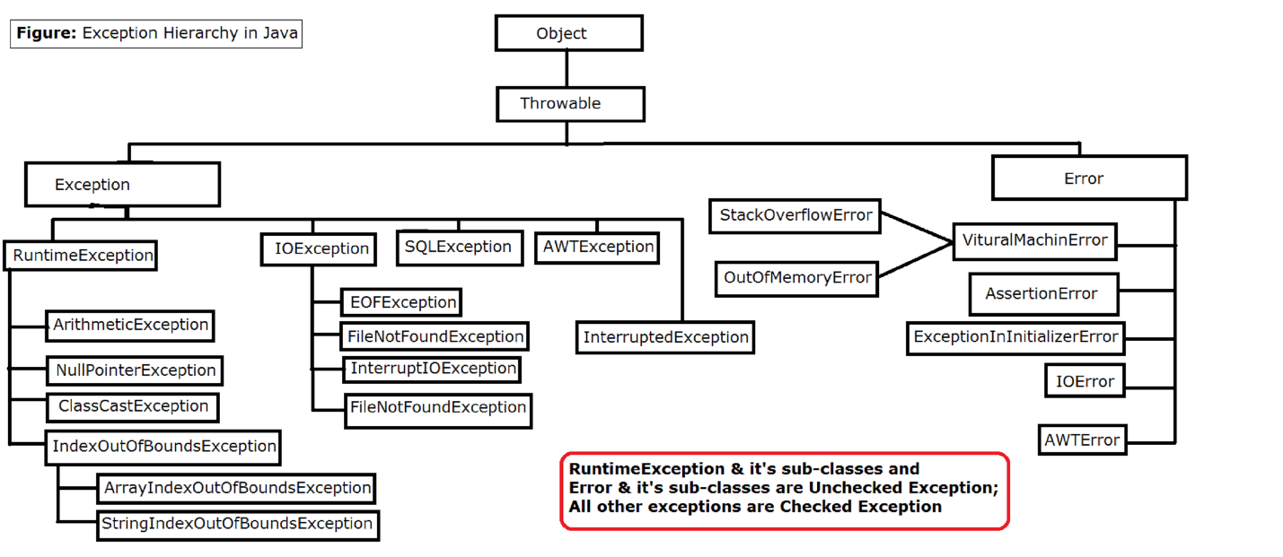

Type of exceptions
- Checked Exception
  - The exception which is other than Runtime Exception and its sub classes are known as check exception.
  - The exception which has to handle at the time of coding and compiler will give a compile time error if this exception not handled, this is called as checked exception.
  - Compiler will force to handle the exception else the program will no compile.
- Unchecked Exception
  - The RuntimeException and all its child classes are known as unchecked exception.
  - The exception can be ignore at the compile and runtime of the program.
  - Compiler will not force to handle the exception.
  - Examples: ArithmeticException, NullPointerException, InputMistmatchException etc.

Difference between
- Checked and Unchecked Exception
- Throw and Throws
- Final and Finally

Multi-Threading
- Thread is called as Light weight process.
- Its is a part of process which is having independent execution.
- Every thread has its own memory which is also known as call by stack memory.
- Thread can have a independent execution and memory.
- By Default in java every program executes using a thread.
- The default thread will be created by java internally while program execution which is known as main thread.
- In java there are 2 ways to create thread.
  - By Extending Thread class
  - By Implementing Runnable interface
- Thread will always executed by JVM. So developer do not full control on the thread execution.
- Developers can manipulate the execution by using some predefine methods but it cant be fully control.
- Thread output cannot be predict as it is execute by JVM internally.

Create Custom Thread
- Create a class and extends either Thread class or implements Runnable Interface.
- Override the run() Method in which you can assign a task to a thread
- Make thread ready to run. And ready thread will be picked by JVM and sends for the execution.
Most Command methods for Thread Class
Method Name | Description
currentThread() | These is a static method of thread class. Using this you can get the Object of currently Executed thread.
run() | This method is use to assign a task to a thread. This method present inside Runnable interface and Thread class. This method will be invoke by the JVM.
start() | Start method is use to make thread ready to run. And this method is present inside thread class only.
join()  join(long)  join(long, int) | Using this method you can pause the execution of current thread for the another thread until completing the execution of it or for a given time period. This method throws an InterruptedException which is checked exception and it has to handle.
sleep(long)  sleep(long,int) | This is the static method using which you can pause the execution of the thread for a given time and thread will resume the execution after the given time expire. This method throws an InterruptedException which is checked exception and it has to handle.

Thread Life Cycle
- Thread life cycle is manage by JMV for every thread created in a program.
- This life cycle has 5 stage.

Synchronization
- It is used when more than one thread using a same resource and you wanted to access the resource sequentially by the thread.
- It is a process which acquires a lock on share resources and it will be releases when it complete the execution.
- Synchronization can be achieved by 2 ways
  - Synchronized Method
  - Synchronized block

Collection Framework
- Use to work with a group object.
- You can create a group of object and perform the operation on it.
- Collection has multiple class and interfaces using which you can achieve a different behavior of working with a group of object.
- There is a Collection interface available which is consider as a parent exception of all the collection classes or interfaces.
- Collection can be use for a same type of object or you can also group the object of different type.
- Collection id dynamic in size so, there is no fix size has to provide while using a collection.
- There are 3 types of collection
  - List: Is use to store duplicate value
  - Set: Allows only unique value.
  - Queue: Provide a FIFO (First In First Out) functionality.
- All the collection classes and interfaces are present inside java.util package

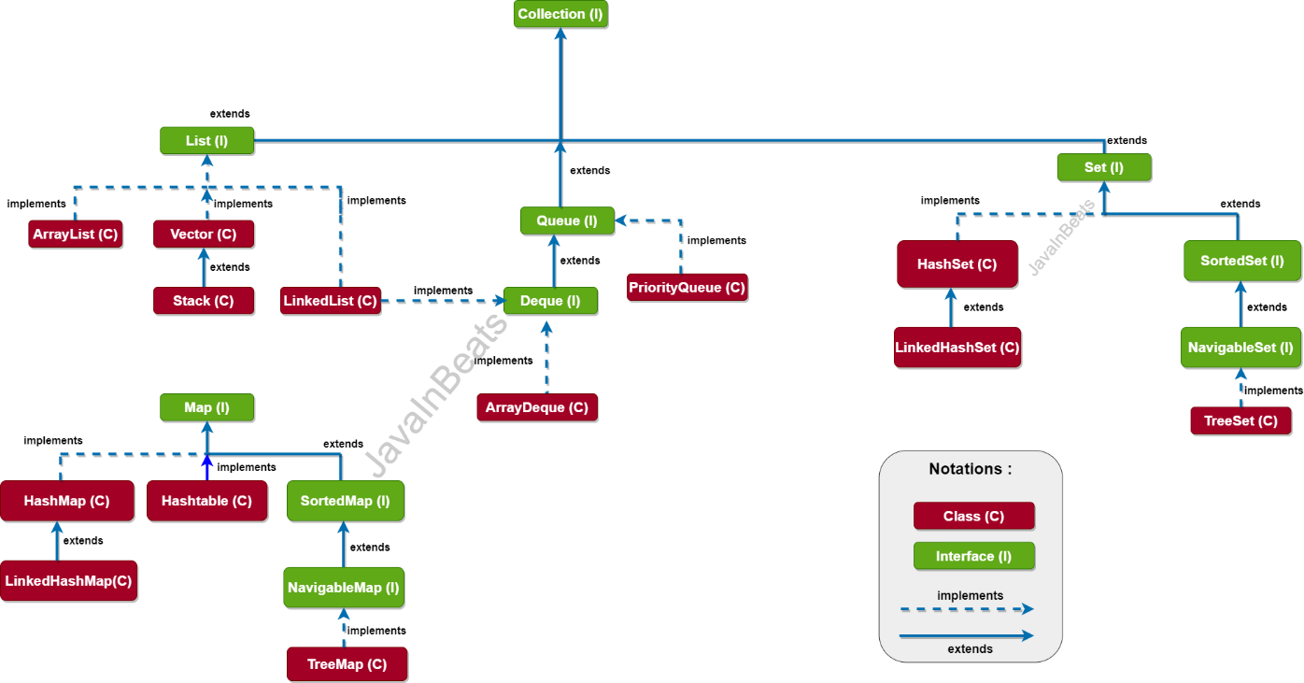
Common Methods inside Collection
- add(Object): it is use to add an object inside collection.
- remove(Object): it is use to remove value from the collection.
- contains(Object): it use to check whether given Object is present or not in collection.
- size(): Is use to get the count of value present inside collection.
- isEmpty(): you can check whether collection is empty or not.
- addAll(Collection): can add multiple object at a time.
- removeAll(Collection): can remove the multiple values from collection.
- containsAll(Collection): Can check whether group of values present inside collection or not.
- iterator(): to get the objects from the collection one by one.

In Collection all values will be store in form of Object only for primitive values java has provided wrapper classes to store a value.
Primitive Type | Wrapper Class
byte | Byte
short | Short
int | Integer
long | Long
float | Float
double | Double
char | Character
boolean | Boolean

List
- List is an interface which implements the property from the collection interface.
- List is use to store a different type of values.
- List is dynamic in size.
- List allows duplicate values.
- List is index based.
- Implemented Classes of the List
  - ArrayList
  - Vector
  - LinkedList
ArrayList Class
- ArrayList is use to store different type of values.
- ArrayList list is dynamic is size.
- ArrayList indexes based.
- It allows the duplicate values.
- ArrayList is backed by array.
- ArrayList maintains the insertion order in a collection.
- It is Order and unsorted.
- You can perform the index based operation such as add, set, remove and get the value from specific index.
- The indexes will be shifted after the index based operation and due to this Array List provides slower performance in the updation.
- But it is faster in the Iteration.
- ArrayList implements the RandomAccess interface which allow to access the element randomly.

Vector Class
- Vector is use to store different type of values.
- Vector is dynamic is size.
- Vector indexes based.
- It allows the duplicate values.
- Vector is backed by array.
- Vector maintains the insertion order in a collection.
- It is Order and unsorted.
- You can perform the index based operation such as add, set, remove and get the value from specific index.
- The indexes will be shifted after the index based operation and due to this Vector provides slower performance in the updation.
- But it is faster in the Iteration.
- Vector implements the RandomAccess interface which allow to access the element randomly.
- Vector methods are synchronized, that’s why only one thread can access the object of vector at time.
- Vector Object is thread safe.
- Vector provides slower performance than the ArrayList.

LinkedList Class
- LinkedList class implements the property from List, Deque and Queue interface.
- LinkedList is used to store different type of values.
- LinkedList is dynamic is size.
- LinkedList is not indexed based.
- In LinkedList you can store duplicate value.
- LinkedList us based on doubly linked list algorithm.
- LinkedList value will be store in the form of nodes. And every node has 3 parts previous value address, next value address and actual value.
- LinkedList provide the faster updation.
- But it is slower in the iteration.
- LinkedList maintains the insertion Order, and hence it is order and unsorted.

Set
- Set is inherits the collection interface
- Set allows only unique values.
- Set is dynamic in size
- Set is used to store different type of values.
- All the implemented classes are non-indexed based.
- Implemented classes of Set interface
  - HashSet
  - LinkedHashSet
  - TreeSet

HashSet
- HashSet implements the property for Set interface.
- HashSet allows only unique elements.
- It is dynamic in size.
- Set allowed different type values.
- HashSet based on the Hashing algorithm.
- It provides faster searching.
- It unorder and unsorted, that is it will not maintain the insertion order.
LinkedHashSet
- LinkedHashSet class internally extends the property of HashSet.
- LinkedHashSet allows only unique values.
- It is dynamic in size.
- Set allowed different type values.
- It is based in the doubly linked list and the hashing alog.
- It is order and unsorted, that is it maintains the insertion order.
- It is used for faster updation and searching.

TreeSet
- TreeSet implements the property from Set, SortedSet, NavigableSet interface
- TreeSet use to store unique values.
- TreeSet can store values of similar data type only.
- TreeSet based on the Balance Tree algo.
- The values will be store and retrieve in the sorted order and by default natural sorting technique is used.
Map
- Map is use to store key and values which is also known as Entry.
- Map is not a collection as it not inherits the property from Collection Interface.
- Map store the key and values both can be of different data types.
- In Map all the key must be unique and values can be duplicate.
- Map is dynamic in size.
- Map has multiple implemented classes
  - HashMap
  - Hashtable
  - LinkedHashMap
  - TreeMap
HashMap
- Map is use to store a Key and value pairs which is also known as entry.
- It is dynamic in size.
- It allows different type of key and values.
- the key must be unique and values can be duplicate.
- If any try to add duplicate key with different value than the old value will be replace by the new values.
- You can store one null key and multiple null values.
- HashMap is unorder and unsorted.
- It is based on Hashing algo.
- HashMap used for a faster searching.
LinkedHashMap
- LinkedHashMap implements the properties from HashMap class.
- Map is use to store a Key and value pairs which is also known as entry.
- It is dynamic in size.
- It allows different type of key and values.
- the key must be unique and values can be duplicate.
- If any try to add duplicate key with different value than the old value will be replace by the new values.
- You can store one null key and multiple null values.
- LinkedHashMap is order and unsorted.
- It is based on Hashing and doubly linked list algo.
- HashMap used for a faster searching and faster updation.
Hashtable
- Map is use to store a Key and value pairs which is also known as entry.
- It is dynamic in size.
- It allows different type of key and values.
- the key must be unique and values can be duplicate.
- If any try to add duplicate key with different value than the old value will be replace by the new values.
- Hashtable not allows null key or null value.
- Hashtable is unorder and unsorted.
- It is based on Hashing algo.
- Hashtable used for a faster searching.
- Hashtable object is synchronized.
- It is also known as thread safe object.
- Its is slower in the performance than HashMap.

TreeMap
- TreeMap implements the property from Map, SortedMap and NavigableMap.
- It is dynamic in size.
- Key must be of same type and values can be of different type.
- If any try to add duplicate key with different value than the old value will be replace by the new values.
- Based on the balance tree algo.
- The entries are in sorted by key.

Generic Type
- It is use to specify the type of Objects which you are going to add inside collection.
- By using this you can restrict the user to store a specific type of values only.
- The Generic Type must be a class Name. you cannot use primitive type in place of Generic type.
- By Specifying a generic type you can make your collection type safe.
- Example:
ArrayList<Double> list = new ArrayList<Double>();
HashMap<String,Integer> map = new HashMap<String,Integer> ();

Iterating Collection
- Iterating collection means getting a values from the collection one by one.
- This can be achieve by 2 ways
  - Iterator Interface
  - For Loop

Create an Collection with name “cart”. In side this collection store the Object of Product class.
And print the billing details by iterating the list.
Product Class Fields: Id, Name, Price, Quantity
O/P
Name Price Quantity Total Price
A 500 2 1000
B 1000 1 1000
C 1200 2 2400
-------------------------------------------------------------------
Total Amount: 4400

Java DataBase Connectivity (JDBC)
- Using this you can connect java application with the database.

- In JDBC, to connect with database you have to follow the steps and the APIs provided by java.
- All the JDBC APIs throws an checked exception which has to be handle during code.

To Add Database Connection in any application you have to first add jar inside Project
Steps to add jar file into Core Java Project
- Right Click on The Project
- Go to “Build Path” Options -> select “Configure Build Path…” option
- Select “Libraries” tab from the new window.
- Click on “Classpath” option from the libraries tab.
- Click on “Add External JARs..” button from the right side of window.
- Browse a jar file and select the jar file and click on “Open” button.
- Click on “Apply and Close” button.

Steps To Connect with Database (JDBC)
- Register Driver
  - In this step the driver will be loaded inside a java application and will be make available for further database interactions.
  - Syntax:
Class.forName(“<DriverName>”);
Example:
Class.forName(“com.mysql.cj.jdbc.Driver”); For MySql
Class.forName(“oracle.jdbc.driver.OracleDriver”); For Oracle

- Create Connection
  - You can connect with the database using this step.
  - You will get an connection object in this step.
  - To connect with database you have to provide the following properties.
URL: jdbc:mysql://localhost:3306/<DBName> Mysql
Jdbc:oracle:thin:@localhost:1521:xe Oracle
UserName: <YourUserName>
Password: <YourPassword>
  - Syntax:
Connection con = DriverManager.getConnection(“URL”,”UserName”,”Password”);

- Create Statement
  - Is use to hold the SQL query which is going to execute.
  - There are 3 ways to create a statement
    - Statement
      - You can execute all types of query.
      - You cannot provide a parameterizes query.
      - There can be a SQL injection chances in this type of statement.
      - It is slower than the other options.
      - Syntax
Statement stmt = conObj.createStatement();
    - PreparedStatement
      - You can execute all type of query using this type of statement.
      - You can provide parameterized query.
      - There are no chances of SQL injection in this type. So it is secure.
      - It is faster than the Statement Option.
      - Syntax:
PreparedStatement stmt = conObj.prepareStatement(“SQL”);
    - CallableStatement
      - You can use this to execute the procedure.
      - It is faster than other applications.
      - Syntax:
CallableStatement stmt = conObj.prepareCall(“call{procedurename}”)

- Execute Statemen
  - The query will be executed and get the result from the database into java program.
  - There are 3 options to execute query
    - executeUpdate()
      - Can execute the DDL and DML type of query.
      - After the query execution you will get an int value as response which is the total number of rows affected.
      - Syntax:
int count = stmtObj.executeUpdate();
    - executeQuery()
      - Can use to execute the DQL (Select) type of query.
      - After query execution you will get an Object of ResultSet by using which you can extract the data which is selected by query.
      - Syntax:
ResultSet rs = stmtObj.executeQuery();
    - execute()
      - Can use to execute any type of query.
      - Adter query execution you will get an Boolean values as a response.
      - If the return value is true then you can get a ResultSet and if value is false then you will get an int count.
      - Syntax:
boolean flag = stmtObj.execute()
- Close Connection
  - It is use to release the resources acquire by the Java Program.

