**Servlet and JSP**

1. Servlet and JSP are the technologies.
2. Using this you can develop the dynamic web application.
3. Along with these technologies you will also required an Html and CSS as a frontend technology.
4. Web Application
   1. There are two parties in the web application such as client and server.
   2. These are communicate with each other by a request and response.



**Types Of Web Application**

1. Static Web Application
   1. In this the content of the page will be same for every user.
   2. Using front technology you can develop a dynamic web application.
   3. Example: HTML, CSS, JS, Angular, React.
2. **Dynamic Web Application**
   1. In this the content of the page will be different for every user.
   2. Using front end and backend technology you can develop the dynamic web application.
   3. Example : HTML, CSS, JS, Angular, React as a frontend technology and JSP, servlet can be use as a backend technology.

**Environment Setup for Development and execution of Web Application**

1. Download Tomcat server

[**https://tomcat.apache.org/download-90.cgi**](https://tomcat.apache.org/download-90.cgi)

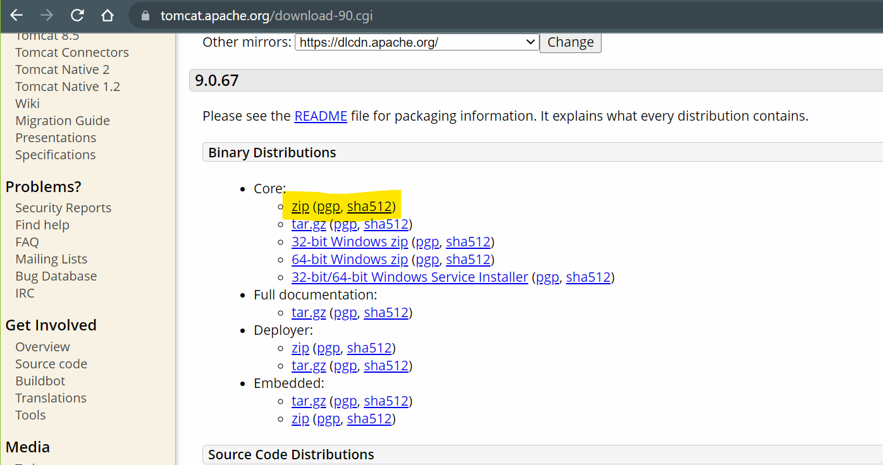

1. Extract Server and Setup server into eclipse
   1. Copy and paste zip file into an appropriate location.
   2. Extract the ZIP file.
   3. Server Setup in eclipse
      1. Open an Eclipse. Set the eclipse perspective to “Java EE”
      2. Go to “servers” tab (at the bottom of the eclipse window)
      3. Click the link to add new Server.
      4. Expand the Apache option from the new Window
      5. Select the Tomcat version which is downloaded.
      6. Click on “Next”
      7. Browse for the tomcat path (path must the parent folder of the extracted tomcat in which bin, lib, config folders are present)
      8. Click on “Next” -> “Finish”

**Create Dynamic Web Application in Eclipse**

1. “File” Menu -> “New” Option -> select “Dynamic Web Project”
2. Provide the Project Name (Make sure that target runtime is selected and It Must not be **<NONE>**)
3. Click on “Next” -> Click “Next”
4. Make Sure that “Generate web.xml deployment descriptor” check box is selected
5. Click on “Finish”



**Servlet**

1. Servlet are the java classes.
2. Servlet is used to create dynamic web pages.
3. In a Servlet you can write HTML code along with Java Code.
4. Servlet is mainly used for getting a request from the end user, process the request and generate the response.
5. Servlet are executed at server side.
6. Servlet are the java class and the file extension of the servlet is .java.
7. Servlet do not have a main method.
8. Servlets are executed and managed by Servlet container which is a part of server.
9. For every servlet there is a unique URL using which that servlet will gets called and executed.

**Servlet Creation Steps**

1. Right Click on “src/main/java” -> Go To “New” -> Select “Servlet” Option.
2. Provide the class name -> Click on “Next”
3. Observe the URL and click on “Next” button
4. Checked the service option and click on Finish

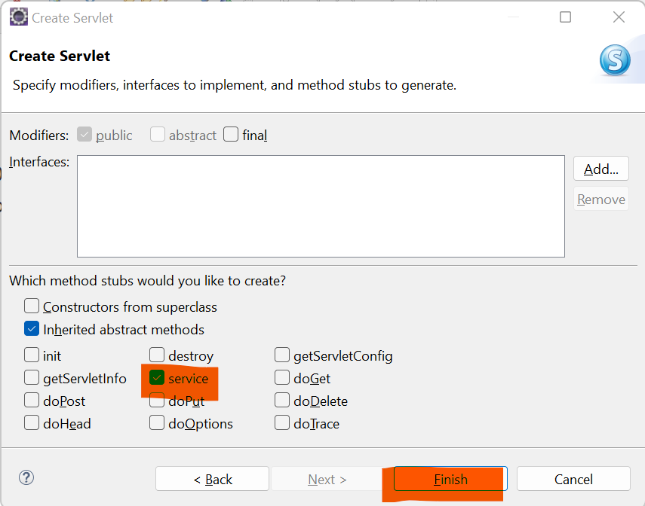

**Response from Servlet**

1. To Return a response to a client you have to use HttpServletResponse Object.
2. This object is by default available on every Servlet and JSP Page.
3. To Return a response you have to set the content type. This is also known as MIME type.

<https://developer.mozilla.org/en-US/docs/Web/HTTP/Basics_of_HTTP/MIME_types/Common_types>

**response.setContentType(“<Type>”);**

1. Create and use the Object of PrintWriter to return response

**PrintWriter out = response.getWriter();**

1. Using a print() method from the PrintWrtier Onject you can return response for the client.