**DataBase**

1. It is use to store the data and maintain the data.
2. Using Database you can generated reposted easily just by using query.
3. The data stored inside database will be available for a longer period of time.
4. There are different type of databases present
   1. **Relational Database**
      1. In this database the records will be store in the structure format that is in the form of rows and columns (table format).
      2. The data can be store in a distributed was into multiple table. And those table will be related with each other by a primary and foreign key.
      3. The data store into the database is also known as structure Data.
      4. Example: **MySql**, Oracle, SQL Server, Postgrace etc.
   2. Document Database
      1. Is use to store the data in the form of document (.JSON)
      2. In this type of database there is not table structure present and cannot store data into a distributes way using primary and foreign key.
      3. Example:

MongoDB, Cassandra etc.

* 1. Graph Database
     1. The data will be store in the form of tables/rows and columns. But is represented as a graph.
     2. Example:

Neo4J

Download Database and Installation

MySql:

<https://dev.mysql.com/downloads/installer/>

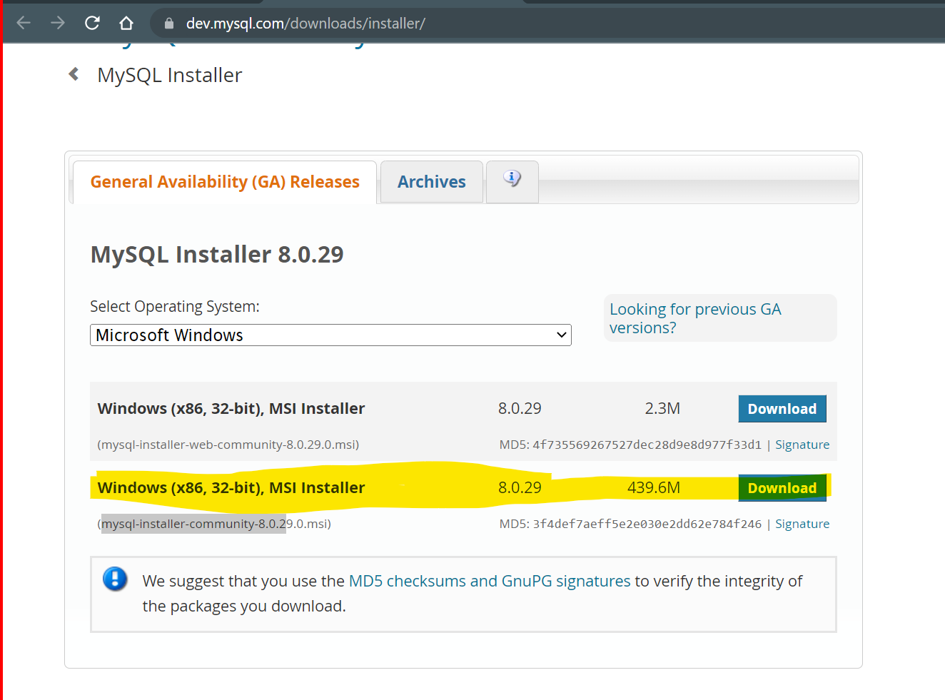

Install MySql:

<https://www.youtube.com/watch?v=OM4aZJW_Ojs>

**Important**

Note down the port number (3306), username (root) and password during the Setup.

SQL (Structure Query Language)

1. It is use to execute the queries inside database.
2. The SQL is use to interact with he database.
3. The SQL is distributed into 5 categories
   1. **DDL (Data Definition Language)**
      1. It is use to create, modify or delete the structure of the table and the different database object such as table, index, tiggers, function etc.
      2. SQL Operation like **CREATE, ALTER, DROP** can be use on the Objects
   2. DML (Data Manipulation language)
      1. Using this you can insert, update or remove the data from the table. It is use to perform the data specific operation.
      2. SQL operations like **INSERT, UPDATE, DELETE** can be perform in this type.
   3. DQL (Data Query Language)
      1. Using this you can retrieve the records from the database. There can multiple options to retrieve the data such as clauses, Join etc.
      2. SQL Operation like **SELECT** can use perform in this type.
   4. TCL
   5. DCL