**Spring Boot**

1. Spring Boot is a java-based framework.
2. Spring Boot is used for the faster Development and it also reduce the development efforts.
3. Using Spring Boot you can develop a product ready applications.
4. Spring Boot also provides the embedded tomcat server and the database such as H2 Database.
5. Spring Boot provides multiple predefine functionality using which with min configuration you can achieve the maximum functions. This are also customized as per requirement.
6. Spring Boot is based on Spring Framework.
7. Spring Boot is used for Creating Full-stack or Micro services application.
8. Spring boot is easy to learn and also Implement because it is distributed into a multiple modules, and to use spring boot you do not have to lean all the spring modules.
9. You can use the specific module as per your project requirement.
10. Some Examples of spring boot modules
    1. Spring IOC/Core
    2. Spring JDBC
    3. Spring ORM
    4. Spring REST
    5. Spring Batch
    6. Spring MVC etc..
11. Spring Boot is a wrapper of Spring Framework. Spring boot has provided an easy way to create a project, to add multiple modules dependency and configuration.
    1. Spring Boot Provided the starter projects using which you can add the dependencies easily and just by adding single dependency.
    2. Spring boot also provide the auto configuration functionality using with you will get the default configuration from the maven which is highly customizable.
    3. Spring Boot provides the Embedded tomcat server and H2 Database so that you can run the application with minimum setup.

**Create Spring Boot Project**

1. Spring CLI (Command Line Interface)
   1. In this approach you have to install CLI tool and using the command you can create spring boot project.
2. Spring STS (Spring Tool Suit)
   1. Spring suit is and IDE which is created as an extension on eclipse and IntelliJ IDE

<https://spring.io/tools>

1. Spring Initializer
   1. This is an web application provided by spring to create a spring boot project.
   2. Here, you can provide the details for creating spring boot application and you can download the application will all the features provided.

<https://start.spring.io/>

**Steps to create and import Spring boot Project in Eclipse**

1. Create Spring Boot Project

Go to <https://start.spring.io/>

Fill up the project details into form

Click on Generate button. It will download the ZIP file.

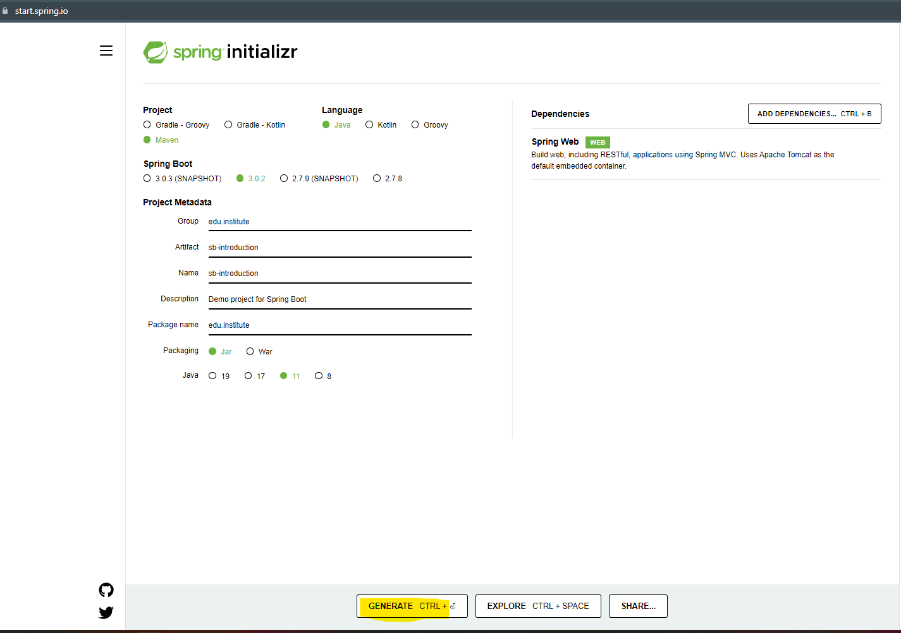

1. Import the project into Eclipse
   1. Copy and paste the project ZIP file into eclipse workspace
   2. Extract the ZIP file.
   3. Open an Eclipse workspace
   4. “File” menu -> click “Import” Option
   5. Search for “Maven” Option in the Wizard -> Select the “Existing Maven Projects” option and click on “Next”
   6. Browse for an extracted project location and select the parent folder of the pom.xml file.
   7. Click on Finish

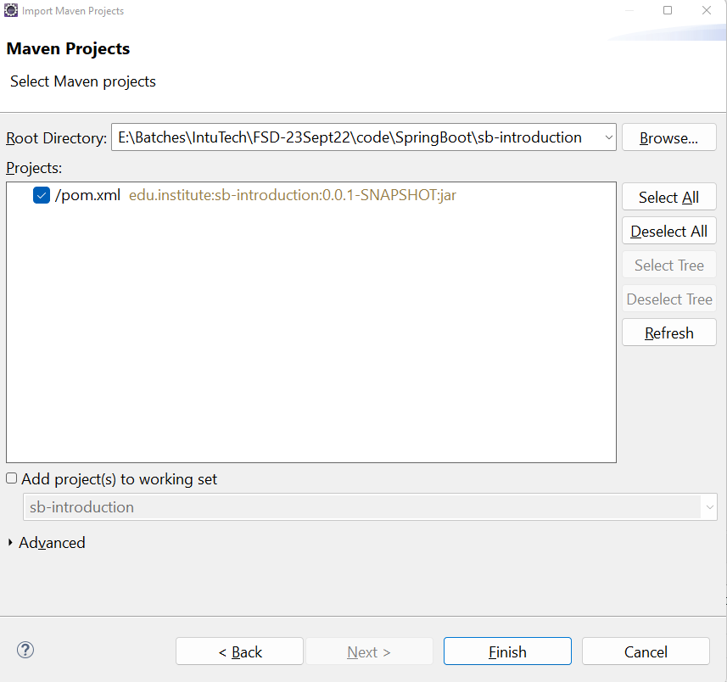

**Spring Boot Application Main Class**

1. This class is present in all the spring boot project
2. This class is use to start/run the spring boot application
3. In this class there are 2 statements which help to start with spring boot project
   1. **@SpringBootApplication** Annotation
      1. This annotation denote the application is a spring boot application.
      2. This annotation is a combination of 3 annotations
      3. **@Configuration** annotation is use to load the configurations. All the configurations are loaded inside spring application at the start of the project.
      4. **@EnableAutoConfiguration** annotation is use to enable the spring boot default configuration. The configuration such as Tomcat Server configuration, DB configurations are added inside application
      5. **@ComponentScan** annotation is use to load all the spring bean class object inside spring container.
4. **Execution of the Run methods**
   1. This method is use to start the spring boot application with the startup arguments.
   2. This method return the Object of Spring Container which is ApplicationConext.