PUNE INSTITUTE OF COMPUTER TECHNOLOGY DHANKAWADI,PUNE–43.

SYNOPSIS STRUCTURE(Mini project-E&TE)

**Department:TE(E&TC)–Mini project Semester:VI**

**AcademicYear: 2022-23 Date:**

1. Title : Design Simulation And Fabrication Of Antenna For MBAN Application

Submitted by :Om Shinde (32236)

Prathmesh Khose(32240)

Prathmesh Kalamkar(32136)

Guided by :Ms. P. Tathe

1. Objective-:

The primary objective of a microstrip antenna for MBAN is to provide reliable and efficient wireless communication between medical sensors and devices attached to a patient's body. The antenna should be small in size and low in power consumption, while still providing sufficient bandwidth and radiation efficiency for data transmission. Additionally, the antenna should be biocompatible, meaning it should not cause any harm to the patient's body.

1. Introduction-:

A microstrip linear antenna is a type of planar antenna that is widely used in various communication systems, such as wireless networks, satellite communication, and radar systems. The microstrip linear antenna is a simple and low-cost antenna that can be easily fabricated using printed circuit board (PCB) technology.

1. LiteratureSurvey-

Several research studies have been conducted on the design and implementation of circularly polarized microstrip antennas for various applications. For example, a circularly polarized microstrip antenna was designed and fabricated for GPS applications in [1]. The antenna had a

compact size and a wide bandwidth of 17.4%. Another study [2] designed and fabricated a circularly polarized microstrip antenna for WLAN applications. The antenna had a high gain of 8.7 dB and a wide bandwidth of 16%. A circularly polarized microstrip antenna for RFID applications was designed and implemented in [3]. The antenna had a compact size and a wide bandwidth of 9.5%. These studies demonstrate the potential of circularly polarized microstrip antennas for various applications.

In conclusion, the design and implementation of a circularly polarized microstrip antenna for MBAN applications is an active area of research. The objective of this project is to design and fabricate an antenna that has a compact size, high gain, and wide bandwidth, and can provide

better signal quality and reduce interference from other sources. The literature survey shows that circularly polarized microstrip antennas have been successfully implemented in various applications, and this project aims to contribute to this body of research.

References:

1. Khilare, Sunny, Rishabh Mhatre, Ganesh Kulkarni, Shahadev Hake, and Pune PICT. “ANTENNA DESIGN FOR WEARABLE MEDICAL DEVICES USING MBAN BAND.”
2. Zhu, Xiao-Qi, Yong-Xin Guo, and Wen Wu. "Miniaturized dual-band and dual-polarized antenna for MBAN applications." *IEEE Transactions on Antennas and Propagation* 64, no. 7 (2016): 2805-2814.
3. T. -W. Koo, J. -G. Yook, Y. -J. Hong, G. Park and K. Shin, "Low profile patch antenna for on-body wireless sensor application in MBAN band," Proceedings of the 2012 IEEE International Symposium on Antennas and Propagation, Chicago, IL, USA, 2012, pp. 1-2, doi: 10.1109/APS.2012.6349020.
4. Bhattacharjee, S., Midya, M., Mitra, M., & Bhadra Chaudhuri, S. (2019). Dual band- dual polarized planar inverted F-antenna for MBAN applications. *International Journal of Microwave and Wireless Technologies,* *11*(1), 76-86. doi:10.1017/S1759078718001228
5. Block diagram and Methodology with detail specification of each component.

The block diagram of the circularly polarized microstrip antenna for MBAN applications consists of the following components:

1. Substrate: The substrate is the base material on which the antenna is fabricated. It should have a low dielectric constant and loss tangent.
2. Patch Antenna: The patch antenna is the radiating element of the antenna. It is designed to provide circular polarization.
3. Feeding Mechanism: The feeding mechanism is used to excite the patch antenna and provide power to the antenna.
4. Ground Plane: The ground plane is placed on the bottom of the substrate to improve the antenna's performance.

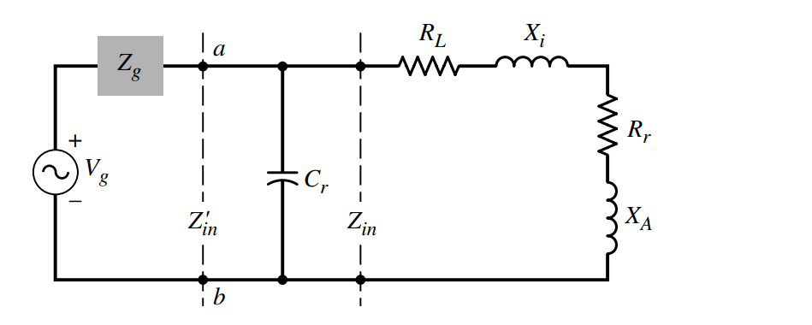

Methodology-:

1. Determine the operating frequency range: Identify the frequency range for the MBAN band application and select an appropriate operating frequency range for the antenna.

b. Choose the antenna type: Select the type of linear polarized microstrip antenna that best suits the application, such as a patch antenna, a helical antenna, or a spiral antenna.

c. Design the antenna structure: Use electromagnetic simulation software such as CST Microwave Studio or Ansys HFSS to design the antenna structure, including the substrate material, the patch shape, the feeding mechanism, and the ground plane.

d. Optimize the antenna performance: Use the simulation software to optimize the antenna performance, including the return loss, the axial ratio, the radiation pattern, and the gain.

e. Fabricate the antenna: Fabricate the antenna using standard PCB manufacturing techniques, such as etching, drilling, and soldering.

f. Test the antenna: Use testing equipment such as a network analyzer and a spectrum analyzer to measure the antenna performance and verify that it meets the design specifications.

g. Tune the antenna: Adjust the antenna dimensions and feeding mechanism to improve the antenna performance, if necessary.

h. Evaluate the antenna performance: Evaluate the antenna performance in terms of bandwidth, efficiency, and radiation characteristics, and compare it with other similar antennas.

i. Optimize the antenna for production: Optimize the antenna design and fabrication process for mass production, including cost and yield considerations.

j. Document the design: Document the antenna design, including the simulation results, the fabrication process, the testing results, and the optimization steps, for future reference.

1. Resources-:
2. Research papers: Research papers published in various journals and conferences provide detailed information about the design and implementation of circularly polarized microstrip antennas. These papers also include performance evaluation results and comparisons with existing antennas.
3. Books: Several books on antenna design provide in-depth knowledge about the principles and practices of antenna design, including microstrip antennas. These books also cover topics such as polarization, radiation patterns, and impedance matching.
4. Online courses: Online courses on antenna design are available on various platforms, such as Coursera, edX, and Udemy. These courses cover topics such as antenna theory, microstrip antennas, and electromagnetic simulation software.
5. Simulation software: Various electromagnetic simulation software, such as CST Microwave Studio, Ansys HFSS, and FEKO, are available for designing and simulating microstrip antennas. These software packages provide accurate results and can help in optimizing the antenna's performance.
6. Antenna design tools: Various antenna design tools, such as Antenna Magus and Genesys, are available for antenna design. These tools provide a user-friendly interface and can help in designing the antenna based on the specifications.
7. Online forums: Online forums such as Antenna-Theory.com and RF Cafe provide a platform for discussing antenna design and related topics. These forums can be helpful in getting answers to specific questions and discussing design challenges.
8. Plan of execution-:

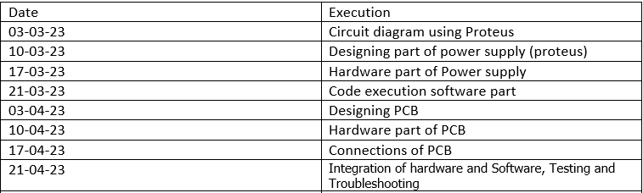

1. Rough cost estimation
2. Fabrication materials: The cost of materials for fabricating the antenna, such as FR4 substrate, conductive adhesive, and SMA connector, depending on the quantity and quality of the materials used.
3. Fabrication equipment: The cost of equipment for fabricating the antenna, such as a laser cutter, a PCB drill, and a soldering iron.

Overall, the cost of designing and implementing a circularly polarized microstrip antenna for MBAN applications can range from a few thousand dollars to tens of thousands of dollars, depending on the specific requirements and design constraints.

1. Application and future scope-:

Microstrip antennas have a wide range of applications in various fields such as communication, aerospace, military, and biomedical engineering. Some of the significant applications of microstrip antennas are:

1. Wireless Communication: Microstrip antennas are widely used in wireless communication systems such as mobile phones, Wi-Fi routers, satellite communication, and GPS systems. Due to their compact size and low profile, they are suitable for mobile and portable devices.
2. Radar Systems: Microstrip antennas are used in radar systems for surveillance, tracking, and imaging applications. They provide a broad bandwidth and high gain, making them suitable for radar systems.
3. Aerospace: Microstrip antennas are used in aerospace applications such as satellite communication, remote sensing, and space exploration. Due to their low weight and compact size, they are ideal for use in space vehicles.

The future scope of microstrip antennas is promising, with increasing demand for wireless communication and portable devices. With the advancement in technology, microstrip antennas are expected to become more efficient, compact, and cost-effective. The integration of microstrip antennas with other electronic components such as RFIDs, sensors, and MEMS is expected to increase, opening new avenues for research and development in the field of microstrip antennas. Additionally, the use of new materials, such as metamaterials, is expected to improve the performance of microstrip antennas and lead to new applications.

1. **References-:**
2. Khilare, Sunny, Rishabh Mhatre, Ganesh Kulkarni, Shahadev Hake, and Pune PICT. “ANTENNA DESIGN FOR WEARABLE MEDICAL DEVICES USING MBAN BAND.”
3. Zhu, Xiao-Qi, Yong-Xin Guo, and Wen Wu. "Miniaturized dual-band and dual-polarized antenna for MBAN applications." *IEEE Transactions on Antennas and Propagation* 64, no. 7 (2016): 2805-2814.
4. T. -W. Koo, J. -G. Yook, Y. -J. Hong, G. Park and K. Shin, "Low profile patch antenna for on-body wireless sensor application in MBAN band," Proceedings of the 2012 IEEE International Symposium on Antennas and Propagation, Chicago, IL, USA, 2012, pp. 1-2, doi: 10.1109/APS.2012.6349020.
5. Bhattacharjee, S., Midya, M., Mitra, M., & Bhadra Chaudhuri, S. (2019). Dual band- dual polarized planar inverted F-antenna for MBAN applications. *International Journal of Microwave and Wireless Technologies,* *11*(1), 76-86. doi:10.1017/S1759078718001228