MACHINE LEARNING · MINI PROJECT No. 34
Predicting Online Ad Clicks
using Random Forest
Project report · Academic Year 2025-26

Item | Detail
Dataset | Advertising click dataset · 1,000 impressions · 10 columns
Algorithm | Random Forest (scikit-learn) + own NumPy implementation
Final model | 167 trees · max_depth 10 · max_features sqrt · min_samples_leaf 4
Test results | Accuracy 96.4% · F1 0.964 · ROC-AUC 0.991
Deliverables | Jupyter notebook · Python package (ml/) · Flask dashboard (app/) · this report
Student | ________________________ Roll No. ________

1. Problem statement and objective
Online advertisers pay for every impression, yet most impressions never lead to a click. If the likelihood of a click can be estimated before an ad is shown, budget can be focused on receptive users and taken away from users who will not respond.
The objective of this project is to build a Random Forest classifier that predicts whether a user will click an online ad (Clicked on Ad = 1/0) from their browsing behaviour and demographics. The model is tuned, evaluated on unseen data, compared with eight other algorithms, and interpreted in business terms. A from-scratch implementation is included to show how the algorithm works internally.

2. Dataset summary
The Advertising dataset (public domain, widely used for click-prediction exercises) contains 1,000 ad impressions logged between 1 January and 24 July 2016. There are no missing values and no duplicate rows, and the target is perfectly balanced (500 clicks, 500 non-clicks), so accuracy is a fair headline metric and no resampling is needed.
Column | Type | Unique | Role | Description
Daily Time Spent on Site | numeric | 900 | feature | Minutes per day on the publisher site
Age | numeric | 43 | feature | User age in years
Area Income | numeric | 1,000 | feature | Avg. yearly income of the user's area (USD)
Daily Internet Usage | numeric | 966 | feature | Minutes per day online overall
Ad Topic Line | text | 1,000 | dropped | Headline text of the ad shown
City | text | 969 | dropped | User city
Male | binary | 2 | feature | Gender flag (1 = male)
Country | text | 237 | dropped | User country
Timestamp | datetime | 1,000 | feature | When the ad was shown
Clicked on Ad | binary | 2 | target | Target: 1 = clicked, 0 = not clicked

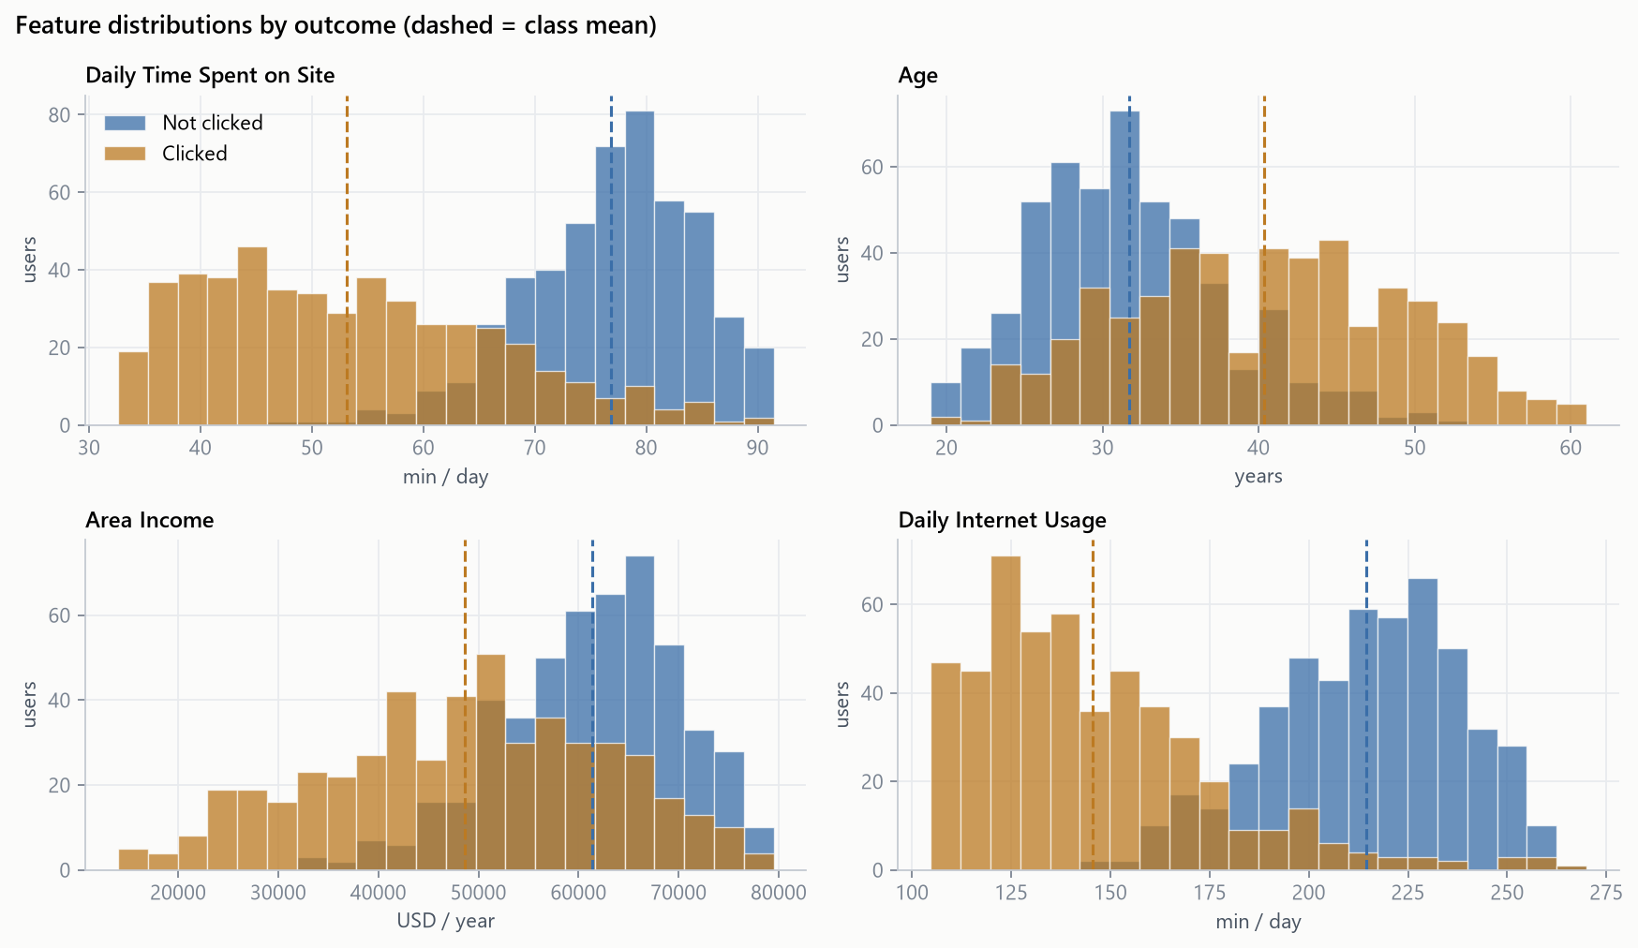
Figure 1. Distribution of each numeric feature by outcome; dashed lines mark class means.
Clickers spend clearly less time on the site and on the internet overall. They are also older and live in lower-income areas. Figure 2 shows that the two usage features alone almost separate the classes, along a nearly straight diagonal. This observation becomes important when comparing algorithms.
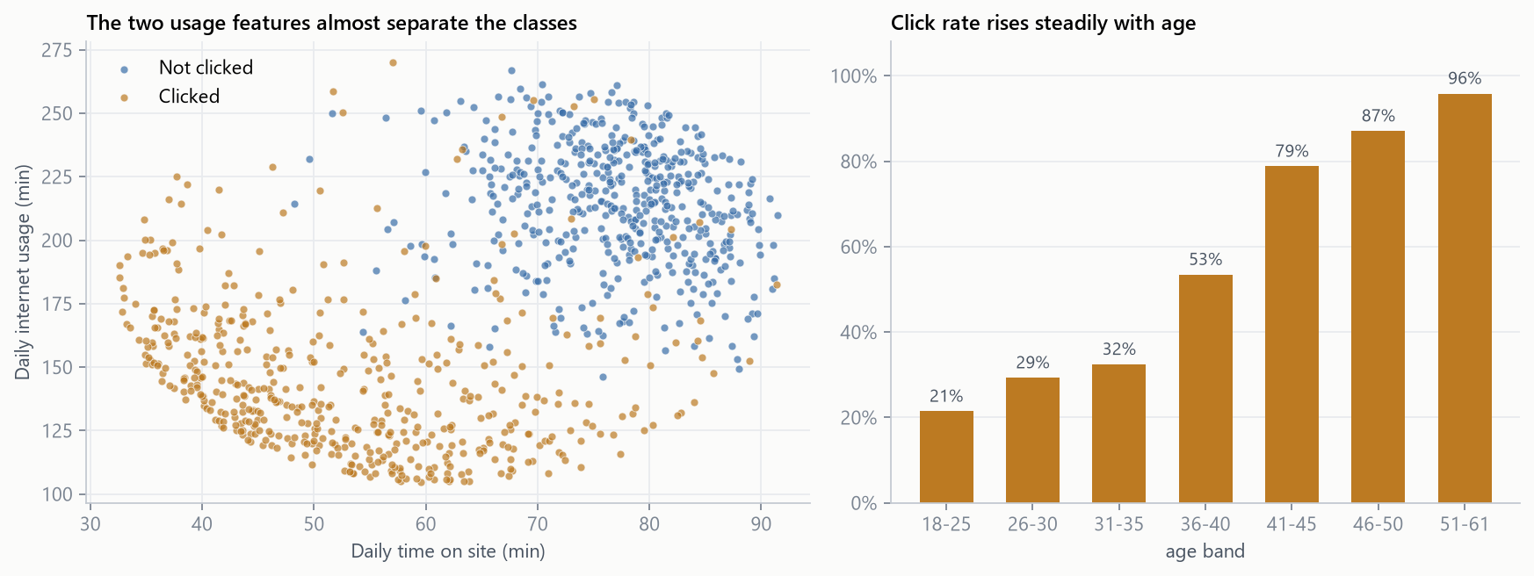
Figure 2. Time on site vs. internet usage (left) and click rate by age band (right).
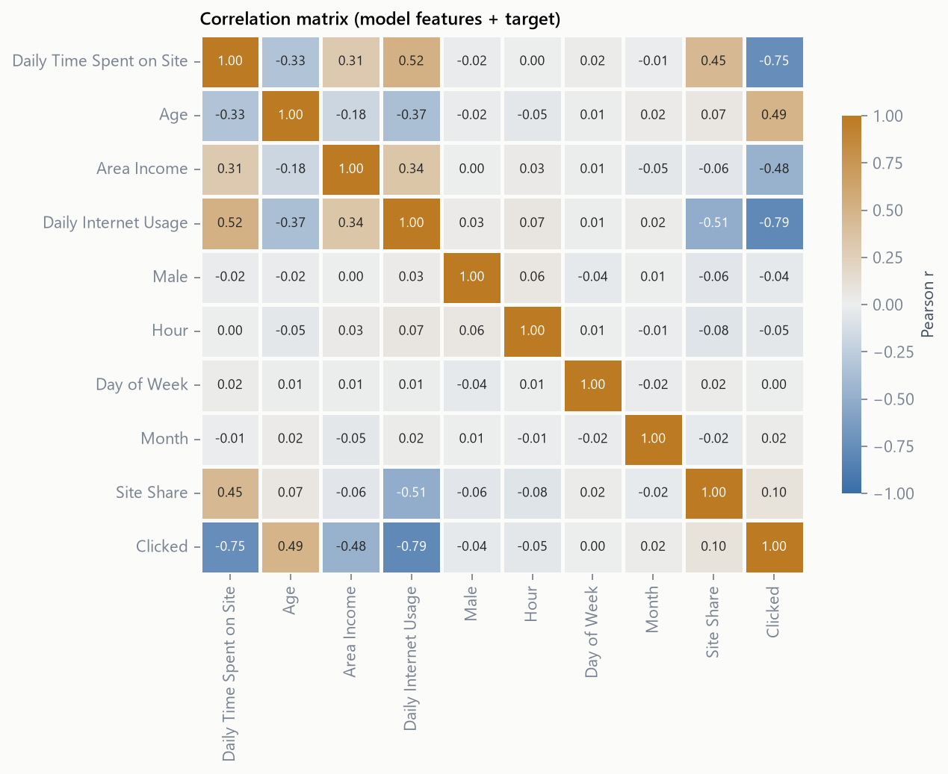
Figure 3. Pearson correlation of model features with each other and with the target.
Internet usage (r = -0.79) and time on site (r = -0.75) are the strongest linear signals, followed by age (+0.49) and area income (-0.48). Gender and all time-of-day features are effectively uncorrelated with clicking.

3. Data preprocessing
All preprocessing is implemented in one scikit-learn transformer (FeatureBuilder). It runs inside the model pipeline, so the same code is applied in every cross-validation fold, on the test set and in the live web app. This prevents information leaking from validation data into training.
Step | What was done | Why
Drop identifier-like columns | Ad Topic Line (100% unique), City (96.9%), Country (23.7%) removed | They behave like row IDs. 237 countries over 1,000 rows would add hundreds of sparse one-hot columns that trees would memorise.
Timestamp decomposition | Hour, Day of Week, Month extracted | A raw datetime cannot be split on. These features test whether timing matters.
Outlier capping (IQR) | Values clipped to Q1 − 1.5·IQR … Q3 + 1.5·IQR, learned on training data only | Only Area Income had outliers (6 low values in training). They are kept but capped, which protects scale-sensitive baselines.
Feature engineering | Site Share = time on site ÷ internet usage | Share of the user's online day spent on this site, a possible interaction signal.
Encoding | Not required | Male is already 0/1 and no text columns remain.
Scaling | Not applied to the forest; StandardScaler only for LR, KNN and SVM | Tree splits (x ≤ t) are unaffected by monotonic rescaling. Distance and linear models need comparable scales.
Train/test split | 750 / 250, stratified, random_state = 42 | Keeps the 50/50 balance in both sets. The test set is used once, at the end.

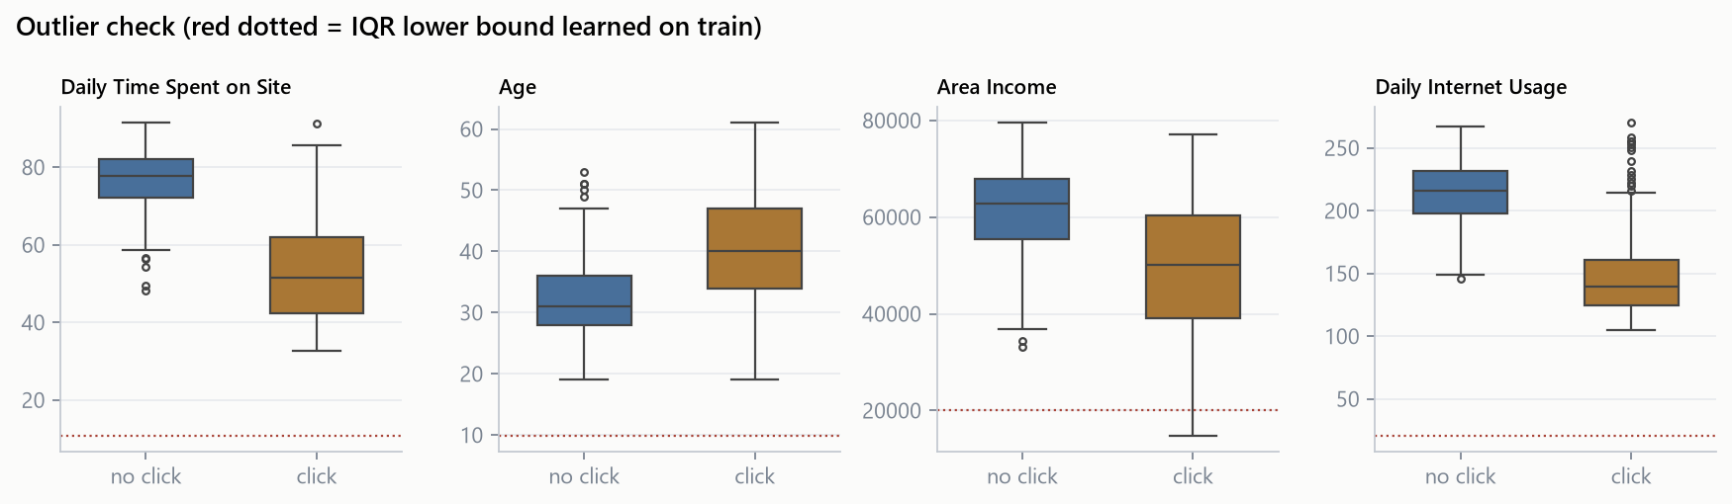
Figure 4. Outlier check per class; the dotted line is the IQR lower bound learned on the training set.

4. Methodology

4.1 How a Random Forest works
- Decision trees. Each tree repeatedly splits the data on the feature/threshold that most reduces Gini impurity, G = 1 − p₁² − p₀².
- Bagging. Each tree is trained on a bootstrap sample: n rows drawn with replacement. About 37% of rows are left out of each sample (out-of-bag).
- Random feature subsets. At every split only √p randomly chosen features are considered. This de-correlates the trees, so their errors partly cancel.
- Aggregation. The forest averages the trees' class probabilities and predicts 'click' when the average is ≥ 0.5.
- Built-in validation. Each row is scored only by the trees that did not see it, giving an out-of-bag (OOB) accuracy estimate at no extra cost.

4.2 Own implementation (from scratch)
A Random Forest was written with NumPy only (ml/scratch_forest.py). For each candidate feature, the split search sorts the values once and uses a running count of positives to score every threshold in linear time. Trees grow recursively until nodes are pure, and the forest adds bootstrap sampling, √p feature sub-sampling, probability averaging, OOB scoring and impurity-based feature importance.
Worked example (from the notebook): ten users with internet usage 120 to 255 min, five of whom clicked. The parent node has G = 1 − 0.5² − 0.5² = 0.5. Splitting at usage ≤ 167.5 gives a pure left node (4/4 clicks, G = 0) and a right node with 1/6 clicks (G = 0.278). The weighted impurity is 0.6 × 0.278 = 0.167, a decrease of 0.333, which is the best of all nine candidate thresholds.
Metric (test set) | From scratch | scikit-learn
Accuracy | 96.0% | 96.8%
F1 | 0.960 | 0.968
ROC-AUC | 0.990 | 0.990
OOB accuracy | 96.5% | 96.5%
Mean tree depth | 10.0 | 9.5

Both implementations, with identical settings (100 trees, √p features, unlimited depth), agree on 99.2% of test predictions and produce nearly identical feature importances (Figure 5). The remaining differences come from different random draws, which confirms the implementation is correct.
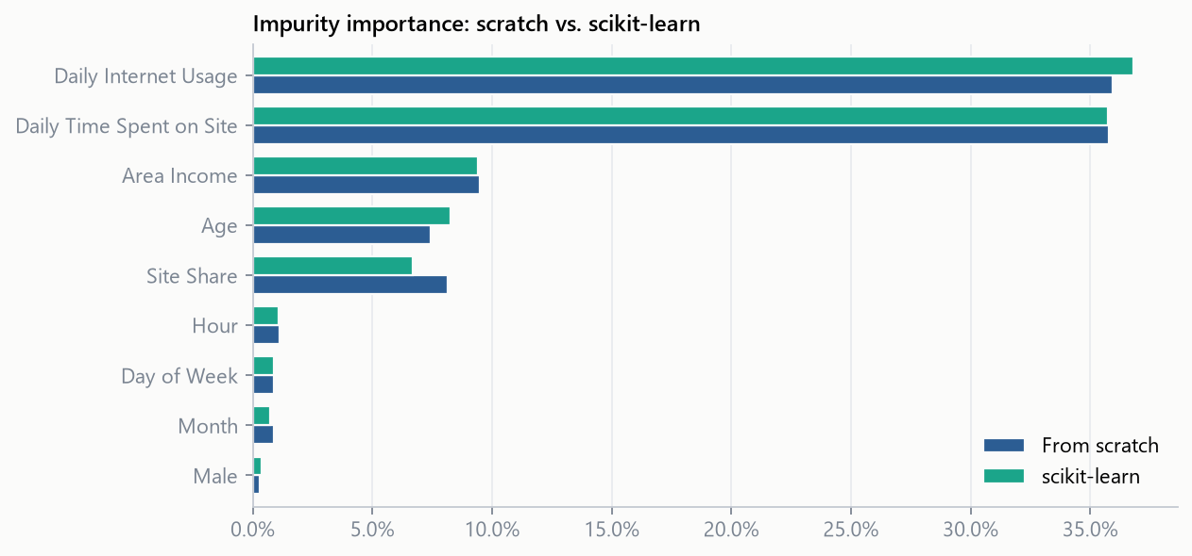
Figure 5. Impurity-based feature importance: own implementation vs. scikit-learn.

5. Hyperparameter tuning
RandomizedSearchCV sampled 60 configurations and scored each with 5-fold stratified cross-validation (300 fits). ROC-AUC was used as the selection metric because it measures ranking quality at every threshold and is much less noisy than accuracy on 150-row folds.
Hyperparameter | Search range | Selected | Effect
n_estimators | integer 100 – 600 | 167 | More trees → lower variance; OOB error flattens after ~150
max_depth | None, 4, 6, 8, 10, 12, 16 | 10 | Caps memorisation of individual rows
max_features | sqrt, log2, 0.5, 0.7, None (all) | sqrt | 3 of 9 features per split de-correlates trees
min_samples_leaf | integer 1 – 10 | 4 | Smooths leaf probabilities
min_samples_split | integer 2 – 20 | 2 | Little influence once leaf size is set
bootstrap | True, False | True | Enables bagging and OOB scoring
criterion | gini, entropy | entropy | Entropy and Gini performed almost identically

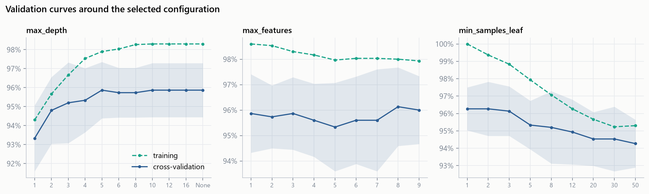
Figure 6. Validation curves: training vs. cross-validation accuracy as one parameter varies.
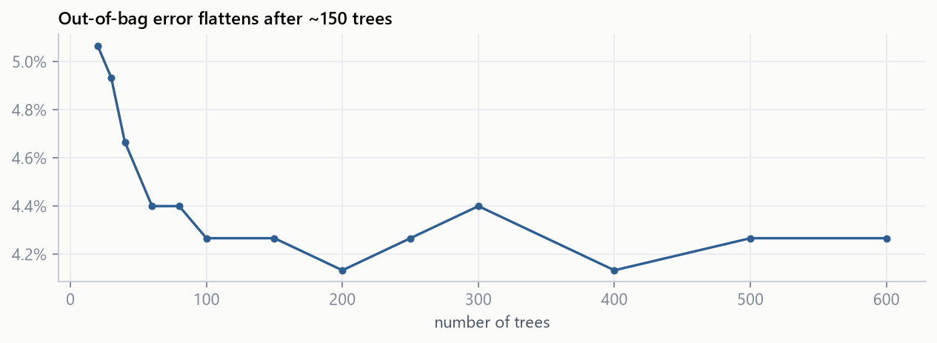
Figure 7. Out-of-bag error as trees are added.
The search picked a regularised forest. Its training accuracy is 98.5%, compared with 100.0% for the default fully-grown forest, while cross-validated accuracy is unchanged. The tuned model memorises less and generalises the same, which makes it safer for new traffic.

6. Results on the held-out test set
Metric | Value
Accuracy | 96.4%
Precision | 96.8%
Recall | 96.0%
F1 score | 0.9639
ROC-AUC | 0.9914
Average precision | 0.9931

6.1 Manual calculation
From the confusion matrix: TP = 120, FP = 4, TN = 121, FN = 5 (N = 250).
- Accuracy = (TP + TN) / N = (120 + 121) / 250 = 0.9640
- Precision = TP / (TP + FP) = 120 / (120 + 4) = 0.9677
- Recall = TP / (TP + FN) = 120 / (120 + 5) = 0.9600
- F1 = 2·P·R / (P + R) = 2 × 0.9677 × 0.9600 / (0.9677 + 0.9600) = 0.9639
- Specificity = TN / (TN + FP) = 121 / (121 + 4) = 0.9680
These hand-calculated values match scikit-learn's output exactly. In practical terms, about 97 of every 100 users the model flags really do click, and the model finds 96 of every 100 real clickers.
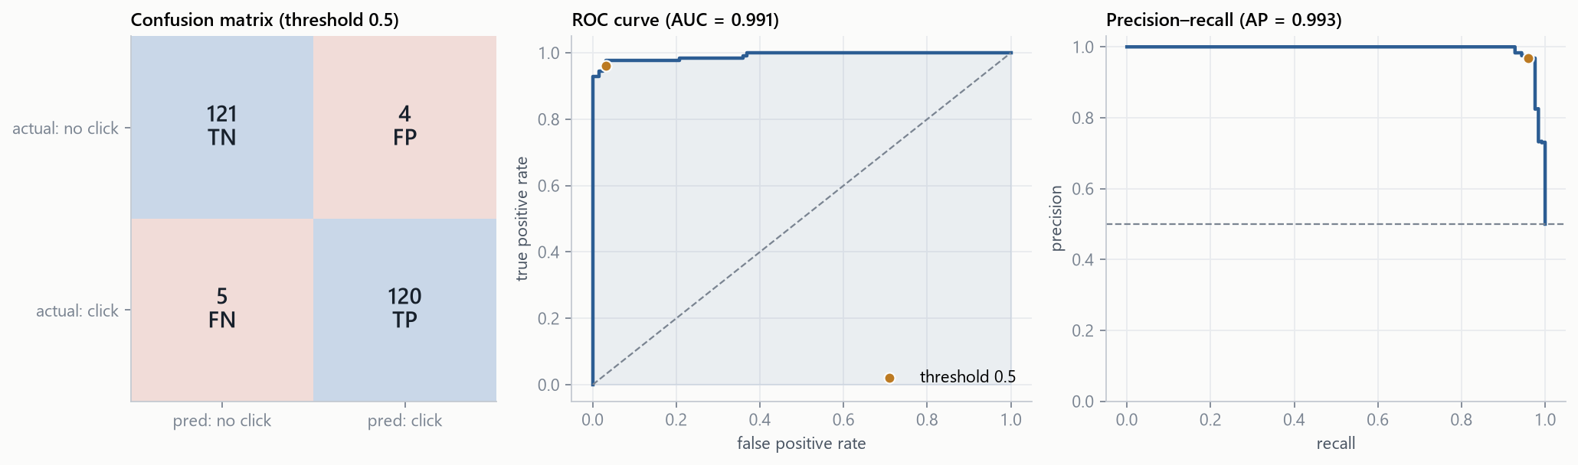
Figure 8. Confusion matrix, ROC curve and precision–recall curve (orange dot = threshold 0.5).
Five-fold cross-validation on the training set gave accuracy 0.959 (range 0.933–0.973). That is consistent with the test score, so the test result is not a lucky split. All 9 misclassified test rows had predicted probabilities close to the boundary or combined clicker and non-clicker traits.
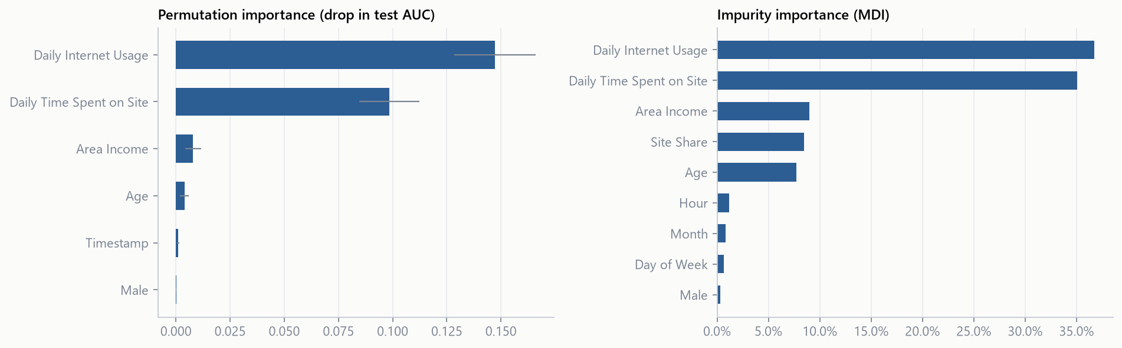
Figure 9. Permutation importance (drop in test AUC) and impurity importance.
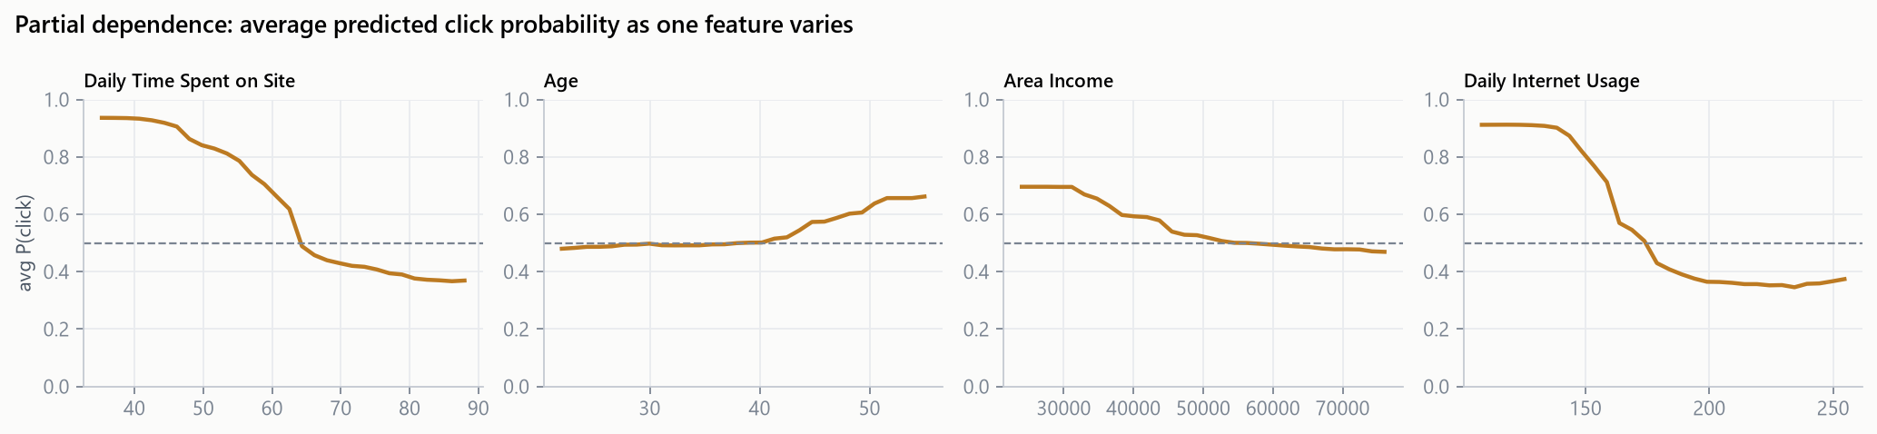
Figure 10. Partial dependence of predicted click probability on each numeric feature.

7. Comparison with other algorithms
Model | Accuracy | F1 | ROC-AUC | CV acc. | Train acc. | McNemar p
Gaussian Naive Bayes | 97.6% | 0.976 | 0.993 | 96.7% | 96.7% | 0.250
Random Forest (tuned) | 96.4% | 0.964 | 0.991 | 95.9% | 98.5% | ref.
Logistic Regression | 98.0% | 0.980 | 0.991 | 96.7% | 97.1% | 0.125
Random Forest (default) | 96.8% | 0.968 | 0.990 | 96.3% | 100.0% | 1.000
Random Forest (from scratch) | 96.0% | 0.960 | 0.990 | — | 100.0% | 1.000
Gradient Boosting | 96.0% | 0.959 | 0.988 | 95.7% | 100.0% | 1.000
SVM (RBF) | 96.0% | 0.960 | 0.988 | 95.7% | 97.7% | 1.000
KNN (k=3) | 96.8% | 0.968 | 0.985 | 96.0% | 96.9% | 1.000
AdaBoost | 95.2% | 0.952 | 0.980 | 94.4% | 97.2% | 0.453
Decision Tree (depth=4) | 96.4% | 0.964 | 0.967 | 95.3% | 97.6% | 1.000

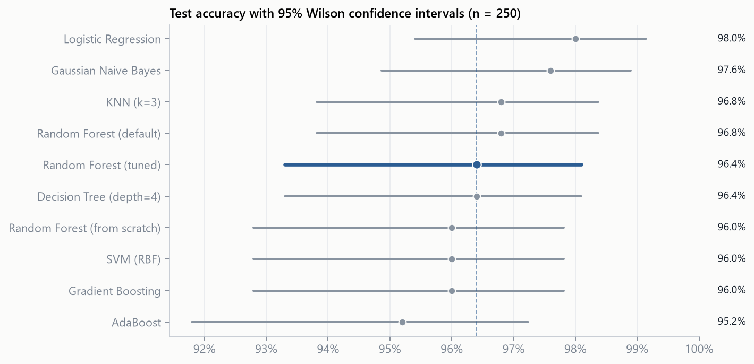
Figure 11. Test accuracy with 95% Wilson confidence intervals.
Statistically tied. Logistic Regression achieved the highest test accuracy (98.0% vs. 96.4% for the forest), a difference of 4 rows out of 250. All 95% confidence intervals overlap, and McNemar's exact test (which only uses the rows where two models disagree) gives p ≥ 0.125 for every model against the tuned forest. No difference is statistically significant.
Why linear models do well here. Exploratory analysis showed that the classes are separated by an almost straight diagonal in the time-on-site × internet-usage plane, with strong monotonic effects. A linear decision boundary is therefore close to ideal. A forest has to approximate that diagonal with many axis-aligned steps, which costs a few rows at the boundary.
Strengths of the forest. Averaging 167 de-correlated trees gives much better probability ranking than a single tree (AUC 0.991 vs. 0.967). The forest also needs no scaling, is robust to outliers, captures non-linear interactions automatically and provides OOB error and feature importance at no cost. Real click logs are far less linear than this dataset, which makes these advantages matter more.
Bagging vs. boosting. Gradient Boosting and AdaBoost concentrate on the hardest examples. Here those are mostly ambiguous users on the boundary, so the extra focus brings no gain, and AdaBoost was the weakest ensemble.

8. Interpretation and business insights
- Light internet users are the responsive audience. Users online less than 150 min/day clicked 99% of the time, those online 200+ min only 7%. Heavy users show classic banner blindness.
- Short site visits convert. Visitors spending under 60 min on the site clicked 96% of the time, versus 9% for those staying 75+ min. Long-staying readers came for the content.
- Older users in lower-income areas click more. Users aged 45+ clicked 91% vs. 25% for under-30s; areas below $40k income 93% vs. 28% above $60k.
- Timing and gender carry no signal. Hour, weekday, month and gender have near-zero permutation importance.

Recommendations
- Use the model's click probability as a pre-bid filter. At the 0.5 threshold ~97% of flagged impressions are real clicks.
- Choose the threshold from campaign economics: lower it when clicks are valuable and impressions cheap (higher recall), raise it when impressions are expensive (higher precision).
- For heavy internet users, test different ad formats (native, video) instead of showing more banners.
- Avoid paying time-of-day bid premiums, since timing has no measurable effect.
- Retrain regularly on fresh logs and monitor OOB error for drift.

Limitations
- The dataset is small, perfectly balanced and unusually clean. Real ad logs have click-through rates around 1–2% and would need class weighting, calibration and log-loss as a metric.
- Ad text and geography could not be used (unique headlines; 237 countries for 1,000 rows). With repeated campaigns, text features and target-encoded country are worth adding.
- The model shows who clicks, not why. Targeting changes should be validated with an A/B test.

9. Conclusion
A tuned Random Forest (167 trees, depth ≤ 10, √p features per split, ≥ 4 rows per leaf) predicts ad clicks on unseen users with 96.4% accuracy, F1 0.964 and ROC-AUC 0.991. The from-scratch implementation reproduces scikit-learn's results, which validates the understanding of bagging and random feature selection.
On this nearly linearly separable dataset, simpler models perform statistically on par. The forest's value lies in robustness, automatic interaction handling and built-in diagnostics. For the business, the result is a clear audience profile (light, short-visit, older internet users) and an impression-level score that can be used to allocate ad spend.

Project structure
Path | Contents
data/advertising.csv | Raw dataset
ml/features.py | FeatureBuilder: preprocessing and feature engineering
ml/scratch_forest.py | Decision tree and Random Forest implemented from scratch (NumPy)
ml/train.py | Training, tuning, evaluation, comparison → artifacts/
notebook/…ipynb | Full analysis notebook with explanations
app/ | Flask dashboard with live predictor

