1. Title of the Project:

Design and Development of a Multi-Shaft Solar Cell Tracking System

2. Abstract
The increasing demand for renewable energy has created the need for more efficient and energy-conscious solar tracking systems. Conventional solar trackers rotate the entire photovoltaic panel, which increases the overall moving mass, structural complexity, and actuator power consumption. These limitations reduce the practical feasibility and overall efficiency of large-scale solar installations.
This project proposes the Design and Development of a Low-Power Multi-Shaft Solar Cell Tracking System Using a Single Worm Gear Drive. Instead of rotating the complete solar panel, the proposed system rotates only the individual rows of solar cells mounted on multiple parallel shafts. A single NEMA 17 stepper motor drives a long worm shaft, which transmits motion to multiple worm gears connected to the solar cell shafts, ensuring synchronized angular movement with minimal energy consumption.
The system utilizes light sensors (LDRs) or an astronomical solar tracking algorithm to continuously orient the solar cells toward maximum sunlight throughout the day. By reducing the moving mass and employing a compact worm gear transmission mechanism, the proposed design minimizes power consumption, improves mechanical efficiency, and reduces structural stress. The prototype is designed using 3D-printed mechanical components, making it lightweight, cost-effective, and easy to manufacture.
The proposed system is expected to provide higher solar energy harvesting efficiency, improved reliability, lower maintenance, and enhanced scalability compared to conventional solar tracking systems. It offers a practical and innovative solution suitable for residential, commercial, agricultural, and research applications.

3 Introduction
Solar energy is one of the most abundant and environmentally friendly renewable energy sources available today. The efficiency of photovoltaic (PV) systems depends on the amount of sunlight received by the solar cells. Since the position of the sun changes continuously throughout the day, fixed solar panels cannot maintain the optimum angle of incidence, resulting in reduced energy generation. Solar tracking systems are developed to overcome this problem by continuously aligning the solar panels with the sun. However, conventional tracking systems rotate the entire solar panel, increasing the moving mass, structural complexity, and power consumption. This project proposes an innovative Low-Power Multi-Shaft Solar Cell Tracking System Using a Single Worm Gear Drive, where only the solar cell rows are rotated instead of the complete panel. This approach improves tracking efficiency while reducing mechanical load, actuator power, and overall system cost.

3.1 Background of the Problem
Traditional solar tracking systems require heavy support structures and high-torque motors because the complete solar panel is rotated. This leads to increased installation cost, higher energy consumption for tracking, greater mechanical wear, and frequent maintenance. These limitations reduce the overall efficiency and practicality of solar tracking systems, especially for compact and cost-sensitive applications.

3.2 Motivation for Choosing the Topic
The motivation behind this project is to develop a lightweight and energy-efficient solar tracking mechanism that overcomes the drawbacks of conventional trackers. By rotating only the individual rows of solar cells using multiple synchronized shafts driven by a single motor, the proposed system minimizes moving weight and power consumption while maximizing solar energy harvesting. This innovative design offers a practical solution for improving the performance of photovoltaic systems.

3.3 Scope and Significance
The proposed system has the potential to improve the efficiency of solar power generation by maintaining the optimum orientation of solar cells throughout the day. Its lightweight structure, low power consumption, and compact design make it suitable for residential, commercial, agricultural, and educational applications. The modular design also allows future expansion to larger solar installations. The project contributes to the development of cost-effective and sustainable renewable energy technologies.
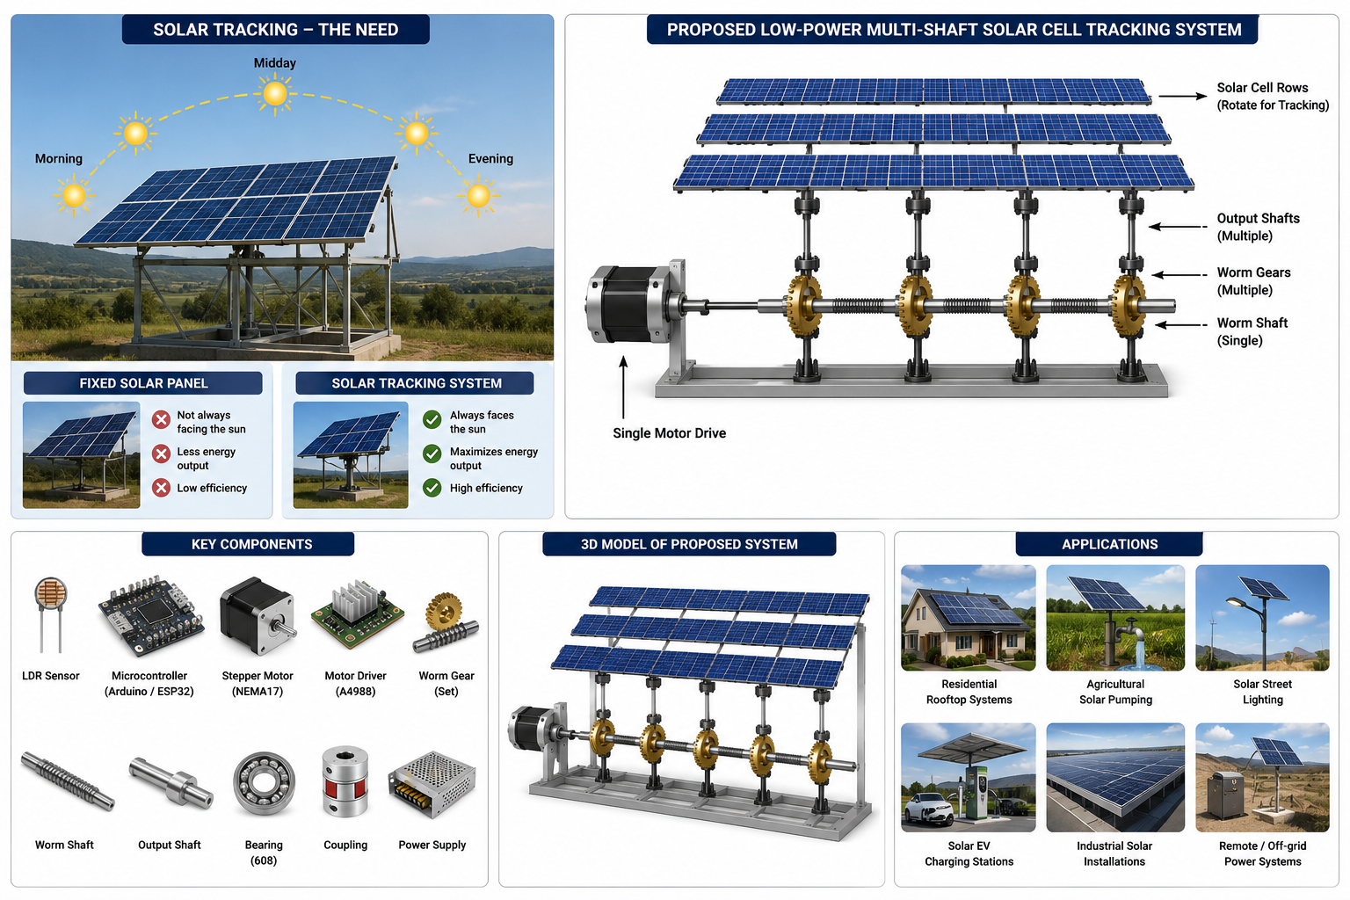
Fig 3.1 Design and Solar tracking systems

3.4 Real-Life Applications
- Residential rooftop solar power systems.
- Commercial and industrial solar installations.
- Agricultural solar water pumping systems.
- Smart solar street lighting systems.
- Solar-powered electric vehicle charging stations.
- Portable and mobile solar power units.
- Research laboratories and educational institutions.
- Remote and off-grid renewable energy systems.

4. Objectives of the Project

The main objectives of the proposed Design and Development of a Low-Power Multi-Shaft Solar Cell Tracking System Using a Single Worm Gear Drive are:
- To design and develop an innovative multi-shaft solar cell tracking system.
- To rotate only the solar cell rows instead of the entire solar panel to reduce moving mass.
- To synchronize multiple rotating shafts using a single stepper motor and worm gear drive.
- To maximize solar energy harvesting by maintaining the optimum orientation of the solar cells throughout the day.
- To reduce actuator power consumption and improve the overall energy efficiency of the tracking system.
- To minimize the mechanical complexity and structural load compared to conventional solar tracking systems.
- To develop a compact, lightweight, and cost-effective prototype using 3D-printed components.
- To evaluate the performance and feasibility of the proposed system for residential, commercial, agricultural, and research applications.

5. Problem Statement
Conventional solar tracking systems improve photovoltaic efficiency by rotating the entire solar panel to follow the sun. However, rotating the complete panel increases the moving mass, requires high-torque motors, consumes additional electrical power, and increases the overall mechanical complexity and installation cost. These limitations reduce the system’s efficiency and make it less suitable for lightweight and cost-effective solar applications.
Therefore, there is a need for an innovative solar tracking mechanism that minimizes moving weight while maintaining accurate solar tracking. The proposed Low-Power Multi-Shaft Solar Cell Tracking System Using a Single Worm Gear Drive addresses this challenge by rotating only the individual rows of solar cells through multiple synchronized shafts driven by a single motor. This approach aims to reduce power consumption, mechanical load, and structural complexity while improving the overall efficiency and reliability of solar energy harvesting.
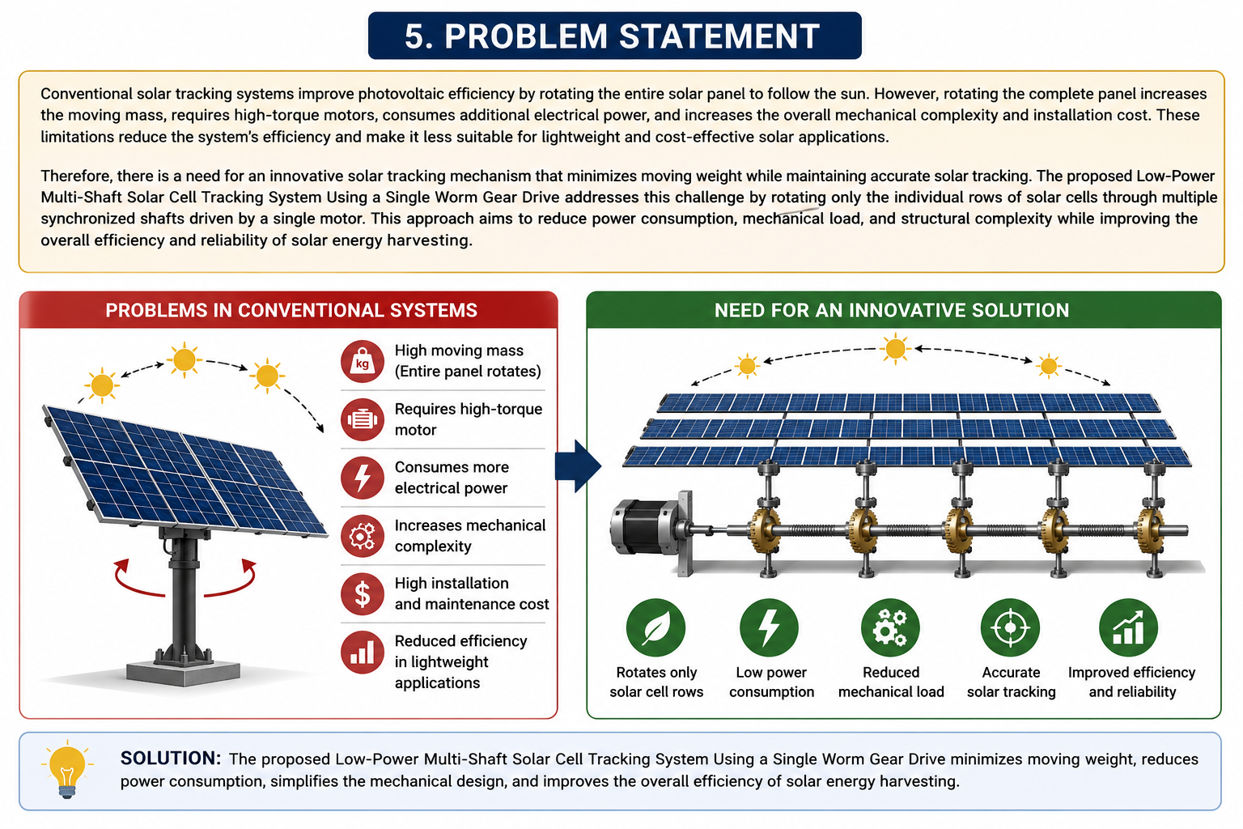
Fig 5.1 Problem in convection System

6. Literature Review / Existing System
Solar tracking systems are widely used to improve the efficiency of photovoltaic (PV) systems by maintaining the solar panels perpendicular to the sun’s rays throughout the day. Existing systems are mainly classified into fixed solar panels, single-axis solar trackers, and dual-axis solar trackers. Fixed solar panels are simple and inexpensive but receive maximum sunlight only for a limited period, resulting in lower energy generation. Single-axis trackers improve efficiency by rotating the panel along one axis, while dual-axis trackers provide more accurate tracking by rotating the panel in both horizontal and vertical directions.
Although conventional tracking systems increase power generation, they rotate the entire solar panel, which increases the moving mass, structural complexity, and actuator power requirements. They require larger motors, stronger support structures, and frequent maintenance, making them more expensive and less suitable for lightweight and compact applications. In addition, the power consumed by the tracking mechanism reduces the net energy gain of the system.
The proposed project introduces an innovative Low-Power Multi-Shaft Solar Cell Tracking System Using a Single Worm Gear Drive. Instead of rotating the complete photovoltaic panel, the system rotates only the individual rows of solar cells mounted on multiple synchronized shafts. A single stepper motor drives a worm shaft that simultaneously rotates all shafts through worm gears, reducing moving weight, motor power consumption, and mechanical complexity. This design provides a compact, lightweight, and energy-efficient alternative to conventional solar tracking systems while maintaining accurate solar tracking and improving the overall efficiency of solar energy harvesting.

6.1 Limitations of Existing Systems
- Rotate the entire solar panel, increasing moving mass.
- Require high-torque motors and higher power consumption.
- Increase structural load and installation cost.
- More complex mechanical design and maintenance.
- Lower overall efficiency due to tracking power consumption.

6.2 Improvement of the Proposed System
- Rotates only the solar cell rows instead of the complete panel.
- Uses a single motor to drive multiple synchronized shafts.
- Reduces moving mass and actuator power consumption.
- Lightweight and compact mechanical design.
- Lower maintenance and improved reliability.
- More energy-efficient and cost-effective than conventional tracking systems.

7. Proposed System
The proposed project, Design and Development of a Low-Power Multi-Shaft Solar Cell Tracking System Using a Single Worm Gear Drive, introduces an innovative solar tracking mechanism that improves the efficiency of photovoltaic (PV) systems while reducing power consumption and mechanical complexity. Unlike conventional solar trackers that rotate the entire solar panel, the proposed system rotates only the individual rows of solar cells mounted on multiple parallel shafts. This significantly reduces the moving mass and the torque required for tracking.
The system consists of a NEMA 17 stepper motor, a flexible coupling, a worm shaft, multiple worm gears, output shafts, 608ZZ bearings, LDR sensors (or an astronomical tracking algorithm), a microcontroller (ESP32/Arduino), and a 3D-printed mechanical frame. The stepper motor drives the worm shaft, which simultaneously rotates all worm gears connected to the individual solar cell shafts. As a result, every row of solar cells moves synchronously to maintain the optimum angle toward the sun throughout the day.
The microcontroller continuously receives sunlight intensity data from the LDR sensors and controls the stepper motor to adjust the position of the solar cell rows. The worm gear mechanism provides precise positioning, high torque transmission, and self-locking characteristics, preventing unwanted movement due to wind or external forces.
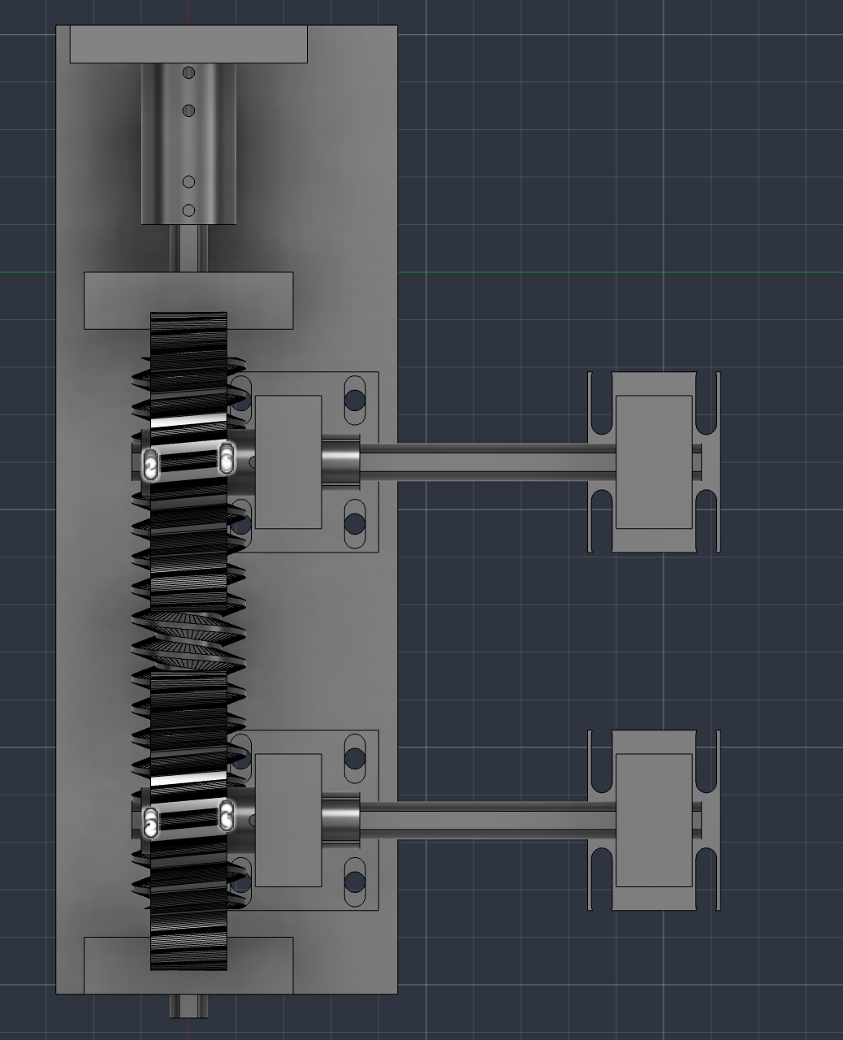
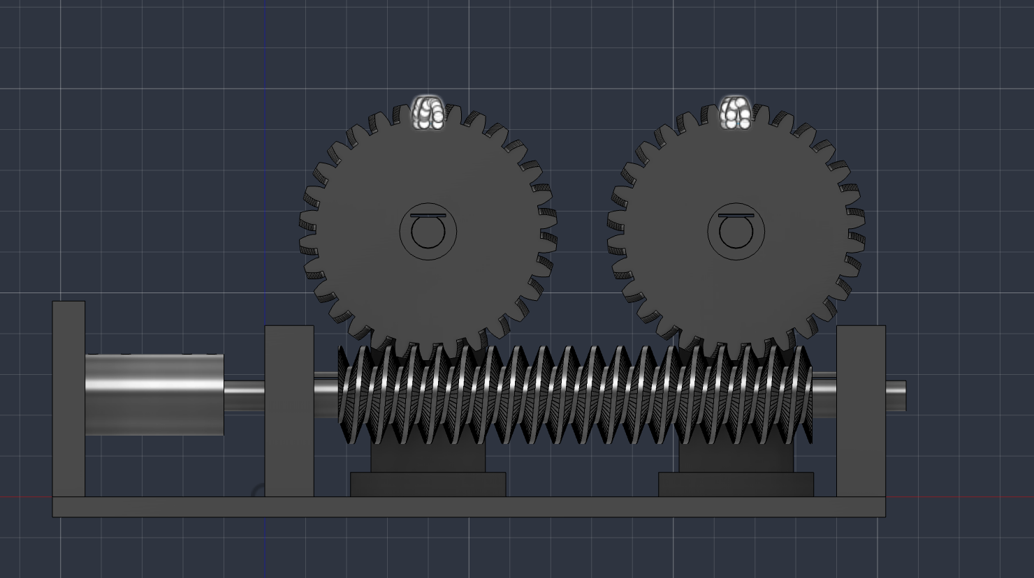
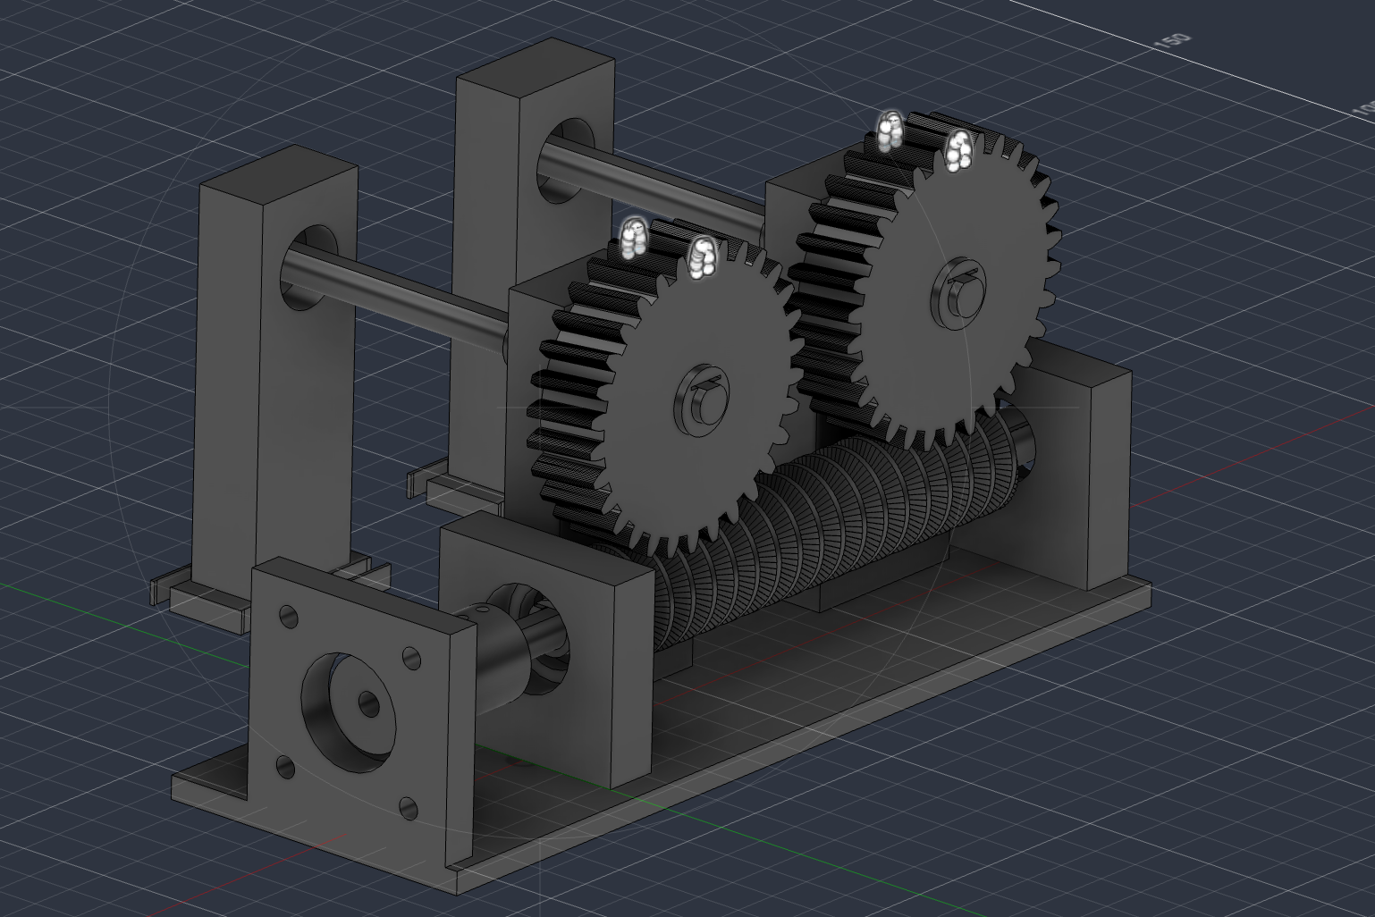
Fig 7.1 3D Model Multi-Shaft Solar Cell Tracking Systems

7.1 Key Modules / Components
- Solar Tracking Module (LDR Sensors / Astronomical Algorithm)
- ESP32 / Arduino Control Module
- Stepper Motor Control Module
- Worm Shaft and Worm Gear Transmission Module
- Multi-Shaft Synchronization Mechanism
- Solar Cell Mounting Module
- Power Supply Module
- 3D-Printed Mechanical Frame

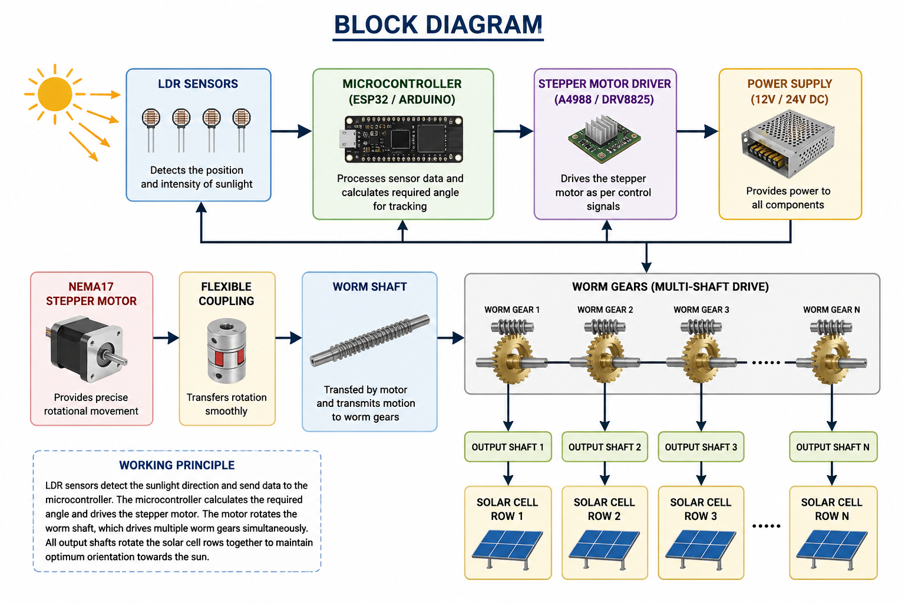
Fig 7.2 Block Diagram

7.2 How the Proposed System Solves the Problem Better
- Rotates only the solar cell rows instead of the complete solar panel.
- Uses a single stepper motor to synchronize multiple shafts.
- Reduces moving mass and motor power consumption.
- Lowers structural load and mechanical complexity.
- Improves solar energy harvesting through accurate tracking.
- Provides a lightweight, compact, and cost-effective design.
- Reduces maintenance due to fewer moving components.
- Offers better reliability and scalability compared to conventional solar tracking systems.
- Suitable for residential, commercial, agricultural, and research applications.

8 Methodology / Technologies to be Used
The proposed system follows a mechanical and embedded system approach for efficient solar tracking. Initially, the position of the sun is determined using LDR sensors (or an astronomical solar tracking algorithm). Based on the sensor inputs, the ESP32/Arduino microcontroller processes the data and calculates the required rotation angle. A NEMA 17 stepper motor is then controlled through a stepper motor driver to rotate a worm shaft. The worm shaft transmits motion to multiple worm gears, which rotate the individual solar cell shafts simultaneously. As a result, all rows of solar cells remain synchronized and continuously face the maximum sunlight direction, improving energy generation while consuming minimal tracking power.
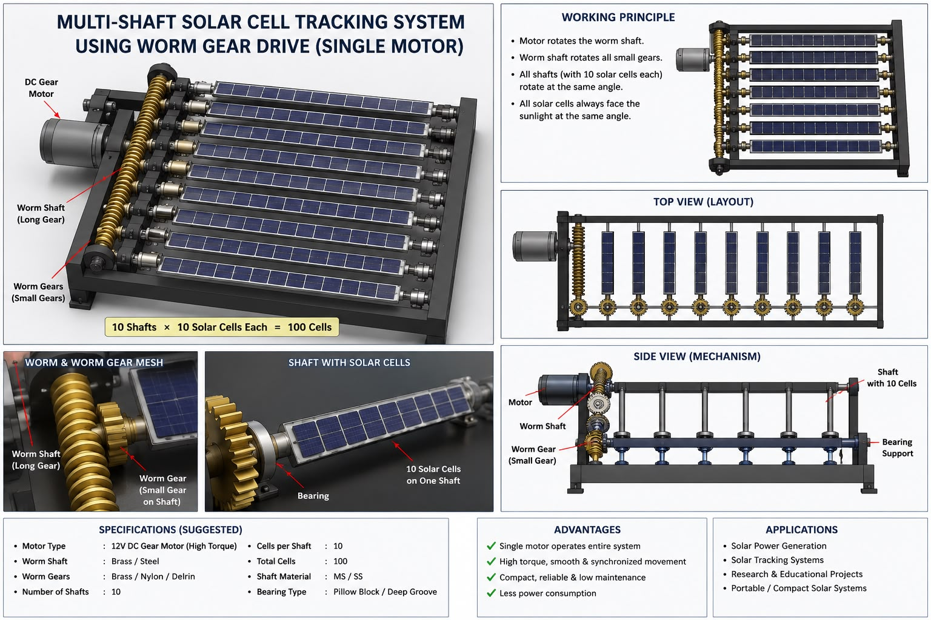
Fig 8.1 Multi-Shaft Solar Cell System

8.1 Programming Language
- Embedded C / C++
- Arduino Programming Language

8.2 Frameworks / Libraries
- Arduino Core
- Stepper Motor Library / AccelStepper
- LDR Sensor Interface Libraries

8.3 Software / Tools
- Fusion 360 (3D CAD Design)
- Arduino IDE
- EasyEDA (Circuit Design - Optional)
- Serial Monitor (Testing & Debugging)

8.4 Hardware Technologies
- ESP32 / Arduino
- NEMA 17 Stepper Motor
- Stepper Motor Driver (A4988 / DRV8825)
- Worm Shaft and Worm Gears
- Flexible Coupling
- 608ZZ Bearings
- Stainless Steel Shafts
- LDR Sensors
- Solar Cells
- 3D-Printed Mechanical Frame
- DC Power Supply
This methodology combines mechanical design, embedded systems, and solar tracking technology to develop a compact, lightweight, and energy-efficient multi-shaft solar cell tracking system.

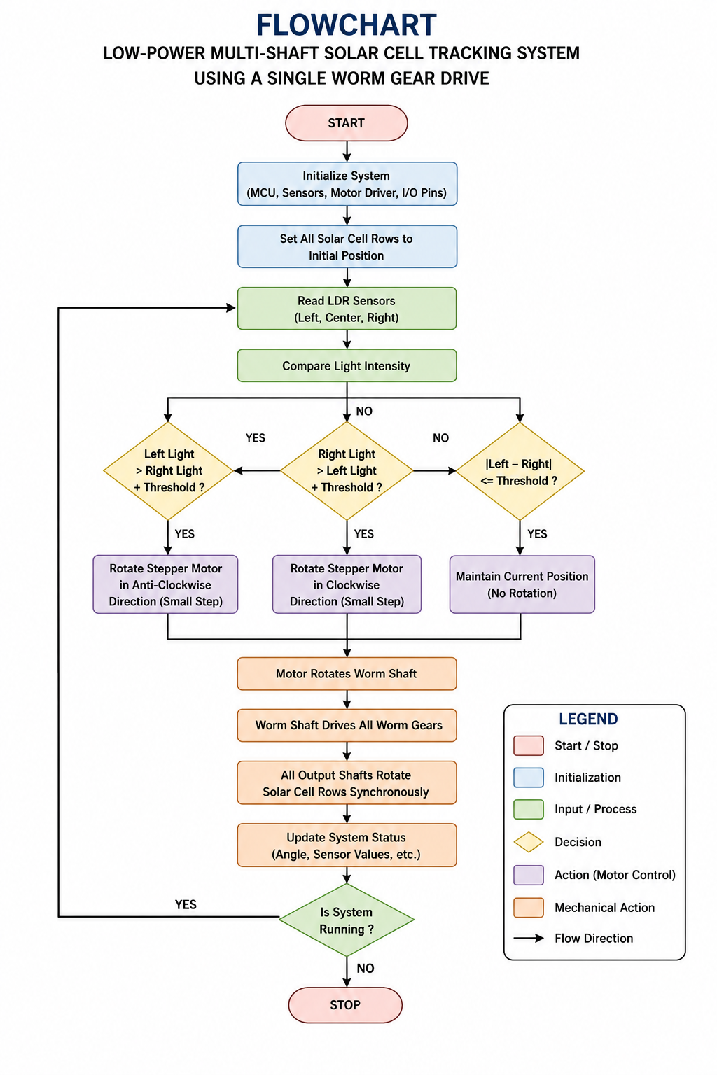
Fig 8.1 Flowchart of System

8.5 Flowchart Explanation
The system starts by initializing the microcontroller, LDR sensors, and stepper motor driver. The LDR sensors continuously detect the direction and intensity of sunlight. Based on the sensor readings, the microcontroller determines the required direction of rotation and controls the NEMA17 stepper motor through the motor driver. The motor rotates the worm shaft, which synchronizes all worm gears and output shafts simultaneously. As a result, all rows of solar cells rotate together to maintain the optimum angle towards the sun. The process repeats continuously until the system is turned off.

9. Modules Description

Module 1: Solar Tracking Module
This module detects the position and intensity of sunlight using LDR sensors (or an astronomical tracking algorithm). It provides the input required to determine the optimum angle of the solar cells.

Module 2: Control Module
The ESP32/Arduino microcontroller processes the sensor data and generates control signals for the stepper motor. It ensures accurate and continuous tracking of the sun throughout the day.

Module 3: Motor Drive Module
This module consists of the NEMA 17 stepper motor and a stepper motor driver (A4988/DRV8825). It converts the control signals into precise rotational movement.

Module 4: Worm Gear Transmission Module
The motor drives a worm shaft, which transfers rotational motion to multiple worm gears. This mechanism provides synchronized movement, high torque transmission, and self-locking capability.

Module 5: Multi-Shaft Synchronization Module
This module consists of multiple output shafts connected to the worm gears. It ensures that all solar cell rows rotate simultaneously at the same angle using a single motor.

Module 6: Solar Cell Mounting Module
This module securely holds the individual rows of solar cells on rotating shafts while allowing smooth and stable movement during tracking.

Module 7: Mechanical Support Module
The mechanical structure includes the 3D-printed frame, 608ZZ bearings, stainless steel shafts, flexible coupling, and mounting brackets. It provides rigidity, proper alignment, and smooth operation of the tracking mechanism.

Module 8: Power Supply Module
This module supplies the required electrical power to the ESP32/Arduino, stepper motor driver, sensors, and stepper motor, ensuring stable and reliable operation of the complete system.

10 Expected Outcomes
The proposed Low-Power Multi-Shaft Solar Cell Tracking System Using a Single Worm Gear Drive is expected to achieve the following functional and non-functional outcomes.

10.1 Functional Outcomes
- Automatically track the sun throughout the day to maintain the optimum orientation of the solar cells.
- Rotate only the individual solar cell rows instead of the entire solar panel.
- Synchronize multiple rotating shafts using a single stepper motor and worm gear drive.
- Improve solar energy harvesting by maximizing sunlight exposure.
- Provide smooth, accurate, and reliable tracking with minimal power consumption.
- Demonstrate the feasibility of the proposed multi-shaft tracking mechanism through a working prototype.

10.2 Non-Functional Outcomes
- Lightweight and compact mechanical design.
- Reduced moving mass and structural load.
- Lower actuator power consumption compared to conventional solar trackers.
- Improved mechanical efficiency and system reliability.
- Cost-effective and easy-to-manufacture design using 3D-printed components.
- Low maintenance due to a simple and robust transmission mechanism.
- Scalable design suitable for larger photovoltaic installations.
- Environment-friendly solution that promotes efficient utilization of renewable solar energy.

Name of Students
Sr. No. | Name of Student | Role | Signature of Students
1 | Mr. Prathamesh Rajesh Sapate | Group Leader | ____________
2 | Mr. Shreyash Arun Pachade | Team Member | ____________
3 | Mr. Vansh Sanjay Dhobale | Team Member | ____________
4 | Mr. Atharv Nilesh Gadge | Team Member | ____________

Dr. Shrikant Chavate Prof Vina Chaudhari Dr. Shrikant Chavate
Project Guide Project Coordinator HOD

