**Test Screenshots:**

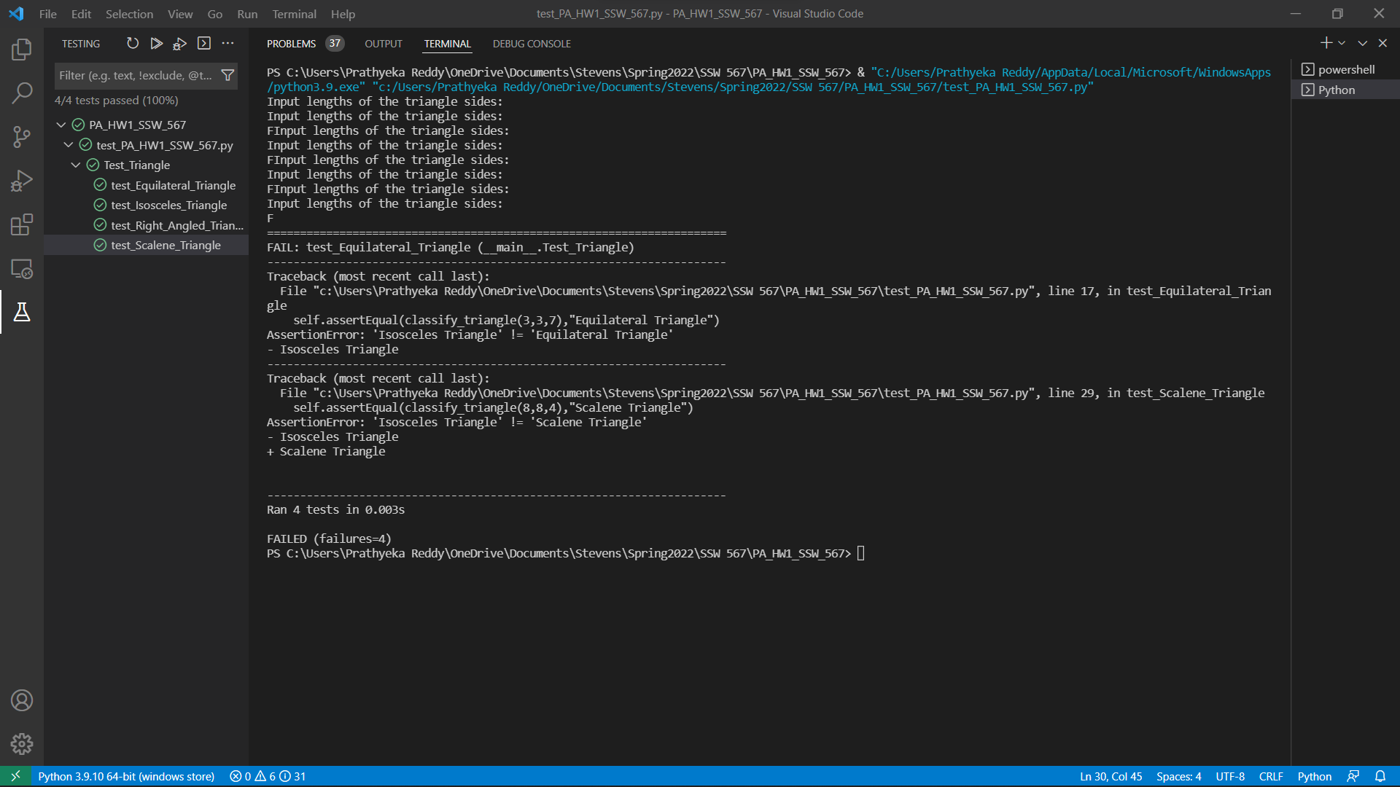

**Challenges faced:**

Setting up the environment. Understanding the execution and workflow of the code.