**HW2a SSW 567-WS**

1. **Assignment Description:** The objective of this assignment is for you to (a) develop a set of tests for an existing triangle classification program, (b) use those tests to find and fix defects in that program, and (c) report on your testing results for the Triangle problem
2. **Author:** Prathyeka Anugu
3. **Summary:**
   1. The initial testing resulted in 9 test failures and 9 defects.
   2. Initially it was confusing and I did not understand which InvalidInput was giving me the error. Later I understood the workflow and resolved as many errors I could and executed test cases. As I fixed each bug, I was able to improve my test case and plan more efficiently. This hands on exercise made me think logically and from a testers perspective to resolve bugs.
   3. The IDE used was VScode and the tool was Unittest for this assignment.
4. **Honor pledge:** I pledge on my honor that I have not given or received any unauthorized assistance on this assignment/examination. I further pledge that I have not copied any material from a book, article, the Internet or any other source except where I have expressly cited the source.
5. **Detailed results, if any:** All Test Cases passed successfully after test run 2.

**Initial Testing:**

**Failed test cases:**

|  |  |  |  |  |
| --- | --- | --- | --- | --- |
| **Test ID** | **Input** | **Expected Results** | **Actual Result** | **Pass or Fail** |
| 1 | 3,4,5 | Right | InvalidInput | Fail |
| 2 | 6,4,9 | Right | InvalidInput | Fail |
| 3 | -2,-3,-4 | InvalidInput | InvalidInput | Pass |
| 4 | 200,300,400 | InvalidInput | InvalidInput | Pass |
| 5 | 7,9,16 | NotATriangle | InvalidInput | Pass |
| 6 | 1,1,1 | Equilateral | InvalidInput | Fail |
| 7 | -6,-6,-6 | InvalidInput | InvalidInput | Pass |
| 8 | 200,200,200 | InvalidInput | InvalidInput | Pass |
| 9 | 4,9,2 | Scalene | InvalidInput | Fail |
| 10 | -4,-9,-2 | InvalidInput | InvalidInput | Pass |
| 11 | 400,900,200 | InvalidInput | InvalidInput | Pass |
| 12 | 4,9,4 | Isosceles | InvalidInput | Fail |
| 13 | -4,-9,-4 | InvalidInput | InvalidInput | Pass |
| 14 | 400,900,400 | InvalidInput | InvalidInput | Pass |

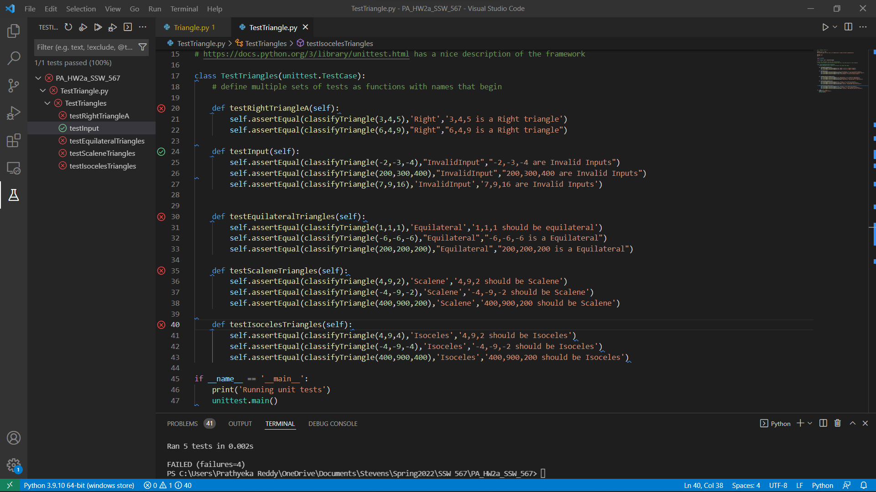

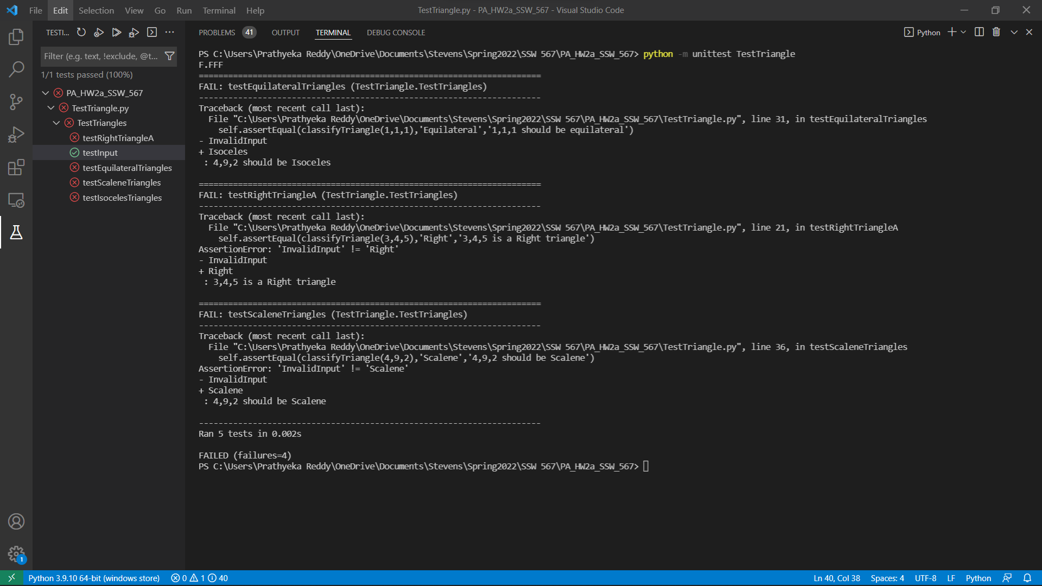

**Final Testing:**

**Passed test cases:**

|  |  |  |  |  |
| --- | --- | --- | --- | --- |
| **Test ID** | **Input** | **Expected Results** | **Actual Result** | **Pass or Fail** |
| 1 | 3,4,5 | Right | Right | Pass |
| 2 | 6, 8, 10 | Right | Right | Pass |
| 3 | 15, 20, 25 | Right | Right | Pass |
| 4 | -2,-3,-4 | InvalidInput | InvalidInput | Pass |
| 5 | 200,300,400 | InvalidInput | InvalidInput | Pass |
| 6 | 7,9,16 | NotATriangle | NotATriangle | Pass |
| 7 | -6,-6,-6 | InvalidInput | InvalidInput | Pass |
| 8 | 1,1,1 | Equilateral | Equilateral | Pass |
| 9 | 6,6,6 | Equilateral | Equilateral | Pass |
| 10 | 40,40,40 | Equilateral | Equilateral | Pass |
| 11 | 4,9,8 | Scalene | Scalene | Pass |
| 12 | 10,13,21 | Scalene | Scalene | Pass |
| 13 | 40,90,100 | Scalene | Scalene | Pass |
| 14 | 33,9,33 | Isosceles | Isosceles | Pass |
| 15 | 33,33,9 | Isosceles | Isosceles | Pass |
| 16 | 9,33,33 | Isosceles | Isosceles | Pass |

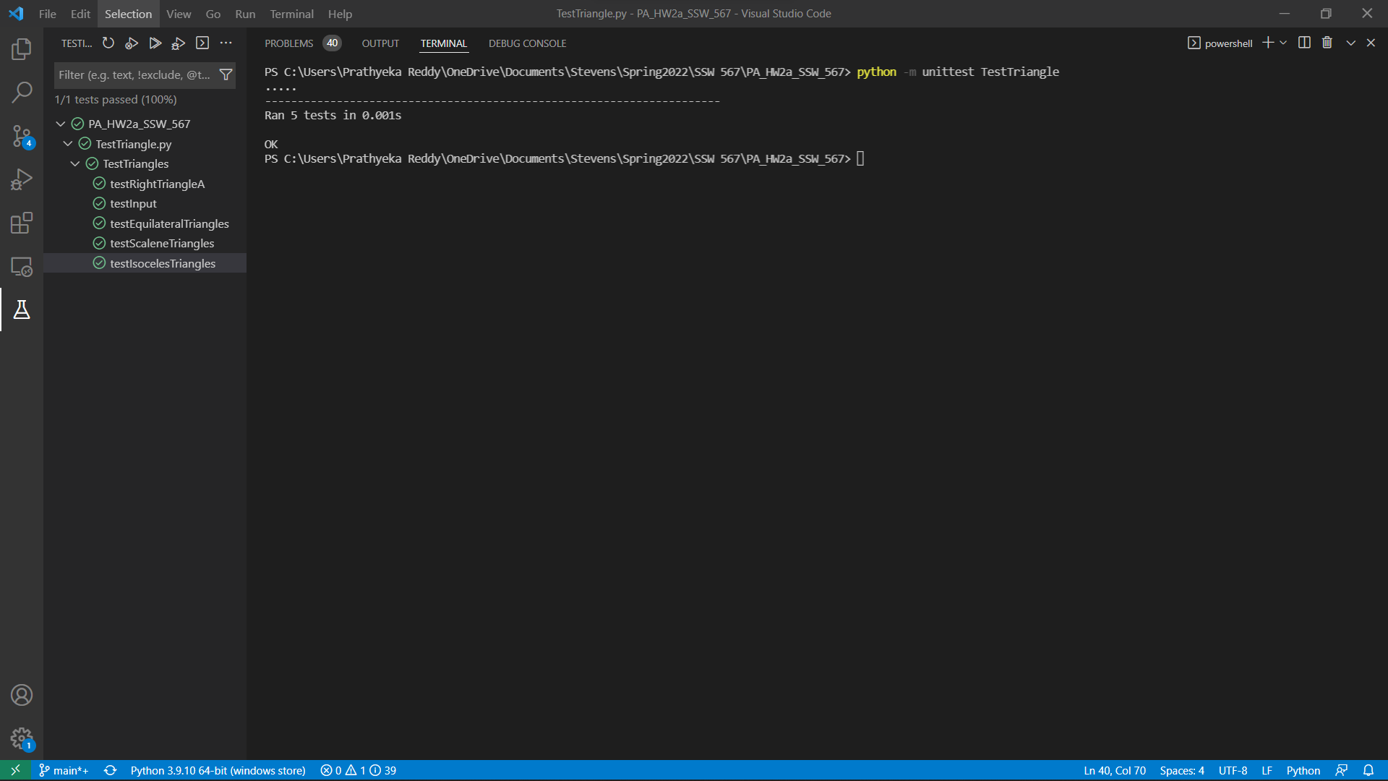

**Summary Report:**

|  |  |  |
| --- | --- | --- |
|  | **Test Run1** | **Test Run2** |
| **Tests Planned** | Input Values to check triangle | Input values to check triangle |
| **Tests Executed** | 14 | 16 |
| **Tests Passed** | 9 | 16 |
| **Defects Found** | 9 | 0 |
| **Defects Fixed** | 0 | 9 |

**Github URL:** <https://github.com/prathyekareddy/Triangle567/blob/main/Triangle.py>