**Given an integer number n, return the difference between the product of its digits and the sum of its digits.**

|  |
| --- |
| **Example 1:**  Input: n = 234  Output: 15  Explanation:  Product of digits = 2 * 3 * 4 = 24  Sum of digits = 2 + 3 + 4 = 9  Result = 24 - 9 = 15 |
| **Example 2:**  Input: n = 4421  Output: 21  Explanation:  Product of digits = 4 * 4 * 2 * 1 = 32  Sum of digits = 4 + 4 + 2 + 1 = 11  Result = 32 - 11 = 21 |

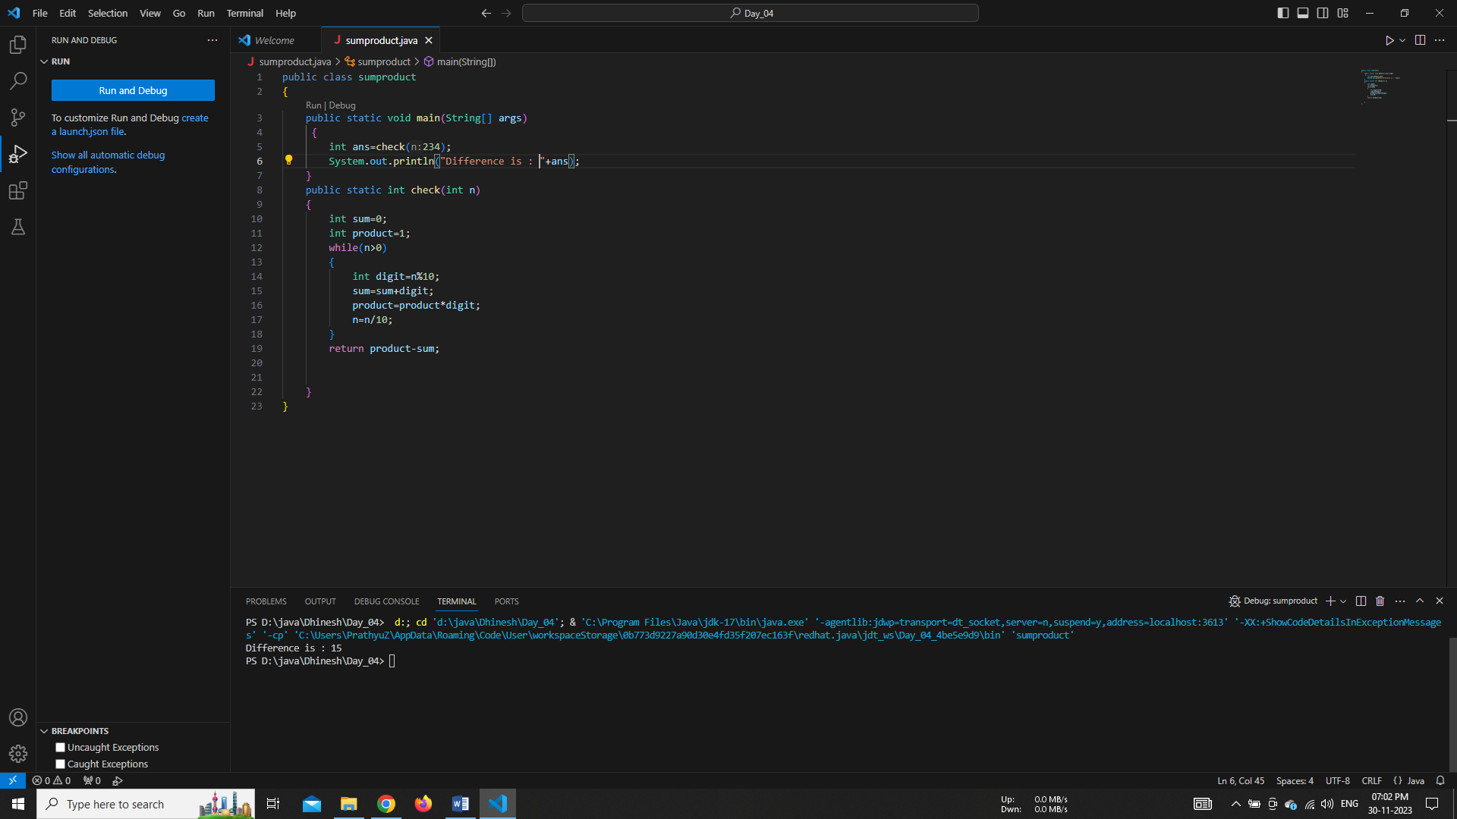

# ***********

**Write a program to print the sum of negative numbers, sum of positive even numbers and the sum of positive odd numbers from a list of numbers (N) entered by the user. The list terminates when the user enters a zero.**

**Note:** Enter the input on run time (using scanner).

**Example 1:**

Input: Enter the numbers 1 -3 4 7 22 0

Output: sum of negative numbers = -3

Sum of positive even numbers = 26 (4 + 22)

Sum of positive odd numbers = 8 (1 + 7)

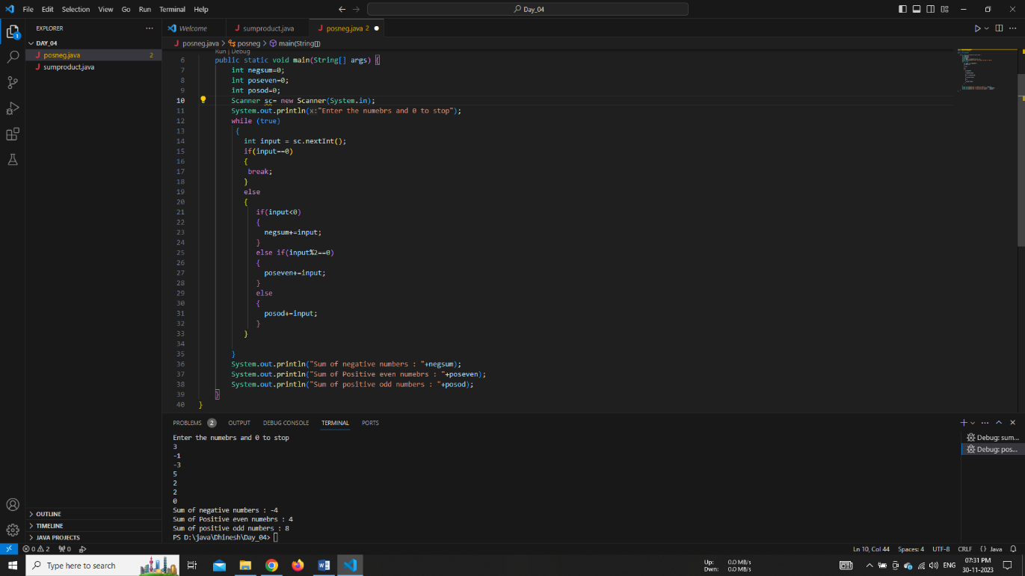

# ***********

**Print the Perfect Numbers between the range m and n.**

**Perfect number:** A number whose sum of factors (excluding the number itself) is equal to the number (ex: 28 = 1 + 2 + 4 + 7 + 14)

|  |
| --- |
| **Example 1:**  Input: m = 1 and n = 30  Output: 6, 28 |
| **Example 2:**  Input: m = 100 and n = 500  Output: 121, 144, 169, 196, 225, 256, 289, 324, 361, 400, 441, 484 |

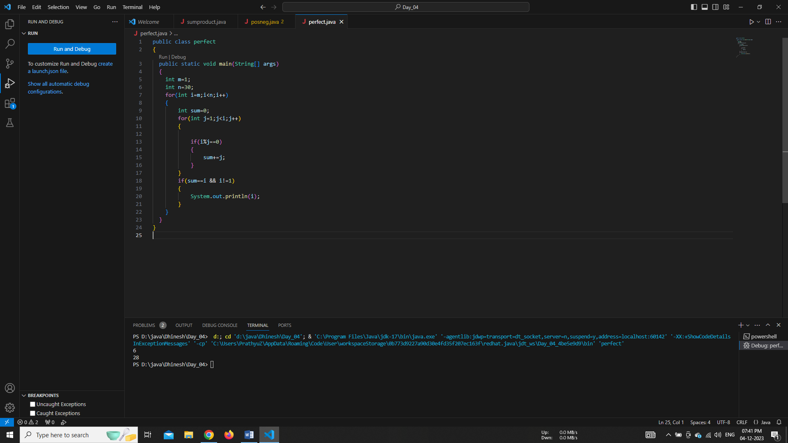

# ***********

**Find the Greatest Common Divisor (GCD) of the give two numbers num1 and num2**

|  |
| --- |
| **Example 1:**  Input: num1 = 20 and num2 = 15  Output: 5  Explanation: 20 = 1, 2, 4, **5**, 10, 20 (factors of 20)  15 = 1, 3, **5** (factors of 5) |
| **Example 2:**  Input: num1 = 52 and num2 = 10  Output: 2 |

# ***********

**Take integer inputs till the user enters 0 and print the largest number from all.**

|  |
| --- |
| **Example 1:**  Input: 52 10 4 2 77 137 55 184 0  Output: 184 |
| **Example 2:**  Input: 77 22 14 142 177 10 0  Output: 177 |

# ***********